THE WORKS OF ARCHIMEDES

Translated by Thomas Heath

A Digireads.com Book Digireads.com Publishing
The Works of Archimedes Translated by Thomas Heath ISBN: 1-4209-3467-8
This edition copyright © 2010 Please visit www.digireads.00171

CONTENTS
ON THE SPHERE AND CYLINDER
BOOK I 1
BOOK II 32
MEASUREMENT OF A CIRCLE 45
ON CONOIDS AND SPHEROIDS 50
ON SPIRALS 80
ON THE EQUILIBRIUM OF PLANES
BOOK I 100
BOOK II 108
THE SAND-RECKONER 118
QUADRATURE OF THE PARABOLA 125
OF FLOATING BODIES
BOOK I 136
BOOK II 141
BOOK OF LEMMAS 159
THE METHOD TREATING OF MECHANICAL PROBLEMS 167

THE WORKS OF ARCHIMEDES INCLUDING THE METHOD

BIOGRAPHICAL NOTE
ARCH1N1EDES, c. 287-212 B.C.
ARCHIMEDES was a citizen of Syracuse, in Sicily, where he was born around the year 287 13.C. IIe was intimate with Hiero, King of Syracuse, and with his son, Gelo, and Plutarch says that he was related to them. In his Sand-Reckoner, which was dedicated to Gelo, Archimedes speaks of his father, Pheidias, as an astronomer who investigated the sizes and distances of the sun and moon.
As a young man Archimedes seems to have spent some time in Egypt, where he invented the water-screw as a means of drawing water out of the Nile for irrigating the fields, though it is also said that he invented this machine to drain bilge water from a huge ship built for King Hiero. He may have studied with the pupils of Euclid in Alexandria. It was probably there that he made the friendship of Conon of Samos and Eratosthenes. To Conon he was in the habit of communicating his discoveries before their publication, and it was for Era-tosthenes that he wrote the Method and through him that he addressed the famous Cattle-Problem to the mathematicians of Alexandria—if the tradition is to be credited that associates Archimedes with this problem. After the death of Conon, Archimedes sent his discoveries to Conon's friend and pupil, Dositheus of Pelusium, to whom four of the extant treatises are dedicated.
His mechanical inventions won great fame for Archimedes and figure largely in the traditions about him. After discovering the solution of the problem To move a given weight by a given force, he boasted to King Hiero: "Give me a place to stand on and I can move the earth." Asked for a practical demonstration, he contrived a machine by which with the use of only one arm he drew out of the dock a large ship, laden with passengers and goods, which the combined strength of the Syracusans could scarcely move. From that day Hiero ordered that "Archimedes was to be believed in everything he might say." At the king's request Archimedes then made for him catapults, battering rams, cranes, and many other engines of war, which were later used with such success in the defense of Syracuse against the Romans that they were unable to take the city except by treachery. There is also a story in Lucian that Archimedes set fire to the Roman ships by an arrangement of burning glasses.
Although Archimedes acquired by his mechanical inventions "the renown of more than human sagacity," according to Plutarch, he "would not deign to leave behind him any commentary or writing on such subjects," since he considered them "sordid and ignoble." He did, however, write a description, now lost, of an apparatus, composed of concentric glass spheres moved by water power, representing the Eudoxian system of the world. This astronomical machine, which survived to be seen and described by Cicero in his Republic, was sufficiently accurate to show the eclipses of the sun and the moon. Except for this lost work On Sphere-making, Archimedes wrote only on strictly mathematical subjects. Ile took all the mathematical sciences for his province: arithmetic, geometry, astronomy, mechanics, and hydrostatics. 1Tnlike Euclid and Apol-

I310GRAPIIICAL NOTE
lonius he wrote no textbooks. Of his writings, although some have been lost, the most important have survived.
The absorption of Archimedes in his mathematical investigations was so great that he forgot his food and neglected his person, and when carried by force to the bath, Plutarch records, "he used to trace geometrical figures in the ashes of the fire and diagrams in the oil on his body." Asked by Hiero to discover whether a goldsmith had alloyed with silver the gold of his crown, Archimedes found the answer while bathing by considering the water displaced by his body, whereupon he is reported to have run home in his excitement without his clothes, shouting, "Eureka" (I have found it).
Archimedes' preoccupation with mathematics is even said to have been the cause of his death. In the general massacre which followed the capture of Syracuse by Marcellus in 212 }lc., Archimedes was so intent upon a mathematical diagram that he took no notice, and when ordered by a soldier to attend the victorious general, he refused until he should have solved his problem, whereupon he was slain by the enraged soldier. No blame attaches to the Roman general, Marcellus, since he had given orders to spare the house and person of the mathematician, and in the midst of his triumph he lamented the death of Archimedes, provided him with an honorable burial, and befriended his surviving relatives. In accordance with the expressed desire of Archimedes, his family and friends inscribed on his tomb the figure of his favorite theorem, on the sphere and the circumscribed cylinder, and the ratio of the containing solid to the contained. When Cicero was in Sicily as quaestor in 75 B.C., he discovered the neglected and forgotten tomb of Archimedes near the Agrigentine Gate and piously restored it.

ON THE SPHERE AND CYLINDER
BOOK ONE
ARCHINIEDES to DOSITHEUS greeting
"On a former occasion I sent you the investigations which I had up to that time completed, including the proofs, showing that any segment bounded by a straight line and a section of a right-angled cone [a parabola] is four-thirds of the triangle which has the same base with the segment and equal height. Since then certain theorems not hitherto demonstrated have occurred to me, and I have worked out the proofs of them. They are these: first, that the surface of any sphere is four times its greatest circle; next, that the surface of any segment of a sphere is equal to a circle whose radius is equal to the straight line drawn from the vertex of the segment to the circumference of the circle which is the base of the segment; and, further, that any cylinder having its base equal to-the greatest circle of those in the sphere, and height equal to the diameter of the sphere, is itself [i.e. in content] half as large again as the sphere, and its surface also [including its bases] is half as large again as the surface of the sphere. Nov these properties were all along naturally inherent in the figures referred to, but remained unknown to those who were before my time engaged in the study of geometry. Having, however, now discovered that the properties are true of these figures, I cannot feel any hesitation in setting them side by side both with my former investigations and with those of the theorems of Eudoxus on solids which are held to be most irrefragably established, namely, that any pyramid is one third part of the prism which has the same base with the pyramid and equal height, and that any cone is one third part of the cylinder which has the same base with the cone and equal height. For, though these properties also were naturally inherent in the figures all along, yet they were in fact unknown to all the many able geometers who lived before Eudoxus, and had not been observed by any one. Now, however, it will be open to those who possess the requisite ability to examine these discoveries of mine. They ought to have been published while Conon was still alive, for I should conceive that he would best have been able to grasp them and to pronounce upon them the appropriate verdict; but, as I judge it well to communicate them to those who are conversant with mathematics, I send them to you with the proofs written out, which it will be open to mathematicians to examine. Farewell.
"I first set out the axioms and the assumptions which I have used for the proofs of my propositions."
1

2 ARCHIMEDES
DEFINITIONS
I. "There are in a plane certain terminated bent lines, which either lie wholly on the same side of the straight lines joining their extremities, or have no part of them on the other side."
- "I apply the term concave in the same direction to a line such that, if any two points on it are taken, either all the straight lines connecting the points fall on the same side of the line, or some fall on one and the same side while others fall on the line itself, but none on the other side."
- "Similarly also there are certain terminated surfaces, not themselves being in a plane but having their extremities in a plane, and such that they will either be wholly on the same side of the plane containing their extremities, or have no part of them on the other side."
- "I apply the term concave in the same direction to surfaces such that, if any two points on them are taken, the straight lines connecting the points either all fall on the same side of the surface, or some fall on one and the same side of it while some fall upon it, but none on the other side."
- "I use the term solid sector, when a cone cuts a sphere, and has its apex at the centre of the sphere, to denote the figure comprehended by the surface of the cone and the surface of the sphere included within the cone."
- "I apply the term solid rhombus, when two cones with the same base have their apices on opposite sides of the plane of the base in such a position that their axes lie in a straight line, to denote the solid figure made up of both the cones."
ASSUMPTIONS
- "Of all lines which have the same extremities the straight line is the least."
- "Of other lines in a plane and having the same extremities, [any two] such are unequal whenever both are concave in the same direction and one of theni is either wholly included between the other and the straight line which has the same extremities with it, or is partly included by, and is partly common with, the other; and that [line] which is included is the lesser [of the two]."
- "Similarly, of surfaces which have the same extremities, if those extremities are in a plane, the plane is the least [in area]."
- "Of other surfaces with the same extremities, the extremities being in a plane, [any two] such are unequal whenever both are concave in the same direction and one surface is either wholly included between the other and the plane which has the same extremities with it, or is partly included by, and partly common with, the other; and that [surface] which is included is the leSser [of the two in area]."
- "Further, of unequal lines, unequal surfaces, and unequal solids, the greater exceeds the less by such a magnitude as, when added to itself, can be made to exceed any assigned magnitude among those which are comparable with [it and with] one another.
"These things being premised, if a polygon be inscribed in a circle, it is ptain that the perimeter of the inscribed polygon is less than the circumference of the circle; for each of the sides of the polygon is less than that part of the circumference of the circle which is cut off by it."

ON THE SPHERE AND CYLINDER I 3
PROPOSITION I
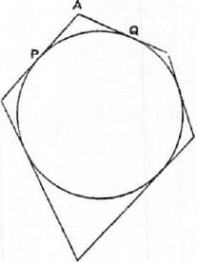
If a polygon be circumscribed about a circle, the perimeter of the circumscribed polygon is greater than the perimeter of the circle.
Let any two adjacent sides, meeting in A, touch the circle at P, Q respectively.
Then [Assumptions, 2]
PA-FAQ> (arc PQ).
A similar inequality holds for each angle of the polygon; and, by addition, the required result follows.
PROPOSITION 2
Given two unequal magnitudes, it is possible to find two unequal straight lines such that the greater straight line has to the less a ratio less than the greater magnitude has to the less.
Let AB,D represent the two unequal magnitudes, AB being the greater.
A Suppose BC measured along BA equal to D, and let GH be any straight line.
Then, if CA be added to itself a sufficient number of times, the sum will exceed D. Let AF be this sum, and take E on GH produced such that GH is the same multiple of HE o that Al? is of AC.
Thus EH : HG = AC : AF.
But, since AF>D (or CB),
AC : AR <.AC :CB.
Therefore, componendo,
El; :GH <.4B : D.
Hence EG, GH are two lines satisfying the given condition.
PROPOSITION 3
Given two unequal magnitudes and a circle, it is possible to inscribe a polygon in the circle and to describe another about it so that the side of the circumscribed polygon may have to the side of the inscribed polygon a ratio less than that of the greater magnitude to the less.

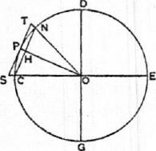
 | A | F

Let A, B represent the given magnitudes, A being the greater.
Find [Prop. 2] two straight lines F, KL, of which F is the greater, such that
: KL <A :13. (1).

4 ARCHIMEDES
Draw LM perpendicular to LK and of such length that KM = F.
In the given circle let CE, DG be two diameters at right angles. Then, bisecting the angle DOC, bisecting the half again, and so on, we shall arrive ultimately at an angle (as NOC) less than twice the angle LKM.
Join NC, which (by the construction) will be the side of a regular polygon inscribed in the circle. Let OP be the radius of the circle bisecting the angle NOC (and therefore bisecting NC at right angles, in H, say), and let the tangent at P meet OC, ON produced in S, T respectively.
Now, since L CON < 2 L LKM,
L HOC < L LKM,
and the angles at H, L are right;
therefore MK : LK > OC : OH
>OP :OH.
Hence ST : CY <MK : LK
<F : LK;
therefore, a fortiori, by (1),
ST :CN <A : B.
Thus two polygons are found satisfying the given condition.
PROPOSITION 4
Again, given two unequal magnitudes and a sector, it is possible to describe a polygon about the sector and to inscribe another in it so that the side of the circumscribed polygon may have to the side of the inscribed polygon a ratio less than the greater magnitude has to the less.
[The "inscribed polygon" found in this proposition is one which has for two sides the two radii bounding the sector, while the remaining sides (the number of which is, by construction, some power of 2) subtend equal parts of the arc of the sector; the "circumscribed polygon" is formed by the tangents parallel to the sides of the inscribed polygon and by the two bounding radii produced.]
T

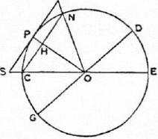
 |  |  |  | 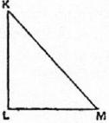
 | A | F | B

In this case we make the same construction as in the last proposition except that we bisect the angle COD of the sector, instead of the right angle between two diameters, then bisect the half again, and so on. The proof is exactly similar to the preceding one.
PROPOSITION 5
Given a circle and two unequal magnitudes, to describe a polygon about the circle and inscribe another in it, so that the circumscribed polygon may hare to the inscribed a ratio less than the greater magnitude has to the less.

ON THE SPHERE AND CYLINDER I 5
Let A be the given circle and B, C the given magnitudes, B being the greater.
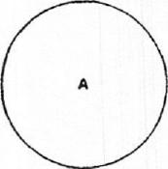
Take two unequal straight lines D, E, of which D is the greater,
B ^{c} such that D : E <B :C [Prop. 2],
and let F be a mean proportional between D, E so that D is also greater than F.
Describe (in the manner of Prop.
E 3) one polygon about the circle,
and inscribe another in it, so that
F the side of the former has to the side
of the latter a ratio less than the ratio D : F.
Thus the duplicate ratio of the side of the former polygon to the side of the latter is less than the ratio D² : le².
But the said duplicate ratio of the sides is equal to the ratio of the areas of the polygons, since they are similar;
therefore the area of the circumscribed polygon has to the area of the inscribed polygon a ratio less than the ratio D² : F², or D : E, and a fortiori less than the ratio B : C.
PROPOSITION 6
"Similarly we can show that, given two unequal magnitudes and a sector, it is possible to circumscribe a polygon about the sector and inscribe in it another similar one so that the circumscribed may have to the inscribed a ratio less than the greater magnitude has to the less.
"And it is likewise clear that, if a circle or a sector, as well as a certain area, be given, it is possible, by inscribing regular polygons in the circle or sector, and by continually inscribing such in the remaining segments, to leave segments of the circle or sector which are [together] less than the given area. For this is proved in the Elements [Eucl. xii. 2].
"But it is yet to be proved that, given a circle or sector and an area, it is possible to describe a polygon about the circle or sector, such that the area remaining between, the circumference and the circumscribed figure is less than the given area."
The proof for the circle (which, as Archimedes says, can be equally applied to a sector) is as follows.

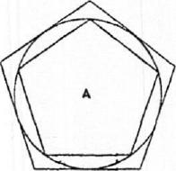
B
so that

Let A be the given circle and B the given area.
Now, there being two unequal magnitudes A +B and A, let a polygon (C) be circumscribed about the circle and a polygon (I) inscribed in it [as in Prop. 5],
C:I<A+B :A.
The circumscribed polygon (C) shall be that required.

6 ARCHIMEDES
For the circle (A) is greater than the inscribed polygon (I).
Therefore, from (1), a fortiori,
C :A<A+B :A,
whence C<A+B,
or C — A <B.
PROPOSITION 7
If in an isosceles cone [i.e. a right circular cone] a pyramid be inscribed having an equilateral base, the surface of the pyramid excluding the base is equal to a triangle having its base equal to the perimeter of the base of the pyramid and its height equal to the perpendicular drawn from the apex on one side of the base.
Since the sides of the base of the pyramid are equal, it follows that the perpendiculars from the apex to all the sides of the base are equal; and the proof of the proposition is obvious.
PROPOSITION 8
If a pyramid be circumscribed about an isosceles cone, the surface of the pyramid excluding its base is equal to a triangle having its base equal to the perimeter of the base of the pyramid and its height equal to the side [i.e. a generator] of the cone.
The base of the pyramid is a polygon circumscribed about the circular base of the cone, and the line joining the apex of the cone or pyramid to the point of contact of any side of the polygon is perpendicular to that side. Also all these perpendiculars, being generators of the cone, are equal; whence the proposition follows immediately.
PROPOSITION 9
If in the circular base of an isosceles cone a chord be placed, and from its extremities straight lines be drawn to the apex of the cone, the triangle so formed will be less than the portion of the surface of the cone intercepted between the lines drawn to the apex.
Let ABC be the circular base of the cone, and 0 its apex.
Draw a chord AB in the circle, and join OA, OB. Bisect the arc ACB in C, and join AC, BC, OC.
Then AOAC+ AOBC> AOAB.
Let the excess of the sum of the first two triangles over the third be equal to the area D.

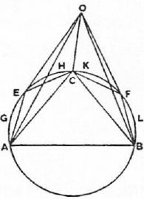
Then D is either less than the sum of the segments AEC, CFB, or not less.
I. Let D be not less than the sum of the segments referred to.
We have now two surfaces
- that consisting of the portion OAEC of the surface of the cone together with the segment AEC, and
- the triangle OAC;

ON THE SPHERE AND CYLINDER I
and, since the two surfaces have the same extremities (the perimeter of the triangle OAC), the former surface is greater than the latter, which is included by it [Assumptions, 3 or 4].
Hence , (surface OA EC) + (segment AEC) > QOAC.
Similarly (surface OCFB)+ (segment CFB) > AOBC.
Therefore, since D is not less than the sum of the segments, we have, by
addition,,
(surface OA ECF B) +D > AOAC+ AOBC
> QOAB+D, by hypothesis.
Taking away the common part D, we have the required result.
II. Let D be less than the sum of the segments AEC, CFB.
If now we bisect the arcs AC, CB, then bisect the halves, and so on, we shall
ultimately leave segments which are together less than D. [Prop. 6]
Let AGE, EHC, CKF, FLB be those segments, and join OE, OF.
Then, as before,
(surface OAGE)-1- (segment AGE) > AOAE
and (surface OEHC)+ (segment EHC) > AOEC.
Therefore (surface OAGHC)+ (segments AGE, EHC)
> AOAE+AOEC
> AOAC, a fortiori.
Similarly for the part of the surface of the cone bounded by OC, OB and
the arc CFB.
Hence, by addition,
(surface OAGEHCKFLB)+ (segments AGE, EHC, CKF, FLB)
> AOAC+6,0BC
> AO AB +D, by hypothesis.
But the sum of the segments is less than D, and the required result follows.
PROPOSITION 10
If in the plane of the circular base of an isosceles cone two tangents be drawn to the circle meeting in a point, and the points of contact and the point of concourse of the tangents be respectively joined to the apex of the cone, the sum of the two triangles formed by the joining lines and the two tangents are together greater than the included portion of the surface of the cone.
Let ABC be the circular base of the cone, 0 its apex, AD, BD the two tangents to the circle meeting in D. Join OA, OB, OD.
Let ECF be drawn touching the circle at C, the middle point of the arc ACB, and therefore parallel to AB. Join 0.e, QF.
Then ED+DF>EF,
and, adding AE+FB to each side,
AD+DB>AE+EF+FB.
Now OA, OC, OB, being generators of the cone, are equal, and they are
respectively perpendicular to the tangents at A, C, B.
It follows that
AOAD+AODB> AOAE+AOEF+ AOFB.
Let the area G be equal to the excess of the first sum over the second.
G is then either lees, or not less, than the sum of the spaces EAHC, FCKB
re paining between the circle and the tangents, which sum we will call L.
I. Let G be not less than L.

8 ARCHIMEDES
We have now two surfaces
- that of the pyramid with apex 0 and base AEFB, excluding the face OAB,
- that consisting of the part OACB of the surface of the cone together with the segment ACB.
These two surfaces have the same extremities, viz. the perimeter of the triangle OAB, and, since the former includes the latter, the former is the greater [Assumptions, 4].
That is, the surface of the pyramid exclusive of the face OAB is greater than the sum of the surface OACB and the segment ACB.
Taking away the segment from each sum, we have
6,0AE-F-AOEF+ AOFB±L> the surface OAIICKB.
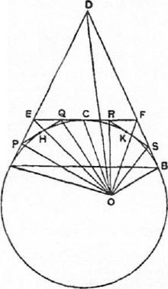And G is not less than L.
It follows. that
L\OAE+ AOEF+ AOFB+G,
which is by hypothesis equal to AOAD+ LODB, is greater than the same surface.
II. Let G be less than L.
If we bisect the arcs AC, CB and draw tangents at their middle points, then bisect the halves and draw tangents, and so on, we shall lastly arrive A at a polygon such that the sum of the parts remaining between the sides of the polygon and the circumference of the segment is less than G.
Let the remainders be those between the segment and the polygon APQRSB, and let their sum be M. Join OP, OQ, etc.
Then, as before,
AOAE+ AOEF-1- AOFB> AOAP+ AOPQ-1- • • -• AOSB.
Also, as before,
(surface of pyramid OAPQRSB excluding the face OAB) > the part OACB of the surface of the cone together with the segment ACB.
Taking away the segment from each sum,
AOAP+ AOPQ-1- • • • > the part OACB of the surface of the cone.
Hence, a fortiori,
AOAE-1-AOEF-i-A0F13-1-G,
which is by hypothesis equal to
LOAD -{- AODB,
is greater than the part OACB of the surface of the cone.
PROPOSITION 11
If a plane parallel to the axis of a right cylinder cut the cylinder, the part of the surface of the cylinder cut off by the plane is greater than the area of the parallelogram in which the plane cuts it.

ON THE SPHERE AND CYLINDER I 9
PROPOSITION 12
If at the extremities of two generators of any right cylinder tangents be drawn to the circular bases in the planes of those bases respectively, and if the pairs of tangents meet, the parallelograms formed by each generator and the two corresponding tangents respectively are together greater than the included portion of the surface of the cylinder between. the two generators.
[The proofs of these two propositions follow exactly the methods of Props. 9, 10 respectively, and it is therefore unnecessary to reproduce them.]
"From the properties thus proved it is clear (1) that, if a pyramid be inscribed in an isosceles cone, the surface of the pyramid excluding the base is less than the surface of the cone [excluding the base], and (2) that, if a pyramid be circumscribed about an isosceles cone, the surface of the pyramid excluding the base is greater than the surface of the cone excluding the base.
"It is also clear from what has been proved both (1) that, if a prism be inscribed in a right cylinder, the surface of the prism made up of its parallelograms [i.e. excluding its bases] is less than the surface of the cylinder excluding its bases, and (2) that, if a prism be circumscribed about a right cylinder, the surface of the prism made up of its parallelograms is greater than the surface of the cylinder excluding its bases."
PROPOSITION 13
The surface of any right cylinder excluding the bases is equal to a circle whose radius is a mean proportional between the side [i.e. a generator] of the cylinder and the diameter of its base.
Let the base of the cylinder be the circle A, and make CD equal to the diameter of this circle, and ER equal to the height of the cylinder.
Let H be a mean proportional between CD, EF, and B a circle with radius equal to H.

M
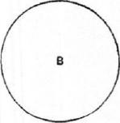
 | 11 | 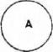

Then the circle B shall be equal to the surface of the cylinder (excluding the bases), which we will call S.
For, if not, B must be either greater or less than S.
I. Suppose B <S.
Then it is possible to circumscribe a regular polygon about B, and to inscribe another in it, such that the ratio of the former to the latter is less than the ratio S : B.
Suppose this done, and circumscribe about A a polygon similar to that described about B; then erect on the polygon about A a prism of the same height as the cylinder. The prism will therefore be circumscribed to the cylinder.
Let KD, perpendicular to CD, and FL, perpendicular to EF, be each equal to the perimeter of the polygon about A. Bisect CD in M, and join MK.

10 ARCHIMEDES
Then AKDM = the polygon about A.
Also OEL= surface of prism (excluding bases).
Produce FE to N so that FE= EN, and join NL.
Now the polygons about A, B, being similar, are in the duplicate ratio .of
the radii of A, B.
Thus
PKDM : (polygon about B) = MD² : H²
=MD² :CD • EF
=MD :NF
= AKDM : ALEN
(since DK =FL).
Therefore (polygon about B) = LLFN
=OEL
= (surface of prism about A),
from above.
But (polygon about B) : (polygon in B) <S : B.
Therefore
(surface of prism about A) : (polygon in B) <S : B,
and, alternately,
(surface of prism about A) : S < (polygon in B) : B;
which is impossible, since the surface of the prism is greater than 8, while the
polygon inscribed in B is less than B.
Therefore B <8.
II. Suppose B> S.
Let a regular polygon be circumscribed about B and another inscribed in it
so that
(polygon about B) : (polygon in B) <B : S.
Inscribe in A a polygon similar to that inscribed in B, and erect a prism on
the polygon inscribed in A of the same height as the cylinder.
Again, let DK, FL, drawn as before, be each equal to the perimeter of the
polygon inscribed in A.
Then, in this case,
AKDM> (polygon inscribed in A)
(since the perpendicular from the centre on a side of the polygon is less than
the radius of A).
Also LLFN =DEL= surface of prism (excluding bases).
Now
(polygon in A) : (polygon in B)= MD' : H²,
= AKDM :LLFN, as before.
And AKD.111> (polygon in A).
Therefore
LLFN, or (surface of prism) > (polygon in B).
But this is impossible, because
(polygon about B) : (polygon in B) <B : S,
< (polygon about B) : S, a fortiori,
so that (polygon in B)> S,
> (surface of prism), a fortiori.
Hence B is neither greater nor less than 8, and therefore
B = S.

ON THE SPHERE AND CYLINDER I 11
l'itorosrrios 14
The surface of any isosceles cone excluding the base is equal to a circle whose radius is a mean proportional between the side of the cone [a generator] and the radius of the circle which is the base of the cone.
Let the circle A be the base of the cone; draw C equal to the radius of the circle, and D equal to the side of the cone, and let E be a mean proportional between C, D.
Draw a circle B with radius equal to E.
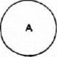
Then shall B be equal to the surface of the cone (excluding the base), which we will call S.
If not, B must be either greater or less than S. I. Suppose B <S.
Let a regular polygon be described about B and a similar one inscribed in it such that the former has to the latter a ratio less than the ratio S : B. Describe about A another similar polygon, and on it set up a pyramid with apex the same as that of the cone.
Then (polygon about A) : (polygon about B)
= C² : E²
= C : D
= (polygon about A) : (surface of pyramid excluding base).
Therefore
(surface of pyramid = (polygon about B).
Now (polygon about B) : (polygon in B) <S B.
Therefore
(surface of pyramid) : (polygon in B) <S : B,
which is impossible, (because the surface of the pyramid is greater than S,
while the polygon in B is less than B).
Hence B <S.
II. Suppose B> S.
Take regular polygons circumscribed and inscribed to B such that the ratio
of the former to the latter is less than the ratio B : S.
Inscribe in A a similar polygon to that inscribed in B, and erect a pyramid
on the polygon inscribed in A with apex the same as that of the cone.
In this case
(polygon in A) : (polygon in B) = C² E²
=C : D
> (polygon in A) : (surface of pyramid excluding base).
This is clear because the ratio of C to D is greater than the ratio of the
perpendicular from the centre of A on a side of the polygon to the perpen-
dicular from the apex of the cone on the same side.
Therefore
(surface of pyramid) > (polygon in B).
But (polygon about B) : (polygon in B) <B : S.

12 ARCHIMEDES
Therefore, a fortiori,
(polygon about B) : (surface of pyramid) <B : S,
which is impossible.
Since therefore B is neither greater nor less than S,
B = S.
PROPOSITION 15
The surface of any isosceles cone has the same ratio to its base as the side of the cone has to the radius of the base.
By Prop. 14, the surface of the cone is equal to a circle whose radius is a mean proportional between the side of the cone and the radius of the base.
Hence, since circles are to one another as the squares of their radii, the proposition follows.
PROPOSITION 16
If an isosceles cone be cut by a plane parallel to the base, the portion of the surface of the cone between the parallel planes is equal to a circle whose radius is a mean proportional between (1) the portion of the side of the cone intercepted by the parallel planes and (2) the line which is equal to the sum of the radii of the circles in the parallel planes.
Let OAR be a triangle through the axis of a cone, DE its intersection with the plane cutting off the frustum, and OFC the axis of the cone.
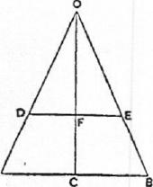Then the surface of the cone OAB is equal to a circle
whose radius is equal to VOA • AC. [Prop. 14.]
Similarly the surface of the cone ODE is equal to a
circle whose radius is equal to VOD•DF.
And the surface of the frustum is equal to the differ-
ence between the two circles.
Now
OA •AC —OD -DF =DA -AC--1-0D •AC —OD -DR.
But OD• AC =OA • DP,
since OA : AC =OD : DF. A
Hence OA • AC —0D• DR =DA-AC-I-DA • DF
= DA • (AC+DF).
And, since circles are to one another as the squares of their radii, it follows that the difference between the circles whose radii are VOA AC, \/OD • DF respectively is equal to a circle whose radius is VDA • (A C-FDF).
Therefore the surface of the frustum is equal to this circle.
LEMMAS
"1. Cones having equal height have the same ratio as their bases; and those having equal bases have the same ratio as their heights'.
2. If a cylinder be cut by a plane parallel to the base, then, as the cylinder is to the cylinder, so is the axis to the axis².
'Euclid XII. 11. "Cones and cylinders of equal height are to one another as their bases." Euclid xit. 14. "Cones and cylinders on equal bases are to one another as their heights."
=Euclid XII. 13. "If a cylinder be cut by a plane parallel to the opposite planes (the bases], then, as the cylinder is to the cylinder, so will the axis be to the axis."

ON THE SPHERE AND CYLINDER I 13
- The cones which have the same bases as the cylinders [and equal height] are in the same ratio as the cylinders.
- Also the bases of equal cones are reciprocally proportional to their heights; and those cones whose bases are reciprocally proportional to their heights are equal.'
- Also the cones, the diameters of whose bases have the same ratio as their axes,
are to one another in the triplicate ratio of the diameters of the bases.²
And all these propositions have been proved by earlier geometers."
PROPOSITION 17
If there be two isosceles cones, and the surface of one cone be equal to the base of the other, while the perpendicular from the centre of the base [of the first cone] on the side of that cone is equal to the height [of the second], the cones will be equal.
Let OA B, DEF he triangles through the axes of two cones respectively, C, G the centres of the respective bases, GH the perpendicular from G on FD; and suppose that the base of the cone 0 AB is equal to the surface of the cone DEF, and that OC = OH.
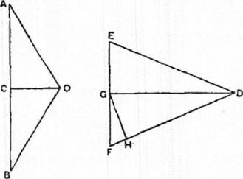
Then, since the base of OAB is equal to the surface of DEF,
(base of cone OAR) : (base of cone DEF)
= (surface of DEF) : (base of DEF)
= DF : FG [Prop. 15]
= DO :Gil, by similar triangles, =DG :0C.
Therefore the bases of the cones are reciprocally proportional to their heights; whence the cones are equal. [Lemma 4.]
PROPOSITION 18
Any solid rhombus consisting of isosceles cones is equal to the cone which has its base equal to the surface of one of the cones composing the rhombus and its height equal to the perpendicular drawn from the apex of the second cone to one side of
the first cone.
Let the rhombus be OABD consisting of two cones with apices 0, D and
with a common base (the circle about AB as diameter).
Let, FHK be another cone with base equal to the surface of the cone OAB
and height FG equal to DE, the perpendicular from D on OB.
Then shall the cone FHK be equal to the rhombus.
Construct a third cone LMN with base (the circle about MN) equal to the
base of OAB and height LP equal to OD.
'Euclid xiI. 15. "The bases of equal cones and cylinders are reciprocally proportional to their heights; and those cones and cylinders whose bases are reciprocally proportional to their heights are equal."
*Euclid xtt. 12. "Similar cones and cylinders are to one another in the triplicate ratio of the diameters of their bases."

14 ARCHIMEUES
Then, since LP = OD,
LP : CD=OD :CD.
But [Lemma 1] OD : CD = (rhombus OADB) : (cone DAB),
and LP : CD= (cone LMN) : (cone DAB). It follows that

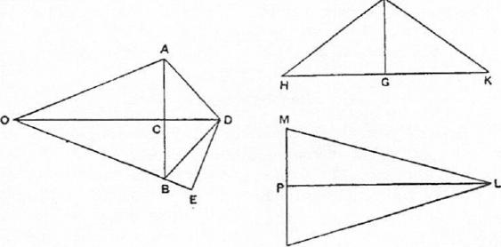

N
(rhombus 0.4 DB) = (cone LMN). (1)
Again, since A B = MN, and
(surface of OAR) = (base of I? HK),
(base of PIIK) : (base of LAIN) = (surface of OA B) : (base of OAR)
=0B : BC [Prop. 15]
=OD : DE, by similar triangles,
= LP : FG, by hypothesis.
Thus, in the cones FHK, LMN, the bases are reciprocally proportional to
the heights.
Therefore the cones FHK, LMN are equal,
and hence, by (1) the cone FHK is equal to the given solid rhombus.
PROPOSITION 19
If an isosceles cone be cut by a plane parallel to the base, and on the resulting circular section a cone be described having as its apex the centre of the base [of the first cone], and if the rhombus so formed be taken away from the whole cone, the part remaining will be equal to the cone with base equal to the surface of the portion of the first cone between the parallel planes and with height equal to the perpendicular drawn from the centre of the base of the first cone on one side of that cone.
Let the cone OAB be cut by a plane parallel to the base in the circle on DE as diameter. Let C be the centre of the base of the cone, and with C as apex and the circle about DE as base describe a cone, making with the cone ODE the rhombus ODCE.
Take a cone FGH with base equal to the surface of the frustum DARE and height equal to the perpendicular (CK) from C on AO.
Then shall the cone FGH be equal to the difference between the cone OAB and the rhombus ODCE.
Take (1) a cone LAIN with base equal to the surface of the cone OAR, and height equal to CK,
(2) a cone PQR with base equal to the surface of the cone ODE and height equal to CK.

ON THE SPHERE AND CYLINDER I 15
Now, since the surface of the cone OAB is equal to the surface of the cone ODE together with that of the frustum DARE, we have, by the construction,
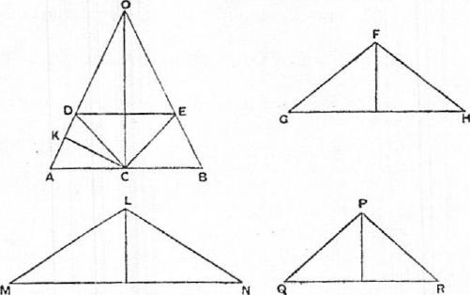
(base of LMN) = (base of FGH)+ (base of PQR)
and, since the heights of the three cones are equal,
(cone LMN) = (cone FGH)+ (cone PQR).
But the cone LMN is equal to the cone OAB [Prop. 17], and the cone PQI?
is equal to the rhombus ODCE [Prop. 18].
Therefore (cone OAB) = (cone FGH)+ (rhombus ODCE), and the proposi-
tion is proved.
PROPOSITION 20
If one of the two isosceles cones forming a rhombus be cut by a plane parallel to the base and on the resulting circular section a cone be described having the same apex as the second cone, and if the resulting rhombus be taken from the whole rhombus, the remainder will be equal to the cone with base equal to the surface of the portion of the cone between the parallel planes and with height equal to the perpendicular drawn from the apex of the second cone to the side of the first cone.
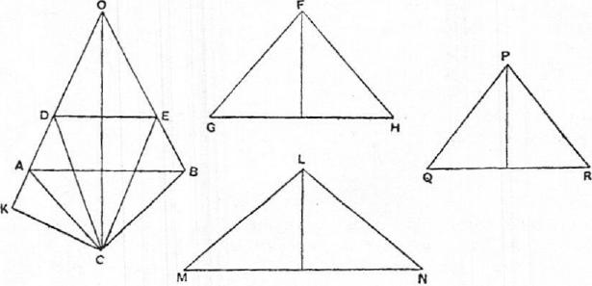
Let the rhombus be OACB, and let the cone OAB be cut by a plane parallel to its base in the circle about DE as diameter. With this circle as base and C

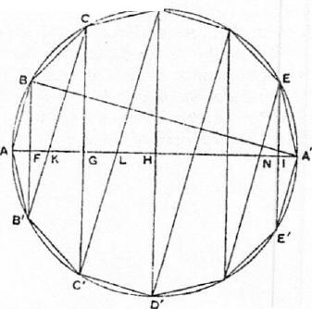16 ARCHIMEDES
as apex describe a cone, which therefore with ODE forms the rhombus ODCE.
Take a cone FGH with base equal to the surface of the frustum DABE and
height equal to the perpendicular (CK) from C on OA.
The cone FGH shall be equal to the difference between the rhombi OACB,
ODCE.
For take (1) a cone LMN with base equal to the surface of OAB and height
equal to CK,
(2) a cone PQR, with base equal to the surface of ODE, and height equal
t o CK.
Then, since the surface of DAB is equal to the surface of ODE together with
that of the frustum DABE, we have, by construction,
(base of LMN)= (base of PQM+ (base of FGH),
and the three cones are of equal height;
therefore (cone LMN) = (cone PQR) + (cone FGH).
But the cone LMN is equal to the rhombus OACB, and the cone PQR is
equal to the rhombus ODCE [Prop. 18].
Hence the cone FGH is equal to the difference between the two rhombi
OACB, ODCE.
PROPOSITION 21
A regular polygon of an even number of sides being inscribed in a circle, as ABC • • •A' • • •C'B' A, so that AA' is a diameter, if two angular points next but one to each other, as B, B', be joined, and the other lines parallel to BB' and joining pairs of angular points be drawn, as CC', DD' • • then (BE-FCC'd- • • .) : AA' =A'B :BA.
Let BB', CC', DD', • • • meet AA'
in F, G, H, • • • ; and let CB', DC',
- • • be joined meeting AA' in K, L,
- • • respectively.
Then clearly CB', DC', • • • are
parallel to one another and to AB.
Hence, by similar triangles,
BF : FA =B'F : FK
=CG :GK
=C'G:GL
=E'l :IA',
and, summing the antecedents and consequents respectively, we have (BB' -{-CC'+ • • .) : AA' =BF : FA
=A'B : BA.
PROPOSITION 22
If a polygon be inscribed in a segment of a circle LAL' so that all its sides excluding the base are equal and their number even, as LK • • •A • • •K'L', A being the middle point of the segment, and if the lines BB', CC', • • • parallel to the base LL' and joining pairs of angular points be drawn, then
(BB'-FCC'-}- • • •-ELM) : AM = A'B : BA,
where M is the middle point of LL' and AA' is the diameter through M.

ON THE SPHERE AND CYLINDER I 17

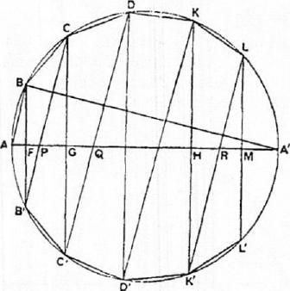
Joining CB', DC', • • • LK', as in the last proposition, and supposing that they meet AM in P, Q, • • • R, while BB', CC', • • KK' meet AM in F, G, • • • II, we have, by similar triangles,
BF : FA= B'F :FP
=CG :PG
=C'G :GQ
=LM :RM;
and, summing the antecedents and
consequents, we obtain
(BB'-FCC'-i- •••A-LM) : AM
=BF :FA
=A'B :BA.

PROPOSITION 23
Take a great circle ABC • • • of a sphere, and inscribe in it a regular polygon whose sides are a multiple of four in number. Let AA', MM' be diameters at right angles and joining opposite angular points of the polygon.
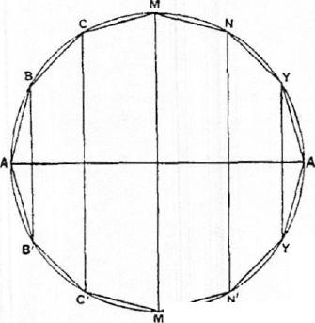Then, if the polygon and great circle revolve together about the diameter AA', the angular points of the polygon, except A, A', will describe circles on the surface of the sphere at right angles to the diameter AA'. Also the sides of the polygon will describe portions of conical surfaces, e.g. BC will describe a surface forming part of a cone whose base is a circle about CC' as diameter and whose apex is the point in which CB, C'B' produced meet each other and the diameter AA'.
Comparing the hemisphere MAM'
- and that half of the figure described by the revolution of the polygon which is included in the hemisphere, we see that the surface of the hemisphere and the surface of the inscribed figure have the same boundaries in one plane (viz. the circle on MM' as diameter), the former surface entirely includes the latter, and they are both concave in the same direction.
Therefore [Assumptions, 41 the surface of the hemisphere is greater than that of the inscribed figure; and the same is true of the other halves of the figures.
Hence the surface of the sphere is greater than the surface described by the revolution of the polygon. inscribed in the great circle about the diameter of the great circle.

18 ARCHIMEDES
PROPOSITION 24
If a regular polygon AB • • •A' • • •B'A, the number of whose sides is a multiple of four, be inscribed in a great circle of a sphere, and if BB' subtending two sides be joined, and all the other lines parallel to BB' and joining pairs of angular points be drawn, then the surface of the figure inscribed in the sphere by the revolution of the polygon about the diameter AA' is equal to a circle the square of whose radius is equal to the rectangle
BA(BB'+CC'--1- • • .)•
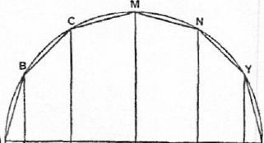
The surface of the figure is made up of the surfaces of parts of different cones.
Now the surface of the cone ABB'
is equal to a circle whose radius is
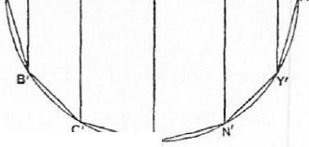VBA•iBB'. [Prop. 14] The surface of the frustum BB'C'C is equal to a circle of radius
V BC •t(BB' •-i-CC'), [Prop. 16] and so on.
It follows, since BA= BC = • • that the whole surface is equal to a
circle whose radius is equal to N/BA(BBH-CC+ . • •i-M/W-f- • • •⁻i⁻Yr).
PROPOSITION 25
The surface of the figure inscribed in a sphere as in the last propositions, consisting of portions of conical surfaces, is less than four times the greatest circle in the sphere.
Let AB • • •A' • • •B'A be a regular polygon inscribed in a great circle, the number of its sides being a multiple of four.
As before, let BB' be drawn subtending two sides, and CC', • • • Y Y' parallel to BB'.
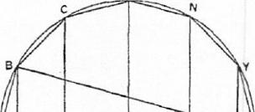
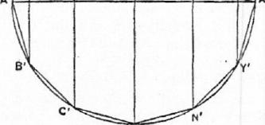
Let R be a circle such that the square of its radius is equal to
AB(BB'+CC'+ • • —FYI"), so that the surface of the figure inscribed in the sphere is equal to R.
[Prop. 24]
Now
(BE-FCC+ • • •+YY') :AA'
=A'B :AB, [Prop. 21] whence AB(BB'+CC'+ • • •+ YY') =AA' .A'B.
Hence (radius of R)² ---- AA' • A' B
<AA'².
Therefore the surface of the inscribed figure, or the circle I?, is less than four
times the circle AAIA'M'.

ON THE SPHERE AND CYLINDER I 19
PROPOSITION 26
The figure inscribed as above in a sphere is equal [in volume] to a cone whose base is a circle equal to the surface of the figure inscribed in the sphere and whose height is equal to the perpendicular drawn from the centre of the sphere to one side of the polygon.
Suppose, as before, that AB • • •A' • • •B'A is the regular polygon inscribed in a great circle, and let BB', CC', • • • be joined.
With apex 0 construct cones whose bases are the circles on BB', CC', • • • as diameters in planes perpendicular to A A'.
M
C N
Then OBAB' is a solid rhombus, and its volume is
..." equal to a cone whose base is
•
„.• equal to the surface of the cone
A A BB' and whose height is
equal to the perpendicular
••• from 0 on AB [Prop. 18]. Let
•
the length of the perpendicular be p.
Again, if CB, C'B' produced meet in T, the portion of the solid figure which is described by the revolution of the triangle BOC about AA' is equal to the difference between the rhombi OCTC' and OBTB', i.e. to a cone whose base is equal to the surface of the frustum
BB'C'C and whose height is p [Prop. 20].
Proceeding in this manner, and adding, we prove that, since cones of equal height are to one another as their bases, the volume of the solid of revolution is equal to a cone with height p and base equal to the sum of the surfaces of the cone BAB', the frustum BB'C'C, etc., i.e. a cone with height p and base equal to the surface of the solid.
PROPOSITION 27
The figure inscribed in the sphere as before is less than four times the cone whose base is equal to a great circle of the sphere and whose height is equal to the radius of the sphere.
By Prop. 26 the volume of the solid figure is equal to a cone whose base is equal to the surface of the solid and whose height is p, the perpendicular from 0 on any side of the polygon. Let R be such a cone.
Take also a cone S with base equal to the great circle, and height equal to the radius, of the sphere.
Now, since the surface of the inscribed solid is less than four times the great circle [Prop. 25], the base of the cone R is less than four times the base of the cone S.
Also the height (p) of R is less than the height of S.
Therefore the volume of R is less than four times that of S; and the proposition is proved.

20 ARCHIMEDES
PROPOSITION 28
Let a regular polygon, whose sides are a multiple of four in number, be circumscribed about a great circle of a given sphere, as AB • - •A' • • •B'A; and about the polygon describe another circle, which will therefore have the same centre as the great circle of the sphere. Let AA' bisect the polygon and cut the sphere in a, a'.
If the great circle and the circumscribed polygon revolve together about AA', the great circle will describe the surface of a sphere, the angular points of the polygon except A, A' will move round the surface of a larger sphere, the points of contact of the sides of the polygon with the great circle of the inner sphere will describe circles on that sphere in planes perpendicular to AA', and the sides of the polygon themselves will describe portions of conical surfaces. The circumscribed figure will thus be greater than the sphere itself.
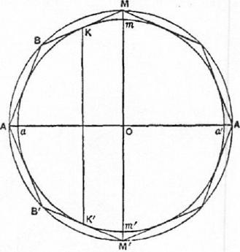
Let any side, as BAI, touch the
inner circle in K, and let K' be the point of contact of the circle with /3/3/'.
Then the circle described by the revolution of KK' about AA' is the boundary in one plane of two surfaces
- the surface formed by the revolution of the circular segment KaK' , and
- the surface formed by the revolution of the part KB • • •A • • .B'K' of the polygon.
Now the second surface entirely includes the first, and they are both concave in the same direction;
therefore [Assumptions, 4] the second surface is greater than the first. The same is true of the portion of the surface on the opposite side of the circle on KK' as diameter.
Hence, adding, we see that the surface of the figure circumscribed to the given sphere is greater than that of the sphere itself.
PROPOSITION 29
In a figure circumscribed to a sphere in the manner shown in the previous proposition the surface is equal to a circle the square on whose radius is equal to
AB(BB'd-CC'••}- • • .).
For the figure circumscribed to the sphere is inscribed in a larger sphere, and the proof. of Prop. 24 applies.
PROPOSITION 30
The surface of a figure circumscribed as before about a sphere is greater than four
times the great circle of the sphere.
Let AB • • •A' • • •B'A be the regular polygon of 4n sides which by its revolu-

ON THE SPHERE AND CYLINDER I 21
tion about AA' describes the figure circumscribing the sphere of which ama'm'
is a great circle. Suppose aa', AA' to be in one straight line.
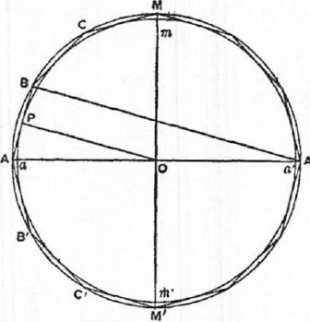
Let R be a circle equal to the surface bf the circumscribed solid. Now
(BB' -FCC' + • • -) :AA' -A'B :BA,
[as in Prop. 21]
so that
AB(BB' +CC'-1- • • •)= AA' •A'B. Hence (radius of R) = VA A' • A' B
[Prop. 29] >A'B.
But A'B = 20P, where P is the point in which AB touches the circle ama'm'.
Therefore (radius of R)> (diameter of circle ama'm');
whence R, and therefore the surface of the circumscribed solid, is greater than four times the great circle of the given sphere.
PROPOSITION 31
The solid of revolution circumscribed as before about a sphere is equal to a cone whose base is equal to the surface of the solid and whose height is equal to the radius of the sphere.
The solid is, as before, a solid inscribed in a larger sphere; and, since the perpendicular on any side of the revolving polygon is equal to the radius of the inner sphere, the proposition is identical with Prop. 26.
COR. The solid circumscribed about the smaller sphere is greater than four times the cone whose base is a great circle of the sphere and whose height is equal to the radius of the sphere.
For, since the surface of the solid is greater than four times the great circle of the inner sphere [Prop. 30], the cone whose base is equal to the surface of the solid and whose height is the radius of the sphere is greater than four times the cone of the same height which has the great circle for base. [Lemma 1.]
Hence, by the proposition, the volume of the solid is greater than four times the latter cone.
PROPOSITION 32
If a regular polygon with 4n sides be inscribed in a great circle of a sphere, as
ab • • • • •b'a, and a similar polygon AB • • •A' • • -B'A be described about the
great circle, and if the polygons revolve with the great circle about the diameters aa', AA' respectively, so that they describe the surfaces of solid figures inscribed in and circumscribed to the sphere respectively, then
- the surfaces of the circumscribed and inscribed figures are to one another in the duplicate ratio of their sides, and
- the figures themselves [i.e. their volumes] are in the triplicate ratio of their aides.

22 ARCHIMEDES
- Let AA', ad be in the same straight line, and let MmOm'M' be a diam-
eter at right angles to them.
Join BE', CC', • • • and bb', cc', • • • which will all be parallel to one another
and MM'.
Suppose R, S to be circles such that
R₄= (surface of circumscribed solid),
S= (surface of inscribed solid).
Then (radius of R)²=AB(Bili-ECC'+ • • •) [Prop. 29]
(radius of 8)²= ab(bb' + cc' + • • •). [Prop. 24]
And, since the polygons are similar, the rectangles in these two equations are similar, and are therefore in the ratio of
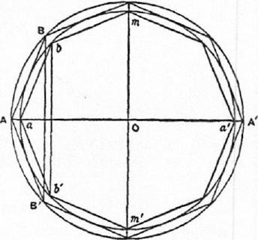
AB² : ab².
Hence
(surface of circumscribed solid) : (surface of inscribed solid) = AB² : ab².
- Take a cone V whose base is the circle R and whose height is equal to Oa, and a cone W whose base is the circle S and whose height is equal to the perpendicular from 0 on ab, which we will call p.
Then V, W are respectively equal to the volumes of the circumscribed
and inscribed figures. [Props. 31, 26]
Now, since the polygons are similar,
AB :ab=0a :p
= (height of cone V) : (height of cone W);
and, as shown above, the bases of the cones (the circles R, S) are in the ratio
of AB² to ab².
Therefore V :W=AB³ :
PROPOSITION 33
The surface of any sphere is equal to four times the greatest circle in it.
Let C be a circle equal to four times the great circle.
Then, if C is not equal to the surface of the sphere, it must either be less or
greater.
I. Suppose C less than the surface of the sphere.
It is then possible to find two lines -y, of which # is the greater, such that
# : y < (surface of sphere) : C. [Prop. 2]
Take such lines, and let S be a mean proportional between them.
Suppose similar regular polygons with 4n sides circumscribed about and inscribed in a great circle such that the ratio of their sides is less than the
ratio : S. [Prop. 3]
Let the polygons with the circle revolve together about a diameter common to all, describing solids of revolution as before.

ON THE SPHERE AND CYLINDER I 23
Then (surface of outer solid) : (surface of inner solid)
= (side of outer)² : (side of inner)= [Prop. 32)
< : 6², or : -y
< (surface of sphere) : C, a fortiori.
M

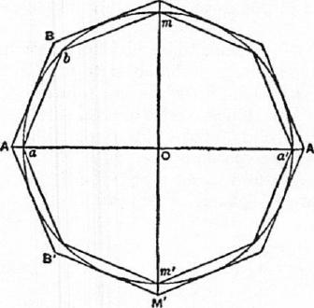
 | 8 |  | 'Y

But this is impossible, since the surface of the circumscribed solid is greater
than that of the sphere [Prop. 28], while the surface of the inscribed solid is less
than C [Prop. 25].
Therefore C is not less than the surface of the sphere.
II. Suppose C greater than the surface of the sphere.
Take lines $, -y, of which $ is the greater, such that
: y <C : (surface of sphere).
Circumscribe and inscribe to the great circle similar regular polygons, as be-
fore, such that their sides are in a ratio less than that of $ to 6, and suppose
solids of revolution generated in the usual manner.
Then, in this case,
(surface of circumscribed solid) : (surface of inscribed solid)
<C : (surface of sphere).
But this is impossible, because the surface of the circumscribed solid is
greater than C [Prop. 30], while the surface of the inscribed solid is less than
that of the sphere [Prop. 23].
Thus C is not greater than the surface of the sphere.
Therefore, since it is neither greater nor less, C is equal to the surface of the
sphere.
PROPOSITION 34
Any sphere is equal to four times the cone which has it bow equal to the greatest
circle in the sphere and its height equal to the radius of the sphere.
Let the sphere be that of which ama'm' is a great oircle.
If now the sphere is not equal to four times the cone described, it is either
greater or less.
I. If possible, let the sphere be greater than four times the cone.
Suppose V to be a cone whose base is equal to four times the great circle and
whose height is equal to the radius of the sphere.

24 ARCHIMEDES
Then, by hypothesis, the sphere is greater than V; and two lines 0, y can be found (of which 0 is the greater) such that
.₄3 : 'y < (volume of sphere) : V.
Between (3 and y pl:aee two arithmetic means 8, e.
As before, let similar regular polygons with sides 4n in number be circumscribed about and inscribed in the great circle, such that their sides are in a ratio less than 0 : S.
Imagine the diameter aa' of the circle to be in the same straight line with a diameter of both polygons, and imagine the latter to revolve with the circle about cc', describing the surfaces of two solids of revolution. The volumes of
these solids are therefore in the triplicate ratio of their sides. [Prop. 32]
Thus (vol. of outer solid) : (vol. of inscribed solid)
< : 3³, by hypothesis,
<13 : y, a fortiori (since $ : 7> j3" : 0),
< (volume of sphere) : V, a fortiori.
M

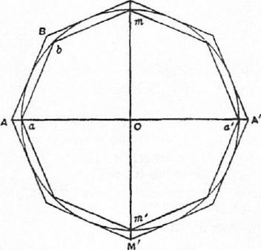
f3 8 c 7

But this is impossible, since the volume of the circumscribed solid is greater
than that of the sphere [Prop. 28], while the volume of the inscribed solid is
less than V [Prop. 27].
Hence the sphere is not greater than V, or four times the cone described in
the enunciation.
II. If possible, let the sphere be less than V.
In this case we take 0, 7 (0 being the greater) such that
,t3 : y < V : (volume of sphere).
The rest of the construction and proof proceeding as before, we have finally
(volume of outer solid) : (volume of inscribed solid)
< V : (volume of sphere).
But this is impossible, because the volume of the outer solid is greater than
V [Prop. 31, Cor.], and the volume of the inscribed solid is less than the volume
of the sphere.
Hence the sphere is not less than V.
Since then the sphere is neither less nor greater than V, it is equal to V, or to
four times the cone described in the enunciation.

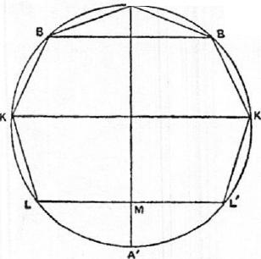ON THE SPHERE AND CYLINDER I 25
COR. From what has been proved it follows that every cylinder whose base is the greatest circle in a sphere and whose height is equal to the diameter of the sphere
is of the sphere, and its surface together with its bases is of the surface of the
sphere.
For the cylinder is three times the cone with the same base and height [Eucl. xi" 10], i.e. six times the cone with the same base and with height equal to the radius of the sphere.
But the sphere is four times the latter cone [Prop. 34]. Therefore the cylinder is of the sphere.
Again, the surface of a cylinder (excluding the bases) is equal to a circle whose radius is a mean proportional between the height of the cylinder and the diameter of its base [Prop. 13].
In this case the height is equal to the diameter of the base and therefore the circle is that whose radius is the diameter of the sphere, or a circle equal to four times the great circle of the sphere.
Therefore the surface of the cylinder with the bases is equal to six times the great circle.
And the surface of the sphere is four times the great circle [Prop. 33] ; whence (surface of cylinder with bases) =3- .(surface of sphere).
PROPOSITION 35
If in a segment of a circle LA L' (where A is the middle point of the arc) a polygon LK • • •A • • •K'L' be inscribed of which LL' is one side, while the other sides are 2n in number and all equal, and if the polygon revolve with the segment about the diameter AM, generating a solid figure inscribed in a segment of a sphere, then the surface of the inscribed solid is equal to a circle the square on whose radius is equal to the rectangle
'
AB (BB' +CC+ • • KK' -F^{LL})
2
The surface of the inscribed figure is
A made up of portions of surfaces of cones.
If we take these successively, the surface of the cone BAB' is equal to a circle whose radius is
\/AB • -1-BB'. [Prop. 14]
The surface of the frustum of a cone BCC'B' is equal t o a circle whose radius is
_{AB •}BB' BB'-}'CC'_{. • [P 2} ' _{rop. 16]}
and so on.
Proceeding in this way and adding, we find, since circles are to one another as the squares of their radii, that the surface of the inscribed figure is equal to a circle whose radius is
±L₂L_{).}
\IAB

26 ARCIIIMEDES
PROPOSITION 36
The surface of the figure inscribed as before in the segment of a sphere is less than that of the segment of the sphere.
This is clear, because the circular base of the segment is a common boundary of each of two surfaces, of which one, the segment, includes the other, the solid, while both are concave in the same direction [Assumptions, 4].
PROPOSITION 37
Dhe surface of the solid _{f}igure inscribed in the segment of the sphere by the revolution of LK • • •A • • •K'L' about AM is less than a circle with radius equal to AL.
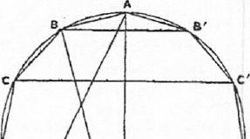
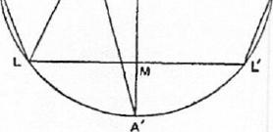
Let the diameter AM meet the circle of which LAL^{l}• is a 8egrtftt again in A'. Join A'B.
As in Prop. 35, the surf ace of the inscribed solid is equal to a circle the square on whose radius is
AB(BB¹-1-CC'l- • • :+KK'-FLM). But this rectangle
= A'B •AM [Prop. 22] <A'A •AM
<AL².
Hence the surface of the inscribed solid is less than the circle whose radius is AL.
PROPOSITION 38
The solid figure described as before in a segment of a sphere less than a hemisphere, together with the cone whose base is the base of the segment and whose apex is the
centre of the sphere, is equal to a cone whose base is equal to the surface of the inscribed solid and whose height is equal to the perpendicular from the centre of the sphere on any side of the polygon.
Let 0 be the centre of the sphere, and p the length of the perpendicular from 0 on AB.
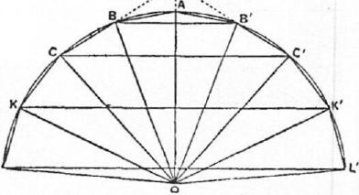
Suppose cones described with 0 as apex, and with the circles on BB', CC', • • • as diameters as bases.
Then the rhombus OBAB' is equal to a cone whose base is equal to the surface of the cone BAB', and whose
height is p. [Prop. 18]
Again, if CB, C'B' meet in T, the solid described by the triangle BOC as the polygon revolves about AO is the difference between the rhombi OCTC' and OB7'8', and is therefore equal to a cone whose base is equal to the surface of

ON THE SPHERE AND CYLINDER I 27
the frustum BCC' B' and whose height is p. [Prop. 20]
Similarly for the part of the solid described by the triangle COD as the polygon revolves; and so on.
Hence, by addition, the solid figure inscribed in the segment together with the cone OLL' is equal to a cone whose base is the surface of the inscribed solid and whose height is p.
Cox. The cone whose base is a circle with radius equal to AL and whose height is equal to the radius of the sphere is greater than the sum of the inscribed solid and the cone OLL'.
For, by the proposition, the inscribed solid together with the cone OLL' is equal to a cone with base equal to the surface of the solid and with height p.
This latter cone is less than a cone with height equal to OA and with base equal to the circle whose radius is AL, because the height p is less than OA, while the surface of the solid is less than a circle with radius AL. [Prop. 37]
PROPOSITION 39
Let lal' be a segment of a great circle of a sphere, being less than a semicircle. Let 0 be the centre of the sphere, and join 01, 01'. Suppose a polygon circumscribed about the sector Olal' such that its sides, excluding the two radii, are 2n in number and all equal, as LK, • • .BA, AB', • • •K'L'; and let OA be that radius of the great circle which bisects the segment lal'.
The circle circumscribing the polygon will then have the same centre 0 as the given great circle.
Now suppose the polygon and the two circles to revolve together about OA. The two circles will describe spheres, the angular points except A will describe circles on the outer sphere, with diameters BB' etc., the points of contact of the sides with the inner segment will describe circles on the inner sphere, the sides themselves will describe the surfaces of cones or frusta of cones, and the whole figure circumscribed to the segment of the inner sphere by the revolution of the equal sides of the polygon will have for its base the circle on LL' as diameter.
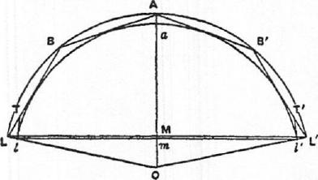
The surface of the solid figure so circumscribed about the sector of the sphere [excluding its base] will be greater than that of the segment of the sphere whose base is the circle on 11' as diameter.
For draw the tangents 1T, l'T' to the inner segment at 1, 1'. These with the sides of the polygon will describe by their revolution a solid whose surface is greater than that of the segment [Assumptions, 4].
But the surface described by the revolution of 1T is less than that described by the revolution of LT, since the angle T1L is a right angle, and therefore LT>1T.
Hence, a fortiori, the surface described by LK • • •A • • •K'L' is greater than that of the segment.

28 ARCHIMEDES
Co 1. The surface of the figure so described about the sector of the sphere is equal
to a circle the square on whose radius is equal to the rectangle
AB (1313¹-1-CC'+ • • • +KK' +ILL%
For the circumscribed figure is inscribed in the outer sphere, and the proof
of Prop. 35 therefore applies.
PROPOSITION 40
The surface of the figure circumscribed to the sector as before is greater than a circle whose radius is equal to al.
Let the diameter Aa0 meet the great circle and the circle circumscribing the revolving polygon again in a', A'. Join A'B, and let ON be drawn to N, the point of contact of AB with the inner circle.
Now, by Prop. 39, Cor., the surface of the solid figure circumscribed to the sector OlAl' is equal to a circle the square on whose radius is equal to the rectangle
AB (BB'A-CC¹+ • • •-f-KK' | LL'  +T).

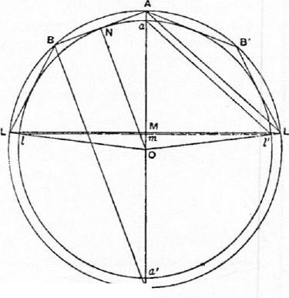But this rectangle is equal to A'B • AM [as in Prop. 22].
Next, since AL', al' are parallel, the triangles A M L' , cue are similar. And AL' > al'; therefore AM > am.
Also A'B =20N = aa'.
Therefore A'B •AM> am -ad
>al'².
Hence the surface of the solid figure circumscribed to the sector is greater than a circle whose radius is equal to al', or al.
CoR. 1. The volume of the figure circumscribed about the sector together with the cone whose apex is° and base the circle on LL' as diameter, is equal to the volume of a cone
whose base is equal to the surface of the circumscribed figure and whose height is ON.
For the figure is inscribed in the outer sphere which has the same centre as the inner. Hence the proof of Prop. 38 applies.
CoR. 2. The volume of the circumscribed figure with the cone OLL' is greater than the cone whose base is a circle with radius equal to al and whose height is equal to the radius (Oa) of the inner sphere.
For the volume of the figure with the cone OLL' is equal to a cone whose base is equal to the surface of the figure and whose height is equal to ON.
And the surface of the figure is greater than a circle with radius equal to al [Prop. 40], while the heights Oa, ON are equal.

ON THE SPHERE AND CYLINDER I 29
PROPOSITION 41
Let lar be a segment of a great circle of a sphere Ivhich is less than a semicircle.
Suppose a polygon inscribed in the sector Olal' such that the sides lk, • • •ba, all, ...el' are 2n in number and all equal. Let a similar polygon be circumscribed about the sector so that its sides are parallel to those of the first polygon; and draw the circle circumscribing the outer polygon.
Now let the polygons and circles revolve together about Oa A, the radius bisecting the segment lar.
Then (1) the surfaces of the outer and inner solids of revolution so described are in the ratio of AB² to ab², and (2) their volumes together with the corresponding cones with the same base and with apex 0 in each case are as AB³ to ab³.
(1) For the surfaces are equal to circles the squares on whose radii are equal respectively to
AB(B.B' -1-CC'+ • • •+KIC' LL' [Prop. 39, Cor.]
and ab (bb' +cc' ± • • •-f-kk'+— ₂ ). [Prop. 35]
But these rectangles are in the ratio of AB² to ab². Therefore so are the surfaces.
(2) Let OnN be drawn perpendicular to ab and AB; and suppose the circles which are equal to the surfaces of the outer and inner solids of revolution to be denoted by S, s respectively.
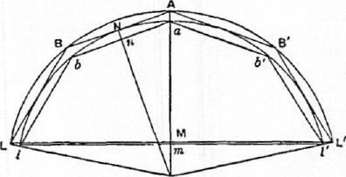
Now the volume of the circumscribed solid together with the cone OLL' is equal to a cone whose base is S and whose height is ON [Prop. 40, Cor. 1].
And the volume of the inscribed figure with the cone Ole is equal to a cone with base s and height On [Prop. 38].
But S s = AB²: ab²,
and ON : On= AB : ab.
Therefore the volume of the circumscribed solid together with the cone OLL' is to the volume of the inscribed solid together with the cone 011' as AB³ is to ab³ [Lemma 5].
PROPOSITION 42
If lal' be a segment of a sphere less than a hemisphere and Oa the radius perpendicular to the base of the segment, the surface of the segment is equal to a circle whose radius is equal to al.
Let R be a circle whose radius is equal to al. Then the surface of the segment, which we will call S, must, if it be not equal to R, be either greater or less than R.

30 ARCHIMEDES
- Suppose, if possible, S>I?.
Let lal' be a segment of a great circle which is less than a semicircle. Join 01, 01', and let similar polygons with 2n equal sides be circumscribed and inscribed to the sector, as in the previous propositions, but such that (circumscribed polygon) : (inscribed polygon) <45 : I?.
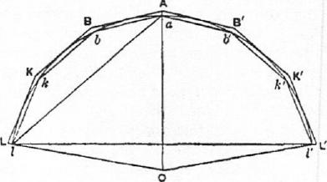
[Prop. 6] Let the polygons now revolve with the segment about OaA, generating solids of revolution circumscribed and inscribed to the segment of the sphere.
Then
(surface of outer solid) : (surface of inner solid)
= AB² : ab² [Prop. 41]
= (circumscribed polygon) : (inscribed polygon)
<S : R, by hypothesis.
But the surface of the outer solid is greater than S [Prop. 39].
Therefore the surface of the inner solid is greater than I?; which is impossible,
by Prop. 37.
- Suppose, if possible, 8 <R.
In this case we circumscribe and inscribe polygons such that their ratio is
less than R : S; and we arrive at the result that
(surface of outer solid) : (surface of inner solid)
<I? : S.
But the surface of the outer solid is greater than R [Prop. 40]. Therefore the
surface of the inner solid is greater than S : which is impossible [Prop. 36].
Hence, since S is neither greater nor less than R,
S=R.
PROPOSITION 43
Even if the segment of the sphere is greater than a hemisphere, its surface is still
equal to a circle whose radius is equal to al.
For let lal'a' be a great circle of the sphere, aa' being the diameter perpen-
dicular to ii'; and let la'l' be a segment less than a
semicircle.
Then, by Prop. 42, the surface of the segment la'l'
of the sphere is equal to a circle with radius equal to
a'1.
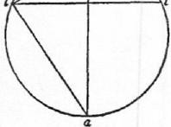
Also the surface of the whole sphere is equal to a
circle with radius equal to aa' [Prop. 33].
But aa¹² — a'1² = al², and circles are to one another
as the squares on their radii.
Therefore the surface of the segment lal', being
the difference between the surfaces of the sphere and
of la'l', is equal to a circle with radius equal to al.

ON THE SPHERE AND CYLINDER I 31
PROPOSITION 44
The volume of any sector of a sphere is equal to a cone whose base is equal to the surface of the segment of the sphere included in the sector, and whose height is equal to the radius of the sphere.
Let R be a cone whose base is equal to the surface of the segment tat' of a sphere and whose height is equal to the radius of the sphere; and let S be the volume of the sector Olal'.
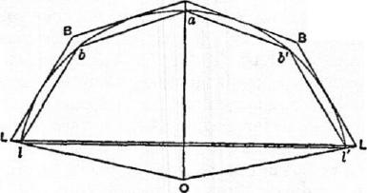p
a
Then, if S is not equal to R, it must be either greater or less.
I. Suppose, if possible, that S> R.
Find two straight lines fi, 7, of which /3 is the greater, such that
t3:7<S:R;
and let (5, e be two arithmetic means between /3, 7.
Let tat' be a segment of a great circle of the sphere. Join 01, 01', and let similar poly-
₇ gons with 2n equal sides be
circumscribed and inscribed to the sector of the circle as before, but such that their sides are in a ratio less than fi : S. [Prop. 4].
Then let the two polygons revolve with the segment about OaA, generating two solids of revolution.
Denoting the volumes of these solids by V, v respectively, we have
(V-1-cone OLL') : (v+cone OW) =AB³ : ab³ {Prop. 41]
<9:a³
< 13 : 7, a fortiori,
<S : R, by hypothesis.
Now (V-1-cone OLL') >S.
Therefore also (v+cone 011')> R.
But this is impossible, by Prop. 38, Cor. combined with Props. 42, 43.
Hence S> R.
II. Suppose, if possible, that S <R.
In this case we take 0, y such that
/3. .y <R :8,
and the rest of the construction proceeds as before.
We thus obtain the relation
(V-I-cone OLL') : (v- -cone 011') <R : S.
Now (v-}-cone 011') <S.
Therefore (V-}-cone OLL') <R;
which is impossible, by Prop. 40, Cor. 2 combined with Props. 42, 43.
Since then S is neither greater nor less than R,
S=R.

ON THE SPHERE AND CYLINDER
BOOK TWO
ARCHIMEDES to Dositheus greeting.
"On a former occasion you asked me to write out the proofs of the problems t he enunciations of which I had myself sent to Conon. In point of fact they depend for the most part on the theorems of which I have already sent. you the demonstrations, namely (1) that the surface of any sphere is four times the greatest circle in the sphere, (2) that the surface of any segment of a sphere is equal to a circle whose radius is equal to the straight line drawn from the vertex of the segment to the circumference of its base, (3) that the cylinder whose base is the greatest circle in any sphere and whose height is equal to the diameter of the sphere is itself in magnitude half as large again as the sphere, while its surface [including the two bases] is half as large again as the surface of the sphere, and (4) that any solid sector is equal to a cone whose base is the circle which is equal to the surface of the segment of the sphere included in the sector, and whose height is equal to the radius of the sphere. Such then of the theorems and problems as depend on these theorems I have written out in the book which I send herewith; those which are discovered by means of a different sort of investigation, those namely which relate to spirals and the conoids, I will endeavour to send you soon.
"The first of the problems was as follows: Given a sphere, to find a plane area equal to the surface of the sphere.
"The solution of this is obvious from the theorems aforesaid. For four times the greatest circle in the sphere is both a plane area and equal to the surface of the sphere.
"The second problem was the following."
PROPOSITION 1 (PROBLEM)
Given a cone or a cylinder, to find a sphere equal to the cone or to the cylinder. If V be the given cone or cylinder, we can make a cylinder equal to W. Let this cylinder be the cylinder whose base is the circle on AB as diameter and whose height is OD.
Now, if we could make another cylinder, equal to the cylinder (OD) but such that its height is equal to the diameter of its base, the problem would be solved, because this latter cylinder would be equal to IV, and the sphere whose diameter is equal to the height (or to the diameter of the base) of the same cylinder would then be the sphere required [I. 34, Cor.].
Suppose the problem solved, and let the cylinder (CG) be equal to the cylinder (OD), while EF, the diameter of the base, is equal to the height CG.
32

ON THE SPHERE AND CYLINDER II 33
Then, since in equal cylinders the heights and bases are reciprocally pro-
portional,
AB² : EF²=CG :OD
=EF :OD. (1)
M

a |  |  | 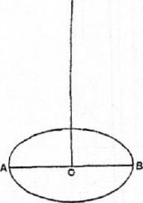
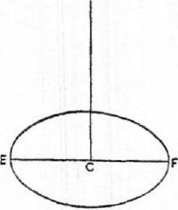
 | N

Suppose MN to be such a line that
' EF²=AB MIN. (2)
Hence AB : EF=EF : MN,
and, combining (1) and (2), we have
AB : MN =EF : OD,
or AB : EP' =MN :OD.
Therefore AB :EF=EF : MN =MN : OD,
and EF, MN are two mean proportionals between AB, OD.
The synthesis of the problem is therefore as follows. Take two mean pro-
portionals EF, MN between AB and OD, and describe a cylinder whose base
is a circle on EF as diameter and whose height CG is equal to EF.
Then, since
AB : EF = EF :MN=MN : OD,
EF² = AB •MN,
and therefore AB² : EF²=AB : MN
=EF :OD
=CG : OD;
whence the bases of the two cylinders (OD), (CG) are reciprocally proportional
to their heights.
Therefore the cylinders are equal, and it follows that
cylinder (CG) =V.
The sphere on EF as diameter is therefore the sphere required, being equal
to V.
PROPOSITION 2
If BAB' be a segment of a sphere, B13' a diameter of the base of the segment, and 0 the centre of the sphere, and if AA' be the diameter of the sphere bisecting BB' in M, then the volume of the segment is equal to that of a cone whose base is the same as that of the segment and whose height is h, where
h :AM=0A'±A'M : A'M.
Measure MI? along MA equal to h, and MH' along MA' equal to h', where
h' : A'M=OA+AM :AM.

34 ARCHIMEDES
Suppose the three cones constructed which have 0, H, 11' for their apices and the base (BB') of the segment for their common base. Join AB, A'B.
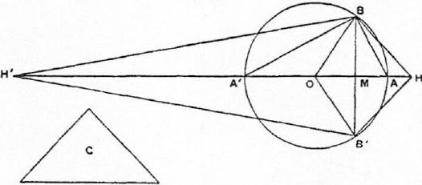
Let C be a cone whose base is equal to the surface of the segment BAB' of the sphere, i.e. to a circle with radius equal to AB [I. 42], and whose height is equal to OA.
Then the cone C is equal to the solid sector OBAB' [I. 44].
Now, since HM :MA=0A'+A'111 :A'M,
dividendo, HA :AM=0A : A'M,
and, alternately, HA : AO =AM : MA',
so that
HO : OA =AA' : A'M
=AB² : BM²
= (base of cone C) : (circle on BB' as diameter).
But OA is equal to the height of the cone C; therefore, since cones are equal if
their bases and heights are reciprocally proportional, it follows that the cone C
(or the solid sector OBAB') is equal to a cone whose base is the circle on BB' as
diameter and whose heigkit is equal to OH.
And this latter cone is equal to the sum of two others having the same base
and with heights OM, M11, i.e. *to the solid rhombus 01311.8'.
Hence the sector OBAB' is equal to the rhombus OBHB'.
Taking away the common part, the cone OBB',
the segment BAB' =the cone HBB'.
Similarly, by the same method, we can prove that
the segment BA'B' = the cone H'BB'.
Alternative proof of the latter property.
SupPw 4 to be a cone whose base is equal to the surface of the whole sphere
and whose height is equal to OA.
Thus D is equal to the volume of the sphere. [1. 33, 34]
Now, since OA'+A'M :A'M=HM : MA,
dividendo and aiternando, as before,
OA : AH=A'M :MA.
Again, since H'M : MA' =0A+AM : AM,
WA' :OA= A'M :MA
=OA : AH, from above.
Componendo, : OA =OH : HA, (1)
Alternately. H'0 :011=0A : A H, (2)

ON THE SPHERE AND CYLINDER II 35
and, componendo, : HO =OH : HA,
=H'0 : OA, from (1),
whence HH' • OA =H'0 • OH. (3)
Next, since H'0 : OH = OA : AH, by (2),
=A'M : MA,
(11/0+0H)² : H'0 • OH = (A'M-FMA)² : A'M MA,
whence, by means of (3),
HH'² :HH' • OA =AA" : A'M•• MA,
or HH' :OA = AZ1¹² : BAP.
Now the cone D, which is equal to the sphere, has for its base a circle whose
radius is equal to AA', and for its height a line equal to OA.
Hence this cone D is equal to a cone whose base is the circle on BR' as diam-
eter and whose height is equal to HH';
therefore the cone D= the rhombus HRIPB',
or the rhombus HBH'B' = the sphere.
But the segment BAB' = the cone H BB' ;
therefore the remaining segment BA'B' = the cone H'BB'.
Cox. The segment BAB' is to a cone with the same base and equal height in the
ratio of OA'-i-A'M to A'M.
PROPOSITION 3 (PRoBLI•:1i)
To cut a given sphere by a plane so that the surfaces of the segments may have to one another a given ratio.
Suppose the problem solved. Let AA' be a diameter of a great circle of the sphere, and suppose that a plane perpendicular to AA' cuts the plane of the great circle in the straight line BB', and AA' in M, and that it divides the sphere so that the surface of the segment BAB' has to the surface of the
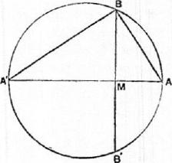
H K
segment BA'B' the given ratio.
Now these surfaces are respectively
equal to circles with radii equal to AB,
A'B [I. 42, 43].
Hence the ratio AB² : A'B² is equal to
the given ratio, i.e. AM is to MA' in the
given ratio.
Accordingly the synthesis proceeds as follows.
If H : K be the given ratio, divide AA' in M so that
AM : MA' =H : K.
Then AM : MA' = AB² : A'B²
= (circle with radius AB) : (circle with radius A'B)
= (surface of segment BAB') : (surface of segment BA'B').
Thus the ratio of the surfaces of the segments is equal to the ratio H : K.
PROPOSITION 4 (PROBLEM)
To cut a given sphere by a plane so that the volumes of the segments are to one
another in a given ratio.
Suppose the problem solved, and let the required plane cut the great circle

36 ARCHIMEDES
ABA' at right angles in the line BB'. Let AA' be that diameter of the great circle which bisects BB' at right angles (in M), and let 0 be the centre of the sphere.

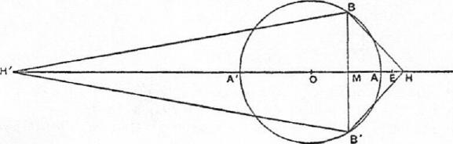 | 0

Take H on OA produced, and H' on OA' produced, such that
OA'+A'M : A'M=HM : MA, (1)
and OA+AM : AM =H'M : MA'. (2)
Join BH, B'H, BH', B'H'.
Then the cones HBB', H'BB' are respectively equal to the segments BAB',
BA'B' of the sphere [Prop. 2].
Hence the ratio of the cones, and therefore of their altitudes, is given, i.e.
HM H'M = the given ratio. (3)
We have now three equations (1), (2), (3), in which there appear three as yet undetermined points M, H, H'; and it is first necessary to find, by means of them, another equation in which only one of these points (M) appears, i.e. we have, so to speak, to eliminate H, H'.
Now, from (3), it is clear that IIH' : H'M is also a given ratio; and Archimedes' method of elimination is, first, to find values for each of the ratios A'H' : H'M and HIP : H'A' which are alike independent of II, H', and then, secondly, to equate the ratio compounded of these two ratios to the known value of the ratio IIH'
- To find such a value for A'H' : H'M. It is at once clear from equation (2) above that
A'H' : M =DA : OA+AM. (4)
- To find such a value for HH' : A'H'.
From (1) we derive
A'M :MA=0A'+A'M :HM
=OA' : AH; (5)
and, from (2), A'M : MA = :0A+AM
A'H' :OA. (6)
Thus HA : AO =OA' :
whence OH : OA' =OH' : A'H',
or OH :OH' =OA' : A'H'.
It follows that
HH' : OH' =OH' : A'H',
or HH' •H'A'=011'².
Therefore HH` : H'A' =OH'² :H'A'²
=AA/² : A'M², by means of (6)
- To express the ratios A'H' : H'M and HIP : H'M more simply we make

ON THE SPHERE AND CYLINDER II 37
the following construction. Produce OA to D so that OA = AD. (D will lie beyond H, for A'AI > M A, and therefore, by (5), OA> AH.)
Then A'H' : H'M =OA : OA +AM
=AD :DM. (7)
Now divide AD at E so that
HH' : H'M =AD : DE. (8)
Thus, using equations (8), (7) and the value of HH' : H'A' above found, we have
AD :DE=HH' : H'M
= : H'A') •(A'H' 11'M)
= (AA'² : A'M²) •(AD : DM).
But AD : DE= (DM : DE) •(AD : DM).
Therefore MD : DE = AA" : A'M². (9)
And D is given, since AD =OA. Also AD : DE (being equal to HH' : H'M) is a given ratio. Therefore DE is given.
Hence the problem reduces itself to the problem of dividing A' D into two parts at Al so that
MD : (a given length) = (a given area) : A'M².
Archimedes adds: "If the problem is propounded in this general form, it requires a otoptal.tin [i.e. it is necessary to investigate the limits of possibility], but, if there be added the.conditions subsisting in the present case, it does not require a ocoptabios."
In the present case the problem is:
Given a straight line A'A produced to D so that A'A = 2AD, and given a point E on AD, to cut AA' in a point M so that
AA'² : A'Al²=MD : DE.
"And the analysis and synthesis of both problems will be given at the end."'
The synthesis of the main problem will be as follows. Let R : S be the given ratio, R being less than S. AA' being a diameter of a great circle, and 0 the centre, produce OA to D so that OA =AD, and divide AD in E so that
AE : ED = R : 8.
Then cut AA' in Al so that
MD DE = AA'² : A' Al².
Through M erect a plane perpendicular to AA'; this plane will then divide
the sphere into segments which will be to one another as R to S.
'Fake II on A'A produced, and H' on AA' produced, so that
OA'-1-A/M A'M=HM : MA, (¹)
OA + AM : AM = H' AI : MA'. (2)
We have then to show that
JIM : M H' =R :S, or AE : ED.
(a) We first find the value of : H'A' as follows.
As was shown in the analysis (b),
HIP •11' A' =011¹²,
or IIH' : H'A' =OH'² : H'A'²
=AA" : A'M²
=AID : DE, by construction.
'As Archimedes' commentator, Eutocius, notes: "... we do not find the promise kept in any of the copies." Sir Thomas Heath's translation of Eutocius' note on the matter, along with the solutions of Dionysodorus and Diodes, is omitted from this edition.—ED.

38 ARCHIMEDES  (13) Next we have  H'A' : 11¹ M =OA : OA+ AM  =AD :DM.  Therefore HH' : H'M = (HH' : H'A') •(H` A' : H'M)  = (MD : DE) •(AD : DM) =AD : DE,  whence HM : MH' =AE :ED  =1? : S. | Q. E. D.

PROPOSITION 5 (PROBLEM)
To construct a segment of a sphere similar to one segment and equal in volume to another.
Let ABB' be one segment whose vertex is A and whose base is the circle on BB' as diameter; and let DEF be another segment whose vertex is D and whose base is the circle on EF as diameter. Let AA', DD' be diameters of the great circles passing through BB', EF respectively, and let 0, C be the respective centres of the spheres.
Suppose it required to draw a segment similar to DEF and equal in volume to ABB'.
Analysis. Suppose the problem solved, and let def be the required segment, d being the vertex and ef the diameter of the base. Let dd' be the diameter of the sphere which bisects ef at right angles, c the centre of the sphere.
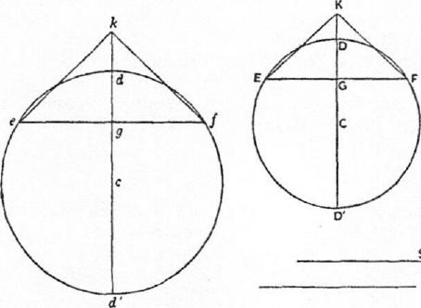Let M, G, g be the points where BB', EF, ef are bisected at right angles by

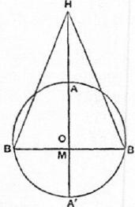
R
AA', DD', dd' respectively, and produce OA, CD, cd respectively to H, K, k,
so that
OA' -1-A¹M : A'M =HM :MA)
:D'G=KG :GD
cd'-Fd'g : d'g --kg : gd
and suppose cones formed with vertices H, K, k and with the same bases as the
respective segments. The cones will then be equal to the segments respectively
[Prop. 2].
Therefore, by hypothesis,

ON THE SPHERE AND CYLINDER II 39
the cone the cone kef.
Hence
(circle on diameter BB') : (circle on diameter.ef)..-- kg : HM,
so that BB'² : ef²=kg : HM (¹)
But, since the segments DEF, def are similar, so are the cones KEF, kef.
Therefore KG : EF = kg : ef.
And the ratio KG EF is given. Therefore the ratio kg : ef is given.
Suppose a length R taken such that
kg : ef =HM : R. (2)
Thus R is given.
Again, since kg : HM =BB'² : eP=ef : R, by (1) and (2), suppose a length S
taken such that
ef² = BB' .8,
or BB'² : ef² =BB' : S.
Thus BB' : ef =ef : S=8 : R,
and ef, S are two mean proportionals in continued proportion between BB', R.
Synthesis. Let ABB', DEF be great circles, AA', DD' the diameters bisecting
BB', EF at right angles in M, G respectively, and 0, C the centres.
Take H, K in the same way as before, and construct the cones HBB', KEF,
which are therefore equal to the respective segments ABB', DEF.
Let it be a straight line such that
KG :EF=HM :R,
and between BB', R take two mean proportionals ef, S.
On ef as base describe a segment of a circle with vertex d and similar to the
segment of a circle DEF. Complete the circle, and let dd' be the diameter
through d, and c the centre. Conceive a sphere constructed of which def is a
great circle, and through ef draw a plane at right angles to dd'.
Then shall def be the required segment of a sphere.
For the segments DEF, def of the spheres are similar, like the circular seg-
ments DEF, def.
Produce cd to k so that
cd'+d'g : d'g =kg : gd.
The cones KEF, kef are then similar.
Therefore kg : ef = KG : EF= HM : R,
whence kg :HM=ef :R.
But, since BB', ef, S, R are. hi continued proportion,
BB" : efl =BB' : S
=ef:R
=kg :HM.
Thus the bases of the cones HBB', kef are reciprocally proportional to their
heights. The cones are therefore equal, and def is the segment required, being
equal in volume to the cone kef. [Prop. 2]
PROPOSITION 6 (PROBLEM)
Given two segments of spheres, to find a third segment of a sphere similar to one of the given segments and having its surface equal to that of the other.
Let ABB' be the segment to whose surface the surface of the required seg. ment is to be equal, ABA'B' the great circle whose plane cuts the plan© of the

40 ARCHIMEDES
base of the segment ABB' at right angles in BB'. Let AA' be the diameter which bisects BB' at right angles.
Let DEF be the segment to which the required segment is to be similar, DED'F the great circle cutting the base of the segment at right angles in EF. Let DD' be the diameter bisecting EF at right angles in G.
Suppose the problem solved, def being a segment similar to DEF and having its surface equal to that of ABB'; and complete the figure for def as for DEF, corresponding points being denoted by small and capital letters respectively.
Join AB, DF, df.
Now, since the surfaces of the segments def, ABB' are equal, so are the circles on df, AB as diameters;
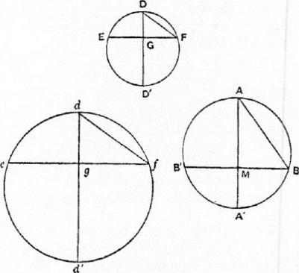
[I. 42, 43]
that is, df = AB.
From the similarity of the segments DEF, def we obtain d'd : dg = D' D : DG,
and dg : df=DG :DF;
whence d'd : df =D'D : DF,
or d'd : AB =D'D : DF.
But AB, D'D, DF are all given;
therefore d'd is given. Accordingly the synthesis is as follows.
Take d'd such that
d'd : AB =D'D :DF. (I)
Describe a circle on d'd as diameter, and conceive a sphere constructed of
which this circle is a great circle.
Divide d'd at g so that
d'g : gd=D'G : GD,
and draw through g a plane perpendicular to d'd cutting off the segment def
of the sphere and intersecting the plane of the great circle in ef. The segments
def, DEF are thus similar, and
dg : df =DG : DF.
But from above, componendo,
d'd : dg= D'D : DG.
Therefore, ex aequali, d'd : df =D'D : DF,
whence, by (1), df =AB.
Therefore the segment def has its surface equal to the surface of the segment
ABB' [I. 42, 43], while it is also similar to the segment DEF.
PROPOSITION 7 (PnosLEm)
From a given sphere to cut off a segment by a plane so that the segment may have a given ratio to the cone which has the same base as the segment and equal height.
Let AA' be the diameter of a great circle of the sphere. It is required to draw a plane at right angles to AA! cutting off a segment, as ABB', such that the segment ABB' has to the cone ABB' a given ratio.

ON THE SPHERE AND CYLINDER II 41
Analysis.
Suppose the problem solved, and let the plane of section cut the plane of the
great circle in BB', and the diameter AA' in M. Let 0 be the centre of the
sphere.
Produce OA to H so that
OA'-FA'M : A'M=HM : MA. (1)
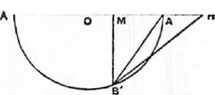Thus the cone HBB' is equal

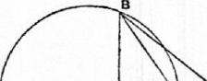
o to the segment ABB'.
[Prop. 2]
Therefore the given ratio
c must be equal to the ratio of
the cone HBB' to the cone ABB', i.e. to the ratio HM : MA.
a Hence the ratio OA' +
A'M : A'M is given; and
therefore A'M is given. Scopcoµbs.
Now OA' :A'M>OA' : A'A,
so that OA'-FA'M :21`111>OA'-l-A'A : A'A
>3 : 2.
Thus, in order that a solution may be possible, it is a necessary condition that
the given ratio must be greater than 3 : 2.
The synthesis proceeds thus.
Let AA' be a diameter of a great circle of the sphere, 0 the centre.
Take a line DE, and a point F on it, such that DE : EF is equal to the given
ratio, being greater than 3 : 2.
Now, since OA'+A'A : A'A =3 : 2,
DE :EF>OA'-FA'A :A'A,
so that DF : FE>OA' : A'A.
Hence a point M can be found on AA' such that
DF : FE = OA' : A'M. (2)
Through M draw a plane at right angles to AA' intersecting the plane of the
great circle in BB', and cutting off from the sphere the segment ABB'.
As before, take H on OA produced such that
: A'M=HM : MA.
Therefore HM : MA =DE : EF, by means of (2).
It follows that the cone HBB', or the segment ABB', is to the cone ABB' in
the given ratio DE : EF.
PROPOSITION 8
If a sphere be cut by a plane not passing through the centre into two segments
A'BB', ABB', of which A'BB' is the greater, then the ratio
(segmt. A'BB') : (segmt. ABB')
<(surface of A'BB')² : (surface of ABB')²
but> (surface of A'BB'); : (surface of ABB')'.
Let the plane of section cut a great circle A'BAB' at right angles in BB', and
let AA' be the diameter bisecting BB' at right angles in M.
Let 0 be the centre of the sphere.

42 ARCHIMED&S
Join A'B, AB.
As usual, take H on OA produced, and H' on OA' produced, fig that
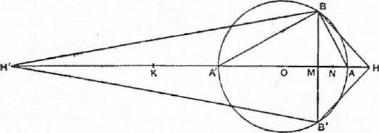
OA'+A'M : A'M =HM :MA, (1)
OA- AM : AM = H'M : MA', (2)
and conceive cones drawn each with the same base as the two segments and with apices H, H' respectively. The cones are then respectively equal to the segments [Prop. 2], and they are in the ratio of their heights HM, H'M. Also
(surface of A'BB') : (surface of ABB')=A'B² : AB² [I. 42, 43]
=A'M : AM.
We have therefore to prove
- that H'M : MH<A¹M² : MA²,
- that H'M : MH>A'Ml : MAI.
- From (2) above,
A'M : AM = H'M :04-1-AM
=H'A' : OA', since ()A =0A'.
Since A'M> AM, H'A' >OA' ; therefore, if we take K on H'A' so that
OA' =4¹K, K will fall between H' and A'.
And, by (1), A'M : AM—gm ;wt.
Thus KM : MH=H'A' : AR, singe A'K =OA',
>H'M ;MK.
Therefore 411-1 <KM ².
It follows that
H'M •MH : MI⁻1²<KM'
or : MH <KM ² : MR ²
<44 W² : A M², by (1).
- Since QA¹=0A,
A'M .MA < A/0 • OA,
or A'M :OA' <OA : AM
<H'A' : A'M, by means of (2).
Therefore A'M ² < H'4' • 0441.'
<11'A' .A'K.
Take a point N on A'A such that
A'N².1i'A' • A'K.
Thus H'A' : A/K=A/N² : A'K'. (3)
Also : 41'N =4¹N : A'K,
and, componendo,
H'N : A'N =NK : A'K,

ON TILE SPHERE AND CYLINDER II 43
whence A'N² : A'K² =1/W² : NK².
Therefore, by (3),
H'A' : A'K = H'N² : NK².
Now H'M : MK>H'N : NK.
Therefore H'M² : MK²>H'A' : A'K
> H'A' : OA'
>A'M : MA, by (2), as above,
>0A'-FA'Al :A1H, by (1),
> KM : MH.
Hence H'M² : MH² = (H'M² : MK²) • (KM² : MH²)
> (KM : MH) • (KM² : MH²).
It follows that
H'M : MH>KAla
>A' : AMT, by (1).
PROPOSITION 9
Of all segments of spheres which have equal surfaces the hemisphere is the greatest in volume.
Let ABA'B' be a great circle of a sphere, AA' being a diameter, and 0 the centre. Let the sphere be cut by a plane, not passing through 0, perpendicular to AA' (at M), and intersecting the plane of the great circle in BB'. The segment ABB' may then be either less than a hemisphere as in Fig. 1, or greater than a hemisphere as in Fig. 2.
Let DED'E' be a great circle of another sphere, DD' being a diameter and C the centre. Let the sphere be cut by a plane through C perpendicular to DD' and intersecting the plane of the great circle in the diameter EE'.
Suppose the surfaces of the segment ABB' and of the hemisphere DEE' to be equal.
Since the surfaces are equal, AB =DE.  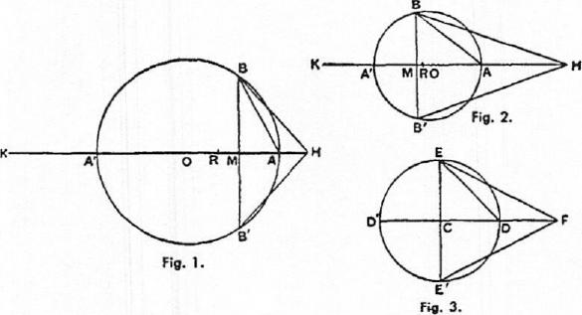  Fig. 3.  Fig. 1.  Now, in Fig. 1, AB²>2AM² and <2A0²,  and, in Fig. 2, AB' <2AM² and >2A0². Hence, if R be taken on AA' such that  AR²=iAB², | CI. 42, 43]

44 ARCHIMEDES
R will fall between 0 and M.
Also, since AB² = DE', AR= CD.
Produce OA' to K so that OA' = A'K, and produce A'A to H so that
A'K : A'M =HA : AM,
or, componendo, A'K-FA'M : A'M =HAI : MA. (1)
Thus the cone HBB' is equal to the segment ABB'. [Prop. 2]
Again, produce CD to F so that CD = DF, and the cone FEE' will be equal
to the hemisphere DEE'. [Prop. 2]
Now AR •RA' > AM •MA',
and AR²=1.4B²=iAM •AA' =AM •A'K.
Hence
AR •RA'-FRA²>AM•MA¹-FAM •A'K,
or AA' •AR> AM .MK
>HM •A'M, by (1).
Therefore AA' : A'M>HM : AR,
or AB² : BM²>HM : AR,
i.e. AR² : BM²>HM : 2AR, since AB²=2AR²,
>HM :CF.
Thus, since AR= CD, or CE,
(circle on diam. EE') : (circle on diam. BB') > HM :
It follows that
(the cone FEE')> (the cone HBB' ),
and therefore the hemisphere DEE' is greater in volume than the segment
ABB'.

MEASUREMENT OF A CIRCLE
PROPOSITION 1
The area of any circle is equal to a right-angled triangle in which one of the sides about the right angle is equal to the radius, and the other to the circumference, of the circle.
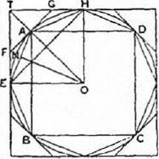
K
Let ABCD be the given circle, K the triangle described.
Then, if the circle is not equal to K, it must be either greater or less.
- If possible, let the circle be greater than K.
Inscribe a square ABC!), bisect the arcs AB, BC, CD, DA, then bisect (if necessary) the halves, and so on, until the sides of the inscribed polygon whose angular points arc the points of division subtend segments whose sum is less than the excess of the area of the circle over K.
Thus the area of the polygon is greater than K.
Let AE be any side of it, and ON the perpendicular on AB from the centre 0.
Then ON is less than the radius of the circle and therefore less than one of the sides about the right angle in K. Also the perimeter of the polygon is less than the circumference of the circle, i.e. less than the other side about the right angle in K.
Therefore the area of the polygon is less than K; which is inconsistent with the hypothesis.
Thus the area of the circle is not greater than K.
- If possible, let the circle be less than K.
Circumscribe a square, and let two adjacent sides, touching the circle in E,
H, meet in T. Bisect the arcs between adjacent points of contact and draw the
45

46 ARCHIMEDES
tangents at the points of bisection. Let A be the middle point of the arc Ell,
and FAG the tangent at A.
Then the angle TAG is a right angle.
Therefore TG> GA
>GH.
It follows that the triangle FTC: is greater than half the area TEAH. Similarly, if the arc AH be bisected and the tangent at the point of bisection be drawn, it will cut off from the area GAH more than one-half.
Thus, by continuing the process, we shall ultimately arrive at a circumscribed polygon such that the spaces intercepted between it and the circle are together less than the excess of K over the area of the circle.
Thus the area of the polygon will be less than K.
Now, since the perpendicular from 0 on any side of the polygon is equal to the radius of the circle, while the perimeter of the polygon is greater than the circumference of the circle, it follows that the area of the polygon is greater than the triangle K; which is impossible.
Therefore the area of the circle is not less than K.
Since then the area of the circle is neither greater nor less than K, it is equal to it.
PROPOSITION 2
The area of a circle is to the square on its diameter as 11 to 14'.
PROPOSITION 3
The ratio of the circumference of any circle to its diameter is less than 3+ but greater than 3.'4'.
I. Let AB be the diameter of any circle, 0 its centre, AC the tangent at A and let the angle AOC be one-third of a right angle.
Then OA : AC[= N/3 : 1]> 265 : 153, (11
and OC : CA[= 2 : 1] =300: 153. (21
First, draw OD bisecting the angle AOC and meeting AC in 1).
Now CO : OA =CD : DA, [Eucl. VI.
so that [C0+0A : OA =CA :DA, or]
CO-FOA :CA =OA :AD.
Therefore [by (1) and (2)]
OA : AD>571 : 153. (3)
'The text of this proposition is not satisfactory, and Archimedes cannot have placed it before Proposition 3, as the approximation depends upon the result of that proposition.
'In view of the interesting questions arising out of the arithmetical content of this proposition of Archimedes, it is necessary, in reproducing it, to distinguish carefully the actual steps set out in the text as we have it from the intermediate steps (mostly supplied by Eutocius) which it is convenient to put in for the purpose of making the proof easier to follow. Accordingly all the steps not actually appearing in the text have been enclosed in square brackets, in order that it may be clearly seen how far Archimedes omits actual calculations and only gives results. It will be observed that he gives two fractional approximations to ,./3 (one being less and the other greater than the real value) without any explanation as to how he arrived at them; and in like manner approximations to the square roots of several large numbers which arc not complete squares are merely stated.

Hence  BO that | MEASUREMENT OF A CIRCLE  OD² AD²[=(0A²-1-AD!) : AD²  > (571²+ 153²) : 153²]  >349450 : 23409,  OD :DA >591i : 153. | 47  (4)

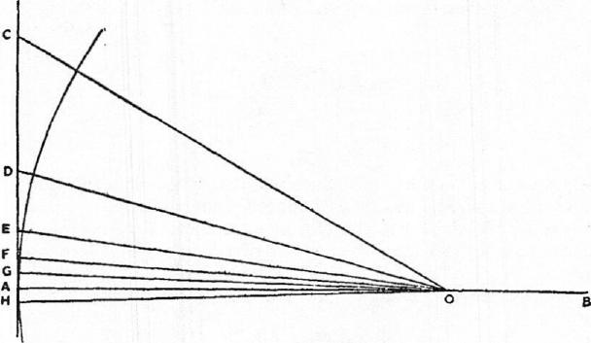
Secondly, let OE bisect the angle A OD, meeting AD in E.
[Then DO : OA = DE : EA,
so that DO+OA : DA =OA : AE.]
Therefore OA : AE [> (5911+571) 153, by (3) and (4)]
> 11621 : 153. (5)
[It follows that
0E² : EA²> 1(1162)0²+1531 : 153²
>(1350534-N+23409) :23409
>1373943U : 23409.1
Thus OE : EA > 11721 : 153. (6)
Thirdly, let OF bisect the angle AOE and meet AE in F.
We thus obtain the result [corresponding to (3) and (5) above] that
OA : AF [> (11621+11721) :153]
>23341 : 153. (7)
[Therefore OFZ : FA²> [ (23341)²+153²} : 153²
>5472132A : 23109.]
Thus OF : FA > 23391 : 153. (8)
Fourthly, let OG bisect the angle .40F, meeting A in G.
We have then
OA : AG [> (23341+23391) : 153, by means of (7) and (8)]
>46731 : 153.
Now the angle AOC, which is one-third of a right angle, has been bisected
four times, and it follows that
Z AOG= (a right angle).
Make the angle AOH on the other side of OA equal to the angle AOG, and
let GA produced meet 0/1 in 11.
Then L GO//:-..-.₂¹₁- (a right angle).

4-8 ARCHINIEDES
Thus GH is one side of a regular polygon of 96 sides circumscribed to the given circle.
And, since OA : AG>46731 : 153,
while A B =20A, GH =2AG,
it follows that
AB : (perimeter of polygon of 96 sides)[> 46731 : 153 X96]
>4673₹ : 14688.
14688₋₃₊ 6672
But
46734 467n
[
6671
<3+_{4672i}
<34-.
Therefore the circumference of the circle (being less than the perimeter of the polygon) is a fortiori less than 3+ times the diameter AB.
II. Next let AB be the diameter of a circle, and let AC, meeting the circle in C, make the angle CAB equal to one-third of a right angle. Join BC.
Then AC : CB[= :1]<1351 780.
First, let AD bisect the angle BAC and meet BC in d and the circle in D.
Join BD.
Then L BAD= ZdAC
= L dBD,
and the angles at D, C are both right angles.
It follows that the triangles ADB,[ACd], BDd are similar.
Therefore AD : DB = BD : Dd
[=AC :Cd]
=AB : Bd [Eucl. vi. 3]
=AB-FAC : Bd+Cd
=AB-E-4C : BC
or BA -FAC : BC =AD :DB.
[But AC : CB <1351 : 780, from above,
while BA : BC = 2 : 1
=1560 : 780.]
Therefore AD : DB <2911 : 780. (l)
[Hence AB² BD²<(2911²+780²) : 780'
<9082321 : 608400.]
Thus AB : BD<30131 : 780. (2)
Secondly, let AE bisect the angle BAD, meeting the circle in E; and let BE
be joined.
Then we prove, in the same way as before, that
AE :EB[=BA+AD :BD
<(30134+2911) : 780, by (1) and (2)]
<59241 : 780
<5924ixil_{g} : 780XA
<1823 : 240. (3)
[Hence AB² BE² < (1823²+240²) : 240²
<3380929 : 57600.]
Therefore AB : BE <1838A : 240. (4)
Thirdly, let AF bisect the angle BAE, meeting the circle in F.

MEASUREMENT OF A CIRCLE 49
Thus AF :FBC=BA+AE : BE
<3661₁⁹r : 240, by (3) and (4)]
<3661AX-14 : 240X ⁻H
<1007 : 66. (5)
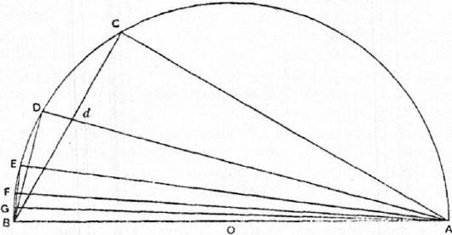
[It follows that
AB² : BF' < (1007²+66') : 66²
<1018405 : 4356]
Therefore AB : BF <1009i : 66. (6)
Fourthly, let the angle BAF be bisected by AG meeting the circle in G.
Then AG :GB[=BA+AF : BF]
<2014 : 66, by (5) and (6).
[And AB² : BG'< 1(2014)²+661 : 66²
<4069284k : 4356.]
Therefore AB : BG <20171 : 66,
whence BG : AB> 66 : 20171. (7)
[Now the angle BAG which is the result of the fourth bisection of the angle
BAC, or of one-third of a right angle, is equal to one-fortyeighth of a right
angle.
Thus the angle subtended by BG at the centre is
(a right angle).]
Therefore BG is a side of a regular inscribed polygon of 96 sides.
It follows from (7) that
(perimeter of polygon) : AB [> 96 X66 : 20171]
>6336 : 20174.
6336
And
₂₀₁₇₁>31t.
Much more then is the circumference of the circle greater than 344 times the
diameter.
Thus the ratio of the circumference to the diameter
<3+ but >344.

ON CONOIDS AND SPHEROIDS
INTRODUCTION'
"ARCHIMEDES to Dositheus greeting.
"In this book I have set forth and send you the proofs of the remaining t heorems not included in what I sent you before, and also of some others discovered later which, though I had often tried to investigate them previously, I had failed to arrive at because I found their discovery attended with some difficulty. And this is why even the propositions themselves were not published with the rest. But afterwards, when I had studied them with greater care, I discovered what I had failed in before.
"Now the remainder of the earlier theorems were propositions concerning the right-angled conoid [paraboloid of revolution]; but the discoveries which I have now added relate to an obtuse-angled conoid [hyperboloid of revolution] and to spheroidal figures, some of which I call oblong and others flat."
I. "Concerning the right-angled conoid it was laid down that, if a section of a right-angled cone [a parabola] be made to revolve about the diameter [axis] which remains fixed and return to the position from which it started, the figure comprehended by the section of the right-angled cone is called a right-angled conoid, and the diameter which has remained fixed is called its axis, while its vertex is the point in which the axis meets the surface of the conoid. And if a plane touch the right-angled conoid, and another plane drawn parallel to the tangent plane cut off a segment of the conoid, the base of the segment cut off is defined as the portion intercepted by the section of the conoid on the cutting plane, the vertex [of the segment] as the point in which the first plane touches the conoid, and the axis [of the segment] as the portion cut off within the segment from the line drawn through the vertex of the segment parallel to the axis of the conoid.
"The questions propounded for consideration were"
- "why, if a segment of the right-angled conoid be cut off by a plane at right angles to the axis, will the segment so cut off be half as large again as the cone which has the same base as the segment and the same axis, and"
- "why, if two segments be cut off from the right-angled conoid by planes drawn in any manner, will the segments so cut off have to one another the duplicate ratio of their axes."
II. "Respecting the obtuse-angled conoid we lay down the following prem-isses. If there be in a plane a section of an obtuse-angled cone [a hyperbola], its
'The whole of this introductory matter, including the definitions, is translated literally from the Greek text in order that the terminology of Archimedes may be faithfully represented. When this has once been set out, nothing will be lost by returning to modern phraseology and notation. These will accordingly be employed, as usual, when we come to the actual propositions of the treatise.
50

ON CONOIDS AND SPHEROIDS 51
diameter [axis], and the nearest lines to the section of the obtuse-angled cone
[i.e. the asymptotes of the hyperbola], and if, the d^{iameter} [axis] remaining fixed, the plane containing the aforesaid lines be made to revolve about it and return to the position from which it started, the nearest lines to the section of the obtuse-angled cone [the asymptotes] will clearly comprehend an isosceles cone whose vertex will be the point of concourse of the nearest lines and whose axis will be the diameter [axis] which has remained fixed. The figure comprehended by the section of the obtuse-angled cone is called an obtuse-angled conoid [hyperboloid of revolution], its axis is the diameter which has remained fixed, and its vertex the point in which the axis meets the surface of the conoid. The cone comprehended by the nearest lines to the section of the obtuse-angled cone is called [the cone] enveloping the conoid, and the straight line between the vertex of the conoid and the vertex of the cone enveloping the conoid is called [the line] adjacent to the axis. And if a plane touch the obtuse-angled conoid, and another plane drawn parallel to the tangent plane cut off a segment of the conoid, the base of the segment so cut off is defined as the portion intercepted by the section of the conoid on the cutting plane, the vertex [of the segment] as the point of contact of the plane which touches the conoid, the axis [of the segment] as the portion cut off within the segment from the line drawn through the vertex of the segment and the vertex of the cone enveloping the conoid; and the straight line between the said vertices is called adjacent to the axis.
"Right-angled conoids are all similar; but of obtuse-angled conoids let those be called similar in which the cones enveloping the conoids are similar.
"The following questions are propounded for consideration":
- "why, if a segment be cut off from the obtuse-angled conoid by a plane at right angles to the axis, the segment so cut off has to the cone which has the same base as the segment and the same axis the ratio which the line equal to the sum of the axis of the segment and three times the line adjacent to the axis bears to the line equal to the sum of the axis of the segment and twice the line adjacent to the axis, and"
- "why, if a segment of the obtuse-angled conoid be cut off by a plane not at right angles to the axis, the segment so cut off will bear to the figure which has the same base as the segment and the same axis, being a segment of a cone, the ratio which the line equal to the sum of the axis of the segment and three times the line adjacent to the axis bears to the line equal to the sum of the axis of the segment and twice the line adjacent to the axis."
III: "Concerning spheroidal figures we lay down the following premisses. If a section of an acute-angled cone [ellipse] b_{e m}ad_{e} t_{o revo}l_{ve a}b_{out t}h_{e greater} diameter [major axis] which remains fixed and return to the position from which it started, the figure comprehended by the section of the acute-angled cone is called an oblong spheroid. But if the section of the acute-angled cone revolve about the lesser diameter [minor axis] which remains fixed and return to the position from which it started, the figure comprehended by the section of the acute-angled cone is called a flat spheroid. In either of the spheroids the
axis isdefined as the diameter [axis] which has remai_{ne}d fi_{xe}d, th_{e ver}t_{ex as} the point in which the axis meets the surface of the spheroid, the centre as the
middle point of the axis, and the diameter as the line drawn through the centre at right angles to the axis. And, if parallel planes touch, without cutting, either

52 ARCHIMEDES
of the spheroidal figures, and if another plane be drawn parallel to the tangent planes and cutting the spheroid, the base of the resulting segments is defined as the portion intercepted by the section of the spheroid on the cutting plane,
their vertices as the p_{o}i_{n}t_{s} i_{n w}hi_{c}h _{t}h_{e paral}lel planes touch the spheroid, and
their axes as the portions cut off within the segments from the straight line joining their vertices. And that the planes touching the spheroid meet its surface at one point only, and that the straight line joining the points of contact passes through the centre of the spheroid, we shall prove. Those spheroidal figures are called similar in which the axes have the same ratio to the 'diameters.' And let segments of spheroidal figures and conoids be called similar if they are cut off from similar figures and have their bases similar, while their axes, being either at right angles to the planes of the bases or making equal angles with the corresponding diameters [axes] of the bases, have the same ratio to one another as the corresponding diameters [axes] of the bases.
"The following questions about spheroids are propounded for consideration,"
- "why, if one of the spheroidal figures be cut by a plane through the centre at right angles to the axis, each of the resulting segments will be double of the cone having the same base as the segment and the same axis; while, if the plane of section be at right angles to the axis without passing through the centre, (a) the greater of the resulting segments will bear to the cone which has the same base as the segment and the same axis the ratio which the line equal to the sum of half the straight line which is the axis of the spheroid and the axis of the lesser segment bears to the axis of the lesser segment, and (b) the lesser segment bears to the cone which has the same base as the segment and the same axis the ratio which the line equal to the sum of half the straight line which is the axis of the spheroid and the axis of the greater segment bears to the axis of the greater segment";
- "why, if one of the spheroids be cut by a plane passing through the centre but not at right angles to the axis, each of the resulting segments will be double of the figure having the same base as the segment and the same axis and consisting of a segment of a cone.
- "But, if the plane cutting the spheroid be neither through the centre nor at right angles to the axis, (a) the greater of the resulting segments will have to the figure which has the same base as the segment and the same axis the ratio which the line equal to the sum of half the line joining the vertices of the segments and the axis of the lesser segment bears to the axis of the lesser segment, and (b) the lesser segment will have to the figure with the same base as the segment and the same axis the ratio which the line equal to the sum of half the line joining the vertices of the segments and the axis of the greater segment bears to the axis of the greater segment. And the figure referred to is in these cases also a segment of a cone.
"When the aforesaid theorems are proved, there are discovered by means of them many theorems and problems.
"Such, for example, are the theorems":
- "that similar spheroids and similar segments both of spheroidal figures and conoids have to one another the triplicate ratio of their axes, and"
- "that in equal spheroidal figures the squares on the `diameters' are reciprocally proportional to the axes, and, if in spheroidal figures the squares on

ON CONOIDS AND SPHEROIDS 53
the `diameters' are reciprocally proportional to the axes, the spheroids are equal.
"Such also is the problem, From a given spheroidal figure or conoid to cut off a segment by a plane drawn parallel to a given plane so that the segment cut off is equal to a given cone or cylinder or to a given sphere.
"After prefixing therefore the theorems and directions which are necessary for the proof of them, I will then proceed to expound the propositions themselves to you. Farewell."
DEFINITIONS
"If a cone be cut by a plane meeting all the sides [generators] of the cone, the section will be either a circle or a section of an acute-angled cone [an ellipse]. If then the section be a circle, it is clear that the segment cut off from the cone towards the same parts as the vertex of the cone will be a cone. But, if the section be a section of an acute-angled cone [an ellipse], let the figure cut off from the cone towards the same parts as the vertex of the cone be called a segment of a cone. Let the base of the segment be defined as the plane comprehended by the section of the acute-angled cone, its vertex as the point which is also the vertex of the cone, and its axis as the straight line joining the vertex of the cone to the centre of the section of the acute-angled cone.
"And if a cylinder be cut by two parallel planes meeting all the sides [generators] of the cylinder, the sections will be either circles or sections of acute-angled cones [ellipses] equal and similar to one another. If then the sections be circles, it is clear that the figure cut off from the cylinder between the parallel planes will be a cylinder. But, if the sections be sections of acute-angled cones [ellipses], let the figure cut off from the cylinder between the parallel planes be called a frustum of a cylinder. And let the bases of the frustum be defined as the planes comprehended by the sections of the acute-angled cones [ellipses], and the axis as the straight line joining the centres of the sections of the acute-angled cones, so that the axis will be in the same straight line with the axis of the cylinder."
LEMMA
If in an ascending arithmetical progression consisting of the magnitudes A1,
A₂, • • 'An the common difference be equal to the least term A₁, then
n -A_{n} <2(ArfA2-1-• • • •±An),
and >2(Ai-F A 2+ • • •+An-1).
[The proof of this is given incidentally in the treatise On Spirals, Prop. 11. By placing lines side by side to represent the terms of the progression and then producing each so as to make it equal to the greatest term, Archimedes gives the equivalent of the following proof.
If Sn=Al+A2+ • • •-f-An-1-1-An,
we have also Sn=An+An-i+An-2+ • •
And Ai+A....4=A2+An-2=⁻- • • • =An.
Therefore 2S_{n}= (n-1-1)An,
whence n •An<28„,
and n •An>2S.-i.
Thus, if the progression is a, 2a, • • •na,
₀ n(n+1)
On— 2 a,

54 ARCHIMEDES
and n²a<2S,„
but >2Sn-1.]
PROPOSITION I
If A₁, B₁, C₁, • • •K1 and A₂, B2, C2, • • •K₂ be two series of magnitudes such that
AI:Bi=A2: B2, (°)
B₁ : C_{I} =B2 : C₂, and so on,
and if A₃, B₃, C₃, • • •K₃ and A1, B4, C4, • • •K4 be two other series such that
A_{I}: A₃= A2 : A4, 1 (3)
B₁ : B₃= B₂ : B4, and so on, j
then (Ai+Bi+CI⁻1⁻• • • .+Ki) :(A3-1-1334-Ca+ • • .+K3)
=(A2-1-B2-FC2+ • • •+K2) :(A.4-1-B4-1- • • •+K4). The proof is as follows.
Since A₃ :A/=A4 : A₂,
and A_{I} :B1=A2 :B2
while B₁ : B₃ = B2 : B4,
we have, ex aequali, A₃ : B₃= A4 : B4. (7)
Similarly B₃ : C3 =B4 : C4, and so on.
Again, it follows from equations (a) that
441:A2=131:B2=GL : C₂= • • •
Therefore
A_{l} : A2= (A_{l}+B_{l}+Cl+ •+Kl) (212+B2+ • .+K2),
or (A1-1-.81-1-C1-1- • • •-FKI) : Ai= (A2-1-B2+C2-1- • • •+K2) : A 2;
and A_{i} :A₃=A₂:A4,
while from equations (7) it follows in like manner that
A3 : (A3+B3-FC3+ • • •+K3) =A4 : (A4+1344-C4+ • • •A-K4).
By the last three equations, ex aequali,
(A1+B1+C1+ - • •+I(1) :(A3+B3i-C₃+ • • •+K₃)
=(A24-B2i-C2+ • "-FK2) :(A4-1-B4-4-C44- • • •4⁻K4)•
COR. If any terms in the third and fourth series corresponding to terms in
the first and second be left out, the result is the same. For example, if the last
terms K₃, K4 are absent,
(A1+B1+C1+ • • •+Ki) : (A3-f-B3+C3+ • • •+./3)
= (A2+B2-+-C24- • • --FK2) : (A4-+-B44-C4-1-- • • •.4-I41,
where I immediately precedes K in each series.
LEMMA TO PROPOSITION 2
[On Spirals, Prop. 10.]
If A₁, A ₂, A3, • • • A _{n} be n lines forming an ascending arithmetical progression in
which the common difference is equal to the least term A₁, then
(n+1)A„²-FAi(Ai+A2+A3+ • • • +An) =3(Al²+A2²+A3²+ • • •+An²).
Let the lines A., An_1, An-2, ...Ai be placed in a row from left to right.
Produce An...1, An_2, ...AI until they are each equal to A_{n}, so that the parts
produced are respectively equal to A1, A2.....n-i.
Taking each line successively, we have
2A _{n}² = 2A_{n}²,
(Zii-FAn-1)²=A/²+A²n-1+2A1 *An-1,
(112+A n-2)²= A 2²+ A ²n-2+2A 2 'An--2,

ON CONOIDS AND SPHEROIDS 56
- A₁.
And, by addition,
(n+ 1)21,,² = 2(Ai² +A ₂²+ • • • -1-21„²)
/•" -N
-1-2A₁ .A.,-₁+2A2 •A,,-.2-1- • • • -1--2An-1 •A₁. Therefore, in order to obtain the required result, we have to prove that 2(A₁ •A_{h}_H-A2 v1,2+ • • •-f-An_i •A1)+ Al(441-i-A2-1--A3+ • • •⁻E-An)
=A_{l}²-1-A₂²+ - • •+A„². (a)
Now
2A2.An-2-⁻-⁻-AI-4A,,t, because A2=2,41, 2A 3 •A*-3 = Al •6A,3, because A8= 3A 1,
A..3An-2 A14.1
Al A:
A_{n}, A_{ft}_2

2A„._₁ •A = A_{i} .2(n-1)A₁.
It follows that
2(A₁ •A_{n}_i+A2 •An_2+ • • • A-An-i •A1)+
A3 A3 Al A1(A1+A2+ • • •—FA„) = A1 { A n+ 3A „_.₁+
5A „...t+ • • • + (2n — 1)A
And this last expression can be proved to be equal to
21₁²-FA₂²+ • • •+A„².
For A_{n}²--=-Ai(n •An)
=A_{i}{An+(n-1)A_{n}}
=1411A,,-F2(A,,_14-A2+ • • •-f•Ai)),
because (n —1 )A„.
+An-2+A2
Similarly A²,;__{i}=i11{An__{I}-1-2(A„_2-FAn_3+ • • •-f•Ai)},
At²=Ai(A2+2211),
Ai' •A1;
whence, by addition,
Al²-FA2²-FA3²+ • • •+44,²=AdAn+3A7,-1-1-5A.-2-1- • • •+(2n—I)Ail• Thus the equation marked (a) above is true; and it follows that
(n-1-1)A„²-FAI(A1-1-A2-i-A3-1- • • • -FA.)=3(Al²-1-A2²-1- • • •+An²). COR. 1. From this it is evident that
n •An'<3(A_{l}²+A₂²-1- • • •-•f-An²). (1)
Also An²=At{A,.+2(An-i+An-2+ • • H-A1)}, as above.
so that An²>A1(An+A.-1+ • • •-kAi),
and therefore
- A,,²+.111(Ari-A24- • • • FA.) <2A,,² .
It follows from the proposition that
n•An²>3(Al²-i-A2²4- • • •-f-A².-1). (2)
COR. 2. All these results will hold if we substitute similar figures for squares on all the lines; for similar figures are in the duplicate ratio of their sides.

56 ARCHIMEDES
PROPOSITION 2
If A_{i}, A2 • • •A T, be any number of areas such that
A_{l}=ax+x²,
A2=a .2x+(2x)²,
A_{s}= a .3x+ (3x)² ,
A n= a •ns⁻1⁻(nx)²,
then n .A„ : (Ai+ A2+ • • •- A.) <(a+nx) (^{c1-}1⁻¹¹⁻D •
and n•A_{n}:(A_{i}+A₂+ • • .+A,1)>(a+nx) 6+7).
For, by the Lemma immediately preceding Prop. 1,
n •anx<(ax+a .2x+ • • • +a .nx),
and >2(ax-1-a .2x-1- • • • +a •n—lx). by the Lemma preceding this proposition,
n .(n:c)² <3 { x²+ (2x)²+(3x)²+ • • • ± (nx)²1
and > 3{ x²-1- (2:0²+ • • • (n — 1 x)²}
Hence
an₂²x n(nx)²
<[(ax+x²)+ fa .2x+ (2x)²1 + • • • + {a •itx-f- (nx)²}j,
3
and
>[(ax+ x²) +{a -2x+ (2x)²} + • • • ± { a •n— lx (n — lx)²}],
or 2 3
an²x n(nx)2 _{<A14-A2+ • • • +A.,}
and >A1-1-A2+ • • •+A.--i.
It follows that
n •A„ : (A_{l}+ A₂+ • • • +A.)<n{a •nx+ (nx)²} Icc+11(7 ₃1.4² },
or n •A„ : (A1-1-A2+ • • •-f-An)<(a-Enx) : (₂+₃^{-:-T});
also n.A„: (A1+A2+ • • • +An-i)> (a+nx) : 6+¹f).
PROPOSITION 3
(1) If TP, TP' be two tangents to any conic meeting in T, and if Qq, Q'q' be any
two chords parallel respectively to TP, TP' and meeting in 0, then
QO .0q : Q/0 •Oq' = TP² : TP".
"And this is proved in the elements of conics."'
(2) If QQ' be a chord of a parabola bisected in V by the diameter PV, and if P
be of constant length, then the areas of the triangle PQQ' and of the segment PQQ'
are both constant whatever be the direction of QQ'.
Let ABB' be the particular segment of the parabola whose vertex is A, so
that BB' is bisected perpendicularly by the axis at the point H, where AH = PV.
Draw QD perpendicular to PV.
¹In the treatises on conics by Aristaeus and Euclid.

ON CONOIDS AND SPHEROIDS 57
Let p_{a} be the parameter of the principal ordinates, and let p be another line
of such length that
QV' : QD²=p : p.;
it will then follow that p is equal to the par-
ameter of the ordinates to the diameter PV,
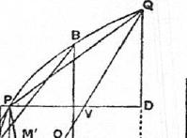
i.e. those which are parallel to QV.
"For this is proved in the conics."'
Thus QV²=p•PV.
And BH²= p_{a} -A H, while AH =PV.
_{Pap} Therefore QV² : BH² = p : p_{a}.
TA But QV² : QD² =p : p_{a};
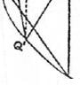hence BH = QD.
Thus BH•AH=QD •PV,
and therefore LABB' = LPQQ';
that is, the area of the triangle PQQ' is con-
s, stant so long as PV is of constant length. Hence also the area of the segment PQQ' is constant under the same conditions; for the segment is equal to 4/PQQ'. [Quadrature of the Parabola, Prop. 17 or 24.]
PROPOSITION 4
The area of any ellipse is to that of the auxiliary circle as the minor axis to the
major.
Let AA' be the major and BB' the minor axis of the ellipse, and let BB'
meet the auxiliary circle in b, b'.
Suppose 0 to be such a circle that
(circle AbA'b') : 0 = CA : CB.
Then shall 0 be equal to the area of the ellipse.
For, if not, 0 must be either greater or less than the ellipse.

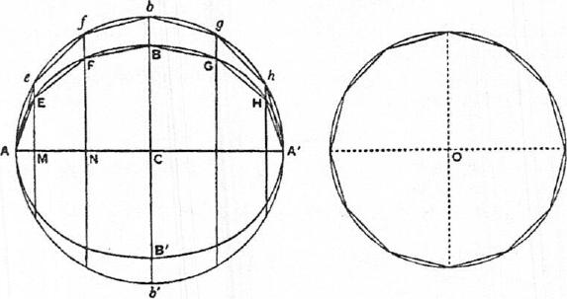
b'
f
b
I. If possible, let 0 be greater than the ellipse.
We can then inscribe in the circle 0 an equilateral polygon of 4n sides such
that its area is greater than that of the ellipse. [cf. On the Sphere and Cylinder,
I.6.]
'The theorem which is here assumed by Archimedes as known ... is easily deduced from
Apollonius I. 49....

58 ARCHIW.1%6
Let this be done, and inscribe in the auxiliary circle of the ellipse the polygon AefbghA' . similar to that inscribed in 0. Let the perpendiculars eM, IN,. on AA' meet the ellipse in E, F,... respectively. Join AE, EF, FB,....
Suppose that P' denotes the area of the polygon inscribed in the auxiliary circle, and P that of the polygon inscribed in the ellipse.
Then, since all the lines elf fN,• • • are cut in the same proportions at E,
F, • • •
i.e. eM : EM =fN FN = • • • =bC : BC,
the pairs of triangles, as eAM, EAM, and the pairs of trapeziums, as eMNf,
EMNF, are all in the same ratio to one another as bC to BC, or as CA to CB.
Therefore, by addition,
P' :P=CA :CB.
Now P' ; (polygon inscribed in 0)
= (circle AbA'6') :0
= CA : CB, by hypothesis.
Therefore P is equal to the polygon inscribed in 0.
But this is impossible, because the latter polygon is by hypothesis greater
than the ellipse, and a fortiori greater than P.
Hence 0 is not greater than the ellipse.
II. If possible, let 0 be less than the ellipse.
In this case we inscribe in the ellipse a polygon P with 4n equal sides such
that P>0.
Let the perpendiculars from the angular points on the axis AA' be produced
to meet the auxiliary circle, and let the corresponding polygon (P') in the
circle be formed.
Inscribe in 0 a polygon similar to P'.
Then : P = CA : CB
= (circle AbA'b') :0, by hypothesis,
=--P' : (polygon inscribed in 0).
Therefore the polygon inscribed in 0 is equal to the polygon P; which is
impossible, because P> O.
Hence 0, being neither greater nor less than the ellipse, is equal to it; and
the required result follows.
PROPOSITION 5
If AA', BB' be the major and minor axis of an ellipse respectively, and if d be the
diameter of any circle, then
(area of ellipse) : (area of circle) =AA' • BB' :
For
(area of ellipse) : (area of auxiliary circle) =iBB' : AA' [Prop. 4]
.AA' • BB' : AA'².
And
(area of aux. circle) : (area of circle with diam. d) =AA": d².
Therefore the required result follows ex aequali.
PROPoSI'TION 6
The areas of ellipses are as the rectangles under their axes.
This follows at once from Props. 5.
Cox. The areas of similar ellipses are as the squares of corresponding oases,

ON CONOIDS AND SPHEROIDS 59
PROPOSITION 7
Given an ellipse with centre C, and a line CO drawn perpendicular to its plane, it is possible to find a circular cone with vertex 0 and such that the given ellipse is a section of it[or, in other words, to find the circular sections of the cone with vertex 0 passing through the circumference of the ellipse].
Conceive an ellipse with BB' as its minor axis and lying in a plane perpendicular to that of the paper. Let, CO be drawn perpendicular to the plane of the ellipse, and let 0 be the vertex of the required cone. Produce OB, OC, OB', and in the same plane with them draw BED meeting OC, OR' produced in E, D respectively and in such a direction that
BE • ED : E0² =CA" : CO²,
where CA is half the major axis of the ellipse.
"And this is possible, since
BE • ED E0²> BC • CB' :CO²."
[Both the construction and this proposition are assumed as known.]
Now conceive a circle with BD as diameter lying in a plane at right angles to that of the paper, and describe a cone with this circle for its base and with vertex 0.
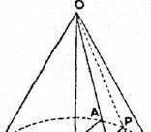
We have therefore to prove that the given ellipse is a section of the cone, or, if P be any point on the ellipse, that P lies
⁸ on the surface of the cone.
Draw PN perpendicular to BB'. Join ON and produce it to meet BD in M, and let MQ be drawn in the plane of the circle on BD as diameter perpendicular to BD and meeting the circle in Q. Also let FG, HK be drawn through E, M respectively parallel to BB'.
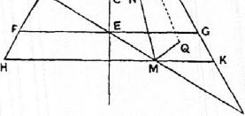
We have then
QM²:HM MK = BM • MD :HM • MK
=BE • ED : FE • EG
= (BE • ED : E0²) • (E0² : FE • EC)
=(CA² : CO²) • (CO' : BC • CB')
=CA' : CB'
=PN² : BN • NB'.
Therefore QM² : PN²=HM •MK : BN • NB'
=0M² :ON';
whence, since PN, QM are parallel, OPQ is a straight line.
But Q is on the circumference of the circle on BD as diameter; therefore OQ
is a generator of the cone, and hence P lies on the cone.
Thus the cone passes through all points on the ellipse.
PROPOSITION 8
Given an ellipse, a plane through one of its axes AA' and perpendicular to the plane of the ellipse, and a line CO drawn from C, the centre, in the given plane through AA' but not perpendicular to AA', it is possible to find a cone with vertex

60 ARCHIMEDES
0 such that the given ellipse is a section of it [or, in other words, to find the circular sections of the cone with vertex 0 whose surface passes through the circumference of the ellipse].
By hypothesis, OA, OA' are unequal. Produce OA' to D so that OA =OD. Join AD, and draw FG through C parallel to it.
The given ellipse is to be supposed to lie in a plane perpendicular to the plane of the paper. Let BB' be the other axis of the ellipse.
Conceive a plane through AD perpendicular to the plane of the paper, and in it describe either (a), if CB²=FC • CG, a circle with diameter AD, or (b), if not, an ellipse on AD as axis such that, if d be the other axis,
d² : AD² =CB' : FC • CG.
Take a cone with vertex 0 whose surface passes through the circle or ellipse just drawn. This is possible even when the curve is an ellipse, because the line from 0 to the middle point of AD is perpendicular to the plane of the ellipse, and the construction is effected by means of Prop. 7.
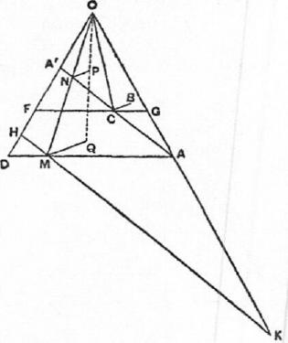
Let P be any point on the given ellipse, and we have only to prove that P lies on the surface of the cone so described.
Draw PN perpendicular to AA'. Join ON, and produce it to meet AD in M. Through M draw HK parallel to A'A.
Lastly, draw MQ perpendicular to the plane of the paper (and therefore perpendicular to both HK and AD) meeting the ellipse or circle about AD (and therefore the surface of the cone) in Q.
Then
QM² : HM • MK = (QM' :DM • MA) • (DM • MA :HM • MK)
= (d² : AD²) • (FC • CG : A'C • CA) =(CB² : FC • CG) • (FC • CG : A'C • CA) =CB² :CA²
= PN² : A 'N • NA.
Therefore, alternately,
QM² : PN²=HM • MK : A'N • NA
=0M² : ON².
Thus, since PN, QM are parallel, OPQ is a straight line; and, Q being on the
surface of the cone, it follows that P is also on the surface of the cone.
Similarly all points on the ellipse are also on the cone, and the ellipse is
therefore a section of the cone.
PROPOSITION 9
Given an ellipse, a plane through one of its axes and perpendicular to that of the ellipse, and a straight line CO drawn from the centre C of the ellipse in the given plane through the axis but not perpendicular to that axis, it is possible to find a

ON CONOIDS AND SPHEROIDS 61
cylinder with axis OC such that the ellipse is a section of it [or, in other words, to find the circular sections of the cylinder with axis OC whose surface passes through the circumference of the given ellipse].
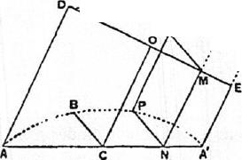Let AA' be an axis of the ellipse, and suppose the plane of the ellipse to be perpendicular to that of the paper, so that OC lies in the plane of the paper. Draw AD, A'E parallel to CO, and let DE be the line through 0 perpendicular
. to both AD and A'E.
......... • •
- ...,_{E}' We have now three different cases
,
according as the other axis BB' of the
- ellipse is (1) equal to, (2) greater than, •
or (3) less than, DE.
(1) Suppose BB' = DE.
Draw a plane through DE at right angles to OC, and in this plane describe a circle on DE as diameter. Through this circle describe a cylinder with axis OC.
This cylinder shall be the cylinder required, or its surface shall pass through every point P of the ellipse.
For, if P be any point on the ellipse, draw PN perpendicular to AA'; through N draw NM parallel to CO meeting DE in M, and through M, in the plane of the circle on DE as diameter, draw MQ perpendicular to DE, meeting the circle in Q.
Then, since DE = BB',
PN² : AN • NA' =D0² : AC • CA'.
And DM • ME : AN • NA' =DO' • AC²,
since AD, NM, CO, A'E are parallel.
Therefore PN² = DM • ME
₌012,
by the property of the circle.
Hence, since PN, QM are equal as Nvell as parallel, PQ is parallel to MN and therefore to CO. It follows that PQ a generator of the cylinder, whose surface accordingly passes through P.
(2) If BB' > DE, we take E' on A'E such that DE' =BB' and describe a circle on DE' as diameter in a plane perpendicular to that of the paper; and the rest of the construction and proof is exactly similar to those given for case (1).
R (3) Suppose BB' <DE.
Take a point K on CO produced such
......
.••
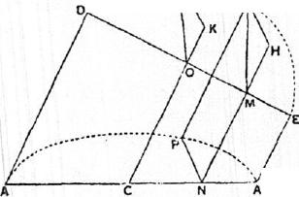that
DO' — CB' =OK'.
From K draw KR perpendicular to the plane of the paper and equal to CB. Thus OR²=0K²+CB²=0D².
In the plane containing DE, OR describe a circle on DE as diameter. Through this circle (which must pass through R) draw a cylinder with axis OC.
We have then to prove that, if P be
any point on t lie given ellipse, P lice on the cylinder so described.

62 ARCHIMEDES
Draw PN perpendicular to AA', and through N draw NM parallel to CO meeting DE in M. In the plane of the circle on DE as diameter draw MQ perpendicular to DE and meeting the circle in Q.
Lastly, draw QII perpendicular to NM produced. QH will then be perpendicular to the plane containing AC, DE, i.e. the plane of the paper.
Now QH² : Q' = KR² :OR', by similar triangles.
And QM' : AN NA' =DM • ME : AN • NA'
=0D² : CA².
Hence, ex aequali, since OR = OD,
QII² : AN • NA' = KR² :CA'
=CB² :CA²
=PN² : AN • NA'.
Thus QII =PN. And QII, PN are also parallel. Accordingly PQ is parallel to
MN, and therefore to CO, so that PQ is a generator, and the cylinder passes
through P.
PROPOSITION 10
It was proved by the earlier geometers that any two cones have to one another the ratio compounded of the ratios of their bases and of their heights.' The same method of proof will show that any segments of cones have to one another the ratio compounded of the ratios of their bases and of their heights.
The proposition that any `frustum' of a cylinder is triple of the conical segment which has the same base as the frustum and equal height is also proved in the same manner as the proposition that the cylinder is triple of the cone which has the same base as the cylinder and equal height.'
PROPOSITION 11
(1) If a paraboloid of revolution be cut by a plane through, or parallel to, the axis, the section will be a parabola equal to the original parabola which by its revolution generates the paraboloid. And the axis of the section will be the intersection between the cutting plane and the plane through the axis of the paraboloid at right angles to the cutting plane.
If the paraboloid be cut by a plane at right angles to its axis, the section will be a circle whose centre is on the axis.
- If a hyperboloid of revolution be cut by a plane through the axis, parallel to the axis, or through the centre, the section will be a hyperbola, (a) if the section be through the axis, equal, (b) if parallel to the axis, similar, (c) if through the centre, not similar, to the original hyperbola which by its revolution generates the hyper-boloid. And the axis of the section will be the intersection of the cutting plane and the plane through the axis of the hyperboloid at right angles to the cutting plane.
Any section of the hyperboloid by a plane at right angles to the axis will be a circle whose centre is on the axis.
- If any of the spheroidal figures be cut by a plane through the axis or parallel to the axis, the section will be an ellipse, (a) if the section be through the axis, equal, (b) if parallel to the axis, similar, to the ellipse which by its revolution gen-
¹This follows from Eucl. xII. 11 and 14 taken together. Cf. On the Sphere and Cylinder z, Lemma 1.
'This proposition was proved by Eudoxus, as stated in the preface to On the Sphere and Cylinder I. Cf. Eucl. xii. 10.

ON CONOIDS AND SPHEROIDS 63
erates the figure. And the axis of the section will be the intersection of the cutting plane and the plane through the axis of the spheroid at right angles to the culling plane.
If the section be by a plane at right angles to the axis of the spheroid, it will be a circle whose centre is on the axis,
(4) If any of the said figures be cut by a plane through the axis, and if a perpendicular be drawn to the plane of section from any point on the surface of the figure but not on the section, that perpendicular will fall within the section.
"And the proofs of all these propositions are evident."
PROPOSITION 12
If a paraboloid of revolution be cut by a plane neither parallel nor pendicular to the axis, and if the plane through the axis perpendicular to the cutting plane intersect it in a straight line of which the portion intercepted within the paraboloid is RR', the section of the paraboloid will be an ellipse whose major axis is RR' and whose minor axis is equal to the perpendicular distance between the lines through I?, I?' parallel to the axis of the paraboloid.
Suppose the cutting plane to be perpendicular to the plane of the paper, and let the latter be the plane through the axis ANF of the paraboloid which intersects the cutting plane at right angles in RR'. Let RH be parallel to the axis of the paraboloid, and R'H perpendicular to RH.
Let Q be any point on the section made by the cutting plane, and from Q draw QM perpendicular to RR'. QM will therefore be perpendicular to the plane of the paper.
Through M draw DMFE perpendicular to the axis ANF meeting the parabolic section made by the plane of the paper in D, E. Then QM is perpendicular to DE, and, if a plane be drawn through
7 DE, QM, it will be perpendicular to the
axis and will cut the paraboloid in a circular section.
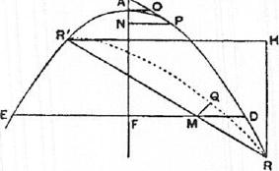
Since Q is on this circle,
QM² = DM • ME.
Again, if PT be that tangent to the parabolic section in the plane of the paper which is parallel to RR', and if the tangent at A meet PT in 0, then, from the property of the parabola,
DM • ME : RM . MR' =A0² :OP [Prop. 3 (1)]
=A0² : OT², since AN = A7'.
Therefore QM² : RM • MR' = A 0² : 0T²
= R'11² : RR",
by similar triangles.
Hence Q lies on an ellipse whose major axis is RI?' and whose minor axis is
equal to R'H.
PROPOSITIONS 13, 14
if a hyperboloid of revolution be cut by a plane meeting all the generators of the enveloping cone, or if an `oblong' spheroid be cut by a plane not perpendicular to

64 ARCHIMEDES
the axis,' and if a plane through the axis intersect the cutting plane at right angles in a straight line on. which the hyperboloid or spheroid intercepts a length RR', then the section by the cutting plane will be an ellipse whose major axis is RR'.
Suppose the cutting plane to be at right angles to the plane of the paper, and suppose the latter plane to be that through the axis ANF which intersects the
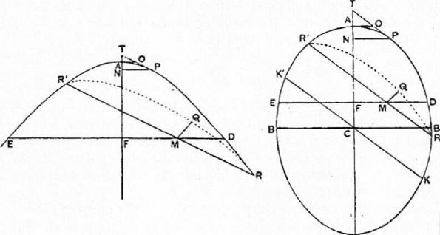
cutting plane at right angles in RR'. The section of the hyperboloid or spheroid by the plane of the paper is thus a hyperbola or ellipse having :INF for its transverse or major axis.
Take any point on the section made by the cutting plane, as Q, and draw QM perpendicular to RR'. QM will then be perpendicular to the plane of the paper.
Through M draw DFE at right angles to the axis ANY meeting the hyperbola or ellipse in D, E; and through QM, DE let a plane be described. This plane 'Will accordingly be perpendicular to the axis and will cut the hyperboloid or spheroid in a circular section.
Thus QM² =Dm • ME.
Let PT be that tangent to the hyperbola or ellipse which is parallel t o RR',
and let the tangent at A meet PT in 0.
Then, by the property of the hyperbola w•
DM • ME • MR' =0.4² :OP',
or Q.1/ : RM. • MR' =OA' : OP'.
Now (11 in the hyperbola OA <OP, because :17' <A N, and accordingly
OT <OP, while OA <OT,
(2) in the ellipse, if KK.' be the diameter parallel to Bic, and DB' the
minor axis,
BC • CB' : KC • CK' =OA' :OP";
and BC • CB' <KC •CK' , so that OA <VI'.
Hence in both cases the locus of Q is an ellipse whose major axis is UR'.
COR. 1. If the spheroid be a `flat' spheroid, the section will be an ellipse, and
everything will proceed as before except that RR' will in this case he the
minor axis.
'Archimedes begins Prop. 14 for the spheroid with the remark that, when the cutting plane passes through or is parallel to the axis, the case is clear. Cf. Prop. 11 (3).

ON CONOIDS AND SPHEROIDS 65
CoR 2. In all conoids or spheroids parallel sections will be similar, since the ratio 0A² : OP' is the same for all the parallel sections.
PROPOSITION 15
(1) If from any point on the surface of a conoid a line be drawn, in the case of the paraboloid, parallel to the axis, and, in the case of the hyperboloid, parallel to any line passing through the vertex of the enveloping cone, the part of the straight line which is in the same direction as the convexity of the surface will fall without it, and the part which is in the other direction within it.
For, if a plane be drawn, in the case of the paraboloid, through the axis and the point, and, in the case of the hyperboloid, through the given point and through the given straight line drawn through the vertex of the enveloping cone, the section by the plane will be (a) in the paraboloid a parabola whose axis is the axis of the paraboloid, (b) in the hyperboloid a hyperbola in which the given line through the vertex of the enveloping cone is a diameter.' [Prop. 11] Hence the property follows from the plane properties of the conics.
(2) If a plane touch a conoid without cutting it, it will touch it at one point only, and the plane drawn through the point of contact and the axis of the conoid will be at right angles to the plane which touches it.
For, if possible, let the plane touch at two points. Draw through each point a parallel to the axis. The plane passing through both parallels will therefore either pass through, or be parallel to, the axis. Hence the section of the conoid made by this plane will be a conic [Prop. 11 (1), (2)], the two points will lie on this conic, and the line joining them will lie within the conic and therefore within the conoid. But this line will be in the tangent plane, since the two points are in it. Therefore some portion of the tangent plane will be within the conoid; which is impossible, since the plane does not cut it.
Therefore the tangent plane touches in one point only.
That the plane through the point of contact and the axis is perpendicular to the tangent plane is evident in the particular case where the point of contact is the vertex of the conoid. For, if two planes through the axis cut it in two conics, the tangents at the vertex in both conics will be perpendicular to the axis of the conoid. And all such tangents will be in the tangent plane, which must therefore be perpendicular to the axis and to any plane through the axis.
If the point of contact P is not the vertex, draw the plane
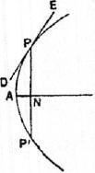
passing through the axis AN and the point P. It will cut the conoid in a conic whose axis is AN and the tangent plane in a line DPE touching the conic at P. Draw PNP' perpendicular to the axis, and draw a plane through it also perpendicular to the axis. This plane will make a circular section and meet the tangent plane in a tangent to the circle, which will therefore be at right angles to PN. Hence the tangent to the circle will be at right angles to the plane containing PN, AN; and it follows that this last plane is perpendicular to the tangent plane.
¹There seems to be some error in the text here, which says that "the diameter" (i.e. axis) of the hyperbola is "the straight line drawn in the conoid from the vertex of the cone." But this straight line is not, in general, the axis of the section.

66 ARCHIMEDES
PROPOSITION 16
(1) If a plane touch any of the spheroidal figures without cutting it, it will touch at one point only, and the plane through the point of contact and the axis will be at right angles to the tangent plane.
This is proved by the same method as the last proposition.
- If any conoid or spheroid be cut by a plane through the axis, and if through any tangent to the resulting conic a plane be erected at right angles to the plane of section, the plane so erected will touch the conoid or spheroid in the same point as that in which the line touches the conic.
For it cannot meet the surface at any other point. If it did, the perpendicular from the second point on the cutting plane would be perpendicular also to the tangent to the conic and would therefore fall outside the surface. But it must
fall within it. [Prop. 11 (4)]
- If two parallel planes touch any of the spheroidal figures, the line joining the points of contact will pass through the centre of the spheroid.
If the planes are at right angles to the axis, the proposition is obvious. If not, the plane through the axis and one point of contact is at right angles to the tangent plane at that point. It is therefore at right angles to the parallel tangent plane, and therefore passes through the second point of contact. Hence both points of contact lie on one plane through the axis, and the proposition is reduced to a plane one.
PROPOSITION 17
If two parallel planes touch any of the spheroidal figures, and another plane be drawn parallel to the tangent planes and passing through the centre, the line drawn through any point of the circumference of the resulting section parallel to the chord of contact of the tangent planes will fall outside the spheroid.
This is proved at once by reduction to a plane proposition.
Archimedes adds that it is evident that, if the plane parallel to the tangent planes does not pass through the centre, a straight line drawn in the manner described \Sill fall without the spheroid in the direction of the smaller segment but within it in the other direction.
PROPOSITION 18
Any spheroidal figure which is cut by a plane through the centre is divided, both as regards its surface and its volume, into two equal parts by that plane.
To prove this, Archimedes takes another equal and similar spheroid, divides it similarly by a plane through the centre, and then uses the method of application.
PROPOSITIONS 19, 20
Given a segment cut off by a plane from a paraboloid or hyperboloid of revolution, or a segment of a spheroid less than half the spheroid also cut off by a plane, it is possible to inscribe in the segment one solid figure and to circumscribe about it another solid figure, each made up of cylinders or "frusta" of cylinders of equal height, and such that the circumscribed figure exceeds the inscribed figure by a volume less than that of any given solid.
Let the plane base of the segment be perpendicular to the plane of the paper,

CONOIDS AND SPHEROIDS 67
and let the plane of the paper be the plane through the axis of the conoid or spheroid which cuts the base of the segment at right angles in BC. The section
in the plane of the paper is then a conic BAC. [Prop. 11]
Let EAF be that tangent to the conic which is parallel to BC, and let A be the point of contact. Through EAF draw a plane parallel to the plane through BC bounding the segment. The plane so drawn will then touch the conoid or
spheroid at A. [Prop. 16]
- If the base of the segment is at right angles to the axis of the conoid or spheroid, A will be the vertex of the conoid or spheroid, and its axis AD will bisect BC at right angles.
- If the base of the segment is not at right angles to the axis of the conoid or spheroid, we draw AD
- in the paraboloid, parallel to the axis,
- in the hyperboloid, through the cent re (or the vertex of the enveloping cone),
- in the spheroid, through the centre,
and in all the cases it will follow that AD bisects BC in D.
Then A will be the vertex of the segment, and AD will be its axis.
Further, the base of the segment will be a circle or an ellipse with BC as diameter or as an axis respectively, and with centre D. We can therefore describe through this circle or ellipse a cylinder or a `frustum' of a cylinder
whose axis is AD. [Prop. 9]
Dividing this cylinder or frustum continually into equal parts by planes parallel to the base, we shall at length arrive at a cylinder or frustum less in volume than any given solid.
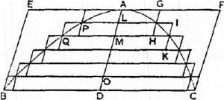
Let this cylinder or frustum be that whose axis is OD, and let AD be divided into parts equal to OD, at L, M Through L, M, . draw lines parallel to BC meeting the conic in P, Q,. , and through these lines draw planes parallel to the base of the segment. These will cut the conoid or spheroid in circles or similar ellipses. On each of these circles or ellipses describe two cylinders or frusta of cylinders each with axis equal to OD, one of them lying in the direction of A and the other in the direction of D, as shown in the figure.
Then the cylinders or frusta of cylinders drawn in the direction of A make up a circumscribed figure, and those in the direction of D an inscribed figure, in relation to the segment.
Also the cylinder or frustum PG in the circumscribed figure is equal to the cylinder or frustum PH in the inscribed figure, QI in the circumscribed figure is equal to QK in the inscribed figure, and so on.
Therefore, by addition,
(circumscribed fig.) = (inscr. fig.)-1- (cylinder or frustum whose axis is OD). But the cylinder or frustum whose axis is OD is less than the given solid figure; whence the proposition follows.
"Having set out these preliminary propositions, let us proceed to demonstrate the theorems propounded with reference to the figures."

68 ARCHIMEDHs
PROPOSITIONS 21, 22
Any segment of a paraboloid of revolution is half as large again as the cone or segment of a cone which has the same base and the same axis.
Let the base of the segment be perpendicular to the plane of the paper, and let the plane of the paper be the plane through the axis of the paraboloid which cuts the base of the segment at right angles in BC and makes the parabolic section BAC.
Let EF be that tangent to the parabola which is parallel to BC, and let A he the point of contact.
Then (1), if the plane of the base of the segment is perpendicular to the axis of the paraboloid, that axis is the line AD bisecting BC at right angles in D.
(2) If the plane of the base is not perpendicular to the axis of the paraboloid, draw AD parallel to the axis of the paraboloid. AD will then bisect BC, but not at right angles.
Draw through EF a plane parallel to the base of the segment. This will touch the paraboloid at A, and A will be the vertex of the segment, AD its axis.
The base of the segment will be a circle with diameter BC or an ellipse with BC as major axis.
Accordingly a cylinder or a frustum of a cylinder can be found passing through the circle or ellipse and having AD for its axis [Prop. 9]; and likewise a cone or a segment of a cone can be drawn passing through the circle or
ellipse and having A for vertex and A D for axis. [Prop. 8]
Suppose X to be a cone equal to :1 (cone or segment of cone ABC). The cone X is therefore equal to half the cylinder or frustum of a cylinder EC. [Cf. Prop. 10; We shall prove that the volume of the segment of the paraboloid is equal to X.
If not, the segment must be either greater or less than X.
I. If possible, let the segment be greater than X.
We can then inscribe and circumscribe, as in the last proposition, figures made up of cylinders or frusta of cylinders with equal height and such that. (circumscribed fig.) — (inscribed fig.) < (segment) — X.
Let the greatest of the cylinders or frusta forming the circumscribed figure be that whose base is the circle or ellipse about BC and whose axis is OD, and let the smallest of them be that whose base is the circle or ellipse about PP' and whose axis is AL.
Let the greatest of the cylinders forming the inscribed figure be that whose base is the circle or ellipse about RR' and whose axis is OD, and let the smallest be that whose base is the circle or ellipse about PP' and whose axis is LM.
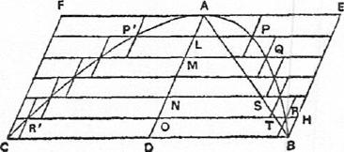
Produce all the plane bases of the cylinders or frusta to meet the surface of the complete cylinder or frustum EC.
Now, since
(circumscribed fig.) — (inscr. fig.) < (segment)— X ,

ON CONOIDS AND SPHEROIDS 69
it follows that (inscribed figure)> X. (a)
Next, comparing successively the cylinders or frusta with heights equal to
OD and respectively forming parts of the complete cylinder or frustum EC
and of the inscribed figure, we have
(first cylinder or frustum in EC) : (first in inscr. fig.)
w.B.D² : RO²
=AD :AO
= BD : TO, where AB meets OR in T.
And (second cylinder or frustum in EC) : (second in inscr. fig.)
=HO : SN, in like manner,
and so on.
Hence [Prop. 1] (cylinder or frustum EC) : (inscribed figure)
=(BD-1-H0+ • • •) : (TO-f-SN-1- • • -),
where BD, HO, ... are all equal, and BD, TO, SN, ... diminish in arithmetical
progression.
But [Lemma preceding Prop. 1]
BD-1-H0-1- • • •>2(T0-1--SN+ • • •).
Therefore (cylinder or frustum EC)>2 (inscribed fig.),
or X> (inscribed fig.);
which is impossible, by (a) above.
II. If possible, let the segment be less than X.
In this case we inscribe and circumscribe figures as before, but such that
(circumscr. fig.) —• (inscr. fig.) <X-- (segment),
whence it follows that
(circumscribed figure) <X. (0)
And, comparing the cylinders or frusta making up the complete cylinder or
frustum CE and the circumscribed figure respectively, we have
(first cylinder or frustum in CE) : (first in circurnscr. fig.)
=BD² : BD²
=BD : BD.
(second in CE) : (second in circumscr. fig.)
=HO' : RO'
=AD :AO
=HO : TO,
and so on.
Hence [Prop. I]
(cylinder or frustum CE) : (circumscribed fig.)
_(BD-I-H0-1- • • •) : (BD-1-T0+ .),
<2:1, [Lemma preceding Prop. 1]
and it follows that
X < (circumscribed fig.);
which is impossible, by (13).
Thus the segment, being neither greater nor less than X, is equal to it, and
therefore to (cone or segment of cone ABC).
PROPOSITION 23
If frotn a paraboloid of revolution two segments be cut off, one by a plane perpendicular to the axis, the other by a plane not perpendicular to the axis, and if the axes of the segments are equal, the segments will be equal in volume.

70 ARCH IM EDES
Let the two planes be supposed perpendicular to the plane of the paper, and let the latter plane be the plane through the axis of the paraboloid cutting the other two planes at right angles in BB', QQ' respectively and the paraboloid itself in the parabola QPQ'B'.
Let AN, PV be the equal axes of the segments, and A, P their respective vertices.
I.
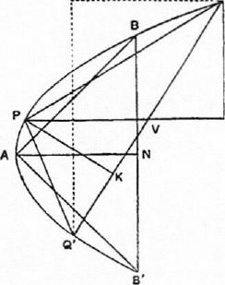
Draw QL parallel to AN or PV and Q'L perpendicular to QL.
Now, since the segments of the parabolic section cut off by BB', QQ' have equal axes, the triangles ABB', PQQ' arc equal [Prop. 3]. Also, if QD be perpendicular to PV,QD=BN (as in the same Prop. 3).
Conceive two cones drawn with the same bases as the segments and with A, P as vertices respectively. The height of the cone PQQ' is then PK, where PK is perpendicular to QQ'.
Now the cones are in the ratio compounded of the ratios of their bases and of their heights, i.e. the ratio compounded of (1) the ratio of the circle about BB' to the ellipse about QQ', and (2) the ratio of AN to PK.
That is to say, we have, by means of Props. 5, 12,
(cone ABB') : (cone PQQ') = (BB'² : QQ' • Q'L) •(AN : PK).
And BB' = 2BN = 2QD = Q'L, while QQ' = 2QV.
Therefore
(cone ABB') : (cone PQQ') = (QD :QV) •(AN : PK)
= (PK : PV) •(AN : PK)
= AN : PV.
Since AN = PV, the ratio of the cones is a ratio of equality; and it follows
that the segments, being each half as large again as the respective cones [Prop.
22], are equal.
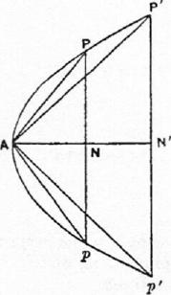 | PROPOSITION 24  If from a paraboloid of revolution two segments be cut off by planes drawn in any manner, the segments will be to one another as the squares on their axes.  For let the paraboloid be cut by a plane through the axis in the parabolic section P'PApp', and let the axis of the parabola and paraboloid he ANN'.  Measure along ANN' the lengths A N, AN' equal to the respective axes of the given segments, and through N, N' draw planes perpendicular to the axis, making circular sections on Pp, P'p' as diameters respectively. With these circles as bases and with the common vertex A let two cones be described.  Now the segments of the paraboloid whose bases are the circles about Pp, P'p' are equal to the given segments respectively, since their respective axes are

ON CONOIDS AND SPHEROIDS 71
equal [Prop. 23]; and, since the segments APp, AP'p' are half as large again
as the cones APp, AP'p' respectively, we have only to show that the cones
are in the ratio of AN² to AN'².
But
(cone APp) : (cone AP'p') = (PN² : P'N") -(AN : AN')
(AN : AN') •(AN : AN')
= AN² : AN'²;
thus the proposition is proved.
PROPOSITIONS 25, 26
In any hyperboloid of revolution, if A be the vertex and AD the axis of any segment cut off by a plane, and if CA be the semidiameter of the hyperboloid through A (CA being of course in the same straight line with AD), then
(segment) : (cone with same base and axis)
= (AD-E3CA) : (AD-F2CA).
Let the plane cutting off the segment be perpendicular to the plane of the paper, and let the latter plane be the plane through the axis of the hyperboloid which intersects the cutting plane at right angles in BB', and makes the hyperbolic segment BAB'. Let C be the centre of the hyperboloid (or the vertex of the enveloping cone).
Let EF be that tangent to the hyperbolic section which is parallel to BB'. Let EF touch at A, and join CA. Then CA produced will bisect BB' at D, CA will be a semi-diameter of the hyperboloid, A will be the vertex of the segment, and AD its axis. Produce AC to A' and H, so that AC =CA' =A'H.
Through EF draw a plane parallel to the base of the segment. This plane will touch the hyperboloid at A.
Then (1), if the base of the segment is at right angles to the axis of the hyperboloid, A will be the vertex, and AD the axis, of the hyperboloid as well as of the segment, and the base of the segment will be a circle on BB' as diameter.
(2) If the base of the segment is not perpendicular to the axis of the hyper-
boloid, the base will be an ellipse on BB' as major axis. [Prop. 13]
Then we can draw a cylinder or a frustum of a cylinder EBB' F passing through the circle or ellipse about BB' and having AD for its axis; also we can describe a cone or a segment of a cone through the circle or ellipse and having A for its vertex.
We have to prove that
(segment ABB') : (cone or segment of cone ABB') = HD : A'D. Let V be a cone such that
V : (cone or segment of cone ABB') =HD : A'D, (a)
and we have to prove that V is equal to the segment.
Now
(cylinder or frustum EB') : (cone or segmt. of cone ABB') =3 : 1.
Therefore, by means of (a), (cylinder or frustum EB') : V= A' D : HD ((3)
If the segment is not equal to V, it must either be greater or less.
I. If possible, let the segment be greater than V.
Inscribe and circumscribe to the segment figures made up of cylinders or
frusta of cylinders, with axes along AD and all equal to one another, such that

72 ARCIIIMEDES
(circumscribed fig.) — (inscr. fig.) < (segmt.) — V,
whence (inscribed figure) > V. (7)
Produce all the planes forming the bases of the cylinders or frusta of cylin-
ders to meet the surface of the complete cylinder or frustum EB'.
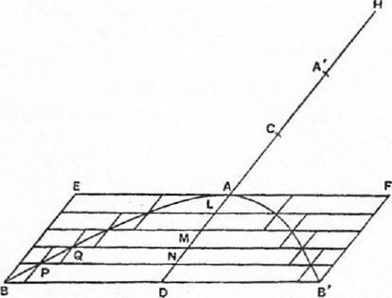

p
(AD) p q
(A A') a a a
a
b
$

Then, if ND be the axis of the greatest cylinder or frustum in the circumscribed figure, the complete cylinder will be divided into cylinders or frusta each equal to this greatest cylinder or frustum.
Let there be a number of straight lines a equal to AA' and as many in number as the parts into which AD is divided by the bases of the cylinders or frusta. To each line a apply a rectangle which shall overlap it by a square, and let
the greatest of the rectangles be equal to the rectangle AD and the least
equal to the rectangle AL •A'L; also let the sides of the overlapping squares b, p, q,.. .1 be in descending arithmetical progression. Thus h, p, q,. . .1 will be respectively equal to AD, AN, AM,. . . AL, and the rectangles (ab-+b²), (ap-Fp²),. (a1+1²) will be respectively equal to AD -A'D, AN •A'N,. . AL A'L.
Suppose, further, that we have a series of spaces S each equal to the largest rectangle AD •A'D and as many in number as the diminishing rectangles. Comparing now the successive cylinders or frusta (1) in the complete cylin-

ON CONOIDS AND SPHEROIDS 73
der or frustum EB' and (2) in the inscribed figure, beginning from the base of
the segment, we have
(first cylinder or frustum in £B') : (first in inscr. figure)
=BD² : PN²
=AD •A'D : AN •A'N, from the hyperbola,
=8 : (ap-Fp²).
Again
(second cylinder or frustum in EB') : (second in inscr. fig.)
=BD² : QM²
=AD •A'D : AM •A'M
=8 : (aq+q²),
and so on.
The last cylinder or frustum in the complete cylinder or frustum EB' has no
cylinder or frustum corresponding to it in the inscribed figure.
Combining the proportions, we have [Prop. 1]
(cylinder or frustum EB') : (inscribed figure)
= (sum of all the spaces S) : (api-p²)+(aq+0)-1- • • •
> (a+b) : (²₂ -1- ¹²0 [Prop. 2]
^{D}
H
>A' D : —₃—, since a=AA' , b= AD,
> (EB') : V, by (0) above.
Hence (inscribed figure) < V.
But this is impossible, because, by (7) above, the inscribed figure is greater
than V
II. Next suppose, if possible, that the segment is less than V.
In this case we circumscribe and inscribe figures such that
(circumscribed fig.) — (inscribed fig.) < V— (segment),
whence we derive
V> (circumscribed figure). (5)
We now compare successive cylinders or frusta in the complete cylinder or
frustum and in the circumscribed figure; and we have
(first cylinder or frustum in EB') : (first in circumscribed fig.)
=S : S
=S : (ab+b²),
(second in EB') : (second in circumscribed fig.)
=8 : (ap+p²),
and so on.  Hence [Prop. 1]  (cylinder or frustum EB') : (circumscribed fig.)  = (sum of all spaces S) : (ab+b²)+(ap-1-73²)+ • • •  <(a+b) : (₂^{c1}4)₃  <ii'D :^{D}  —₃—  < (EB') : V, by (i3) above. | [Prop. 2]

74 ARCHIMEDES
Hence the circumscribed figure is greater than V; which is impossible, by
(6) above.
Thus the segment is neither greater nor less than V, and is therefore equal
to it.
Therefore, by (a),
(segment ABB') : (cone or segment of cone ABB')
=(AD+3CA) : (AD+2CA).
PROPOSITIONS 27, 28, 29, 30
(1) In any spheroid whose centre is C, if a plane meeting the axis cut off a segment not greater than half the spheroid and having A for its vertex and AD for its axis, and if A'D be the axis of the remaining segment of the spheroid, then
(first segmt.) : (cone or segmt. of cone with same base and axis) =CAI-A'D : A'D
[=3CA—AD :2CA—AD].
(2) As a particular case, if the plane passes through the centre, so that the segment is half the spheroid, half the spheroid is double of the cone or segment of a cone which has the same vertex and axis.
Let the plane cutting off the segment be at right angles to the plane of the paper, and let the latter plane be the plane through the axis of the spheroid which intersects the cutting plane in BB' and makes the elliptic section ABA'B'.
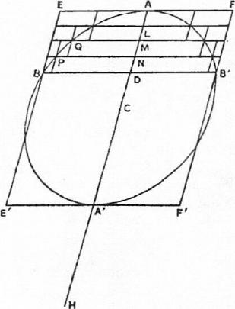
a' |  |  |  |  | a' |  |  | a'
 | ‘,..  I |  | a |  |  | a
 |  | ,_..., x |  |  |  |  |  |  | a S
 | d d d

Let EF, E'F' be the two tangents to the ellipse which are parallel to BB', let them touch it in A, A', and through the tangents draw planes parallel to the base of the segment. These planes will touch the spheroid at A, A', which will be the vertices of the two segments into which it is divided. Also AA' will pass through the centre C and bisect BB' in D.
Then (1) if the base of the segments be perpendicular to the axis of the spheroid, A, A' will be the vertices of the spheroid as well as of the segments, AA' will be the axis of the spheroid, and the base of the segments will be a circle on BB' as diameter;
(2) if the base of the segments be not perpendicular to the axis of the spheroid, the base of the segments will be an ellipse of which BB' is one axis, and AD, A'D will be the axes of the segments respectively.

ON CONOIDS AND SPHEROIDS 75
We can now draw a cylinder or a frustum of a cylinder EBB'? through the circle or ellipse about BB' and having AD for its axis; and we can also draw a cone or a segment of a cone passing through the circle or ellipse about BB' and having A for its vertex.
We have then to show that, if CA' be produced to H so that CA' =All,
(segment ABB') : (cone or segment of cone ABB') = HD : A'D. Let V be such a cone that
V : (cone or segment of cone ABB')= HD : A'D; (a)
and we have to show that the segment ABB' is equal to V.
But, since
(cylinder or frustum EB') : (cone or segment of cone ABB') = 3 : I, we have, by the aid of (a),
D H
(cylinder or frustum EB') :V =A'D : —₃ (0)
Now, if the segment ABB' is not equal to V, it must be either greater or less.
I. Suppose, if possible, that the segment is greater than V.
Let figures be inscribed and circumscribed to the segment consisting of
cylinders or frusta of cylinders, with axes along AD and all equal to one
another, such that
(circumscribed fig.) — (inscribed fig.) < (segment) — V,
whence it follows that
(inscribed fig.) > V. (7)
Produce all the planes forming the bases of the cylinders or frusta to meet the surface of the complete cylinder or frustum EB'. Thus, if ND be the axis of the greatest cylinder or frustum of a cylinder in the circumscribed figure, the complete cylinder or frustum EB' will be divided into cylinders or frusta of cylinders each equal to the greatest of those in the circumscribed figure.
Take straight lines da' each equal to A'D and as many in number as the parts into which AD is divided by the bases of the cylinders or frusta, and measure da along da' equal to AD. It follows that aa' = 2CD.
Apply to each of the lines a'd rectangles with height equal to ad, and draw the squares on each of the lines ad as in the figure. Let S denote the area of each complete rectangle.
From the first rectangle take away a gnomon with breadth equal to AN (i.e. with each end of a length equal to AN); take away from the second rectangle a gnomon with breadth equal to AM, and so on, the last rectangle having no gnomon taken from it.
Then
the first gnomon = A'D •AD —ND -(A'D —AN)
=A'D -AN-FAT •AN
=AN •A'N.
Similarly,
the second gnomon =AM •A'M,
and so on.
And the last gnomon (that in the last rectangle but one) is equal to AL -A/L.
Also, after the gnomons are taken away from the successive rectangles, the remainders (which we will call RI, R2, • • • R., where n is the number of rectangles and accordingly R„= 2) are rectangles applied to straight lines each of

76 ARCHIMEDES
length aa' and "exceeding by squares" whose sides are respectively equal to
DN, DM,. . . DA.
For brevity, let DN be denoted by x, and aa' or 2CD by c, so that
R_{i} =CX+X², R2 = c .2x (2x)², • • •
Then, comparing successively the cylinders or frusta of cylinders (1) in the
complete cylinder or frustum EB' and (2) in the inscribed figure, we have
(first cylinder or frustum in EB') : (first in inscribed fig.)
=BD' :PN²
=AD •A'D : AN •A'N
=8 : (first gnomon);
(second cylinder or frustum in EB') : (second in inscribed fig.)
=S : (second gnomon),
and so on.
The last of the cylinders or frusta in the cylinder or frustum ER' has none
corresponding to it in the inscribed figure, and there is no corresponding
gnomon.
Combining the proportions, we have [by Prop. 1]
(cylinder or frustum ER') : (inscribed fig.)
= (sum of all spaces S) : (sum of gnomons).
Now the differences between S and the successive gnomons are R_{I}, R2,
while
R₁=CX+2²,
R2= C '2x+ (2x)²,
1?„=cb-Fb²=8,
where b = nx= AD.
Hence [Prop. 2]
(sum of all spaces S) : -1-R2+ • • • -F-R7,) <(c+b) : (2+0• It follows that
c 2b
(sum of all spaces 8) : (sum of gnomons)>(c+b) : )
>A'D :--₃^{D}.
Thus (cylinder or frustum EB') : (inscribed fig.) >A'D HD
> (cylinder or frustum EB') : V,
from (0) above.
Therefore (inscribed fig.) < V;
which is impossible, by (7) above.
Hence the segment ABB' is not greater than V.
II. If possible, let the segment ABB' be less than V.
We then inscribe and circumscribe figures such that
(circumscribed fig.) — (inscribed fig.) < V — (segment),
whence V> (circumscribed fig.). (⁸)
In this case we compare the cylinders or frusta in (ER') with those in the
circumscribed figure.

ON CONOIDS AND SPHEROIDS 77
Thus
(first cylinder or frustum in EB') : (first in circumscribed fig.)
=S : S;
(second in ER') : (second in circumscribed fig.)
: (first gnomon),
and so on.
Lastly (last in EB') : (last in circumscribed fig.)
: (last gnomon).
Now
18-1- (all the gnomons)} = nS (R_{I}+ R_{I}+ • • • +1?„_₁1
And nS : R1+R2+ • • • +R.-1> (c+b) (2A), [Prop. 2]
so that
c 2b
nS : {S+ (all the gnomons)} < (c+b) : (-₂+-₃).
It follows that, if we combine the above proportions as in Prop. 1, we obtain (cylinder or frustum ER') : (circumscribed fig.)
< (c+b) : (--²⁾
2 3
_{<ND:} HD
3
<(EB') : V, by (j3) above.
Hence the circumscribed figure is greater than V; which is impossible, by (3)
above.
Thus, since the segment ABB' is neither greater nor less than V, it is equal
to it; and the proposition is proved.
(2) The particular case [Props. 27, 28] where the segment is half the spheroid
differs from the above in that the distance CD or c/2 vanishes, and the rec-
tangles cb+b² are simply squares (b²), so that the gnomons are simply the
differences between b² and x², b² and (2x)², and so on.
Instead therefore of Prop. 2 we use the Lemma to Prop. 2, Cor. 1, given above
[On Spirals, Prop. 10], and instead of the ratio (c+b) : (-^{c}2+ ^{—2b} we obtain the
3
ratio 3 : 2, whence (segment ABB') : (cone or segment of cone ABB')=2 : I. PROPOSITIONS 31, 32
If a plane divide a spheroid into two unequal segments, and if AN, A'N be the axes of the lesser and greater segments respectively, while C is the centre of the spheroid, then
(greater segmt.) : (cone or segmt. of cone with same base and axis)
=CA+AN : AN.
Let the plane dividing the spheroid be that through PP' perpendicular to the plane of the paper, and let the latter plane be that through the axis of the spheroid which intersects the cutting plane in PP' and makes the elliptic section PAP'A'.
Draw the tangents to the ellipse which are parallel to PP'; let them touch the ellipse at A, A', and through the tangents draw planes parallel to the base of the segments. These planes will touch the spheroid at A, A', the line AA'

78 ARCHIMEDES
will pass through the centre C and bisect PP' in N, while AN, A'N will be the axes of the segments.
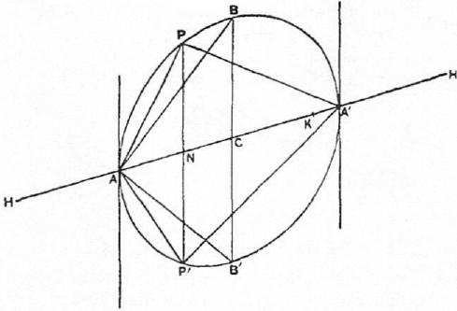
Then (1) if the cutting plane be perpendicular to the axis of the spheroid,
A A' will be that axis, and A, A' will be the vertices of the spheroid as well as of
the segments. Also the sections of the spheroid by the cutting plane and all
planes parallel to it will be circles.
(2) If the cutting plane be not perpendicular to the axis, the base of the
segments will be an ellipse of which PP' is an axis, and the sections of the
spheroid by all planes parallel to the cutting plane will be similar ellipses.
Draw a plane through C parallel to the base of the segments and meeting the
plane of the paper in BB'.
Construct three cones or segments of cones, two having A for their common
vertex and the plane sections through PP', BB' for their respective bases, and
a third having the plane section through PP' for its base and A' for its vertex.
Produce CA to H and CA' to H' so that
AH=A'H'=CA.
We have then to prove that
(segment A'PP') : (cone or segment of cone A'PP')
=CA-FAN : AN
=NH : AN.
Now half the spheroid is double of the cone or segment of a cone ABB'
[Props. 27, 281. Therefore
(the spheroid) =4(cone or segment of cone A BB').
But
(cone or segmt. of cone ABB') : (cone or segmt. of cone APP')
= (CA : AN) • (BC² : PAT')
= (CA : AN) • (CA • CA' : AN • AR). (a)
If we measure .4K along AA' so that
AK : AC = AC : AN,
we have AK • A'N : AC • A'N =CA : AN,
and the compound ratio in (a) becomes
(AK • A'N : CA • A'N) • (CA • CA' : AN • A'N),
i.e. AK • CA' : AN • A'N.

ON CONOIDS AND SPHEROIDS 79
Thus
(cone or segmt. of cone ABB') : (cone or segmt. of cone APP')
=AK • CA' : AN • A'N.
But (cone or segment of cone APP') : (segment API")
=A'N : NH' [Props. 29, 301
=AN • A'N : AN • NH'.
Therefore, ex aequali,
(cone or segment of cone ABB') : (segment API")
=AK • CA' : AN • NH',
so that (spheroid) : (segment APP')
=HH' • AK : AN • NH',
since HH' =4CA'.
Hence (segment A'PP') : (segment APP')
=(HH' • AK—AN - NH') : AN • NH'
= (AK • NH-}-NH' • NK) : AN • NH'.
Further,
(segment APP') : (cone or segment of cone APP')
=NH' : A'N
=AN • NH' AN • A'N,
and
(cone or segmt. of cone APP') : (cone or segmt. of cone A'PP')
=AN : A'N
=AN • A'N : A'N'.
From the last three proportions we obtain, ex aequali,
(segment A'PP') : (cone or segment of cone A'PP')
= (AK • NH-I-NH' • NK) : A'N²
= (AK • NII+NH' • NK) : (CA²-1-NH' • CN)
=(AK • NHA-NH' • NK) : (AK - • CN). (13)
But
AK •NH : AK •AN =NH :AN
=CA+AN : AN
=AK+CA :CA (since AK : AC = AC : AN)
=HK :CA
=HK—NH :CA—AN
=NK : CN
=NH' • NK :NH' • CN.
Hence the ratio in (0) is equal to the ratio
AK•NH : AK • AN, or NH : AN.
Therefore
(segment A'PP') : (cone or segment of cone A'PP')
=NH : AN
=CA+AN : AN.

ON SPIRALS
"ARCHIMEDES to Dositheus greeting.
"Of most of the theorems which I sent to Conon, and of which you ask me from time to time to send you the proofs, the demonstrations are already before you in the books brought to you by Heracleides; and some more are also contained in that which I now send you. Do not be surprised at my taking a considerable time before publishing these proofs. This has been owing to my desire to communicate them first to persons engaged in mathematical studies and anxious to investigate them. In fact, how many theorems in geometry which have seemed at first, impracticable are in time successfully worked out! Now Conon died before he had sufficient time to investigate the theorems referred to; otherwise he would have discovered and made manifest all these things, and would have enriched geometry by many other discoveries besides. For I know well that it was no common ability that he brought to bear on mathematics, and that his industry was extraordinary. But, though many years have elapsed since Conon's death, I do not find that any one of the problems has been stirred by a single person. I wish now to put them in review one by one, particularly as it happens that there are two included among them which are impossible of realisation [and which may serve as a warning] how those who claim to discover everything but produce no proofs of the same may be confuted as having actually pretended to discover the impossible.
"What are the problems I mean, and what are those of which you have already received the proofs, and those of which the proofs are contained in this book respectively, I think it proper to specify. The first of the problems was, Given a sphere, to find a plane area equal to the surface of the sphere; and this was first made manifest on the publication of the book concerning the sphere, for, when it is once proved that the surface of any sphere is four times the greatest circle in the sphere, it is clear that it is possible to find a plane area equal to the surface of the sphere. The second was, Given a cone or a cylinder, to find a sphere equal to the cone or cylinder; the third, To cut a given sphere by a plane so that the segments of it have to one another an assigned ratio; the fourth, To cut a given sphere by a plane so that the segments of the surface have to one another an assigned ratio; the fifth, To make a given segment of a sphere similar to a given segment of a sphere;' the sixth, Given two segments of either the same or different spheres, to find a segment of a sphere which shall be similar to one of the segments and have its surface equal to the surface of the other segment. The seventh was, From a given sphere to cut off a segment by a plane so that the segment bears to the cone which has the same base
'Cf. On the Sphere and Cylinder, II. 5.
80

ON SPIRALS 81
as the segment and equal height an assigned ratio greater than that of three to two. Of all the propositions just enumerated Heracleides brought you the proofs. The proposition stated next after these was wrong, viz. that, if a sphere be cut by a plane into unequal parts, the greater segment. will have to the less the duplicate ratio of that which the greater surface has to the less. That this is wrong is obvious by what I sent you before; for it included this proposition: If a sphere be cut into unequal parts by a plane at right angles to any diameter in the sphere, the greater segment of the surface will have to the less the same ratio as the greater segment of the diameter has to the less, while the greater segment of the sphere has to the less a ratio less than the duplicate ratio of that which the greater surface has to the less, but greater than the sesqui-alteratel of that ratio. The last of the problems was also wrong, viz. that, if the diameter of any sphere be cut so that the square on the greater segment is triple of the square on the lesser segment, and if through the point thus arrived at, a plane be drawn at right angles to the diameter and cutting the sphere, the figure in such a form as is the greater segment of the sphere is the greatest of all the segments which have an equal surface. That this is wrong is also clear from the theorems which I before sent you. For it was there proved that the hemisphere is the greatest of all the segments of a sphere bounded by an equal surface.
"After these theorems the following were propounded concerning the cone.' If a section of a right-angled cone [a parabola], in which the diameter [axis] remains fixed, be made to revolve so that the diameter [axis] is the axis [of revolution], let the figure described by the section of the right-angled cone be called a conoid. And if a plane touch the conoidal figure and another plane drawn parallel to the tangent plane cut off a segment of the conoid, let the base of the segment cut off be defined as the cutting plane, and the vertex as the point in which the other plane touches the conoid. Now, if the said figure be cut by a plane at right angles to the axis, it is clear that the section will be a circle; but it needs to be proved that the segment cut off will be half as large again as the cone which has the same base as the segment and equal height. And if two segments be cut off from the conoid by planes drawn in any manner, it is clear that the sections will he sections of acute-angled cones [ellipses] if the cutting planes be not at right angles to the axis; but it needs to be proved that the segments will bear to one another the ratio of the squares on the lines drawn from their vertices parallel to the axis to meet the cutting planes. The proofs of these propositions are not yet sent to you.
"After these came the following propositions about the spiral, which are as it were another sort of problem having nothing in common with the foregoing; and I have written out the proofs of them for you in this book. They are as follows. If a straight line of which one extremity remains fixed be made to revolve at a uniform rate in a plane until it returns to the position from which it started, and if, at the same time as the straight line revolves, a point move at a uniform rate along the straight line, starting from the fixed extremity, the point will describe a spiral in the plane. I say then that the area bounded by the spiral and the straight line which has returned to the position from which it started is a third part of the circle described with the fixed point as centre and with radius the length traversed by the point along the straight line during
'See On the Sphere and Cylinder, II. 8.
'This should be presumably "the conoid," not "the cone."

82 ARCHIMEDES
the one revolution. And, if a straight line touch the spiral at the extreme end of the spiral, and another straight line be drawn at right angles to the line which has revolved and resumed its position from the fixed extremity of it, so as to meet the tangent, I say that the straight line so drawn to meet it is equal to the circumference of the circle. Again, if the revolving line and the point moving along it make several revolutions and return to the position from which the straight line started, I say that the area added by the spiral in the third revolution will be double of that added in the second, that in the fourth three times, that in the fifth four times, and generally the areas added in the later revolutions will be multiples of that added in the second revolution according to the successive numbers, while the area bounded by the spiral in the first revolution is a sixth part of that added in the second revolution. Also, if on the spiral described in one revolution two points be taken and straight lines be drawn joining them to the fixed extremity of the revolving line, and if two circles be drawn with the fixed point as centre and radii the lines drawn to the fixed extremity of the straight line, and the shorter of the two lines be produced, I say that (1) the area bounded by the circumference of the greater circle in the direction of (the part of) the spiral included between the straight lines, the spiral (itself) and the produced straight line will bear to (2) the area bounded by the circumference of the lesser circle, the same (part of the) spiral and the straight line joining their extremities the ratio which (3) the radius of the lesser circle together with two thirds of the excess of the radius of the greater circle over the radius of the lesser bears to (4) the radius of the lesser circle together with one third of the said excess.
"The proofs then of these theorems and others relating to the spiral are given in the present book. Prefixed to them, after the manner usual in other geometrical works, are the propositions necessary to the proofs of them. And here too, as in the books previously published, I assume the following lemma, that, if there be (two) unequal lines or (two) unequal areas, the excess by which the greater exceeds the less can, by being [continually] added to itself, be made to exceed any given magnitude among those which are comparable with [it and with] one another."
PROPOSITION 1
If a point move at a uniform rate along any line, and two lengths be taken on it, they will be proportional to the times of describing them.
Two unequal lengths are taken on a straight line, and two lengths on another straight line representing the times; and they are proved to be proportional by taking equimultiples of each length and the corresponding time after the manner of Eucl. V, Def. 5.
PROPOSITION 2
If each of two points on different lines respectively move along them each at a uniform rate, and if lengths be taken, one on each line, forming pairs, such that each pair are described in equal times, the lengths will be porportionals.
This is proved at once by equating the ratio of the lengths taken on one line to that of the times of description, which must also be equal to the ratio of the lengths taken on the other line.

ON SPIRALS 83
PROPOSITION 3
Given any number of circles, it is possible to find a straight line greater than the sum of all their circumferences.
For we have only to describe polygons about each and then take a straight line equal to the sum of the perimeters of the polygons.
PROPOSITION 4
Given two unequal lines, viz. a straight line and the circumference of a circle, it is possible to find a straight line less than the greater of the two lines and greater than the less.
For, by the Lemma, the excess can, by being added a sufficient number of times to itself, be made to exceed the lesser line.
Thus e.g., if c> 1 (where c is the circumference of the circle and 1 the length of the straight line), we can find a number n such that
n(c—l)>l.
Therefore c-1>_{n}-/'
and c>/-1--_{n}-/>/.
Hence we have only to divide 1 into n equal parts and add one of them to 1. The resulting line \vitt satisfy the condition.
PROPOSITION 5
Given a circle with centre 0, and the tangent to it at a point A, it is possible to draw from 0 a straight line OPF, meeting the circle in P and the tangent in. F, such that, if c be the circumference of any given circle whatever,
FP:OP< (arc AP) : c.
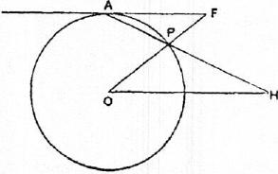
Take a straight line, as D, greater than the circumference c. [Prop. 3]
Through 0 draw OH parallel to the given tangent, and draw through A a line APH, meeting the circle in P and OH in H, such that the portion PH intercepted between the circle and the line OH may he equal to D. Join OP and produce it to meet the tangent in F.
Then FP :OP=AP : PH, by parallels,
D = AP : D
< (arc AP) : c.
PROPOSITION 6
Given a circle with centre 0, a chord AB less than the diameter, and OM the per-
pendicular on AB from 0, it is possible to draw a straight line OFP, meeting the
chord AB in F and the circle in P, such that
FP :PB=D :E,
where D : E is any given ratio less than BM : MO.
Draw 011 parallel to AB, and B7' perpendicular to BO meeting 011 in 7'.

84 ARCHIMEDES
Then the triangles BRIO, OBT are similar, and therefore
BM : ilfO =OB : BT,
whence D : E <OR : 137¹.
Suppose that a line PH (greater than BT) is taken such that
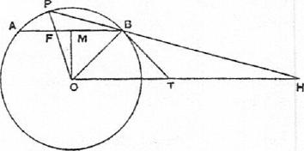
D
D :E=OB :PH,
and let PH be so placed that it passes through B and P lies on the circumference of the circle, while H is on the line OH. (PH will fall outside BT, because PH>BT.) Join OP meeting AB in F.
We now have
FP :PB=OP :PH
=OB :PH
=D : E.
PROPOSITION 7
Given a circle with centre 0, a chord AB less than the diameter, and OM the per-
pendicular on it from 0, it is possible to draw from 0 a straight line OPF, meeting
the circle in P and AB produced in F, such that
FP :PB=D :E,
where D : E is any given ratio greater than BM :MO.
Draw OT parallel to AB, and BT perpendic-
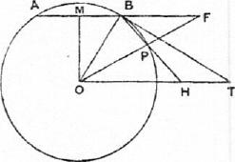
0
E
ular to BO meeting OT in T.
In this case,
D : E> BM : MO
> OB : BT, by Fimilar triangles.
Take a line PH (less than BT) such that
D : E=OB :PH,
and place PH so that P, II are on the circle and
on OT respectively, while HP produced passes
through B.
Then FP :PB=OP : PH
=D : E.
PROPOSITION 8
Given a circle with centre 0, a chord AB less than the diameter, the tangent at B,
and the perpendicular OM from 0 on AB, it is possible to draw from 0 a straight
line OFP, meeting the chord AB in F, the circle in P and the tangent in G, such
that
FP : BG = D : E,
where D : E is any given ratio less than BM : MO.
If OT be drawn parallel to AB meeting the tangent at B in T,
BM :2110=0B : BT,
so that D : E <OB : BT.
Take a point C on TB produced such that
D : E= OB : 13C,
whence BC> BT.

ON SPIRALS 85
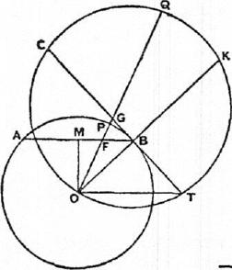
Through the points 0, T,C describe a circle, and let OB be produced to meet this circle in K.
Then, since BC>BT, and 013 is perpendicular to CT, it is possible to draw from 0 a straight line OGQ, meeting CT in G and the circle about OTC in Q, such that GQ=BK.
Let OGQ meet AB in F and the original circle in P.
Now CG • GT =OG • GQ;
o and OF :0G=BT :GT,
E SO that OF • GT =OG • BT.
It follows that
CG • GT :OF • GT =OG • GQ : OG • BT,
or CG :OF =GQ :B7'
= BK : BT, by construction,
=BC : OB
=BC :OP.
Hence OP : OF =BC :CG,
and therefore PF : OP= BG : BC,
or PF : BG =OP : BC
=OB : BC
=D :E.
PROPOSITION 9
Given a circle with centre 0, a chord AB less than. the diameter, the tangent at B,
and the perpendicular OM from 0 on AB, it is possible to draw from 0 a straight
line OPGF, meeting the circle in P, the tangent in G, and AB produced in F,
such that
FP : BG =D :E,
where D : E is any given ratio greater than BM : MO.
Let OT be drawn parallel to AB
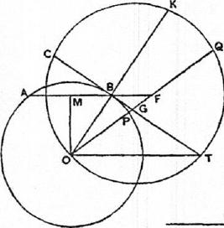
meeting the tangent at B in T.
Then
D E> BM : MO
> OB : BT, by similar triangles.
Produce TB to C so that
D :E=OB : BC,
whence BC<BT.
Describe a circle through the
points 0, T, C, and produce OB to
meet this circle in K.
Then, since TB>BC, and OB is
perpendicular to CT, it is possible to
draw from 0 a line OGQ, meeting
CT in G, and the circle about OTC in Q, such that GQ= BK. Let OQ meet the original circle in P and AB produced in F.

86 ARCHIMEDES
We now prove, exactly as in the last proposition, that
CG :OF = BK :BT
=BC :OP.
Thus, as before,
OP :OF =BC :CG,
and OP : PF = BC : BG,
whence PF : BG=OP : BC
=OB : BC
=D : E.
PROPOSITION 10
If A₁, A2, A3, • • •An be n lines forming an ascending arithmetical progression in which the common difference is equal to A₁, the least term, then
(n-1-1).A_{n}²-FA_{I}(A_{i}d-A2+ • • • +A„)=3(44₁²-1-A₂²-1- • • •-1-21„²). [Archimedes' proof of this proposition is given above, pp. 456-7, and it is there pointed out that the result is equivalent to
_{12+22+32+ ...+n2=} n(n-1-1)(2n+1)
6
Colt. 1. It follows from this proposition that
n•An²<3(Al²-1-A2²+ • • •+An²),
and also that
n•An²>3(Al²-FA2²+ • • -⁻FAn-1²).
[For the proof of the latter inequality see p. 457 above.]
COR. 2. All the results will equally hold if similar figures are substituted for
squares.
PROPOSITION 11
[in
If A1, A2, • • 'A_{n} be n lines forming an ascending arithmetical progression which the common difference is equal to the least term A_{l}], then
(n-1)A_{n}² :(A_{n}²-FA,i²+ • • •+A₂²)<A_{n}² : {A.-A14-1(An—A1)²); but
(n-1)A_{n}² :(24,1²+A.-2²+ • • •-i-Al²)>An² : {An •Ai-FEA.—A1)2}. [Archimedes sets out the terms side by side in the manner shown in the figure, where BC=A_{n}, DE= c . .RS= A₁, and produces DE, FG, ...RS until they are respectively equal to BC or A_{n}, so that EH,
T U
GI, . SU in the figure are respectively equal to A₁,
A2... An_1. He further measures lengths BK, DL,
FM, ...PV along BC, DE, FG, ...PQ respectively
each equal to RS.
The figure makes the relations between the terms
easier to see with the eye, but the use of so large a K- L- M
number of letters makes the proof somewhat difficult
to follow, and it may be more clearly represented as a o
follows.]
It is evident that (An— A1)=
The following proportion is therefore obviously true, viz.
(n-1)A„² : (n-1)(An•ArfiA.-1²)=An² : {An •A1-i-i(A.—A1)2}•

ON SPIRALS 87
In order therefore to prove the desired result, we have only to show that (n- 1).A. •Ai+I(n- 1)An-1²<(An²+An-1²+ • • •±A2²)
but > (A n-1²±An-2²+ • • •±Al²).
1. To prove the first inequality, we have
(n- 1)A,, •A_{l}+I(n-1)A_{n}_₄²
=(n-1)A_{l}²+(n- 1)A₁ •An-i+1(n-1)A....1². (1)
And
A.²4-A.-1²+ • • •-i⁻A = (An-i+A1)²+(An_2+Ai)²+ • • -+(.A1-1--A₁)²
=(A„..42+An_22+ • • •+/1.12)
+(n-1)Al²
+2Ai(An-i+A.-2+ • • •+A₁)
..---(A,,i2+An...22+ • • •+A_{l}2)
+(n- 1),41²
+AliA,i+An_2+An_a+ • • •+Ai
+Al+A2+ • • •+An-2+A„_.1i
=(An_1²+A.-2²+ • • •+Al²)
+(n-1)Al²
+n21₁ •An_1. (2)
Comparing the right-hand sides of (1) and (2), we see that (n- 1)A_{l}² is com-
mon to both sides, and
(n-1)A1•An_i<nAi•A,1,
while, by Prop. 10, Cur. 1,
i(n⁻1)A.-1²<A,-1²-1-A.-2²+ • • -MI².
It follows therefore that
(n-1)A_{n} .A1+•I(n-1)An-12<(An2.l..A_{n}_₁2+ • • •+A₂2);
and hence the first part of the proposition is proved.
H. We have now, in order to prove the second result, to show that
(n- 1)A. •Ai+i(n- 1)A n_1²> (A n-1²+A n_22+ • • •+Al2).
The right-hand side is equal to
(A,,2+A1)²+ (An_3+A1)2+ • • • + (A +Ai)²+A 1²
:----An_..22-1-An_a2+ • • •+Ai2
+(n-1)Al²
- 2A1(An-2+An-3+ • • • +Ai)
= (A n-22+An-32+ • • •+A_{l}2)
- (n- 1)Al²
+Alf A.-2+An-s+ • • •+A₁
1 +AI +A2 + • • •+A.....2f
=(An_22+An_32+ • • .+Al2)
+(n-1)Al²
+ (n - 2)A I •A_{n}-₁. (3)
Comparing this expression with the right-hand side of (1) above, we see that (n-1)Al² is common to both sides, and
(n- 1)A₁ (n - 2)A 1
while, by Prop. 10, Cor. 1,
1(n— 1 )A,,_12 > (A,2²+An-32+ • • •+Al²)•
Hence (n- 1 )A „ •A + (n - 1)A n_1²> (An_1²+A.-2²+ • • • +Ai²)
and the second required result follows.
Con. The results in the above proposition are equally true if similar figures be
substituted for squares on the several lines.

88 ARCHIMEDES
DEFINITIONS
- If a straight line drawn in a plane revolve at a uniform rate about one extremity which remains fixed and return to the position from which it started, and if, at the same time as the line revolves, a point move at a uniform rate along the straight line beginning from the extremity which remains fixed, the point will describe a spiral (04 in the plane.
- Let the extremity of the straight line which remains fixed while the straight line revolves be called the origin of the spiral.
- And let the position of the line from which the straight line began to revolve be called the initial line in the revolution.
- Let the length which the point that moves along the straight line describes in one revolution be called the first distance, that which the same point describes in the second revolution the second distance, and similarly let the distances described in further revolutions be called after the number of the particular revolution.
- Let the area bounded by the spiral described in the first revolution and the first distance be called the first area, that bounded by the spiral described in the second revolution and the second distance the second area, and similarly for the rest in order.
- If from the origin of the spiral any straight line be drawn, let that side of it which is in the same direction as that of the revolution be called forward (rpoa7oiweva), and that which is in the other direction backward (i7r6Aeva.).
- Let the circle drawn with the origin as centre and the first distance as radius be called the first circle, that drawn with the same centre and twice the radius the second circle, and similarly for the succeeding circles.
PROPOSITION 12
If any number of straight lines drawn from the origin to meet the spiral make equal
angles with one another, the lines will be in arithmetical progression.
[The proof is obvious.]
PROPOSITION 13
If a straight line touch the spiral, it will touch it in one point only.
Let 0 be the origin of the spiral, and BC a tangent to it.
If possible, let BC touch the spiral in two
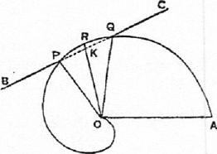
points P, Q. Join OP, OQ, and bisect the angle
POQ by the straight line OR meeting the
spiral in R.
Then [Prop. 12] OR is an arithmetic mean
between OP and OQ, or
OP-FOQ=20R.
But in any triangle POQ, if the bisector of the
angle POQ meets PQ in K,
OP-FOQ>20K.
Therefore OK <OR, and it follows that some point on BC between P and Q
lies within the spiral. Hence BC cuts the spiral; which is contrary to the
hypothesis.

ON SPIRALS
PROPOSITION 14
If 0 be the origin, and P, Q two points on the first turn of the spiral, and if OP, OQ produced meet the "first circle" AKP'Q' in P', Q' respectively, OA being the initial line, then
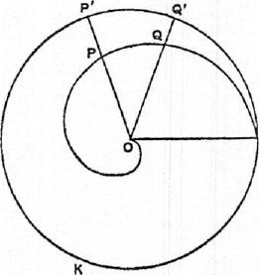 | A | OP :0Q= (arc AKP') : (arc AKQ').  For, while the revolving line OA moves about 0, the point A on it moves uniformly along the circumference of the circle AKP'Q' , and at the same time the point describing the spiral moves uniformly along OA.  Thus, while A describes the arc AKP', the moving point on OA describes the length OP, and, while A describes the arc A KQ', the moving point on OA describes the distance OQ.  Hence  OP : OQ= (arc AKP') : (arc AKQ'). [Prop. 2]

PROPOSITION 15
If P, Q be points on the second turn of the spiral, and OP, OQ meet the "first circle" AKP'Q' in P', Q', as in the last proposition, and if c be the circumference of the `first circle," then
OP : OQ =c+(arc AKP') : c+ (arc AKQ').
For, while the moving point on OA describes the distance OP, the point A describes the whole of the circumference of the "first circle" together with the arc AKP'; and, while the moving point on OA describes the distance OQ, the point A describes the:whole circumference of the "first circle" together with the arc AKQ'.
COR. Similarly, if P, Q are on the nth turn of the spiral,
OP : OQ = (n 1)c+ (arc AKP') : (n 1)c+ (arc AKQ').
PROPOSITIONS 16, 17
If BC be the tangent at P, any point on the spiral, PC being the "forward" part of BC, and if OP be joined, the angle OPC is obtuse while the angle OPB is acute.
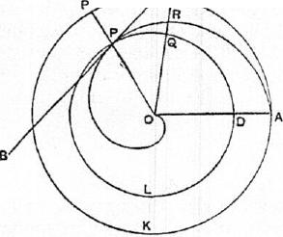c I. Suppose P to be on the first turn of
the spiral.
Let OA be the initial line, AKP' the "first circle." Draw the circle DLP with centre 0 and radius OP, meeting OA in D. This circle must then, in the "forward" direction from P, fall within the spiral, and in the "backward" direction outside it, since the radii vectores of the spiral are on the "forward side" greater, and on the "backward" side less, than OP. Hence the angle OPC cannot be acute, si:ace it cannot be less than the angle between OP and

90 ARCHIMEDES
the tangent to the circle at P, which is a right angle.
It only remains therefore to prove that OPC is not a right angle.
If possible, let it be a right angle. BC will then touch the circle at P.
Therefore [Prop. 5] it is possible to draw a line OQC meeting the circle
through P in Q and BC in C, such that
CQ : OQ < (arc PQ) : (arc DLP). (1)
Suppose that OC meets the spiral in R and the "first circle" in R' ; and produce OP to meet the "first circle" in P'.
From (1) it follows, componendo, that CO : OQ < (arc DLQ) : (arc DLP)
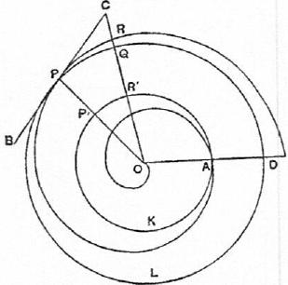
< (arc AKR') : (arc AKP')
<OR : OP. [Prop. 14] But this is impossible, because 0Q=OP, and OR <OC.
Hence the angle OPC is not a right angle. It was also proved not to be acute.
Therefore the angle OPC is obtuse, and the angle OPB consequently acute.
II. If P is on the second, or the nth turn, the proof is the same, except that in the proportion (1) above we have to substitute for the arc DLP an arc equal to (p+arc DLP) or (n-1 •p-1-arc DLP), where p is the perimeter of the circle DLP through P. Similarly, in the later steps, p or (n— 1)p will be added to each of the arcs DLQ and DLP, and c or (n —1)c to each of the arcs AKR', AKP', where c is the circumference of the "first circle" AKP'.
PROPOSITIONS 18, 19
I. If OA be the initial line, A the end of the first turn of ,the spiral, and if the tangent to the spiral at A be drawn, the straight line OB drawn from 0 perpendicular to OA will meet the said tangent in some point B, and OB will be equal to the circumference of the "first circle."
- If A' be the end of the second turn, the perpendicular OB will meet the tangent at A' in some point B', and OB' will be equal to 2 (circumference of "second circle").
- Generally, if An be the end of the nth turn, and OB meet the tangent at
An in Bn, then OBn= nen,
where c„ is the circumference of the "nth circle."
I. Let AKC be the "first circle." Then, since the "backward" angle between OA and the tangent at A is acute [Prop. 16], the tangent will meet the "first circle" in a second point C. And the angles CAO, BOA are together less than two right angles; therefore OB will meet AC produced in some point B.
Then, if c be the circumference of the first circle, we have to prove that
OB=c.
If not, OB must be either greater or less than c.
(1) If possible, suppose OB> c.
Measure along OB a length OD less than OB but greater than c.
We have then a circle AKC, a chord AC in it less than the diameter, and a
ratio AO : OD which is greater than the ratio AO : 013 or (what is, by similar

ON SPIRALS 91
triangles, equal to it) the ratio of iAC to the perpendicular from 0 on AC. Therefore [Prop. 7] we can draw a straight line OPF, meeting the circle in P and CA produced in F, such that
FP : PA = AO :OD.

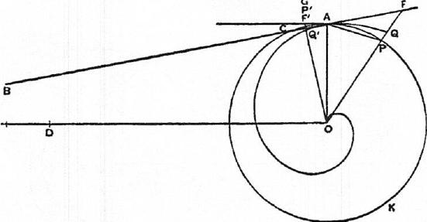
P'
Thus, alternately, since AO = P0,
FP : PO= PA : OD
< (arc PA) : c,
since (arc PA) > PA , and OD > c.
Componendo,
FO : PO <(c-1- arc PA) : c
<OQ :OA,
where OF meets the spiral in Q. [Prop. 15]
Therefore, since OA =OP, FO <OQ; which is impossible.
Hence OB>c.
(2) If possible, suppose OB <c.
Measure OE along OB so that OE is greater than OB but less than c.
In this case, since the ratio AO : OE is less than the ratio AO : OB (or the
ratio of 1AC to the perpendicular from 0 on AC), we can [Prop. 8] draw a line
OF'P'G, meeting AC in F', the circle in P', and the tangent at A to the circle
in G, such that
F'P' : AG =AO :OE.
Let OP'G cut the spiral in Q'.
Then we have, alternately,
F'P' : P'0= AG :OE
> (arc AP') : c,
because AG> (arc AP'), and OE <c.
Therefore
F'0 : P'0 < (arc AKP') : c
<OQ' :OA. [Prop. 14]
But this is impossible, since OA = OP', and OQ' <OF'.
Hence OB
Since therefore OB is neither greater nor less than c,
OB =c.
II. Let A' K'C' be the "second circle," A'C' being the tangent to the spiral

92 ARCHIMEDES
at A' (which will cut the second circle, since the "backward" angle OA'C' is acute). Thus, as before, the perpendicular OB' to OA' will meet A'C' produced in some point B'.
If then c' is the circumference of the "second circle," we have to prove that
OB' = 2c'.

E' | 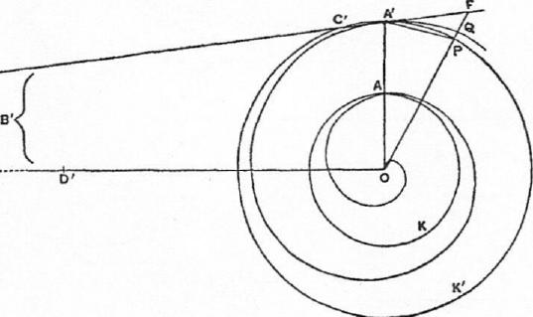

For, if not, OB' must be either greater or less than 2c'.
(1.) If possible, suppose OB' >2c`.
Measure OD' along OB' so that OD' is less than OB' but greater than 2c'.
Then, as in the case of the "first circle" above, we can draw a straight line
OPF meeting the "second circle" in P and C'A' produced in F, such that
FP : PA' = A'0 :OD'.
Let OF meet the spiral in Q.
We now have, since A'0 = PO,
PP : PO = PA' :OD'
< (arc A'P) : 2c',
because (arc A' P)> A'P and OD' > 2c'.
Therefore FO : PO < (2c' + arc A'P) : 2c'
<OQ : OA'. [Prop. 15, Cor.]
Hence FO <OQ; which is impossible.
Thus OB' > 2c'.
Similarly, as in the case of the "first circle," we can prove that
OB' -4: 2c'.
Therefore OB' = 2c'.
III. Proceeding, in like manner, to the "third" and succeeding circles, we
shall prove that
OB. = nc_{n}.
PROPOSITION 20
1. If P be any point on the first turn of the spiral and OT be drawn perpendicular to OP, OT will meet the tangent at P to the spiral in some point T; and, if the circle drawn with centre 0 and radius OP meet the initial line in K, then OT is equal to the arc of this circle between K and P measured in the "forward" direction of the spiral.

ON SPIRALS 93
II. Generally, if P be a point on the nth turn, and the notation be as before,
while p represents the circumference of the circle with radius OP,
OT = (n— 1)p+ arc KP (measured "forward").
- Let P be a point on the first turn of the spiral, OA the initial line, PR the tangent at P taken in the "backward" direction.
Then [Prop. 16] the angle OPR is acute. Therefore PR meets the circle through P in some point R; and also OT will meet PR produced in some point T.
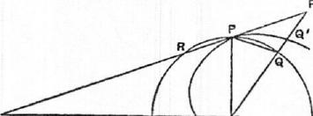
If now OT is not equal to the arc KRP, it must be either greater or less.
(1) If possible, let OT be greater than the arc KRP.
Measure 0 Ualong OT less than OT but greater than the arc KRP.
Then, since the ratio PO : OU
A is greater than the ratio PO : OT,
or (what is, by similar triangles, equal to it) the ratio of IPR to the perpendicular from 0 on PR, we can draw a line OQF, meeting the circle in Q and RP produced in F, such that
FQ : PQ=P0 :OU. [Prop. 7]
Let OF meet the spiral in Q'.
We have then
FQ :Q0=PQ :OU
< (arc PQ) : (arc KRP), by hypothesis.
Componendo,
FO : QO < (arc KRQ) : (arc KRP)
<OQ' : OP. [Prop. 14]
But QO =OP.
Therefore FO <OQ'; which is impossible.
Hence OT> (arc KRP).
(2) The proof that OT < (arc KRP) follows the method of Prop. 18, I. (2),
exactly as the above follows that of Prop. 18, I. (1).
Since then OT is neither greater nor less than the arc KRP, it is equal to it.
- If P be on the second turn, the same method shows that
OT =p+ (arc KRP);
and, similarly, we have, for a point P on the nth turn,
OT = (n —1)p+ (arc KRP).
PROPOSITIONS 21, 22, 23
Given an area bounded by any arc of a spiral and the lines joining the extremities of the arc to the origin, it is possible to circumscribe about the area one figure, and to inscribe in it another figure, each consisting of similar sectors of circles, and such that the circumscribed figure exceeds the inscribed by less than any assigned area.
For let BC be any arc of the spiral, 0 the origin. Draw the circle with centre

94 ARCHIMEDES
0 and radius OC, where C is the "forward" end of the arc.
Then, by bisecting the angle BOC, bisecting the resulting angles, and so on continually, we shall ultimately arrive at an angle COr cutting off a sector of the circle less than any assigned area. Let COr be this sector.
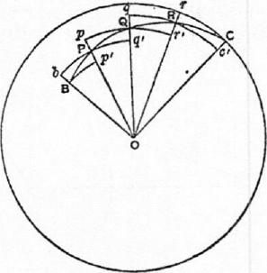
Let the other lines dividing the angle BOC into equal parts meet the spiral in P, Q, and let Or meet it in R. With 0 as centre and radii OB, OP, OQ, OR respectively describe arcs of circles Bp', bBq' , pQr', qRc' , each meeting the adjacent radii as shown in the figure. In each case the arc in the "forward" direction from each point will fall within, and the arc in the "backward" direction outside, the spiral.
We have now a circumscribed figure and an inscribed figure each consisting of similar sectors of circles. To compare their areas, we take the successive sectors of each, beginning from OC, and compare them.
The sector OCr in the circumscribed figure stands alone.
And (sector ORq) = (sector ()Re),
(sector 0Qp) = (sector 0Qr'),
(sector OPb) = (sector OPq'),
while the sector 0Bp' in the inscribed figure stands alone.
Hence, if the equal sectors be taken away, the difference between the circumscribed and inscribed figures is equal to the difference between the sectors OCr and 0Bp', and this difference is less than the sector OCr, which is itself less than any assigned area.
The proof is exactly the same whatever be the number of angles into which the angle BOC is divided, the only difference being that, when the arc begins from the origin, the smallest sectors OPb, OPq' in each figure are equal, and there is therefore no inscribed sector standing by itself, so that the difference between the circumscribed and inscribed figures is equal to the sector OCr itself.
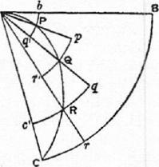
Thus the proposition is universally true.
COR. Since the area bounded by the spiral is intermediate in magnitude between the circumscribed and inscribed figures, it follows that
- a figure can be circumscribed to the area such that it exceeds the area by less than any assigned space,
- a figure can be inscribed such that the area exceeds it by less than any assigned space.
PROPOSITION 24
The area bounded by the first turn of the spiral and the initial line is equal to one-third of the "first circle" [=.1-7r(27ra)², where the spiral is r = a0].

ON SPIRALS 95
[The same proof shows equally that, if OP be any radius vector in the first turn of the spiral, the area of the portion of the spiral bounded thereby is equal to one-third of that sector of the circle drawn with radius OP which is bounded by the initial line and OP, measured in the "forward" direction from the initial line.]
Let 0 be the origin, OA the initial line, A the extremity of the first turn.
Draw the "first circle," i.e. the circle with 0 as centre and OA as radius.
Then, if C₁ be the area of the first circle, R₁ that of the first turn of the spiral bounded by OA, we have to prove that
Ri = le_{i}.
For, if not, R₁ must be either greater or less than C₁.
- If possible, suppose R_{I} <
We can then circumscribe a figure about R1 made up of similar sectors of
circles such that, if F be the area of this figure,
whence F
Let OP, 0Q, • • • be the radii of the circular sectors, beginning from the smallest. The radius of the largest is of course OA.
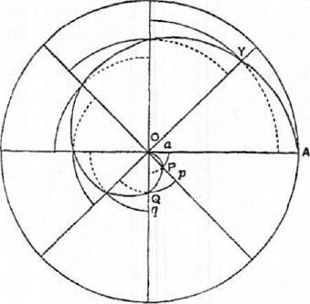
The radii then form an ascending arithmetical progression in which the common difference is equal to the least term OP. If n be the number of the sectors, we have [by Prop. 10, Cor. 1]
n • 0A²<3(0/³²+0Q²-1- • • • +OLP); and, since the similar sectors are proportional to the squares on their radii, it follows that
C1< 3F,
or F>
But this is impossible, since F was less than 1C1.
Therefore R1<-1-C1.
- If possible, suppose RI> WI.
We can then inscribe a figure made up of similar sectors of circles such that,
if f be its area,
whence f>
If there are (n-1) sectors, their radii, as OP, OQ, • • form an ascending
arithmetical progression in which the least term is equal to the common differ-
ence, and the greatest term, as OY, is equal to (n— 1)0P.
Thus [Prop. 10, Cor. 1]
n -0A²>3(0P²-1-0Q²-1- • • •-1-OY2),
whence C1 > 3f,
or f
which is impossible, since f
Therefore R1> -4C1.
Since then R_{I} is neither greater nor less than iC1,
RI =WI.

96 ARCHIMEDES
PRoPosirrioNs 25, 26, 27
[Prop. 25.] If A2 be the end of the second turn of the spiral, the area bounded by the second turn and OA 2 /8 to the area of the "second circle" in the ratio of 7 to 12, being the ratio of {r2rid-i(r2—r0²) to r2², where r₁, r2 are the radii of the "first" and "second" circles respectively.
[Prop. 26.] If BC be any arc measured in the "forward" direction on any turn of a spiral, not being greater than the complete turn, and if a circle be drawn with 0 as centre and OC as radius meeting OR in B', then
(area of spiral between OB, OC) : (sector OB'C)
= {0C • 0B+ROC —0B)²} : 0C².
[Prop. 27.] If R₁ be the area of the first turn of the spiral bounded by the initial line, R₂ the area of the ring added by the second complete turn, R₃ that of the ring added by the third turn, and so on, then
R₃=2R₂, R4=3R₂, R5= 4R2, • . Rn= (n-1)R₂.
Also R2 =
[Archimedes' proof of Prop. 25 is, mutatis mutandis, the same as his proof of the more general Prop. 26. The latter will accordingly be given here, and applied to Prop. 25 as a particular case.]
Let BC be an arc measured in the "forward" direction on any turn of the spiral, CKB' the circle drawn with 0 as centre and OC as radius.
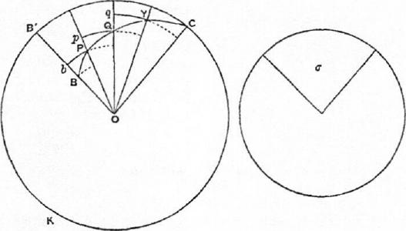
Take a circle such that the square of its radius is equal to
OC • 0B+1(0C-0B)²,
and let a he a sector in it whose central angle is equal to the angle BOC.
Thus a : (sector OB'C) = OC • OB +1(OC —0B)²1 : 0C²,
and we have therefore to prove that
(area of spiral OBC) = a.
For, if not, the area of the spiral ORC (which we will call S) must be either
greater or less than a.
I. Suppose, if possible, S <a.
Circumscribe to the area S a figure made up of similar sectors of circles, such
that, if F be the area of the figure,
F 8<a —S,
whence F <a.

ON SPIRALS 97
Let the radii of the successive sectors, starting from 08, be OP, OQ, • • .0C. Produce OP, OQ, • • • to meet the circle CKB', • • •
If then the lines OB, OP, OQ,. . .0C be n in number, the number of sectors in the circumscribed figure will be (n-1), and the sector OB'C will also be
divided into (n-1) equal sectors. Also OB, OP, OQ, • • •OC form an ascend-
ing arithmetical progression of n terms.
Therefore [see Prop. 11 and Cor.]
(n-1)0C2 (0p2+0(22+ • • .+0C2₎ <0C2 IOC • 0B+1(0C —0B)²1
< (sector OB'C) : a, by hypothesis.
Hence, since similar sectors are as the squares of their radii,
(sector OB'C) : F < (sector OB'C) : cr,
so that F> a.
But this is impossible, because
Therefore 8<a.
II. Suppose, if possible, S> 0-.
Inscribe in the area S a figure made up of similar sectors of circles such that,
if f be its area,
S—f<S—o⁻,
whence f> o-.
Suppose OR, OP,. . .0Y to be the radii of the successive sectors making up
the figure f, being (n-1) in number.
We shall have in this case [see Prop. 11 and Cor.]
(n 1)0C² : (0B²+0P²+ • • • + Or) > 0C² : 10C • 0B-4-1(0C —0B)²1,
whence (sector OB'C) : f> (sector OB'C) : a,
so that f <a•
But this is impossible, because f> a.
Therefore S> a.
Since then S is neither greater nor less than Cr, it follows that
S=cr.
In the particular case where B coincides with A1, the end of the first turn of
the spiral, and C with A 2, the end of the second turn, the sector 013'C becomes
the complete "second circle," that, namely, with 0A₂ (or r2) as radius.
Thus (area of spiral bounded by 0A2) : ("second circle")
= {r2ri-Fi(r2—r0²} : r₂²
= (2+1) : 4 (since r2= 21%)
=7 : 12.
Again, the area of the spiral bounded by 0A2 is equal to Ri+ R2 (i.e. the area
bounded by the first turn and OA', together with the ring added by the second
turn). Also the "second circle" is four times the "first circle," and therefore
equal to 12 R₁.
Hence (R1+R2) : 12R₁= 7 : 12,
or Ri+R₂=7Ri.
Thus R2 = 681. (1)
Next, for the third turn, we have
(R_{I}+ R2+ R3) : ("third circle") = {r₃ r2+/(r3—r2)²1 : r₃²
= (3 • 2+1) : 3²
=19 : 27,
and ("third circle") =9("first circle")
=27R1;

98 ARCHIMEDES
therefore Ri+R2+R3=19R1,
and, by (1) above, it follows that
R3= 12Ri
= 282, (2)
and so on.
Generally, we have
(R1+R₂+ • • • +Rh) : (nth circle) = try, —rn_i)21 rn2,
(RIA⁻R2+ • • • +Rn-1) : (n— lth circle) = frn_1 rn_2+Ern_i—r.-2r1 :
and (nth circle) : (n— lth circle) =r₇,² :
Therefore
(R1+R2+ • • •-FR.) : (Ri-ER2+ • • • -1-R.-1) = tn(n-1)+11 : f (n-1)(n-2)+-11
= f3n(n-1)+11 : 13(n-1)(n-2)+11.
Dirimendo,
Rn : (RI +R2+ • • • -FIL..1) =6(n — 1) : 13(n — 1)(n —2) +11. (a)
Similarly
: (Ri+R2+ • • --ER.--2) =6(n-2) : 13(n-2)(n-3)+11,
from which we derive
: (Ri+R2+ • • •+Rn-i)
=6(n-2) : f 6(n-2)+3(n-2)(n-3)+11
=6(n — 2) : f 3(n — 1)(n — 2) + 11. (13).
Combining (a) and ((3), we obtain
R_{n} : (n-1) : (n-2).
Thus
R2, R3, R4, • • are in the ratio of the successive numbers 1, 2, 3 • • • (n-1).
PROPOSITION 28
If 0 be the origin and BC any arc measured in the "forward" direction on any turn of the spiral, let two circles be drawn (1) with centre 0, and radius OB, meeting OC in C', and (2) with centre 0 and radius OC, meeting OB produced in B'. Then, if E denote the area bounded by the larger circular arc B'C, the line B'B, and the spiral BC, while F denotes the area bounded by the smaller arc BC', the line CC' and the spiral BC,
E : F= {0B-11(0C —0B)} : { 0/3±1-(0C —0B)}.
Let o denote the area of the lesser sector OBC' ;
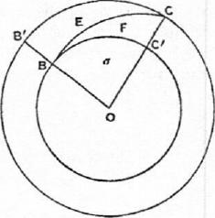
then the larger sector OB'C is equal to cr +F +E.
Thus [Prop. 26]
(o+F) : (a+F+E)=
{OC • 0B+1(0C-0B)²} : 0C², (1)
whence
E : (0-4-F) = {0C(OC — OB) —1(0C — OB)²}
: {0C • 0B+ROC—OB)²1
= {0B(OC OB) +ROC —0B)²}
: {OC • OB +(OC —0B)²}. (2)
Again
F F E) : o-=0C² : OB².
Therefore, by the first proportion above, ex aequali,
(o- F) : o= {OC • 0B+-¹,-(0C-0B)²1 : OB2,

ON SPIRALS 99
whence
(a + F) : F= lOC • 0B+EOC —0B)²}
: f OB(OC — OB)± i (0C— OB)²1 .
Combining this with (2) above, we obtain
E : F= 10B(OC —0B)+ -3(0C —0B)²1 : {0B(OC —0B)+¹₃.(0C —0B)²1
= 10B-1-1(0C —0B)1 : tOB +1(0C —0B)).

ON THE EQUILIBRIUM OF PLANES OR
THE CENTRES OF GRAVITY OF PLANES
BOOK ONE
"1 POSTULATE the following":
- "Equal weights at equal distances are in equilibrium, and equal weights at unequal distances are not in equilibrium but incline towards the weight which is at the greater distance."
- "If, when weights at certain distances are in equilibrium, something be added to one of the weights, they are not in equilibrium but incline towards that weight to which the addition was made."
- "Similarly, if anything be taken away from one of the weights, they are not in equilibrium but incline towards the weight from which nothing was taken."
- "When equal and similar plane figures coincide if applied to one another, their centres of gravity similarly coincide."
- "In figures which are unequal but similar, the centres of gravity will be similarly situated. By points similarly situated in relation to similar figures I mean points such that, if straight lines be drawn from them to the equal angles, they make equal angles with the corresponding sides."
- "If magnitudes at certain distances be in equilibrium, (other) magnitudes equal to them will also be in equilibrium at the same distances."
- "In any figure whose perimeter is concave in (one and) the same direction the centre of gravity must be within the figure."
PROPOSITION 1
Weights which balance at equal distances are equal.
For, if they are unequal, take away from the greater the difference between the two. The remainders will then not balance [Post. 3] ; which is absurd. Therefore the weights cannot be unequal.
PROPOSITION 2
Unequal weights at equal distances will not balance but will incline towards the greater weight.
For take away from the greater the difference between the two. The equal remainders will therefore balance [Post. 1]. Hence, if we add the difference again, the weights will not balance but incline towards the greater [Post. 2].
PROPOSITION 3
Unequal weights will balance at unequal distances, the greater weight being at the
lesser distance.
Let A, B be two unequal weights (of which A is the greater) balancing about
C at distances AC, BC respectively.
100

ON THE EQUILIBRI•UM OF PLANES I 101
Then shall AC be less than BC. For, if not, take away from A the weight (A — B). The remainders will then incline towards B [Post. 3]. But this is impossible, for (1) if A C. CB, the equal remainders will balance, or (2) if AC>CB,
they will' incline towards A at the
greater distance [Post. 1].
Hence AC <CB.
Conversely, if the weights balance, and AC <CB, then A> B.
PROPOSITION 4
If two equal weights have not the same centre of gravity, the centre of gravity of both
taken together is at the middle point of the line joining their centres of gravity.
[Proved froln Prop. 3 by reductio ad absurdum.]
PROPOSITION 5
If three equal magnitudes have their centres of gravity on a straight line at equal distances, the centre of gravity of the system will coincide with that of the middle magnitude.
[This follows 'immediately from Prop. 4.]
COR. 1. Thesarne is true of arty odd number of magnitudes if those which are at equal. distances from the middle one are equal, while the distances between their centres of gravity are equal.
COR. 2. If there be an even number of magnitudes with their centres of gravity situated at equal distances on one straight line, and if the two middle ones be equal, while those which are equidistant from them (on each side) are equal respectively, the centre of gravity of the system is the middle point of the line joining the centres of gravity of the two middle ones.
PROPOSITIONS 6, 7
Two magnitudes, whether commensurable [Prop. 6] or incommensurable [Prop. 7], balance at distances reciprocally proportional to the magnitudes.
I. Suppose the magnitudes A, B to be commensurable, and the points A, B to be their centres of gravity. Let DE be a straight line so divided at C that A : B =DC :CE.
We have then to prove that, if A be placed at E and B at D, C is the centre of gravity of the two taken
_{o} together.
Since A.,13 are commensurable, so are DC, CE. Let N be a common measure of DC, CE. Make DH, DK

N
is bisected at E, as HK is bisected at D.
Thus LH, HK must each contain N an even number of times.

A |  | a

c

H
i I D
K each equal to CE, and EL (on CE
produced) equal to CD. Then EH = CD, since DII =CE. Therefore LH

102 ARCHIMEDES
Take a magnitude 0 such that 0 is contained as many times in A as N is
contained in LH, whence
.1 : 0 = LH : N.
But B : A =CE : DC
=HK :LH.
Hence, ex aequali, B : 0 =11K : N, or 0 is contained in B as many times as N is contained in HK.
Thus 0 is a common measure of A, B.
Divide LH, HK into parts each equal to N, and A, B into parts each equal to 0. The parts of A will therefore be equal in number to those of LH, and the parts of B equal in number to those of HK. Place one of the parts of A at the middle point of each of the parts N of LH, and one of the parts of B at the middle point of each of the parts N of HK.
Then the centre of gravity of the parts of A placed at equal distances on LH will be at E, the raiddle.point of LH [Prop. 5, Cor. 2], and the centre of gravity of the parts of B placed at equal distances along HK will be at D, the middle point of 11K.
Thus we may suppose A itself applied at E, and B itself applied at D.
But the system formed by the parts 0 of A and B together is a system of equal magnitudes even in number and placed at equal distances along LK. And, since LE = CD, and EC = DK, LC = CK, so that C is the middle point of LK. Therefore C is the centre of gravity of the system ranged along LK.
Therefore A acting at E and B acting at D balance about the point C.
II. Suppose the magnitudes to be incommensurable, and let them be (A +a) and B respectively. Let DE be a line divided at C so that
(A+a) : B=DC :CE.
Then, if (A +a) placed at E and
B placed at D do not balance
about C, (A + a) is either too great to balance B, or not great enough.
a A
Suppose, if possible, that (A +a) is too great. to balance B. Take from (A +a) a magnitude a smaller than the deduction which would make the remainder balance B, but such that the remainder A and the magnitude B are commensurable.
B
Then, since A, B are commensurable, and
A : B <DC :CE,
A and B will not balance [Prop. 6], but D will be depressed.
But this is impossible, since the deduction a was an insufficient deduction from (A +a) to produce equilibrium, so that E was still depressed.
Therefore (A +a) is not too great to balance B; and similarly it may be proved that B is not too great to balance (A+a).
Hence (A +a), B taken together have their centre of gravity at C.
PROPOSITION 8
If AB be a magnitude whose centre of gravity is C, and AD a part of it whose centre of gravity is F, then the centre of gravity of the remaining part will be a point G on FC produced such that

ON THE EQUILIBRIUM OF PLANES I 103
GC :CF= (AD) : (DE).
For, if the centre of gravity of the re-
mainder (DE) be not G, let it be a point
H. Then an absurdity follows at once
from Props. 6, 7.
PROPOSITION 9
The centre of gravity of any parallelogram lies on the straight line joining the middle points of opposite sides.
Let ABCD be a parallelogram, and let EF join the middle points of the opposite sides AD, BC.
If the centre of gravity does not lie on EF, suppose it to be H, and draw HK parallel to AD or BC meeting EF in K.
Then it is possible, by bisecting ED, then bisecting the halves, and so on continually,
:////: to arrive at a length EL less than KH. Divide
both AE and ED into parts each equal to
EL, and through the points of division draw parallels to AB or CD.
We have then a number of equal and simi-
lar parallelograms, and, if any one be applied to any other, their centres of gravity coincide [Post. 4]. Thus we have an even number of equal magnitudes whose centres of gravity lie at equal distances along a straight line. Hence the centre of gravity of the whole parallelogram will lie on the line joining the centres of gravity of the two middle parallelograms [Prop. 5, Cor. 2].
But this is impossible, for H is outside the middle parallelograms. Therefore the centre of gravity cannot but lie on EF.
PROPOSITION 10
The centre of gravity of a parallelogram is the point of intersection of its diagonals. For, by the last proposition, the centre of gravity lies on each of the lines which bisect opposite sides. Therefore it is at the point of their intersection; and this is also the point of intersection of the diagonals.
Alternative proof.
Let ABCD be the given parallelogram, and BD a diagonal. Then the triangles ABD, CDB are equal and similar, so that [Post. 4], if one be applied to the other, their centres of gravity will fall one upon the other.
Suppose F to be the centre of gravity of the triangle ABD. Let G be the middle point of BD. Join FG and produce it to H, so that PG = GH.
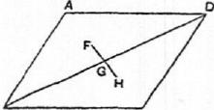
If we then apply the triangle ABD to the triangle CDB so that AD falls on CB and AB on CD, the point F will fall on H.
But [by Post. 4] F will fall on the centre of grav-
ity of CDB. Therefore H is the centre of gravity of CDB.
Hence, since F, H are the centres of gravity of the two equal triangles, the centre of gravity of the whole parallelogram is at the middle point of FH, i.e. at the middle point of BD, which is the intersection of the two diagonals.

104 ARCHIMEDES
PROPOSITION II
If abc, ABC be two similar triangles, and g, G two points in them similarly situated with respect to them respectively, then, if g be the centre of gravity of the triangle abc, G must be the centre of gravity of the triangle ABC.
Suppose
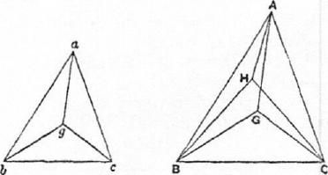
ab :bc :ca=AB :BC :CA.
The proposition is proved by an obvious reductio ad absurdum. For, if G be not the centre of gravity of the triangle ABC, suppose H to be its centre of gravity.
Post. 5 requires that g, H shall be similarly situated with respect to the triangles respectively; and this leads at once to the absurdity that the angles HAB, GAB are equal.
PROPOSITION 12
Given two similar triangles abc, ABC, and d, D the middle points of be, BC
respectively, then, if the centre of gravity of abc lie on ad, that of ABC will lie
on AD.
Let g be the point on ad which
is the centre of gravity of abc.
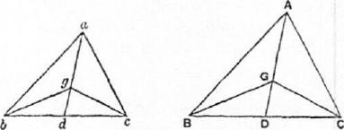
Take G on AD such that
ad : ag =AD : AG,
and join gb, gc, GB, GC.
Then, since the triangles are
similar, and bd, BD are the
halves of bc, BC respectively,
ab:bd=AB :BD,
and the angles abd, ABD are equal.
Therefore the triangles abd, ABD are similar, and
Lbad= L BAD.
Also ba : ad=BA :AD,
while, from above, ad : ag =AD : AG.
Therefore ba : ag = BA : AG, while the angles bag, BAG are equal.
Hence the triangles bag, BAG are similar, and
abg = L ABG.
And, since the angles abd, ABD are equal, it follows that
Lgbd= LGBD.
In exactly the same manner we prove that
L gac = LGAC,
Lacg= LACG,
.Cgcd= ZGCD.
Therefore g, G are similarly situated with respect to the triangles respec-
tively; whence [Prop. 11] C, is the centre of gravity of ABC.

ON THE EQUILIBRIUM OF PLANES I 105
PROPOSITION 13
In any triangle the centre of gravity lies on the straight line joining any angle to the middle point of the opposite side.
Let ABC be a triangle and D the middle point of BC. Join AD. Then shall the centre of gravity lie on AD.
For, if possible, let this not be the case, and let H be the centre of gravity. Draw HI parallel to CB meeting AD in I.
Then, if we bisect DC, then bisect the halves, and so on, we shall at. length arrive at a length, as DE, less than HI. Divide both BD and DC into lengths each equal to DE, and through the points of division draw lines each parallel to DA meeting BA and AC in points as K, L, M and N, P, Q respectively.
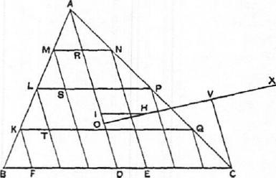
Join MN, LP, KQ, which lines will then be each parallel to BC.
We have now a series of parallelograms as FQ, TP, SN, and AD bisects opposite sides in each. Thus the centre of gravity of each parallelogram lies on AD [Prop. 9], and therefore the centre of gravity of the figure made up of them all lies on AD.
Let the centre of gravity of all the parallelograms taken together be 0. Join OH and produce it; also draw CV parallel to DA meeting OH produced in V. Now, if n be the number of parts into which AC is divided,
AADC : (sum of triangles on AN, NP, • • •)= AC² : (AN²+NP²+ • • .)
n²=: n
n:1
=AC : AN.
Similarly
/ABD : (sum of triangles on AM, ML, • • •) =AB :AM.
And AC : AN=AB :AM.
It follows that
PABC : (sum of all the small Ps) = CA : AN
> VO : OH, by parallels.
Suppose OV produced to X so that
PA BC : (sum of small Ps) = XO : OH,
whence, dividendo,
(sum of parallelograms) : (sum of small Ps) = XH : HO.
Since then the centre of gravity of the triangle ABC is at H, and the centre of
gravity of the part of it made up of the parallelograms is at 0, it follows from
Prop. 8 that the centre of gravity of the remaining portion consisting of all the
small triangles taken together is at X.
But this is impossible, since all the triangles are on one side of the line
through X parallel to AD.
Therefore the centre of gravity of the triangle cannot but lie on AD.

106 ARCHIMEDES
Alternative proof.
Suppose, if possible, that H, not lying on AD, is the centre of gravity of the triangle ABC. Join All, BH, CH. Let E, F be the middle points of CA, AB respectively, and join DE, EF, FD. Let EF meet AD in M.
Draw FK, EL parallel to AH meeting BH, CH in K, L respectively. Join KD, HD, LD, KL. Let KL meet DH in N, and join MN.
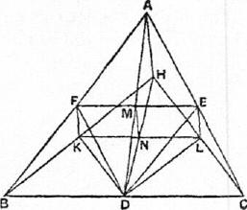
Since DE is parallel to AB, the triangles ABC, EDC are similar.
And, since CE=EA, and EL is parallel to AH, it follows that CL = LH. And CD = DB. Therefore NI is parallel to DL.
Thus in the similar and similarly situated triangles ABC, EDC the straight lines AH, BH are respectively parallel to EL, DL; and it follows that H, L are similarly situated with respect to the triangles respectively.
But II is, by hypothesis, the centre of gravity of ABC. Therefore L is the
centre of gravity of EDC. [Prop. 11]
Similarly the point K is the centre of gravity of the triangle FBD.
And the triangles FBD, EDC are equal, so that the centre of gravity of both together is at the middle point of KL, i.e. at the point N.
The remainder of the triangle ABC, after the triangles FBD, EDC are deducted, is the parallelogram AFDE, and the centre of gravity of this parallelogram is at M, the intersection of its diagonals.
It follows that the centre of gravity of the whole triangle ABC must lie on MN; that is, MN must pass through H, which is impossible (since MN is parallel to AH).
Therefore the centre of gravity of the triangle ABC cannot but lie on AD.
PROPOSITION 14
It follows at once from the last proposition that the centre of gravity of any triangle is at the intersection of the lines drawn from any two angles to the middle points of the opposite sides respectively.
PROPOSITION 15
If AD, BC be the two parallel sides of a trapezium ABCD, AD being the smaller,
and if AD, BC be bisected at E, F respectively, then the centre of gravity of the
trapezium is at a point G on EF such that
GE :GF (2BC-FAD) : (2AD-1-BC).
Produce BA, CD to meet at 0. Then FE produced Will also pass through 0,
since AE =ED, and BF
Now the centre of gravity of the triangle OAD will lie on OE, and that of the
triangle OBC will lie on OF. [Prop. 13]
It follows that the centre of gravity of the remainder, the trapezium ABCD,
will also lie on OF. [Prop. 8]
Join BD, and divide it at L, M into three equal parts. Through L, M draw PQ, RS parallel to BC, meeting BA in P, R, FE in W, V, and CD in Q,.,S respectively,

ON THE EQUILIBRIUM OF PLANES I 107
Hence [Props. 6, 73
PDBC : QABD= KG :GH
=VG :GIV.
But /DBC : PABD=BC : AD.
Therefore BC : A D = VG :GU'.
It follows that
(2BC- AD) : (2AD+ BC) = (2VG+GTV) : (2G1V+VG)
=EG : GF. Q.E.D.

Join DF, BE meeting PQ in H and RS in K respectively.
Now, since BL =1BD,
FH.iFD.
Therefore H is the centre of gravity of the triangle DBC.
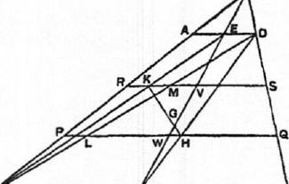
Similarly, since EK=1BE, it follows that K is the centre of gravity of the triangle ADB.
Therefore the centre of gravity of the triangles DBC, ADB together, i.e. of the trapezium, lies on the line HK.
But it also lies on OF.
Therefore, if OF, HK meet in G, G
9 r c is the centre of gravity of the trape-
zium.

ON THE EQUILIBRIUM OF PLANES
BOOK TWO
PROPOSITION 1
If P, P' be two parabolic segments and D, E their centres of gravity respectively, the centre of gravity of the two segments taken together will be at a point C on DE determined by the relation
P :P'=CE :CD.
In the same straight line with DE measure Ell, EL each equal to DC, 4nd DK equal to DH; whence it follows at once that DK=CE, and also that
KC =CL.
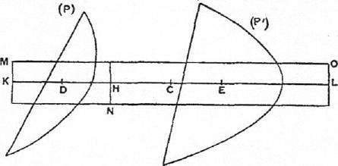
Apply a rectangle MN equal in area to the parabolic segment P to a base equal to KH, and place the rectangle so that KH bisects it, and is parallel to its base.
Then D is the centre of gravity of MN, since KD = DH.
Produce the sides of the rectangle which are parallel to KH, and complete the rectangle NO whose base is equal to HL. Then E is the centre of gravity of the rectangle NO.
Now (MN) : (N0)=.1(1.1 : HL
=DH :EH
=CE :CT)
=P : P'.
But (MN) = P.
Therefore (NO)=P'.
Also, since C is the middle point of KL, C is the centre of gravity of the whole parallelogram made up of the two parallelograms (MN), (NO), which are equal to, and have the same centres of gravity as, P, P' respectively.
Hence C is the centre of gravity of P, P' taken together.
108

ON THE EQUILIBRIUM OF PLANES II 109
DEFINITION AND LEMMAS PRELIMINARY TO PROPOSITION 2
"If in a segment bounded by a straight line and a section of a right-angled cone [a parabola] a triangle be inscribed having the same base as the segment and equal height, if again triangles be inscribed in the remaining segments having the same bases as the segments and equal height, and if in the remaining segments triangles be inscribed in the same manner, let the resulting figure be said to be inscribed in the recognised manner in the segment.
"And it is plain"
- "that the lines joining the two angles of the figure so inscribed which are nearest to the vertex of the segment, and the next pairs of angles in order, will be parallel to the base of the segment,"
- "that the said lines will be bisected by the diameter of the segment, and"
- "that they will cut the diameter in the proportions of the successive odd numbers, the number one having reference to [the length adjacent to] the vertex of the segment.
"And these properties will have to be proved in their proper places."
PROPOSITION 2
If a figure be "inscribed in the recognised manner" in a parabolic segment, the centre of gravity of the figure so inscribed will lie on the diameter of the segment.
For, in the figirre of the foregoing lemmas, the centre of gravity of the trapezium BRrb must lie on XO, that of the trapezium RQqr on WX, and so on, while the centre of gravity of the triangle PAp lies on AV.
Hence the centre of gravity of the whole figure lies on AO.
PROPOSITION 3
If BAB', bab' be two similar parabolic segments whose diameters are AO, ao
respectively, and if a figure be inscribed in each segment "in the recognised man-
ner," the number of sides in each figure being equal, the centres of gravity of the
inscribed figures will divide AO, ao in the same ratio.¹
Suppose BRQPAP'Q'R'B', brqpap'q'r'b' to be the two figures inscribed "in
the recognised manner." Join PP', QQ', RR' meeting AO in L, M, N, and pp',
qq', rr' meeting ao in 1, m, n.
Then [Lemma (3)]
AL :LM :MN :NO=1 : 3 : 5 : 7
=al : lm : mn : no,
so that AO, ao are divided in the same proportion.
Also, by reversing the proof of Lemma (3), we see that
PP' : pp' =QQ' : qq' =RR' : rr' = BB' : bb'.
Since then RR' : BB' = rr' : bb', and these ratios respectively determine the
proportion in which NO, no are divided by the centres of gravity of the tra-
pezia B RR' B' , brr'b' [r. 15], it follows that the centres of gravity of the trapezia
divide NO, no in the same ratio.
Similarly the centres of gravity of the trapezia RQQ' R' , rqq'r' divide MN,
inn in the same ratio respectively, and so on.
lArehimedes enunciates this proposition as true of similar segments, but it is equally true of segments which are not similar, as the course of the proof will show.

HO ARCHIMEDES
Lastly, the centres of gravity of the triangles PAP', pap' divide AL, al respectively in the same ratio.
a
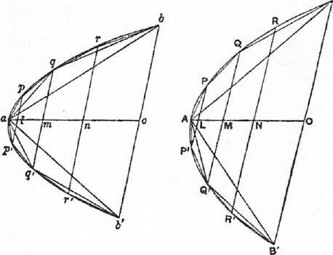
Moreover the corresponding trapezia and triangles are, each to each, in the same proportion (since their sides and heights are respectively proportional), while AO, ao are divided in the same proportion.
Therefore the centres of gravity of the complete inscribed figures divide AO, ao in the same proportion.
PROPOSITION 4
The centre of gravity of any parabolic segment cut off by a straight line lies on the diameter of the segment.
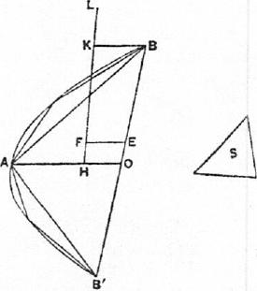
Let BAB' be a parabolic segment, A its vertex and AO its diameter.
Then, if the centre of gravity of the segment does not lie on AO, suppose it to be, if possible, the point F. Draw FE parallel to AO meeting BB' in E.
Inscribe in the segment the triangle ABB' having the same vertex and height as the segment, and take an area S such that
4!1,ABB' : 8=BE :BO.
We can then inscribe in the segment "in the recognised manner" a figure such that the segments of the parabola left over are together less than S.'
¹For Prop. 20 of the Quadrature of the Parabola proves that, if in any segment the triangle with the same base and height be inscribed, the triangle is greater than half the segment; whence it appears that, each time that we increase the number of the sides of the figure inscribed "in the recognised manner," we take away more than half of the remaining segments.

ON THE EQUILIBRIUM Olf PLANES ¹¹ 111
Let the inscribed figure be drawn accordingly; its centre of gravity then lies
on AO [Prop. 2]. Let it be the point H.
Join HF and produce it to meet in K the line through B parallel to AO.
Then we have
(inscribed figure) : (remainder of segmt.)> L1 ABB' : S
>BE :EO
>KF : FH.
Suppose L taken on HK produced so that the former ratio is equal to the ratio
LF :PH.
Then, since H is the centre of gravity of the inscribed figure, and F that of
the segment, L must be the centre of gravity of all the segments taken together
which form the remainder of the original segment. [I. 8]
But this is impossible, since all these segments lie on one side of the line drawn through L parallel to AO (Cf. Post. 7].
Hence the centre of gravity of the segment cannot but lie on AO.
PROPOSITION 5
If in a parabolic segment a figure be inscribed "in the recognised manner," the centre of gravity of the segment is nearer to the vertex of the segment than the centre of gravity of the inscribed figure is.
Let BAB' be the given segment, and AO its diameter. First, let ABB' be the triangle inscribed "in the recognised manner."
Divide AO in F so that AF = 2F0; F is then the centre of gravity of the triangle ABB'.
Bisect AB, AB' in D, D' respectively, and join DD' meeting AO in E. Draw DQ, D'Q' parallel to OA to meet the curve. QD, Q'D' will then be the diameters of the segments whose bases are AB, AB', and the centres of gravity of those segments will lie respectively on QD, Q'D' [Prop. 4]. Let them be H, H', and join HIP meeting AO in K.
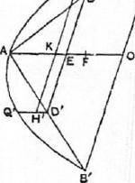
Now QD, Q'D' are equal,' and therefore the segments of which they are the diameters are equal [On Conoids and Spheroids, Prop. 3].
Also, since QD, Q'D' are parallel, and DE = ED', K is the middle point of
Hence the centre of gravity of the equal segments AQB, AQ'B' taken together is K, where K lies between E and A. And the centre of gravity of the triangle ABB' is F.
It follows that the centre of gravity of the whole segment BAB' lies between K and F, and is therefore nearer to the vertex A than F is.
Secondly, take the fire-sided figure BQAQ'B' inscribed "in the recognised manner," QD, Q'D' being, as before, the diameters of the segments AQB, AQ'B'.
Then, by the first part of this proposition, the centre of gravity of the segment AQB (lying of course on QD) is nearer to Q than the centre of gravity of
'This may either be inferred from Lemma (1) above (since QQ', DD' are both parallel to BB'), or from Prop. I of the Quadrat re of the Parabola, which applies equally to Q or V.

112 ARCHIM EDES
the triangle AQB is. Let the centre of gravity of the segment be //, and that of
the triangle I.
Similarly let II' be the centre of gravity of the segment AQ'B', and I' that of the triangle AQ'B'.
It follows that the centre of gravity of the two segments AQB, AQ'B' taken together is K, the middle point of 1111', and that of the two triangles AQB, AQ'B' is L, the middle point of II'.
If now the centre of gravity of the triangle ABB' be F, the centre of gravity of the whole segment BAB' (i.e. that of the triangle ABB' and the two segments AQB, AQ'B' taken together) is a point G on 1‘1,' determined by the proportion
(sum of segments AQB, AQ'B') : PABB' = FG : GK.
[I. 6, 7]
And the centre of gravity of the inscribed figure
BQAQ' B' is a point F' on LF determined by the proportion
(AAQB- AAQ'B') : AA BB' =FP : F'L.
[Hence FG : GK> FF' :
or GK :FG <F'L :FF',
and, componendo, FK : FG <FL : FF', while FK> FL.] Therefore FG> FF', or G lies nearer than F' to the vertex A .
Using this last result, and proceeding in the same way, we can prove the proposition for any figure inscribed "in the recognised manner."
PROPOSITION 6
Given a segment of a parabola cut off by a straight line, it is possible to inscribe in it "in the recognised manner" a figure such that the distance between the centres of gravity of the segment and of the inscribed figure is less than any assigned length.
Let BAB' be the segment, AO its diameter, G its centre of gravity, and ABB' the triangle inscribed "in the recognised manner."
Let D be the assigned length and S an area such that
AG : D= AABB' :S.
In the segment inscribe "in the recognised manner" a figure such that the sum of the segments left over is less than S. Let F be the centre of gravity of the inscribed figure.
We shall prove that PG <D.
For, if not, FG must be either equal to, or greater than, D.
And clearly
(inscribed fig.) : (sum of remaining segmts.)
>PABB' : S
>AG : D
> AG : FG, by hypothesis (since FG <D).
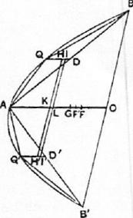
[I. 6, 7]
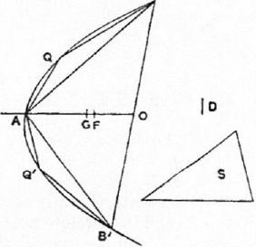

ON THE EQUILIBRIUM OF PLANES II 113
Let the first ratio be equal to the ratio KG : FG (where K lies on GA produced); and it follows that K is the centre of gravity of the small segments
taken together. [I. 8]
But this is impossible, since the segments are all on the same side of a line drawn through K parallel to BB'.
Hence FG cannot but be less than D.
PROPOSITION 7
If there be two similar parabolic segments, their centres of gravity divide their diameters in. the same ratio.
Let BAB', bab' be the two similar segments, AO, ao their diameters, and G, g their centres of gravity respectively.
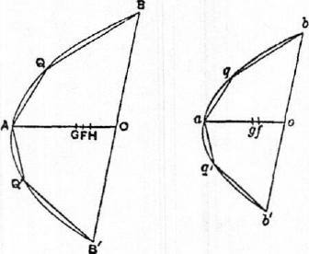
Then, if G, g do not divide AO, ao respectively in the same ratio, suppose H to be such a point on AO that AH : HO=ag :go;
and inscribe in the segment BA B' "in the recognised manner" a figure such that, if F he its centre of gravity,
GF<GH. [Prop. 6,
Inscribe in the segment bab' "in the recognised manner" a similar figure; then, if f be the centre of gravity of this figure,
ag <af. [Prop. 5]
And, by Prop. 3, af :fo= AF : FO.
But AF : FO <AH : HO
<ag : go, by hypothesis.
Therefore af : fo <ag : go; which is impossible.
It follows that G, g cannot but divide AO, ao in the same ratio.
PROPOSITION 8
If AO be the diameter of a parabolic segment, and G its centre of gravity, then
AG=-3-GO.
Let the segment be BAB'. Inscribe the triangle ABB' "in the recognised manner," and let F be its centre of gravity.
Bisect AB, AB' in D, D', and draw DQ, D'Q' parallel to OA to meet the curve, so that QD, Q'D' are the diameters of the segments AQB, AQ'B' respectively.
Let II, H' be the centres of gravity of the segments AQB, AQ'B' respectively. Join QQ', HH' meeting AO in V, K respectively.
K is then the centre of gravity of the two segments AQB, AQ'B' taken together.
Now AG : GO =QH : HD, [Prop. 7]
whence AO : OG =QD : HD.
But AO =4QD [as is easily proved by means of Lemma (3), p. 511].
Therefore OG=4.11D,
and, by subtraction, AG=4QH.

114 ARCHIMEDES
Also, by Lemma (2), QQ' is parallel to BB' and therefore to DD'. It follows
from Prop. 7 that HH' is also parallel to QQ' or DD',
and hence QH=VK.
Therefore AG = 4V K,
and AV+KG=3VK.
Measuring V L along V K so that VL = V, we have
KG =3LK. (1)
Again AO =4AV [Lemma (3)]
=3AL, since AV = 31/1,
whence AL = 3AO =OF. (2)
Now, by I. 6, 7,
P ABB' : (sum of segmts. AQB, AQ'B') = KG : GP,
and ABB' =3(sum of segments AQB, AQ'B') [since the segment ABB' is equal to 3-.ABB' (Quadrature of the Parabola, Props. 17, 241].
Hence KG = 30F.
But KG =3LK, from (1) above.
Therefore LF=LK+KG-FGF
=5GF.
And, from (2),
LF = (AO — A L OF) = 1.40=0F.
Therefore OF = 5GF,
and OG =6GF.
But AO = 3OF = 15GF
Therefore, by subtraction,
AG =9GF
=IGO.
PROPOSITION 9 (LlimmA)
If a, b, c, d be four lines in continued proportion and in descending order of magni-
tude, and if
d : (a — d) =x :(a— c),
and (2a+4b-}-6c-E3d) : (5a+ 10b+ 10c-1-5d) =y : (a— c),
it is required to prove that
x+y=*a.
[The following is the proof given by Archimedes, with the A
only difference that it is set out in algebraical instead of geo-
metrical notation. This is done in the particular case simply
in order to make the proof easier to follow. Archimedes exhi- -r
bits his lines in the figure reproduced in the margin, but, now 0 that it is possible to use algebraical notation, there is no advantage in using the figure and the more cumbrous notation which
only obscures the course of the proof. The relation between ⁻o
Archimedes' figure and the letters used below is as follows:
AB=a, 113=--b, AB=c, EB=d, ZII=x, He=y, 6,0=z.]
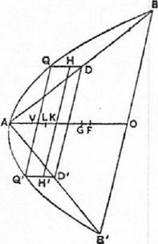
We have a_ b_c (1)
B

ON TILE EQUILIBRIUM OF PLANES II 115
whence
and therefore
Now
a—b b—c c—d
=
d '

a—b b—c ₌a ₌b ₌c
- -———
b—c— c—d b c d
2(a+b) a+b a+b b a—c b—c a—c
=. —
2c c b c b—c c—d⁼ c—d
And, in like manner,
b+c _b+c c a—c
c _{c—d}
It follows from the last two relations that
a—c _2a-F3b+c
c—d 2c+d
Suppose z to be so taken that
2a+4b-}-4c-i-2d _a—c
2c+d
so that z<(c—d).
Therefore a—c+z 2a-1-4b-1-6c-1-3d
a —c - 2(a+d)--1-4(b+c)•
And, by hypothesis,
a—c 5(a+d)-1-10(b+c)
y 2a-F4b1-6c+3d '
so that
a —c+z 5(a+d)+10(b+c) 5
y 2(a+d) -1-4(b+c) ⁼ 2
Again, dividing (3) by (4) crosswise, we obtain
2a+3b-l-c
c—d 2(a+d)+4(b+c)'
whence c—d—z _ b-4-3c-1-2d
c—d 2(a+d)+4(b+c)
But, by (2),
c—d a —b 3(b —c) 2(c—d)
= =
d b 3c 2d '
so that c—d_(a—b)-1-3(b—c)+2(c—d)
d b+3c-1-2d
Combining (6) and (7), we have
c—d—z _(a—b)-1-3(b—c)+2(c—d)
d 2(a+d) +4(b+c)
whence
c—z 3a+6b+3c
d —- 2(a+d)+4(b+r)
And, since [by (I)]
we have whence | c—d _b—c _a—b  c+d— b+c— a+b'  c—d c+d  =  a—c b+c+a-Fb'  a—d a+2b-1-2c+d 2(a+d)-1-4(b+c) a—c a+2b+c = 2(a+c)-1-4b | (9)

-3-(a—c) 412(a-1-0+4bl '
116 ARCHIMEDES
Thus a—d 2(a+d)-1-4(b+c)

and therefore, by hypothesis,
d 2(a+d)--1-4(b+c)
x 4{2(a+c)+41)}
c—z 3a-1-6b1-3c
But, by (8),
d 2(a+d)+4(b+c)'
and it follows, ex aequali, that
c—z 3(a+c)+6b 5 3 5
And, by (5), Therefore
x *{2(a+c)+4b} 3 22'
a—c+z 5
y 2.
5 a
2 x-Ey'
or x+y=*a.
PROPOSITION 10
If PP'B'B be the portion of a parabola intercepted between two parallel chords PP', BB' bisected respectively in N, 0 by the diameter ANO (N being nearer than 0 to A, the vertex of the segments), and if NO be divided into five equal parts of which LM is the middle one (L being nearer than. M to N), then, if G be a point on LM such that
LG :GM =BO' •(2PN+BO) : PN² •(2BO-FPN),
G will be the centre of gravity of the area PP'B'B.
Take a line ao equal to A 0, and an on it equal to AN. Let p, q be points on the line ao such that
ao : aq=aq : an, (1)
ao : an=aq : ap, (2)
[whence ao : aq = aq : an = an : ap, or ao, aq, an, ap are lines in continued pro-
portion and in descending order of magnitude].
Measure along GA a length GF such that
op : ap =OL :GF. (3)
Then, since PN, BO are ordinates to ANO,
B0² : PN² =AO : AN
=ao : an
= ao² : aq², by (1),
so that BO : PN = ao : aq, (4)
and B0³ : PN³=ao³ :
= (ao : aq) -(aq : an) .(an : ap)
=ao : ap. (5)
Thus (segment BAB') : (segment PAP')
= PBAB' : LPAP'
= B0³ : PN³
=ao : ap,
whence
(area PP'B'B) : (segment PAP') =op : ap

ON THE EQUILIBRIUM OF PLANES II
117
=OL : OF, by (3),
=t,,ON : OF. (6)
Now
1302 .(2PN+ BO) : B0³
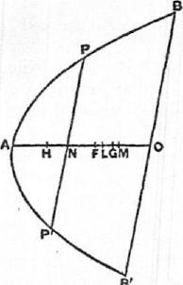
= (2PN +BO) : BO
=(2aq+ao) : ao, by (4),
130³ : PN³
=ao : ap, by (5),
and
a n a PN³ : PN² •(2130+PN)
=PN : (2B0+PN)
=aq : (2ao+aq), by (4),
=ap : (2an+ap), by (2).
Hence, ex aequali,
B0² .(2PN+BO) : PN² •
(280+PN) (2aq+ao) :
(2an+ap),
so that, by hypothesis,
LG : GM = (2aq+ ao) : (2an+ap).
Componendo, and multiplying the antecedents by 5,
ON : GM = 15(ao±ap)+10(aq+an)) : (2an+ap).
But
ON : OM =5 : 2= 5(ao-Fap)+10(aq+an)) : f2(ao+ap)-1-4(aq-l-an)).
It follows that
ON :00= { 5(ao+ap)±10(aq-Fan) : (2ao-1-4aq+6an-F3ap).
Therefore
(2ao 6an+ 3ap) : 5(ao ap) 10(aq+ an) } = OG : ON
=00 :on.
And ap : (ao—ap) = ap :.op
= GF OL, by hypothesis,
=GF :ion,
while ao, aq, an, ap are in continued proportion.
Therefore, by Prop. 9,
GF+OG=OF =*ao = t-OA.
Thus F is the centre of gravity of the segment BA B'. [Prop. 8]
Let H be the centre of gravity of the segment PAP', so that AH =*AN.
And, since AF =*A0,
we have, by subtraction, HF = SON.
But, by (6) above,
(area PP'11'.8) : (segment PAP') = *ON : GF
=HF : FO.
Thus, since F, H are the centres of gravity of the segments BAB', PAP' re-
spectively, it follows [by I. 6, 7] that G is the centre of gravity of the area
PP'B'B.

THE SAND-RECKONER
"THERE are some, King Gelon, who think that the number of the sand is infinite in multitude; and I mean by the sand not only that which exists about Syracuse and the rest of Sicily but also that which is found in every region whether inhabited or uninhabited. Again there are some who, without regarding it as infinite, yet think that no number has been named which is great enough to exceed its multitude. And it is clear that they who hold this view, if they imagined a mass made up of sand in other respects as large as the mass of the earth, including in it all the seas and the hollows of the earth filled up to a height equal to that of the highest of the mountains, would be many times further still from recognising that any number could be expressed which exceeded the multitude of the sand so taken. But I will try to show you by means of geometrical proofs, which you will be able to follow, that, of the numbers named by me and given in the work which I sent to Zeuxippus, some exceed not only the number of the mass of sand equal in magnitude to the earth filled up in the way described, but also that of a mass equal in magnitude to the universe. Now you are aware that `universe' is the name given by most astronomers to the sphere whose centre is the centre of the earth and whose radius is equal to the straight line between the centre of the sun and the centre of the earth. This is the common account (Ta.ypackIleva), as you have heard from astronomers. But Aristarchus of Samos brought out a book consisting of some hypotheses, in which the premisses lead to the result that the universe is many times greater than that now so called. His hypotheses are that the fixed stars and the sun remain unmoved, that the earth revolves about the sun in the circumference of a circle, the sun lying in the middle of the orbit, and that the sphere of the fixed stars, situated about the same centre as the sun, is so great that the circle in which he supposes the earth to revolve bears such a proportion to the distance of the fixed stars as the centre of the sphere bears to its surface. Now it is easy to see that this is impossible; for, since the centre of the sphere has no magnitude, we cannot conceive it to bear any ratio whatever to the surface of the sphere. We must however take Aristarchus to mean this: since we conceive the earth to be, as it were, the centre of the universe, the ratio which the earth bears to what we describe as the `universe' is the same as the ratio which the sphere containing the circle in which he supposes the earth to revolve bears to the sphere of the fixed stars. For he adapts the proofs of his results to a hypothesis of this kind, and in particular he appears to suppose the magnitude of the sphere in which he represents the earth as moving to be equal to what we call the `universe.'
"I say then that, even if a sphere were made up of the sand, as great as Aristarchus supposes the sphere of the fixed stars to be, I shall still prove that,
118

THE SAND-RECKONER 119
of the numbers named in the Principles,' some exceed in multitude the number of the sand which is equal in magnitude to the sphere referred to, provided that the following assumptions be made."
- "The perimeter of the earth is about 3,000,000 stadia and not greater.
"It is true that some have tried, as you are of course aware, to prove that the said perimeter is about 300,000 stadia. But I go further and, putting the magnitude of the earth at ten times the size that my predecessors thought it, I suppose its perimeter to be about 3,000,000 stadia and not greater."
- "The diameter of the earth is greater than the diameter of the moon, and the
diameter of the sun is greater than the diameter of the earth.
"In this assumption I follow most of the earlier astronomers."
- "The diameter of the sun is about 30 times the diameter of the moon and not greater.
"It is true that, of the earlier astronomers, Eudoxus declared it to be about nine times as great, and Pheidias my father twelve times, while Aristarchus tried to prove that the diameter of the sun is greater than 18 times but less than 20 times the diameter of the moon. But I go even further than Aristar-chus, in order that the truth of my proposition may be established beyond dispute, and I suppose the diameter of the sun to be about 30 times that of the moon and not greater."
- "The diameter of the sun is greater than the side of the chiliagon inscribed in
the greatest circle in the (sphere of the) universe.
"I make this assumption because Aristarchus discovered that the sun ap-
peared to be about 7 s ₀th part of the circle of the zodiac, and I myself tried, by
a method which I will now describe, to find experimentally (A czyuciiis) the angle subtended by the sun and having its vertex at the eye."
[Up to this point the treatise has been literally translated because of the historical interest attaching to the ipsissima verba of Archimedes on such a subject. The rest of the work can now be more freely reproduced, and, before proceeding to the mathematical contents of it, it is only necessary to remark that Archimedes next describes how he arrived at a higher and a lower limit for the angle subtended by the sun. This he did by taking a long rod or ruler, fastening on the end of it a small cylinder or disc, pointing the rod in the direction of the sun just after its rising (so that it was possible to look directly at it), then putting the cylinder at such a distance that it just concealed, and just failed to conceal, the sun, and lastly measuring the angles subtended by the cylinder. He explains also the correction which he thought it necessary to make because "the eye does not see from one point but from a certain area."'
The result of the experiment was to show that the angle subtended by the diameter of the sun was less than _{T}i_{T}th part, and greater than ₃.6th part, of a right angle.
To prove that (on this assumption) the diameter of the sun is greater than the side of a chiliagon, or figure with 1000 equal sides, inscribed in a great circle of the "universe."
Suppose the plane of the paper to be the plane passing through the centre of the sun, the centre of the earth and the eye, at the time when the sun has
IA lost work of Archimedes.

120 ARCHIMEDES
just risen above the horizon. Let the plane cut the earth in the circle EHL and the sun in the circle FKG, the centres of the earth and sun being C, 0 respectively, and E being the position of the eye.
Further, let the plane cut the sphere of the "universe" (i.e. the sphere whose centre is C and radius CO) in the great circle AOB.
Draw from E two tangents to the circle FKG touching it at P, Q, and from C draw two other tangents to the same circle touching it in F, G respectively.
Let CO meet the sections of the earth and sun in H, K respectively; and let CF, CG produced meet the great circle AOB in A, B.
Join EO, OF, OG, OP, OQ, AB, and let AB meet CO in M.
Now CO > EO, since the sun is just above the horizon.
Therefore L PEQ> L FCG.
And ZPEQ>_{v}h.R1
but _{<thn f} where R represents a right angle.
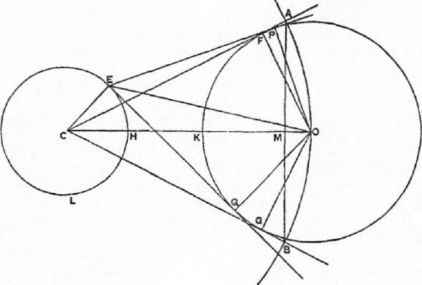
Thus L FCC <-₁4-₄-R, a fortiori,
and the chord AB subtends an arc of the great circle which is less than ₃₃-h_{r}th
of the circumference of that circle, i.e.
AB < (side of 656-sided polygon inscribed in the circle).
Now the perimeter of any polygon inscribed in the great circle is less than
⁵.₇⁴-CO. [Cf. Measurement of a circle, Prop. 3.]
Therefore AB : CO <11 : 1148,
and, a fortiori, AB <TL6C0. (a)
Again, since CA = CO, and AM is perpendicular to CO, while OF is perpen-
dicular to CA, AM = OF.
Therefore AB = 2AM = (diameter of sun).
Thus (diameter of sun) <rhCO, by (a),
and, a fortiori, (diameter of earth) <₁1₀00. [Assumption 2]
Hence CH +0K <_{T}6CO,
so that IIK>MCO,

THE SAND-RECKONER 121
or CO HK <100 : 99.
And CO>CF,
while HK <EQ.
Therefore CF : EQ <100 : 99. ($)
Now in the right-angled triangles CFO, EQO, of the sides about the right
angles, OF =OQ, but EQ <CF (since EO <CO).
Therefore L OEQ : L OCF> CO : ED,
but <CF : EQ.'
Doubling the angles,
LPEQ : LACB<CF : EQ
<100 : 99, by (0) above.
But L PEQ > thR, by hypothesis.
Therefore L ACB>y-_{o}g_{t}6R
> YhR•
It follows that the arc AB is greater than A_{g}th of the circumference of the
great circle AOB.
Hence, a fortiori,
AB> (side of chiliagon inscribed in great circle),
and AB is equal to the diameter of the sun, as proved above.
The following results can now be proved:
(diameter of "universe") <10,000 (diameter of earth),
and (diameter of "universe") <10,000,000,000 stadia.
- Suppose, for brevity, that d_{u} represents the diameter of the "universe," d, that of the sun, d_{e} that of the earth, and d, that of the moon.
By hypothesis, d_{a}> 30d,, [Assumption 3]
and d_{e}>d,u; [Assumption 2]
therefore d_{i}< 30d_{e}.
Now, by the last proposition,
d,> (side of chiliagon inscribed in great circle),
so that (perimeter of chiliagon) <1000d,
<30,000de.
But the perimeter of any regular polygon with more sides than 6 inscribed
in a circle is greater than that of the inscribed regular hexagon, and therefore
greater than three times the diameter. Hence
(perimeter of chiliagon) > 3d..
It follows that du<10,000de.
- (Perimeter of earth) >3,000,000 stadia. [Assumption 1]
and (perimeter of earth) >34.
Therefore d,<1,000,000 stadia,
whence du<10,000,000,000 stadia.
Assumption 5
Suppose a quantity of sand taken not greater than a poppy-seed, and suppose that it contains not more than 10,000 grains.
'The proposition here assumed is of course equivalent to the trigonometrical formula which states that, if a, fi are the circular measures of two angles, each less than a right angle, of which a is the greater, then
tan a> a> sin a
tan t3 sin )9

122 ARCHIMEDES
Next suppose the diameter of the poppy-seed to be not less than i_{s}th of a finger-breadth.
ORDERS AND PERIODS OF NUMBERS
- We have traditional names for numbers up to a myriad (10,000); we can therefore express numbers up to a myriad myriads (100,000,000). Let these numbers be called numbers of the first order.
Suppose the 100,000,000 to be the unit of the second order, and let the second order consist of the numbers from that unit up to (100,000,000)².
Let this again be the unit of the third order of numbers ending with (100,000,000)'; and so on, until we reach the 100,000,000th order of numbers ending with (100,000,000)¹⁰⁰.⁰⁰⁰.^{00°}, which we will call P.
- Suppose the numbers from 1 to P just described to form the first period. Let P be the unit of the first order of the second period, and let this consist of the numbers from P up to 100,000,000P.
Let the last number be the unit of the second order of the second period, and let this end with (100,000,000)²P.
We can go on in this way till we reach the 100,000,000th order of the second period ending with (100,000,000)¹⁰⁰.⁰⁰⁰.⁰⁰⁰ P, or P².
- Taking P² as the unit of the first order of the third period, we proceed in the same way till we reach the 100,000,000th order of the third period ending with P³.
- Taking P³ as the unit of the first order of the fourth period, we continue the same process until we arrive at the 100,000,000th order of the 100,000,000th period ending with P¹⁰°•⁰°°•⁰°°. This last number is expressed by Archimedes as "a myriad-myriad units of the myriad-myriad-th order of the myriad-myriad-th period (al µuptarctoµuptooras irept6r5ou AvinatacrtivpLoarCo IcptOph.7)v µvptat AuptAbes)," which is easily seen to be 100,000,000 times the product of (100,000,000)
99.00,9Q0 _{an}d p99,999,999, i_{.e.} ploopo,000.
OCI'ADS
Consider the series of terms in continued proportion of which the first is 1 and the second 10 [i.e. the geometrical progression 1, 10', 10², 10³, • • •]. The first octad of these terms [i.e. 1, 10', 10², • • 401 fall accordingly under the first order of the first period above described, the second octad [i.e. 10⁸, 10⁹, • • •10'⁵] under the second order of the first period, the first term of the octad being the unit of the corresponding order in each case. Similarly for the third octad, and so on. We can, in the same way, place any number of octads.
THEOREM
If there be any number of terms of a series in continued proportion, say A1, A2, A 3, • • • A_{m}, • • • An, • • • A_{m+n}__{i}, • • • of which A1=1, A2=10 [so that the series forms the geometrical progression 1, 10', 10², • • •10m⁻⁻¹, • • -10-1,
- -], and if any two terms as Am, A_{n} be taken and multiplied, the product Am •A n will be a term in the same series and will be as many terms distant from A_{n} as A_{m} is distant from A_{l}; also it will be distant from Al by a number of terms less by one than the sum of the numbers of terms by which Am and A_{n} respectively are distant from A₁.
Take the term which is distant from A_{n} by the same number of terms as A.

THE SAND-RECKONER 123
is distant from A_{l}. This number of terms is m (the first and last being both counted). Thus the term to be taken is m terms distant from A., and is therefore the term
We have therefore to prove that
- An= Am÷n-i.
Now terms equally distant from other terms in the continued proportion are
Proportional.
Thus A_{m} Am₊n-i

Al A_{n}
But A„,= A_{m} A_{i}, since A₁=1.
Therefore Arn₊n-l= •A_{n}. (1)
The second result is now obvious, since Am is m terms distant from A1, An is n terms distant from A₁, and A„₊,.₁ is (m+n — 1) terms distant from Al.
APPLICATION TO THE NUMBER OF THE SAND
By Assumption 5 [p. 523],
(diam. of poppy-seed) <-₁-¹-₀-(finger-breadth);
and, since spheres are to one another in the triplicate ratio of their diameters,
it follows that
(sphere of diam. 1 finger-breadth)>64,000 poppy-seeds
> 64,000 X 10,000
>640,000,000
>6 units of second grains
order+ 40,000,000 of
units of first order sand.
(a fortiori) < 10 units of second
order of numbers.
We now gradually increase the diameter of the supposed sphere, multiplying
it by 100 each time. Thus, remembering that the sphere is thereby multiplied
by 100³ or 1,000,000, the number of grains of sand which would be contained
in a sphere with each successive diameter may be arrived at as follows.
Diameter of sphere. Corresponding number of grains of sand.
- 100 finger-breadths <1,000,000 X 10 units of second order < (7th term of series) X (10th term of series)
<16th term of series [i.e. 10¹⁵]
<I10⁷ or] 10,000,000 units of the second order.
- 10,000 finger-breadths <1,000,000 X (last number) < (7th term of series) X (16th term)
<22nd term of series [i.e. 10i¹]
<[10⁵ or] 100,000 units of third order.
- 1 stadium <100,000 units of third order. (<10,000 finger-breadths)
- 100 stadia <1,000,000 X (last number) < (7th term of series) X(22nd term)
<28th term of series [1029
<[10g or] 1,000 units of fourth order.
- 10,000 stadia <1,000,000 X (last number) <(7th term of series) X(28th term)
<34th term of series [10³9
<10 units of fifth order.

124 | imam() stadia | ARCHIMEDES  <(7th term of series)X(34th term)
 |  | <40th term | [10³⁹]
 |  | <[10⁷ or] 10,000,000 units of fifth order.
 | 100,000,000 stadia | < (7th term of series) X (40th term)
 |  | <46th term | (1a6]
 |  | <[1O or] 100,000 units of sixth order.
 | 10,000,000,000 stadia | <(7th term of series) X (46th term)
 |  | <52nd term of series | [10^{,1}]
 |  | <[10³ or] 1,000 units of seventh order.

But, by the proposition above [p. 523],
(diameter of "universe") <10,000,000,000 stadia.
Hence the number of grains of sand which could be contained in a sphere of the
size of our "universe" is less than 1,000 units of the seventh order of numbers
[or 10].
From this we can prove further that a sphere of the size attributed by Aristar-
chus to the sphere of the fixed stars would contain a number of grains of sand less
than 10,000,000 units of the eighth order of numbers [or 10'⁶'⁷=10⁶³].
For, by hypothesis,
(earth) : ("universe") = ("universe") : (sphere of fixed stars).
And [p. 523]
(diameter of "universe") <10,000 (diam. of earth);
whence
(diam. of sphere of fixed stars) <10,000 (diam. of "universe").
Therefore
(sphere of fixed stars) < (10,000)³ •("universe").
It follows that the number of grains of sand which would be contained in a
sphere equal to the sphere of the fixed stars
< (10,000)³X 1,000 units of seventh order
< (13th term of series) X (52nd term of series)
<64th term of series [i.e. 10⁶³]
<[10⁷ or] 10,000,000 units of eighth order of numbers.
CONCLUSION.
"I conceive that these things, King Gelon, will appear incredible to the great majority of people who have not studied mathematics, but that to those who are conversant therewith and have given thought to the question of the distances and sizes of the earth, the sun and moon and the whole universe, the proof will carry conviction. And it was for this reason that I thought the subject would he not inappropriate for your consideration."

QUADRATURE OF THE PARABOLA
"ARCHIMEDES to DOSITEIEIIS greeting.
"When I heard that Conon, who was my friend in his lifetime, was dead, but that you were acquainted with Conon and withal versed in geometry, while I grieved for the loss not only of a friend but of an admirable mathematician, I set myself the task of communicating to you, as I had intended to send to Conon, a certain geometrical theorem which had not been investigated before but has now been investigated by me, and which I first discovered by means of mechanics and then exhibited by means of geometry. Now some of the earlier geometers tried to prove it possible to find a rectilineal area equal to a given circle and a given segment of a circle; and after that they endeavoured to square the area bounded by the section of the whole cone and a straight line, assuming lemmas not easily conceded, so that it was recognised by most people that the problem was not solved. But I am not aware that any one of my predecessors has attempted to square the segment bounded by a straight line and a section of a right-angled cone [a parabola], of which problem I have now discovered the solution. For it is here shown that every segment bounded by a straight line and a section of a right-angled cone [a parabola] is four-thirds of the triangle which has the same base and equal height with the segment, and for the demonstration of this property the following lemma is assumed: that the excess by which the greater of (two) unequal areas exceeds the less can, by being added to itself, be made to exceed any given finite area. The earlier geometers have also used this lemma; for it is by the use of this same lemma that they have shown that circles are to one another in the duplicate ratio of their diameters, and that spheres are to one another in the triplicate ratio of their diameters, and further that every pyramid is one third part of the prism which has the same base with the pyramid and equal height; also, that every cone is one third part of the cylinder having the same base as the cone and equal height they proved by assuming a certain lemma similar to that aforesaid. And, in the result, each of the aforesaid theorems has been accepted no less than those proved without the lemma. As therefore my work now published has satisfied the same test as the propositions referred to, I have written out the proof and send it to you, first as investigated by means of mechanics, and afterwards too as demonstrated by geometry. Prefixed are, also, the elementary propositions in conics which are of service in the proof. Farewell."
125

126 ARCHINIEDES
PROPOSITI ON 1
If from a point on a parabola a straight line be drawn which is either itself the axis
or parallel to the axis, as PV, and if QQ' be a chord parallel to the tangent to the
parabola at P and meeting PV in V, then
QV = VQ'.
Conversely, if QV =1⁷(2', the chord QQ' will be parallel to the tangent at P.
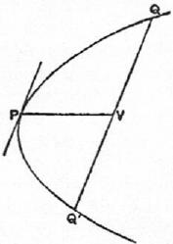
PROPOSITION 2
If in a parabola QQ' be a chord parallel to the tangent at P, and if a straight line be drawn through P which is either itself the axis or parallel to the axis, and which meets QQ' in V and the tangent at Q to the parabola in T, then
PV=PT.
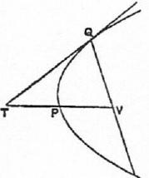
PROPOSITION 3
If from a point on a parabola a straight line be drawn which is either itself the axis or parallel to the axis, as PV, and if from two other points Q, Q' on the parabola straight lines be drawn parallel to the tangent at P and meeting PV in V, V'
respectively, then PV : PV' =QV' :Q'V".
"And these propositions are proved in the elements of conics."'
PROPOSITION 4
If Qq be the base of any segment of a parabola, and P the vertex of the segment, and
if the diameter through any other point R meet Qq in 0 and QP (produced if
necessary) in F, then QV : VO = OF :FR.
Draw the ordinate RW to PV, meeting QP in K.
Then PV : PW = QV' : RIV²;
whence, by parallels, PQ : PK =PQ² : PF².
'i.e. in the treatises on conics by Euclid and Aristaeus.

QUADRATURE OF THE PARABOLA 127
In other words, PQ, PF, PK are in continued proportion; therefore
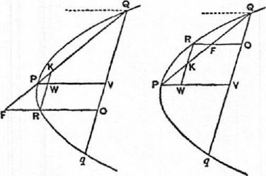
PQ :PF =PF :PK
=PQ+PF :PF-I-PK
=QF : KF.
Hence, by parallels, QV : VO =OF : FR.
PROPOSITION 5
If Qq be the base of any segment of a parabola, P the vertex of the segment, and PV its diameter, and if the diameter of the parabola through any other point R meet Qq in 0 and the tangent at Q in E, then
QO :0q=ER : RO.
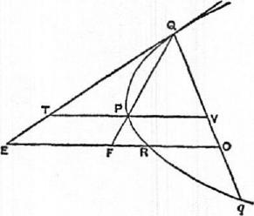
Let the diameter through R meet QP
in F.
Then, by Prop. 4,
QV : VO =OF :FR.
Since QV =V q, it follows that
QV : q0 =OF : OR. (1)
Also, if VP meet the tangent in 7',
PT =PV, and therefore EF =OF.
Accordingly, doubling the antecedents
in (1), we have
Qq : q0 =OE : OR,
whence QO : 0q=ER : RO.
PROPOSITIONS 6, 7'
Suppose a lever AOB placed horizontally and supported at its middle point 0. Let a triangle BCD in which the angle C is right or obtuse be suspended from B and 0, so that C is attached to 0 and CD is in the same vertical line with 0. Then, if P be such an area as, when suspended from A, will keep the system in equilibrium,
P=APBCD.
'In Prop. 6 Archimedes takes the separate case in which the angle BCD of the triangle is a right angle so that C coincides with 0 in the figure and F with E. He then proves, in Prop. 7, the same property for the triangle in which BCD is an obtuse angle, by treating the triangle as the difference between two right-angled triangles BOD, BOG and using the result of Prop. 6. I have combined the two propositions in one proof, for the sake of brevity. The same remark applies to the propositions following Props. 6, 7.

128 ARCIIINIEDES
Take a point E on 0.8 such that BE =20E, and draw ERR parallel to OCD meeting BC, BD in F, H respectively.
Let G be the middle point of FH.
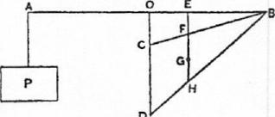
Then G is the centre of gravity of the triangle BCD.
Hence, if the angular points B, C be set free and the triangle be suspended by attaching F to E, the triangle will hang in the same position as before, because EFG is a vertical straight line. "For this is proved."'
Therefore, as before, there will be equilibrium.
Thus P : LBCD=OE : AO
=1 :3,
or P= ,/BCD.
PROPOSITIONS 8, 9
Suppose a lever AOB placed horizontally and supported at its middle point 0. Let a triangle BCD, right-angled or obtuse-angled at C, be suspended from the points B, B on OB, the angular point C being so attached to E that the side CD is in the same vertical line with E. Let Q be an area such that
AO :OE= LBCD : Q.
Then, if an area P suspended from A keep the system in equilibrium, P < PBCD but>Q.
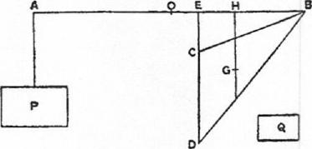
Take G the centre of gravity of the triangle BCD, and draw GH parallel to DC, i.e. vertically, meeting BO in H.
We may now suppose the triangle BCD suspended from H, and, since there is equilibrium,
LBCD : P= AO : OH, (1)
whence P<ABCD.
Also LBCD :Q= AO : OE.
Therefore, by (1), LBCD :Q> LBCD :P,
and P > Q.
PROPosiTIoNS 10, 11
Suppose a lever AOB placed horizontally and supported at 0, its middle point. Let CDEF be a trapezium which can be so placed that its parallel sides CD, FE are vertical, while C is vertically below 0, and the other sides CF, DE meet in B. Let EF meet BO in H, and let the trapezium be suspended by attaching F to H and C to 0. Further, suppose Q to be an area such that
AO : OH = (trapezium CDEF) : Q.
Then, if P be the area which, when suspended from A, keeps the system. in equilibrium,
P<Q.
'Doubtless in the lost book rept ruyi,-,v.

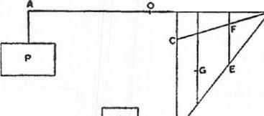
QUADRATURE OF THE PARABOLA 129
The same is true in the particular case where the angles at C, F are right, and
consequently C, F coincide with 0, H respectively.
Divide 0II in K so that
(2CD+FE) : (2FE+CD)=11K : KO.
Draw KG parallel to OD, and
a let G be the middle point of the
portion of KG intercepted within the trapezium. Then G is the centre of gravity of the trapezium [On the equilibrium of planes, I. 15].
Thus we may suppose the trapezium suspended from K, and
the equilibrium will remain undisturbed.
Therefore AO : OK = (trapezium CDEF) : P, and, by hypothesis, AO : OH = (trapezium CDEF) : Q. Since OK <011, it follows that
P <Q.
PRorosmoNs 12, 13
If the trapezium CDEF be placed as in the last propositions, except that CD is
vertically below a point L on OB instead of being below 0, and the trapezium is
suspended from L, H, suppose that Q, R are areas such that
AO : 011 = (trapezium CDEF) :Q,
AO : OL= (trapezium CDEF) : R.
If then an area P suspended
from A keep the system in equilib-
L K
rium,
P>R but<Q.
Take the centre of gravity of the trapezium, as in the last propositions, and let the line through G parallel to DC meet OB in K.
Then we may suppose the trapezium suspended from K, and there will still be equilibrium.
Therefore (trapezium CDEF) : P =AO :OK.
Hence (trapezium CDEF) : P> (trapezium CDEF') : Q,
but < (trapezium CDEF) : R.
It follows that P <Q but >R.
PROPOSITIONS 14, 15
Let Qq be the base of any segment of a parabola. Then, if two lines be drawn from Q, q, each parallel to the axis of the parabola and on the same side of Qq as the segment is, either (1) the angles so formed at Q, q are both right angles, or (2) one is acute and the other obtuse. In the latter case let the angle at q be the obtuse angle.
Divide Qq into any number of equal parts at the points 01, 02, • • Draw
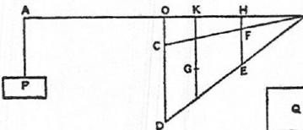
a
and
Q

130 ARCHIMEDES
through q, 0₁, 0₂, • • .0„ diameters of the parabola meeting the tangent at Q in E, E₁, E2, • •E„ and the parabola itself in q; Ri, R2, • • •R„. Join QR1, QR2, QR„ meeting qE, 01E1, 02E2, • • .0,,_1E„_₁ in F, F1, F2, • •F„_1.
Let the diameters Eq, E₁0₁, • • • E „0„ meet, a straight line QOA drawn through Q perpendicular to the diameters in the points 0, III, H2, • • •II„ respectively. (In the particular case where Qq is itself perpendicular to the diameters q will coincide with 0, 0₁ with HI, and so on.)
It is required to prove that
- PEqQ<3(sum of trapezia P¹0₁, F102, • • .F...40„ and E„OuQ),
- AEqQ>3(sum of trapezia 11102,R203, • • •R„_10„ and AR„0.(2).
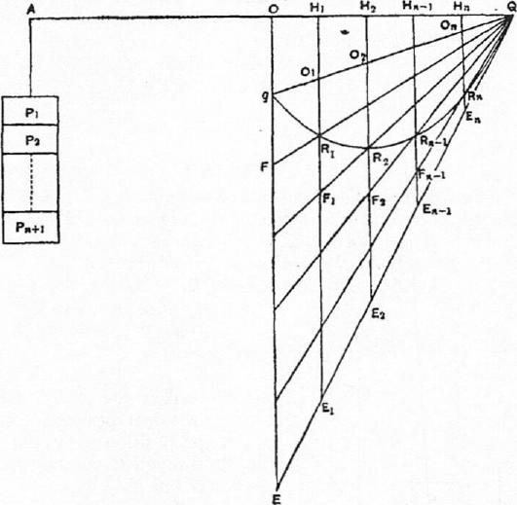
Suppose AO made equal to OQ, and conceive Q0_4 as a lever placed horizontally and supported at.O. Suppose the triangle EqQ suspended from OQ in the position drawn, and suppose that the trapezium E01 in the position drawn is balanced by an area P1 suspended from A, the trapezium E102 in the position drawn is balanced by the area P2 suspended from A, and so on, the triangle E7,0„Q being in like manner balanced by P.+1.
Then P1+P2+ • • • 1-Pn₊ilvill balance the whole triangle EqQ as drawn, and
therefore P1+P2+ • • •+1)„₄.₁= A AEyQ: [Props. 0, 7]
Again AO :011₁=Q0 :011_{i}
=Q_{g} gOi
=E₁0₁: oire, [by means of Prop. 5)
= (trapezium E01) : (trapezium F0₁);
whence [Props. 10, 11] (F01) > P1.

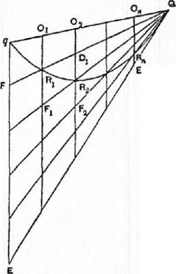QUADRATURE OF THE 1'ARAI3OI.A
131 (a)
(0) 13,
Next AO :Ni_{l}= E101:01Ri
= (E10₂) : (1?102),
while AO :0H2=E202: 02R2
= (E102) : (F102);;
and, since (a) and (g) are simultaneously true, we have, by Props. 12,
(F102) > P2> (R102).
Similarly it may be proved that
(F₂0₃) >P3> (R203),
and so on.
Lastly [Props. 8, 0] PE„0„Q>P₇,₁> ,L/?„0„Q. By addition, we obtain
- (F01)-1-•(P102)± • • •+(F„._10.)-F PE„0„(2>P1-1-P2-1- • • •-i-Pn+i > A PEW,
or ,LEV2 <3(E01-1- F102-1- • • •+1•',•_₃0„-h,LE,.O„Q).
- (/60₂)-1- (/?₂0₃) + • • cien_.,o„)+ Rh0„Q <P2+ P3+ • • • + Pn+1
<J',+1'_+ • • • +P„ ₀, a fortiori,
<1 LEW ,
or 6,14.¹qQ> 3(1602+11203+ • • • +/?„._10,,-1- PR„0,(2).
PitoPosirriox 16
Suppose Qq to be the base of a parabolic segment, q being not more distant than Q from the vertex of the parabola. Draw through q the straight line qE parallel to the axis of the parabola to meet the tangent at Q in E. It is required to prore that (area of segment) = PEW.
For, if not, the area of the segment must be either greater or less than 16,4Q.
T. Suppose the area of the segment greater than AEgQ. Then the excess can, if continually added to itself, be made to exceed AM.
ri And it is possible to find a submultiple of the triangle EqQ less than the said excess of the segment over IAEA
Let the triangle FqQ be such a submultiple of the triangle EqQ. Divide Eq into equal parts each equal to qP, and let all the points of division including F be joined to Q meeting the parabola in R_{I}, R2, • • -R„ respectively. Through R_{I}, R2, • • •R_{n} draw di:Inlet CI'S of the parabola meeting q(2 in 0₁, 02, • • -0„ respectively.
Let. WI', meet Q11₂ in F.
Let 0₂/?₂ meet (2111 in D_{I} and QR₃ in F2.
Let 0₃113 meet (1/?₂ in 1)₂ and QM in F3, and so on.
We have, by hypothesis,
PV2 < (area of segment) — A PEW,
or (area of segment)— L Fq(2> ;PEW. (a)
Now, since all the parts of qE, as qF and the rest., are equal, 01R1=RiFi, 02D1=D1R2=R2F2, and so on; therefore

132 ARCHIMEDES,
AFqQ= (F01-F-R102+ D103+ • • .)
= (F01+ FiDi+F2D2+ • • • + F n_ip„._1+ A EnR.(2)• ($)
But (area of segment) < (FOld-F102-1- • • • -1-11¹7,10.-1⁻ AE.0.(2)•
Subtracting, we have
(area of segment) — A Fq(2 < (R102+ R203+ • • • + R.-10.+ A R.O.Q),
whence, a fortiori, by (a),
1AEqQ<(R102+R203+ • • • +Rn_10.-f- AR.On(2)•
But this is impossible, since [Props. 14, 15]
AEqQ> (11102-1-R203+ • • •+ LR„0,,Q).
Therefore (area of segment) > 1AE9Q.
II. If possible, suppose the area of the segment less than 1PEqQ.
Take a submultiple of the triangle EqQ, as the triangle FqQ, less than the
excess of 1PEq(2 over the area of the segment, and make the same construc-
tion as before.
Since p FqQ <I L — (area of segment),
it follows that
AFqQ-1- (area of segment) <1 PEqQ
<(F01+ F102+ • • • +F Z,E„0„Q).
[Props. 14, 15]
Subtracting from each side the area of the segment, we have
&'qQ < (sum of spaces qFR_{i}, RiFiR2, • • • E.R.Q)
< (F01+ FiD14- • • •+Fn_iD.-1+ AE.R.Q), a fortiori;
which is impossible, because, by (0) above,
6,1⁷W = F03.+FiDi+ • • • + F .LE.R„(2.
Hence (area of segment)<IPEqQ.
Since then the area of the segment is neither less nor greater than IAEA
it is equal to it.
PROPOSITION 17
It is now manifest that the area of any segment of a parabola is four-thirds of the triangle which has the same base as the segment and equal height.
Let Qq be the base of the segment, P its vertex. a
Then PQq is the inscribed triangle with the same base as the segment and equal height.
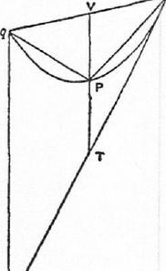
Since P is the vertex of the segment, the diameter through P bisects Qq. Let V be the point of bisection.
Let VP, and 0; drawn parallel to it, meet the tangent at Q in 7', E respectively.
Then, by parallels,
qE =21⁷7',
and PV=PT, [Prop. 2]
so that VT =2PV.
Hence 6.EqQ — 4 PPQq •
But, by Prop. 16, the area of the segment is equal to
EqQ.
Therefore (area of segment)= 46,1)(2g.
DEF. "In segments bounded by a straight line and any curve I call the

QUADRATURE OF TILE PARABOLA 133
straight line the base, and the height the greatest perpendicular drawn from the curve to the base of the segment, and the vertex the point from which the greatest perpendicular is drawn."
fl PROPOSITION 18
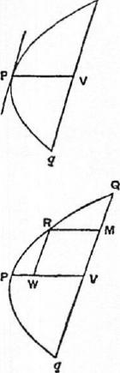
If Qq be the base of a segment of a parabola, and V the middle point of Qq, and if the diameter through V meet the curve in P, then P is the vertex of the segment.
For Qq is parallel to the tangent at P [Prop. 1]. Therefore, of all the perpendiculars which can be drawn from points on the segment to the base Qq, that from P is the greatest. Hence, by the definition, P is the vertex of the segment.
PROPOSITION 19
If Qq be a chord of a parabola bisected in V by the diameter
PV, and if RM be a diameter bisecting QV in M, and R1V
he the ordinate from R to PV, then
PV = ARM.
For, by the property of the parabola,
PV : PW=QV² : R1V²
= 4RIV² : RTV²,
so that PV = 4/³1V,
whence PV =1-R31.
PROPOSITION 20
If Qq be the base, and P the vertex, of a parabolic segment, then the triangle PQq is greater than half the segment PQq.
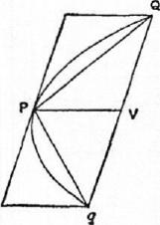
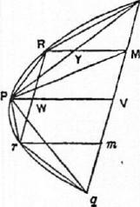
For the chord Qq is parallel to the tangent at P, and the triangle PQq is half the parallelogram formed by Qq, the tangent at P, and the diameters through Q, q.
Therefore the triangle PQq is greater than half the segment.
COR. It follows that it is possible to inscribe in the segment a polygon such that the segments left over are together less than any assigned area..
PROPOSITION 21
If Qq be the base, and 1' the vertex, of any parabolic segment, and if R be the vertex of the segment cut off by PQ, then
PPQg = 8PPRQ.
The diameter through R will bisect the chord PQ, and therefore also QV, where PV is the diameter bisecting Qq. Let the diameter through I? bisect PQ in Y and QV in :II. Join PM.
By Prop. 19, PI/ = ARM.
Also PV=2Y.111.
Therefore YM =2RY,

134 ARCHIMEDES
and APQM=2APRQ.
Hence APQV=4APRQ,
and APQq=8APRQ.
Also, if RTV, the ordinate from 1? to PV, he produced to meet the curve
again in r, RTV=7•Fir,
and the same proof shows that
PQ(/•=8APrq.
PROPOSITION 22
If there be a series of areas A, B, C, I), • • • each of which is four times the next in order, and if the largest, A, be equal to the triangle PQq inscribed in a parabolic segment PQq and having the same base with it and equal height, then
(A+B+C-}-D-}- • • •)<(area of segment PQq).
For, since APQq=8APRQ=8APqr, where I?, r are the vertices of the segments cut off by PQ, Pq, as in the last proposition,
PQq=4(APQR+APqr). Therefore, since APIQq= A,
APQR+APqr=B•
In like manner we prove that the triangles similarly inscribed in the remaining segments are together equal to the area C, and so on.
Therefore Ad-B+C±D-1- • • • is equal to the area of a certain inscribed polygon, and is therefore less than the area of the segment.
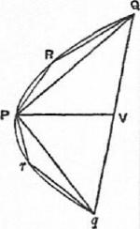
PROPOSITION 23
Given a series of areas A, B, C, D, • • •Z, of which A is
equal to four times the next in order, then A -1-B+C+ • • •+Z-1-V=I-A. Take areas b, c, d, • • • such that b= 3B,
c=1C,
d= 1D, and so on. Then, since b =1/3,
and B =1A,
B+b=i-A.
Similarly C-i-c=iB.
the greatest, and each is
A
F
C
Therefore
13-1-C-FD+ • • •±Z+b-1-c-i-d+ • • •+z=
EA-1-B±C+ • • --FY).
But
b+c-I-d+ • • • -FY —1(B+C⁻1⁻D+ • • •-i-Y).
Therefore, by subtraction,
B+C-I-D+ • • •-1--Z-Fz-=-1A
or A-I-B-1-C+ • • •-1-Z-HlyZ=4-A.

QUADRATURE OF THE PARABOLA 135
PROPOSITION 24
Every segment bounded by a parabola and a chord Qq is equal to four-thirds of the triangle 'which has the same base as the segment and equal height.
Suppose K =tAPQq,
where P is the vertex of the segment; and we have then; to prove that the area
of the segment is equal to K.
Q For, if the segment be not equal to K, it must either be
greater or less.
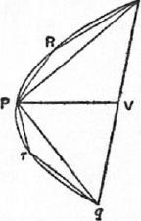
I. Suppose the area of the segment greater than K.
If then we inscribe in the segments cut off by PQ, Pq triangles which have the same base and equal height, i.e. triangles with the same vertices R, r as those of the segments, and if in the remaining segments we inscribe triangles in the same manner, and so on, we shall finally have segments remaining whose sum is less than the area by which the segment PQq exceeds K.
Therefore the polygon so formed must be greater than the area K; which is impossible, since [Prop. 23]
A+B-1-C-1- • • •-1-Z <AA,
where A= APQq.
Thus the area of the segment cannot be greater than K.
II. Suppose, if possible, that the area of the segment is less than K.
If then APQq= A, B = 144, C =113, and so on, until we arrive at an area X
such that X is less than the .difference between K and the segment, we have
A+B-I-C-1- • • .+X-1-4X=4A [Prop. 23]
=K.
Now, since K exceeds A+B-I-C+ • • •+X by an area less than X, and the
area of the segment by an area greater than X, it follows that
A-1-B+C+ • • •-I-X> (the segment);
which is impossible,.by Prop. 22 above.
Hence the segment is not less than K.
Thus, since the v•egment is neither greater nor less than K,
(area of segment PQq) = K =1,APQq,

ON FLOATING BODIES
BOOK ONE
POSTULATE 1
"Let it be supposed that a fluid is of such a character that, its parts lying evenly and being continuous, that part which is thrust the less is driven along by that which is thrust the more; and that each of its parts is thrust by the fluid which is above it in a perpendicular direction if the fluid be sunk in anything and compressed by anything else."
PROPOSITION 1
If a surface be cut by a plane always passing through a certain point, and if the section be always a circumference [of a circle] whose centre is the aforesaid point, the surface is that of a sphere.
For, if not, there will be some two lines drawn from the point to the surface Which are not equal.
Suppose 0 to be the fixed point, and A, B to be two points on the surface such that OA, OB are unequal. Let the surface be cut by a plane passing through 0A, OB. Then the section is, by hypothesis, a circle whose centre is O.
Thus 0A = 0B; which is contrary to the assumption. Therefore the surface cannot but be a sphere.
PROPOSITION 2
The surface of any fluid at rest is the surface of a sphere whose centre is the same as that of the earth.
Suppose the surface of the fluid cut by a plane through 0, the centre of the earth, in the curve ABCD.
ABCD shall be the circumference of a circle.
For, if not, some of the lines drawn from 0 to the curve will be unequal. Take one of them, OB, such that OB is greater than some of the lines from 0 to the curve and less than others. Draw a circle with OB as radius. Let it be EBF, which will therefore fall partly within and partly without the surface of the fluid.
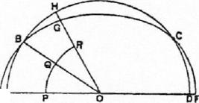Draw OGH making with OB an angle equal to the angle EOB, and meeting the surface in H and the circle in G. Draw also in the plane an arc of a circle PQR with centre 0 and within the fluid.
Then the parts of the fluid along PQR are uniform and continuous, and the part E A PQ is compressed by the part between it and A B, while the part QR is compressed by the part between QR and BH.
136

ON FLOATING BODIES I 137
Therefore the parts along PQ, QR will be unequally compressed, and the part which is compressed the less will be set in motion by that which is compressed the more.
Therefore there will not be rest; which is contrary to the hypothesis. Hence the section of the surface will be the circumference of a circle whose centre is 0; and so will all other sections by planes through 0.
Therefore the surface is that of a sphere with centre 0.
PROPOSITION 3
Of solids those which, size for size, are of equal weight with a fluid will, if let down into the fluid, be immersed so that they do not project above the surface but do not sink lower.
If possible, let a certain solid EFHG of equal weight, volume for volume, with the fluid remain immersed in it so that part of it, EBCF, projects above the surface.
Draw through 0, the centre of the earth, and through: the solid a plane cutting the surface of the fluid in the circle ABCD.
Conceive a pyramid with vertex 0 and base.a parallelogram .at the surface of the fluid, such that it includes the immersed portion of the solid. Let this pyramid be cut by the plane of A BCD in OL,
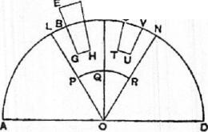c _{M q} OM. Also let a sphere within the fluid and be-
low Gil be described with centre 0, and let the plane of A BCD cut this sphere in PQR.
Conceive also another pyramid in the fluid with vertex 0, continuous with the former pyramid and equal and similar to it. Let the pyramid so described be cut in OM, ON by the plane of ABCD.
Lastly, let ST UV be a part of the fluid within the second pyramid equal and similar to the part BGHC of the solid, and let SV be at the surface of the fluid.
Then the pressures on PQ, QR are unequal, that on PQ being the greater. Hence the part at QR will be set in motion by that at PQ, and the fluid will not be at rest; which 'is contrary to the hypothesis.
Therefore the solid will not stand out above the surface.
Nor will it sink further, because all the parts of the fluid will be under the same pressure.
PROPOSITION 4
A solid lighter than a fluid will, if immersed in it, not be completely submerged, but part of it will project above the :surface.
In this case, after the manner of the previous proposition; we assume the solid, if possible, to be completely submerged and the fluid to be at rest. in that position, and.we conceive (1) a pyramid with its vertex at 0, the centre of the earth, including the solid, (2) another pyramid continuous with the former and equal and similar to it, with the same vertex 0, (3) a portion of the fluid within this latter pyramid equal to the immersed solid in the other pyramid, (4) a sphere with centre 0 whose surface is beloW the immersed solid and the part of the fluid in the second pyramid corresponding thereto. We suppose a plane to be drawn through the centre 0 cutting the surface of the fluid in the circle

138 ARCHIMEDES
ABC, the solid in S, the first pyramid in OA, OB, the second pyramid in OB,
OC, the portion of the fluid in the second pyr. amid in K, and the inner sphere in PQR.
Then the pressures on the parts of the fluid at PQ, QR are unequal, since S is lighter than K. Hence there will not be rest; which is contrary to the hypothesis.
Therefore the solid S cannot, in a condition of rest, be completely submerged.
PnoposiTioN 5
Any solid lighter than a fluid will, if placed in the fluid, be so far immersed that the weight of the solid will be equal to the weight of the fluid displaced.
For let the solid be EGHF, and let BGIIC be the portion of it immersed when the fluid is at rest. As in Prop. 3, conceive a pyramid with vertex 0 including the solid, and another pyramid with the same vertex continuous with
the former and equal and similar to it. Suppose a portion of the fluid STUV at the base of the second pyramid to be equal and similar to the immersed portion of the solid; and let the construction be the same as in Prop. 3.
Then, since the pressure on the 'parts of the fluid at PQ, QR must be equal in order that the fluid may be at rest, it follows that
the weight of the portion STUV of the fluid must be equal to the weight of the solid EGHF. And the former is equal to the weight of the fluid displaced by the immersed portion of the solid BGHC.
PROPOSITION 6
If a solid lighter than a fluid be forcibly ,immersed in it, the solid will be drive* upwards by a force equal to the di_{f}ference between its weight and the weight of the fluid displaced.
For let A be completely immersed in the fluid, and let G represent the weight of A, and (G-I-H) the weight of an equal volume of the fluid. Take a solid D, whose weight is H and add it to A. Then the weight of (A + D) is less than that of an equal volume of the fluid; and, if (A +D) is immersed in the fluid, it will
project so that its weight will be equal to the weight of the fluid displaced. But its weight is (G-F H).
Therefore the • weight of the fluid displaced is (G+11), and hence the volume of the fluid displaced is the vokime of the solid A. There will accordingly be rest with A immersed and D projecting:
Thus the weight of D balances the upward force exerted by the fluid on A, and therefore the latter force is equal to H, which is the difference between the weight of A and the weight of the fluid which A displaces.
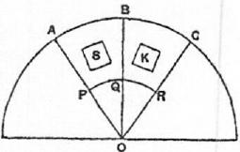
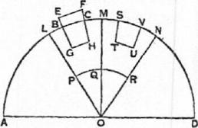

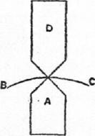
G
4..1.11•10.

ON FLOATING BODIES I 139
PROPOSITION 7
A solid heavier than a fluid will, if placed in. it, descend to the bottom of the fluid, and the solid will, when weighed in the fluid, be lighter than its true weight by the weight of the fluid displaced.
- The first part of the proposition is obvious, since the part of the fluid under the solid Nvill be under greater pressure, and therefore the other parts will give way until the solid reaches the bottom.
- Let A be a solid heavier than the same volume of the fluid, and let (G+11) represent its weight., while G represents the weight of the same volume of the fluid.
Take a solid B lighter than the same volume of the fluid, and such that the weight of B is G, while the weight of the same volume of the fluid is (G+11).
A
Let A and B be now combined into one solid
B
_{H} and immersed. Then, since (A +B) Nvill be of the
same weight as the same volume of fluid, both weights being equal to (G+H)+G, it follows that (A +B) will remain stationary in the fluid. Therefore the force which causes A by itself to sink must he equal to the upward force exerted by the fluid on B by itself. This latter is equal to the difference between (G+H) and [Prop. 6]. Hence A is depressed by a force equal to II, i.e. its weight in the fluid is II, or the difference between ((7-1-11) and G.
POSTUI-1TE
"Let it be granted that bodies which are forced upwards in a fluid are forced upwards along the perpendicular [to the surface] which passes through their centre of gravity."
PROPOSITION 8
If a. solid in the form of a segment of a sphere, and of a substance lighter than a fluid, be immersed in it so that its base does not touch the surface, the solid will rest in. such a position that its axis is perpendicular to the surface; and, if the solid be forced into such a position that its base touches the fluid on one side and be then set free, it will not remain in that position but will return to the symmetrical position.
PROPOSITION 9
If a solid in the form of a segment of a sphere, and of a substance lighter than a fluid, be immersed in it so that its base is completely below the surface, the solid will rest in such a position that its nxis is perpendicular to the surface.
[The proof of this proposition has only survived in a mutilated form. It deals moreover with only one case out of three which are distinguished at the beginning, viz. that in which the segment is greater than a hemisphere. . . .]
Suppose, first, that the segment is greater than a hemisphere. Let it be cut by a plane through its axis and the centre of the earth; and, if possible, let it be at rest in the position shown in the figure, where AB is the intersection of

140 ARCHIMEDES
the plane with the base of the segment, DE its axis, C the centre of the sphere of which the segment is a part, 0 the centre of the earth.
The centre of gravity of the portion of the segment outside the fluid, as F, lies on OC produced, its axis passing through C.
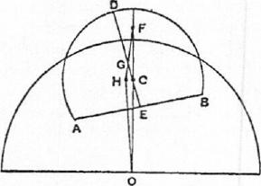
Let G be the centre of gravity of the segment. Join FG, and produce it to II so that
FG : GH = (volume of immersed portion) : (rest of solid).
Join OH.
Then the weight of the portion of the solid outside the fluid acts along FO, and the pressure of the fluid on the immersed portion along 011, while the weight of the immersed portion acts along 110 and is by hypothesis less than the pressure of the fluid acting along OH.
Hence there will not be equilibrium, but the part of the segment towards A will ascend and the part towards B descend, until DE assumes a position perpendicular to the surface of the fluid.

ON FLOATING BODIES
BOOK TWO
PROPOSITION
If a solid lighter than a fluid be at rest in it, the weight of the solid will be to that of
the same volume of the fluid as the immersed portion of the solid is to the whole.
Let (A +B) be the solid, B the portion immersed in the fluid.
Let (C+D) be an equal volume of the fluid,
E C being equal in volume to A and B to D. Further suppose the line E to represent the weight of the solid (A +B), (F +G) to represent the weight of (C+D), and G that of D.
A
F Then
weight of (A +B) : weight of (C+D)
0
E : (F +G). (1)
And the weight of (A + B) is equal to the weight of a volume B of the fluid [I. 5], i.e. to the weight of D.
That is to say, E = G.
Hence, by (1),
weight of (A +B) : weight of (C+D) = G : F+G
=D :C+D
=B:A+B.
PROPOSITION 2
If a right segment of a paraboloid of revolution whose axis is not greater than ip (where p is the principal parameter of the generating parabola), and whose specific gravity is less than that of a fluid, be placed in the fluid with its axis inclined to the vertical at any angle, but so that the base of the segment does not touch the surface of the fluid, the segment of the paraboloid will not remain in that position but will return to the position in which its axis is vertical.
Let the axis of the segment of the paraboloid be AN, and through AN draw a plane perpendicular to the surface of the fluid. Let the plane intersect the paraboloid in the parabola BAB', the base of the segment of the paraboloid in BB', and the plane of the surface of the fluid in the chord QQ' of the parabola.
Then, since the axis AN is placed in a position not perpendicular to QQ', BB' will not be parallel to QQ'.
Draw the tangent PT to the parabola which is parallel to QQ', and let P be the point of contact.'
'The rest of the proof ... is given in brackets as supplied by Commandinus.
141

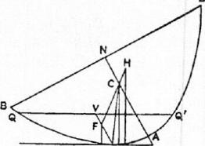
L PKM | T

142 ARCHIMEDES
[From 1' draw PI' parallel to AN meeting QQ' in V. Then P1' will be a diameter of the parabola, and also the axis of the portion of the paraboloid immersed in the fluid.
Let C he the centre of gravity of the pa-
raboloid BAB', and that of the portion immersed in the fluid. Join FC and produce it to II so that. II is the centre of gravity of the remaining portion of the paraboloid
above the surface.
Then, since A N = C,
and AN>b),
it follows that ilC>P
2'
Therefore, if CP he joined, the angle CPT
is acute. Hence, if CK be drawn perpendicular to PT, K will fall between P and T. And, if FL, HM be drawn parallel to CK to meet P7', they Neill each be perpendicular to the surface of the fluid.
Now the force acting on the immersed portion of the segment of the paraboloid will act upwards along LF, while the weight. of t he portion outside the fluid will act downwards along JIM.
Therefore there will not be equilibrium, but the segment will turn so that B will rise and B' will fall, until AN takes the vertical position.]
PROPOSITION 3
If a right segment of a paraboloid of revolution whose axis is not greater than ip (where p is the parameter), and whose specific gravity is less than that of a fluid, be placed in the fluid with its axis inclined at any angle to the vertical, but so that its base is entirely submerged, the solid will not remain in that position but will return to the position in which the axis is vertical.
Let the axis of the paraboloid be AN, and through AN draw a plane perpendicular to the surface of the fluid intersecting the paraboloid in the parabola BAB', the base of the segment in BNB', and the plane of the surface of the
fluid in the chord QQ' of the parabola.
Then, since AN, as placed, is not perpendicular to the surface of the fluid, QQ' and BB' will not be parallel.
Draw PT parallel to QQ' and touching the
parabola at P. Let PT meet NA produced in tzt
T. Draw the diameter PV bisecting QQ' in V. PV is then the axis of the portion of the paraboloid above the surface of the fluid.
Let C be the centre of gravity of the whole segment of the paraboloid, F that of the portion above the surface. Join FC and produce
it. to II so that H is the centre of gravity of the immersed portion.
Then, since A C> -₂, the angle CPT is an acute angle, as in the last proposition.
MK PL
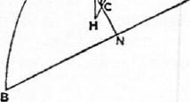

ON FLOATING 130D1ES II 143
Hence, if CK be drawn perpendicular to PT, K will fall between P and 'P. Also, if JIM, FL be drawn parallel to CK, they will be perpendicular to the surface of the fluid.
And the force acting on the submerged portion will act upwards along HM, while the weight of the rest will act downwards along LF produced.
Thus the paraboloid will turn until it takes the position in which AN is vertical.
PROPOSITION 4
Given a right segment of a paraboloid of revolution whose axis AN is greater than ip (where p is the parameter), and whose specific gravity is less than that of a fluid but bears to it a ratio not less than (A N —1-p) ² : A N², if the segment of the paraboloid be placed in the fluid with its axis at any inclination to the vertical, but so that its base does not touch the surface of the fluid, it will not remain in that position but will return to the position in which its axis is vertical.
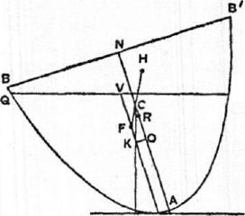Let the axis of the segment of the paraboloid be AN, and let a plane be drawn through AN perpendicular to the surface of the fluid and intersecting the segment in the parabola BAB', the base of the segment in BB', and the surface of the fluid in the chord QQ' of the parabola.
Then AN, as placed, will not be perpendicular to QQ'.
Q' Draw PT parallel to QQ' and touching the
parabola at P. Draw the diameter PV bisecting QQ' in V. Thus PV will be the axis of the submerged portion of the 'solid.
C be the centre of gravity of the whole solid, F that of the immersed portion. Join FC and produce it to H so that H is the centre of gravity of the remaining portion. AN =4AC,
AN>ip,
P
Now, since
and
it follows that
AC > ₂-*
Measure CO along CA equal to -_{2'} and OR along OC equal to -I-AO.
Then, since AN =IAC,
and AR
we have, by subtraction, NR WC.
That is, AN—AR=WC
=iP,
or AR= (AN — tp).
Thus (AN ---ip)² AN² =AR² : AN²,
and therefore the ratio of the specific gravity of the solid to that of the fluid is, by the enunciation, not less than the ratio AR² AN².
But, by Prop. 1, the former ratio is equal to the ratio of the immersed portion to the whole solid, i.e. to the ratio PV² : AN² [On Conoids and Spheroids, Prop. 24].
Hence PV² : AN²<AR² : AN2,

144 ARCHIMEDES
or PIT<AR.
It follows that PF(=3PV)<1AR
<AO.
If, therefore, OK be drawn from 0 perpendicular to OA, it will meet PF between P and F.
Also, if CK be joined, the triangle KCO is equal and similar to the triangle formed by the normal, the subnormal and the ordinate at P (since CO = 1p or the subnormal, and KO is equal to the ordinate).
Therefore CK is parallel to the normal at P, and therefore perpendicular to the tangent at P and to the surface of the fluid.
hence, if parallels to CK be drawn through F, H, they will be perpendicular to the surface of the fluid, and the force acting on the submerged portion of the solid will act upwards along the former, while the weight of the other portion will act downwards along the latter.
Therefore the solid will not remain in its position but will turn until AN assumes a vertical position.
PROPOSITION 5
Given a right segment of a paraboloid of revolution such that its axis AN is greater than ip (where p is the parameter), and its specific gravity is less than that of a fluid but in a ratio to it not greater than the ratio {AN² — (AN — ip)²} AN², if the segment be placed in the fluid with its axis inclined at any angle to the vertical, but so that its base is completely submerged, it will not remain in that position but will return to the position in which AN is vertical.
Let a plane be drawn through AN, as placed, perpendicular to the surface of the fluid and cutting the segment of the paraboloid in the parabola BAB',
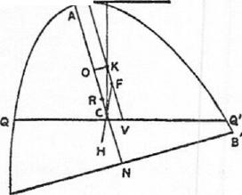the base of the segment in BB', and the T P plane of the surface of the fluid in the chord QQ' of the parabola.
Draw the tangent .PT parallel to QQ', and the diameter PV, bisecting QQ', will accordingly be the axis of the portion of the paraboloid above the surface of the fluid.
Let F be the centre of gravity of the portion above the surface, C that of the whole solid, and produce FC to H, the centre of
gravity of the immersed portion. a
As in the last proposition, Aci>¹-, and we measure CO along CA equal to I
and OR along OC equal to 4.A0.
Then AN =MC, and AR= I-40;
and we derive, as before, AR = (AN —1p).
Now, by hypothesis,
(spec. gravity of solid) : (spec. gravity of fluid)
> tAN²— (AN-179)²i AN²
> (AN² — A R²) : A N² .
Therefore
(portion submerged) : (whole solid)
> (AN= — A R²) : AN²,

ON FLOATING BODIES II 145
and (whole solid) : (portion above surface)
> A" : A /V.
Thus AN2 1.72_{> A} N2 A R2,
whence PV <A R,
and PF<AR
SAO.
Therefore, if a perpendicular to AC be drawn from 0, it will meet. PF in
some point K between P and F.
And, since CO =D), CK Nv i 11 be perpendicular to PT, as in the last prop-
osition.
Now the force acting on the submerged portion of the solid will act upwards
through If, and the weight of the other portion downwards through F, in direc-
tions parallel in both cases to CK; whence the proposition follows.
PROPOSITION 6
If a right segment. of a paraboloid lighter than a fluid be such that its axis AM is greater than p, but AM :1-p <15 : 4, and if the segment be placed in. the fluid with its axis so inclined to the vertical that its base touches the fluid, it will never remain in such a position that the base touches the surface in one point only.
Suppose the segment of the paraboloid to be placed in the position described, and let the plane through the axis AM perpendicular to the surface of the fluid intersect the segment of the paraboloid in the parabolic segment BA B' and the plane of the surface of the fluid in BQ.
Take C on AM such that AC =2CM
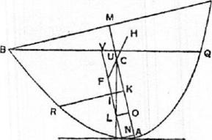
B' (or so that C is the centre of gravity of
the segment of the paraboloid), and measure CK along CA such that
AM :CK=15: 4.
Thus AM : CK>AM by hypo-
thesis; therefore CK
Measure CO along CA equal to Also draw KR perpendicular. to' AC meeting the parabola in R.
Draw the tangent PT parallel to BQ, and through P draw the diameter PV bisecting BQ in V and meeting KR in I.
Then PV :PI_{or>} KM : AK,
"for this is proved."
And CK=AAM =MC;
whence AK=AC—CK=RAC=MM.
Thus KM = MM.
Therefore KM = 4A K.
It follows that PV₀7>IPI,
so that ^{Pl}or<^{2117.}
Let F be the centre of gravity of the immersed portion of the paraboloid, so that PF = 2FV. Produce FC to H, the centre of gravity of the portion above the surface.
Draw OL perpendicular to PV.

146 ARCHIMEDES
Then, since CO=ip, CL must be perpendicular to PT and therefore to the surface of the fluid.
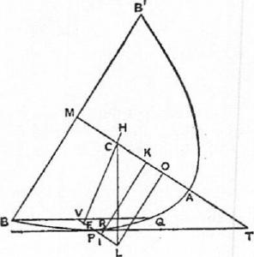
And the forces acting on the immersed portion of the paraboloid and the portion above the surface act respectively upwards and downwards along lines through F and H parallel to CL.
Hence the paraboloid cannot remain in the position in which B just touches the surface, but must turn in the direction of increasing the angle PTM.
The proof is the same in the case where the point I is not on VP but on VP produced, as in the second figure.
PROPOSITION 7
Given a right segment of a paraboloid of revolution lighter than a fluid and such
that its axis AM is greater than ?_{f}p, but.A : !,p, <15 : 4, if the segment be placed
in the fluid so that its base is entirely submerged, it will never rest in such a position that the base touches the surface of the fluid at one point only.
Suppose the solid so placed that one point of the base only (B) touches the surface of the fluid. Let the plane through B arid the axis AM cut the solid in the parabolic segment. BAB' and the plane of the surface of the fluid in the chord BQ of the parabola.
Let C be the centre of gravity of the segment., so that A C= 2C3/; and measure CK along CA such that
AM :CK =15 : 4.
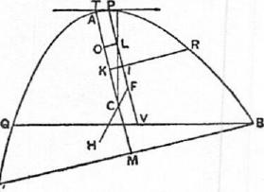
It follows that CK<lp.
Measure CO along CA equal to Draw KR perpendicular to AM. meeting the parabola in R.
Let PT, touching at P, be the tangent to the parabola which is parallel to BQ, and PV the diameter bisecting BQ, the axis of the portion of the paraboloid above the surface.
Then, as in the last proposition, we prove that
PI"
- or> -
and PI = 2/1⁷.
or<
Let F be the centre of gravity of the portion of the solid above the surface; join FC and produce it to H, the centre of gravity of the portion submerged.
Draw OL perpendicular to PV, and, as before, since CO = i p, CL is perpendicular to the tangent PT. And the lines through H, F parallel to CL are perpendicular to the surface of the fluid; thus the proposition is established as before.
The proof is the same if the point I is not on VP but on VP produced.

ON FLOATING BODIES II 147
PROPOSITION S
Given a solid in the form of a right segment of a paraboloid of revolution whose axis
AM is greater than 4p, but such that AM < 15 : 4, and whose specific gravity
bears to that of a fluid a ratio less than (AM — p)² : A M², then, if the solid be placed in the fluid so that its base does not touch the fluid and its axis is inclined at an angle to the vertical, the solid will not return to the position. in which its axis is vertical and will not remain in any position except that in which its axis makes with the surface of the fluid a certain angle to be described.
Let am be taken equal to the axis AM, and let c be a point ,on am such that ac = 2cm. Measure co along ca equal to 3p, and or along oc equal to 2a°.

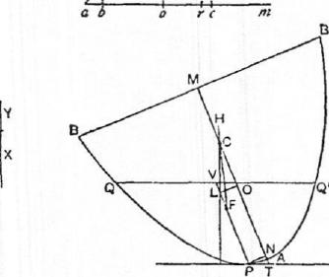
4
0
01
I,
C
P
Let X+ Y be a straight line such t hat
(spec. gr. of solid) : (spec. gr. of
fluid) = (X+ : am², (a)
and suppose X =2Y.
Now ar=4ao= a(iorn— 1p)
=am —41)
= AM —
Therefore, by hypothesis,
(X+ Y)² : ant" <ar' : am',
whence (X+ Y) <ar, and therefore
X <ao.
Measure ob along oa equal to X, and draw bd perpendicular to ab and of such
length that bd²=lco • ab. ((3)
Join ad.
Now let the solid be placed in the fluid with its axis AM inclined at an angle to the vertical. 'Ishrough AM draw a plane perpendicular to the surface of the fluid, and let this plane cut the paraboloid in the parabola BAB' and the plane of the surface of the fluid in the chord QQ' of the parabola.
Draw the tangent PT parallel to QQ', touching at I', and let PV be the diameter bisecting QQ' in V (or the axis of the immersed portion of the solid), and PN the ordinate from P.
Measure AO along AM equal to ao, and OC along OM equal to oc, and draw OL perpendicular to PV.
I. Suppose the angle 07'P greater than the angle dab.
Thus PA" : NT²>db² : ba².
But PN² : N T²= p : 4A N
=co : NT,
and db² : ba²= leo : ab, by (a).
Therefore NT < 2ab,
or AiV<ab,
whence NO>bo (since ao =AO)
>X.
Now (X+ 1¹)" : ant' = (spec. gr. of solid) : (spec. gr. of fluid) = (portion immersed) : (rest of solid)

148 ARCHIMEDES
= PV² :
so that X+Y=PV.
But PL(=NO)> X
>3(X+ Y), since X= 2Y,
>IPV,
or PV <iPL,
and therefore PL> 2LV.
Take a point F on PV so that PP =2FV , i.e. so that F is the centre of grav-
ity of the immersed portion of the solid.
Also AC= ac= lam= 3AM, and therefore C is the centre of gravity of the
whole solid.
Join FC and produce it to //, the centre of gravity of the portion of the solid
above the surface.
Now, since CO=ip, CL is perpendicular to the surface of the fluid;
therefore so are the parallels to CL through and II. But the force on the
immersed portion acts upwards through F and that on the rest of the solid
downwards through II.
Therefore the solid will not rest but turn in
the direction of diminishing the angle 3ITP.
- Suppose the angle OTP less than the angle dab. In this case, we shall have, instead of the above results, the following,

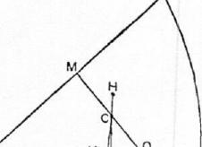
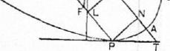
AN>ab,
NO <X.
Also P > iPL,
and therefore PL <2LT' .
Make PF equal to 2FV, so that is the centre of gravity of the immersed portion.
And, proceeding as before, we prove in this case that the solid will turn in the direction of increasing the angle MTP.
- When the angle MTP is equal to the angle dab, equalities replace inequalities in the results obtained, and L is itself the centre of gravity of the immersed portion. Thus all the forces act in one straight line, the perpendicular CL; therefore there is equilibrium, and the solid will rest in the position described.
PROPOSMON 9
Given a solid in the form of a right segment of a paraboloid of revolution whose axis AM is greater than p, but such that AM : ?_{i}p< 15 : 4, and whose specific gravity bears to that of a fluid a ratio greater than {AM²— (AM —;p)²} : AM², then, if the solid be placed in the fluid with its axis inclined at an angle to the vertical but so that its base is entirely below the surface, the solid will not return to the position in which its axis is vertical and will not remain in any position except that in which its axis makes with the surface of the fluid an angle equal to that described in the last proposition.
Take am equal to AM, and take c on am such that ac =2cm. Measure co along ca equal to ip, and or along ac such that ar= gao.
Let X+ Y he such a line that

ON FLOATING BODIES II 149
(spec. gr. of solid) : (spec. gr. of fluid) = lam² — (X+ Y)9 : am², and suppose X = 2Y.
Now ar = lap

^{d}  A  ab | 0 | II  re | m

T
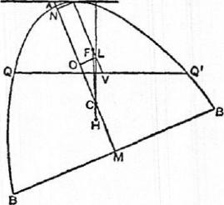
=1(lam—p)
=AM—b.
Therefore, by hypothesis,
am²—ar² :am' < {amt — (X+ Y)9 : am²,
,. whence X-F-Y<ar,
and therefore
Make ob (measured along oa) equal
to X, and draw bd perpendicular to ba
X <ao.
and of such length that
bd²= lc° • ab.
Join ad.
Now suppose the solid placed as in the figure with its axis AM inclined to the vertical. Let the plane through AM perpendicular to the surface of the fluid cut the solid in the parabola BAB' and the surface of the fluid in QQ'. Let PT be the tangent parallel to QQ', PV the diameter bisecting QQ' or) the axis of the portion of the paraboloid above the surface), PN the ordinate from P.
I. Suppose the angle MTP greater than the angle dab. Let AM be cut as before in C and 0 so that AC = 2CM , OC =ip, and accordingly AM, am are equally divided. Draw OL perpendicular to PV.
Then, we have, as in the last proposition,
PN² : NT²>db² : ba²,
whence co :NT>lco : ab,
and therefore AN <ab.
It follows that NO>bo
>X.
Again, since the specific gravity of the solid is to that of the fluid as the
immersed portion of the solid to the whole,
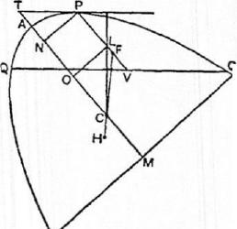AM²— (X+ Y)² : AM²=AM²—PV² AM²,
or (X+ Y)² : AM²=PV² : AM².
That is, X+Y=PV.
And PL (or NO)> X
8' > §PV,
so that PL>2LV.
Take F on PV so that PF =2FV. Then F is the centre of gravity of the portion of the solid above the surface.
Also C is the centre of gravity of the whole solid. Join FC and produce it to H, the centre of gravity of the immersed portion.
Then, since CO = ip, CL is perpendicular to PT and to the surface of the fluid; and
the force acting on the immersed portion of the solid acts upwards along the

150
Parallel to CL through H, while the weight. of the rest of the solid acts downwards along the parallel to CL through F.
Hence the solid will not rest but turn in the direction of diminishing the angle MTP.
II. Exactly as in the last proposition, we prove that, if the angle MTP be less than the angle dab, the solid will not remain in its position but will turn in the direction of increasing the angle MTP.
I If. If the angle MTP is equal to the angle dab, the solid will rest. in that position, because L and F will coincide, and all the forces will act along the one line CL.
PROPOSITION 10
Given a solid in the form of a right segment of a paraboloid of revolution in which the axis AM is of a length such that AM : ip> 15 : 4, and supposing the solid placed in a fluid of greater specific gravity so that its base is entirely above the surface of the fluid, to investigate the positions of rest.
(PRELIMINARY)
Suppose the segment of the paraboloid to be cut by a plane through its axis AM in the parabolic segment BA B_{i} of which BB₁ is the base.
Divide AM at C so that AC= 2CM, and measure CK along CA so that
AM : CK =15 : 4,
(a)
whence, by the hypothesis, CK>ip.
Suppose CO measured along 8 M-M: D
CA equal to ₂ p, and take a point 1? on AM such that
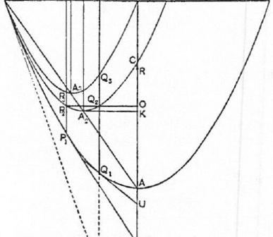
MR = NCO.
'Thus AR= A — MR
=3-(AC—CO)
=3Ao.
Join BA, draw KA₂ perpendicular to AM meeting BA in Az, bisectBA in A₃, and draw A2312, A 3M3 parallel to AM meeting BM in M2, M3 respectively.
On A 2M2, A ₃M₃ as axes describe parabolic segments similar to the segment BA B₁. (It follows, by similar triangles, that BM will be the base of the seg-
ment whose axis is A ₃³/₃ and ,E
RB2 the base of that whose axis
is A₂M₂, where BB2=2BM2.)
The parabola BA₂R₂ will then
pass through C.
[For
13M2:M2M=BM2:A₂K
=KM :AK

ON FLOATING BODIES II 151
=CM+CK : AC—CK
= (§4⁻is)A ji (3 — "YAM
=9:6 (i3)
=MA :AC.
Thus C is seen to be on the parabola BA2B2 by the converse of Prop. 4 of the Quadrature of the Parabola.]
Also, if a perpendicular to AM be drawn from 0, it will meet the parabola BA ₂B2 in two points, as Q2,. 'P2. Let Q1Q2Q₃D be drawn through Q2 parallel to AM meeting the parabolas BA B_{i}, BA ₃M respectively in Q₁, Q₃ and BM in D; and let PIP2P3 be the corresponding parallel to A M through P₂. Let the tangents to the outer parabola at P_{I}, Q₁ meet MA produced in T₁, U respectively.
Then, since the three parabolic segments are similar and similarly situated, with their bases in the same straight line and having one common extremity, and since Q1Q2Q3D is a diameter common to all three segments, it follows that
Q1(22 : Q2(23= (B2/31 : B_{I}B) • (B.1/ : MB2).
Now B213₁ : 13₁13=MM₂: BM (dividing by 2)
=2 : 5, by means of (t3) above.
And BM :MB₂=11:11 : (2BM2 — BM)
 | =5 : (6-5),  =5:1. | by means of (0),
It follows that  or  Similarly  Also, since | : (22(23= 2 : 1, Qd22=2(22Q3.1 P iP2= 2P 2P3.  MR= WO =  AR=AM—MR  = A M —ip.

(ENLINTIATIoN)
If the segment of the paraboloid be placed in the fluid with its base entirely above
the surface, then
(I.) if
(spec. gr. of solid) : (spec. gr. of fluid)<A R² : AM²
[ <(AM 1p)² : AM²],
the solid will rest in the position in which its axis AM is.vertical;
(11.) if
(spec. yr. of `solid) : (spec. gr. of fluid) < A R² : AM²
but>Q1Q3² : AM²,
the solid will not rest with its base touching the surface of the fluid in one pint
only, but in such a position that its bate doss .zot touch the surface at any point
and its axis makes with the 'surface an angle* greater than U;
("II. a) if
(spec. gr. of solid) : (spec. yr. of fluid)=Q₁Q₃² AM²,
the solid will rest and remain in the position in which the base touches the surface
of the fluid at one point only and the axis Makes-with,the surface an angle equal
to U;
(III. b) if
(spec. gr. of solid) : (spec. gr. of fluid) = 1)₁₁)₃2 _{A} M2,
the solid will rest with its base touching the surface of the fluid at one point only
and with its axis inclined to the surface at ati angle equal to T1;

152 ARCHIMEDES
- if
(spec. gr. of solid) : (spec. gr. of fluid)> PiP₃² : AM²
but <Q₁Q₃² : AM²,
the solid will rest and remain in a position with its base more submerged;
- if
(spec. gr. of solid) : (spec. gr. of fluid) <P₁P3² : AM²,
the solid will rest in a position in which its axis is inclined to the surface of the
fluid at an angle less than T₁, but so that the base does not even touch the surface
at one point.
(PROOF)
- Since AM > ip, and
(spec. gr. of solid) : (spec. gr. of fluid) < (A AI : A M²,
it follows, by Prop. 4, that the solid will be in stable equilibrium with its axis
vertical.
- In this case
(spec. gr. of solid) : (spec. gr. of fluid) <A R² : AM²
but > QIQ ₃² : A 11².

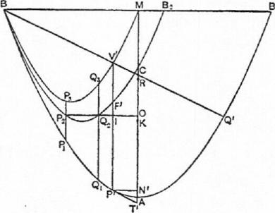
1

Suppose the ratio of the specific gravities to be equal to /² : A M², so that
l<AR but >Q1(23.
Place P'V' between the two parabolas BABI, BP₃ Q₃M equal to land paral-
lel to AM; and let P'V' meet the intermediate parabola in P.
Then, by the same proof as before, we obtain
P'F' =2F'V'.
Let P'T', the tangent at P' to the outer parabola, meet MA in 7", and let
P'N' be the ordinate at P'.
.Join BV' and produce it to meet the outer parabola in Q'. Let OQ₂1'₂ meet
PT' in I.
Now, since, in two similar and similarly situated parabolic segments with
bases BM, BB_{i} in the same straight line, BV', BQ' are drawn making the same
angle with the bases,
By' : BQ' =BM : BB_{I}
=1 :2,
so that BV' = V'Q'.

ON FLOATING BODIES II 153
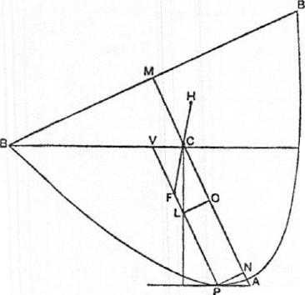Suppose the segment of the paraboloid placed in the fluid, as described, with its axis inclined at an angle to the vertical, and with its base touching the surface at one point B only. Let the solid be cut by a plane through the axis and perpendicular to the surface of the fluid, and let the plane intersect the solid in the parabolic segment BAB' and the plane of the .surface of the fluid in BQ.
Take the points C, 0 on AM as before described. Draw the tangent parallel to BQ touching the parabola in P and meeting AM in T; and let PV be the diameter bisecting BQ (i.e. the axis of the
^{T} immersed portion of the solid).
Then /² : AM² = (spec. gr. of solid) : (spec. gr. of fluid) = (portion immersed) : (whole solid) =PV² : AM²,
whence P'V'=/=Pl⁷.
Thus the segments in the two figures, namely BP'Q', BPQ, are equal and
similar.
Therefore L PTN = L P' 7"N'.
Also AT = AT', AN =AN', PN =P'N'.
Now, in the first figure, P'I <2117'.
Therefore, if OL be perpendicular to PV in the second figure,
PL<2LV.
Take F on LV so that PF=2FV, i.e. so that F is the centre of gravity of the immersed portion of the solid. And C is the centre of gravity of the whole solid. Join FC and produce it to H, the centre of gravity of the portion above the surf ace.
Now, since CO = 2 p, CL is perpendicular to the tangent at P and to the surface of the fluid. Thus, as before, we prove that the solid will not rest with B touching the surface, but will turn in the direction of increasing the angle PTN.
Hence, in the position of rest., the axis AM must make with the surface of the fluid an angle greater than the angle U which the tangent at Q₁ makes with AM.
(III. a) In this case
(spec. gr. of solid) : (spec. gr. of fluid) (2₌ ,Q32 AM². •
•
Let the segment of the paraboloid be placed in the fluid so that its base nowhere touches the surface of the fluid, and its axis is inclined at an angle to the vertical.
Let the plane through AM perpendicular to the surface of the fluid cut the paraboloid in the parabola BAB' and the plane of the surface of the fluid in QQ'. Let PT be the tangent parallel to QQ', PV the diameter bisecting QQ', PN the ordinate at P.

154 ARCHIMEDES
Divide AM as before at C, 0.
In the other figure let Q₁N'. be the ordinate at Q_{i}. Join BQ3 and produce it
to meet the outer parabola in q. Then BQ₃=Q₃q, and the tangent Q_{i}U is
parallel to Bq. Now
Q₁(2₃² : A111² = (spec. gr. of solid) : (spec. gr. of fluid)
= (portion immersed) : (whole solid)
=PV² : AM².
Therefore QiQa=PV; and the
segments QPQ', BQ_{l}q of the
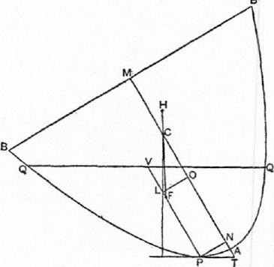
paraboloid are equal in volume.
And the base of one passes
through B, while the base of the
other passes through•Q, a point
nearer to A than B is.
It follows that the angle be-
tween QQ' and BB' is less than
the angle B_{i}Bq.
Therefore
U< ZPTN,
whence AN' > AN,
and therefore
N'0(or Q1Q2) <PL,
where OL is perpendicular to
PV.
It follows, since Q1Q₂ = 2Q2Q3,
that M B, PL>2LV.
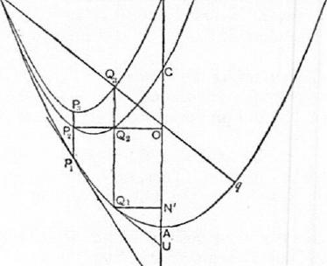
Therefore F, the centre of gravity of the immersed portion of the solid, is between P and L, while, as before, CL is perpendicular to the surface of the fluid.
Producing FC to H, the centre of gravity of the portion of the. solid above the surface, we see that the solid must turn in the direction of diminishing the angle PTN until one point B of the base just touches the surface of the fluid. When this is the case, we shall
have a segment BPQ equal and similar to the segment BQiq, the angle PTN will be equal to the angle U, and AN will be equal to AN'.
Hence in this case PL = 2LV, and F, L coincide, so that F, C, H are all in one vertical straight line.
Thus the paraboloid will remain in, the position in which one point B of the base touches the surface of the fluid, and the axis makes with the surface an angle equal to U.

ON FLO.ATING BODIES II 155
(III. b) In the case where
(spec. gr. of solid) : (spec. gr. of fluid) = P_{i}P₃² AM², we can prove in the same way that, if the solid be placed in the fluid so that its axis is inclined to the vertical and its base does not anywhere touch the surface of the fluid, the solid will take up and rest in the position in which one point only of the base touches the surface, and the axis is inclined to it at an angle
equal to (in the figure on p. 552).
(IV.) In this case
(spec. gr. of solid) : (spec. gr. of fluid) > PiP3² AM²
but <Q1(23² : AM².
Suppose the ratio to be equal to /² : AM², so that l is greater than PiP3 but
less than (2₁(2₃.
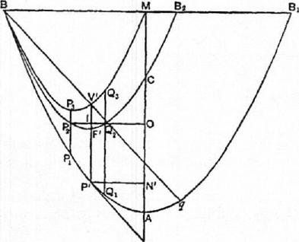 | Place P'V' between the parabolas BPa_{l}, BP₃ Q₃ so that P'V' is equal to 1 and parallel to AM, and let P'V' meet the intermediate parabola in F' and 0Q₂P₂ in I.  Join BV' and produce it to meet the outer parabola in q. Then, as before, BY' =  and accordingly the tangent P'T' P' is parallel to Bq. Let /FA" be the ordinate of P'.  1. Now let the segment be placed in the fluid, first, with its axis so inclined to the vertical that its base does not
anywhere touch the surface of the fluid.
Let the plane through AM perpendicular to the surface of the fluid cut the paraboloid in the parabola BAB' and the plane of the surface of the fluid in (2(2'. Let PT be the tangent parallel to QQ', PV the diameter bisecting QQ'. Divide AM at C, 0 as before, and draw 0/, perpendicular to PV.
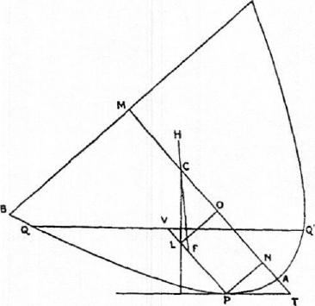
Then, as before, we have PT' =1= PP.
Thus the segments BP' q, QPQ' of the paraboloid are equal in volume; and it follows that the angle between QQ' and BB' is less than the angle B_{i}Bq.
Therefore
L 1"1"A" < L PTN, and hence A /V> A N,
so that NO > N'0,
i.e. PL>P1
> P'F', a fortiori.

156 ARCHIMEDES
Thus PL>2LV, so that F, the centre of gravity of the immersed portion of the solid, is between L and P, while CL is perpendicular to the surface of the
fluid.
s'
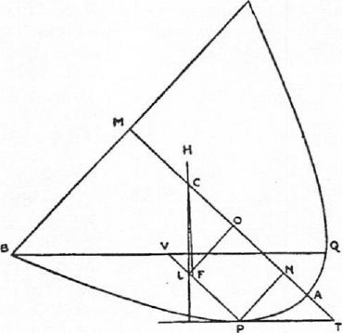
If then we produce FC to H, the centre of gravity of the portion of the solid above the surface, we prove that the solid will not rest but turn in the direction of diminishing the angle PTN.
2. Next let the paraboloid be so placed in the fluid that its base touches the surface of the fluid at one point B only, and let the construction proceed as before.
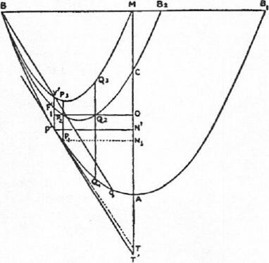
Then PV =P'V', and the segments BPQ, BP'q are equal and similar, so that PTN = L P'T'N'.
It follows that AN = AN', NO = N'0,
and therefore P'I = PL,
whence PL> 2LV.

ON FLOATING BODIES II 157
Thus F' again lies between P and L, and, as before, the paraboloid will turn in the direction of diminishing the angle PTN, i.e. so that the base will be more submerged.
(V.) In this case
(spec. gr. of solid) : (spec. gr. of fluid) <P₁P₃² : AM².
If then the ratio is equal to /² : All1²,1<P₁1³₃. Place P'V' between the parabolas BP1Q1 and BP3Q3 equal in length to 1 and parallel to AM. Let P'V' meet the intermediate parabola in F' and OP₂ in I.
Join BV' and produce it to meet the outer parabola in q. Then, as before, BV'=V'q, and the tangent P'T' is parallel to Bq.
1. Let the paraboloid be so placed in the fluid that its base touches the surface at one point only.
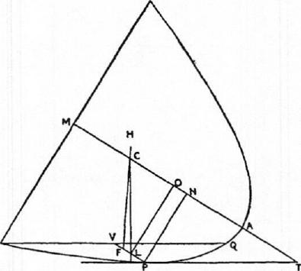
Let the plane through AM perpendicular to the surface of the fluid cut the
paraboloid in the parabolic section BAB' and the plane of the surface of the
fluid in BQ.
Making the usual construction, we find
PV=1=P'T",
and the segments BPQ, BPiq are equal and similar.
Therefore L PTN = L P'T'N',
and AN =AN', N'0=NO.
Therefore PL = P' I,
whence it follows that PL<2LV.
Thus F, the centre of gravity of the immersed portion of the solid, lies between L and V, while CL is perpendicular to the surface of the fluid.
Producing FC to II, the centre of gravity of the portion above the surface, we prove, as usual, that there will not be rest, but the solid will turn in the direction of increasing the angle PTN, so that the base will not anywhere touch the surface.

158 ARCHINIEDES
2. The solid will however rest in a position where its axis makes with the surface of the fluid an angle less than T1.
8'
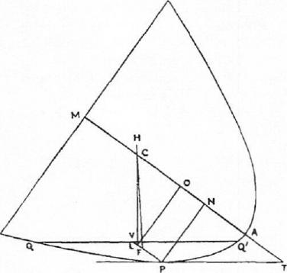
For let it be placed so that the angle PTN is not less than T₁. Then, with the same construction as before, PV =1= P'V'.
And, since T 4: L T₁,
.4N>:1?1'₁,
and therefore NO <N/0, where P1N1 is the ordinate of Pi.
fence PL <P₁P2.
But, P₁P2>P'F'.
Therefore PL> 3P1',
so that F, the centre of gravity of the immersed portion of the solid, lies between P and L.
Thus the solid will turn in the direction of diminishing the angle PTN until that angle becomes less than T1.

BOOK OF LEMMAS
PROPOSITION 1
If two circles touch at A, and if BD, EF be parallel diameters in. them, A DF is a straight line.
Let 0, C be the centres of the circles, and let OC be joined and produced to A. Draw DH parallel to AO meeting OF in II.
A
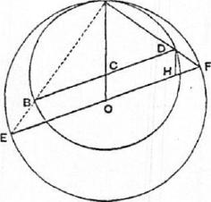
Then, since 0II = CD = CA,
and' OF=0A,
we have, by subtraction, HF=CO=DH.
Therefore Z /MP = Zing).
Thus both' the triangles CAD, HDF are isos-
celes, and the third angles ACD, DHF in each
are equal. Therefore the equal angles in each
are equal to one another, and
LADC= &DM.
Add to each the angle CDF, and it follows that
Z ADC+ ZCDF= LCDF-1- ZDFII
= (two right angles).
Hence ADF is a straight line.
The same proof applies if the circles touch externally.
PROPOSITION 2
Let AB be the diameter of a semicircle, and let the tangents to it at B and at any other point D on it meet in T. If now DE be drawn perpendicular to AB, and if A7', DE meet in F,
DF =FE.
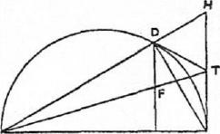
A
a
Produce AD to meet 13T produced in H. Then the angle ADB in the semicircle is right; therefore the angle BDH is also right. And TB, TD are equal.
Therefore '1' is the centre of the semicircle on BH as diameter, which passes through D.
Hence HT = TB.
And, since DE, HB are parallel, it follows that DF=FE.
159

160
ARCHIMEDES
PROPOSITION 3
Let P be any point on a segment of a circle whose base is AB, and let PN be per-
pendicular to AR. Take D on AB so that AN =ND. If now PQ be an. arc equal
to the arc PA, and BQ be joined,
BQ, BD shall be equal.
Join PA, PQ, PD, DQ.
Then, since the arcs PA, PQ are equal,
PA = PQ.
But, since AN =ND, and the angles at
iNT are right,
PA =PD.
Therefore PQ = PD,
and L PQD = L PDQ.
Now, since A, P, Q, B are coneyclic,
.L PAD- Z PQB = (two right angles),
whence L 1'DA + L PQB = (two right angles)
= ZPDA+ L PDB.
Therefore L PQB = L PDB;
(Ind, since the parts, the angles PQD, PDQ, are equal,
BQD= Z BDQ,
and BQ = BD.
PROPOSITION 4
If AB be the diameter of a semicircle and N any point on AR, and if semicircles be described within the first semicircle and haring AN, RN as diameters respectively, the figure included between the circumferences of the three semicircles is "what Archimedes called an apOnXos" ;¹ and its area is equal to the circle on. PN as diameter, where PN is perpewlicida.r to AB and meets the original semicircle
in P.
For
A B² = A N² + NI3²+ 2A N •NB
= A N²+N B²+ 2PA". But circles (or semicircles) are to one another as the squares of their radii (or diameters).
Hence
(semicircle on AB) = (sum of
semicircles on AN, NB)
+2(semicircle on PN).
That is, the circle on PN as diameter is equal to the difference between the semicircle on AB and the sum of the semicircles on AN, NB, i.e. is equal to the area of the apfinXos.
PROPOSITION 5
Let AB be the diameter of a semicircle, C any point on AB, and CD perpendicular toil, and let semicircles be described within the first semicircle and having AC, CB a's diameters. Then, if two circles be drawn touching CD on different sides and each touching two of the semicircles, the circles so drawn will be equal.
Let one of the circles touch CD at E, the semicircle on AB in F, and the semicircle on AC in G.
lapsoo, is literally "a shoemaker's knife."
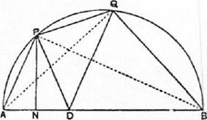
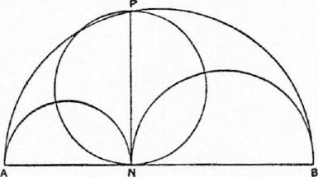

BOOK OI'' LEMMAS 161
I)ra.w the diameter Eli of the circle, which will accordingly be perpendicular to CD and therefore parallel to AB.
Join F11, HA, and FE, EB. Then, by Prop. 1, FHA, FEB are both straight lines, since EH, AB are parallel.
For the same reason AGE, CGH are straight lines.
Let Al,' produced meet CD in D, and let AE produced meet the outer semicircle in I. Join 131, ID.
Then, since the angles AFB, A CD are right, the straight lines :l1), AB are such that the perpendiculars on each from the extremity of the other meet in the point E. Therefore, by the properties of triangles, AE is perpendicular to the line joining B to D.
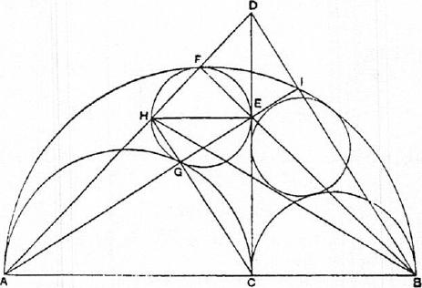
But AE is perpendicular to BI.
Therefore BID is a straight line.
Now, since the angles at G, I are right, CH is parallel to BD.
Therefore AB : BC = AD : DII
=AC :11E,
so that AC • CI3= AB • HE.
In like manner, if d is the diameter of the other circle, we can prove that
AC • CB= AB • d.
Therefore d= HE, and the circles are equal.
PROPOSITION 6
Let AB, the diameter of a semicircle, be divided at C so that AC =g-CB [or in any ratio]. Describe semicircles within the first semicircle and on AC, CB as diameters, and suppose a circle drawn touching all three semicircles. If GII be the diameter of this circle, to find the relation between Gil and AB.
Let Gil be that diameter of the circle which is parallel to AB, and let the circle touch the semicircles on AB, AC, CB in D, E, F respectively.
Join AG, GD and BH, HD. Then, by Prop. 1, AGD, BHD are straight lines. For a like reason AEII, BFG are straight lines, as also are CEG, CF II.
Let AD meet the semicircle on AC in I, and let BD meet the semicircle on CB in K. Join CI, CK meeting AE, BF respectively in L, Al, and let GL, JIM produced meet. AB in N, P respectively.

162 ARCHIMEDES
Now, in the triangle AGC, the perpendiculars from A, C on the opposite sides meet in L. Therefore, by the properties of triangles, GLN is perpendicular to AC.
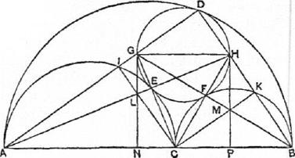
Similarly HMP is perpendicular to CB.
Again, since the angles at I, K, D are right, CK is parallel to AD, and CI to BD.
Therefore AC : CB = AL : LII =AN :NP,
and BC : CA = BM :MG =BP : PN. Hence AN :NP=NP :PB, or AN, NP, PB are in continued proportion.
Now, in the case where AC --gCB,
AN =IN P
whence BP : PN :NA : AB=4 :6:9:19.
Therefore GH=NP=_{T}egAB.
And similarly GH can be found when AC : CB is equal to any other given
ratio.
PROPOSITION 7
If circles be circumscribed about and inscribed in a square, the circumscribed circle is double of the inscribed circle.
For the ratio of the circumscribed to the inscribed circle is equal to that. of the square on the diagonal to the square itself, i.e. to the ratio 2 : 1.
PROPOSITION 8
If AB be any chord of a circle whose centre is 0, and if AB be produced to C so that
BC is equal to the radius; if further CO meet the circle in D and be produced to
meet the circle a second time in E, the arc AE will be equal to three times the arc
BD.
Draw the chord EF parallel to AB, and
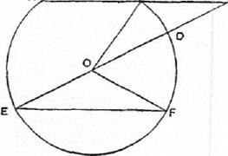
join OB, OF.
Then, since the angles OEF, OFE are
equal,
LCOF =2 LOBE
=2 L BCO, by parallels,
=2 z .BOD, Since BC = BO.
Therefore
LBOF=3 L BOI),
so that the arc BF is equal to three times the arc BD.
Hence the arc A E, which is equal to the arc BF, is equal to three times the
arc BD.
l'itorozirrioN 9
If in a circle two chords AB, CD which do not pass through the centre intersect at right angles, then

BOOK OF LEMMAS 163
(arc AD)-1- (arc CB) = (arc AC)-F (arc DB).
Let the chords intersect at 0, and draw the diameter EF' parallel to AB
intersecting CD in H. EF will thus bisect CD at
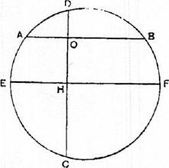
right angles in H, and
(arc ED)= (arc EC).
Also EDF, ECF are semicircles, while
(arc ED) = (arc EA) -F (are AD).
Therefore
(sum of arcs Cl", EA, AD)= (arc of a semicircle).
And the arcs AE, BF are equal.
Therefore
(arc CB)-1- (arc Al))= (arc of a semicircle).
Hence the remainder of the circumference, the
sum of the arcs AC, DB, is also equal to a semi-
circle; and the proposition is proved.
l'aoposrrioN 10
Suppose that TA, TB are two tangents to a circle, while TC cuts it. Let RD he the chord through B parallel to 7¹C, and let AD meet TC in E. Then, if EH be drawn perpendicular to BD, it will bisect it in H.
Let AB meet TC in F, and join RE.
Now the angle TAB is equal to the angle in the alternate segment., i.e.
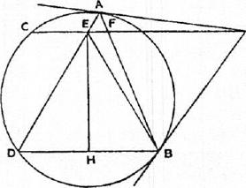
.L TAB= LAUB
= L AET, by parallels. Hence the triangles EAT, AFT have one angle equal and another (at T) common. They are therefore similar, and FT : A7' = A : ET. Therefore ET •TF =TA'
= TB².
It follows that the triangles EBT, BFT are similar.
Therefore LTER= LITT
= Z TAB.
But the angle TEB is equal to the angle EI3D, and the angle TAB was
proved equal to the angle EDB.
Therefore L EDB = L E BD .
And the angles at H are right angles.
It follows that BH =HD.
PROPOSITION 11
if two chords AB, CD in a circle intersect at right angles in a. point 0, not being
the centre, then
A0²4-B0²-FCO²+ DO' =(diameter)².
Draw the diameter CE, and join AC, CR, AD, BE.

184 ARCIiIMEDES  Then the angle CAO is equal to the angle CEB in the same segment, and the angles AOC, EBC are right; therefore the triangles AOC, EBC are similar, and  LACO= Z EC B  It follows that the subtended arcs, and therefore the chords AD, BE, are equal.  Thus (A0²+D0²)+ (B0²-1- CO²) = AD²+BC²  = BE²+ BC' =CE². | 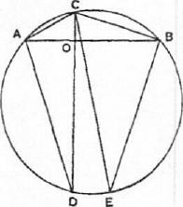

PROPOSITION 12
If AB be the diameter of a semicircle, and TP, 7'Q the tangents to it from any
point T, and if AQ, BP be joined meeting in R, then TR is perpendicular to AB.
Let TI? produced meet AB in M, and join PA, QB.
Since the angle APB is right,
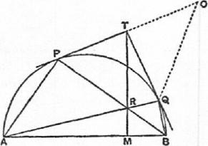
L PAB+ L PBA = (a right angle)
= LAQB.
Add to each side the angle RBQ, and
L PA B + LQBA= (exterior) L PRQ.
But
LTPR= LPAB, and Z TQR= ZQBA,
in the alternate segments;
therefore L TYR+ LTQR= ZPRQ.
It follows from this that
TP= TQ =TR.
[For, if PT be produced to 0 so that TO = TQ, we have
LTOQ= L TQO.
And, by hypothesis, L PRQ= L TPR+TQR.
By addition, Z POQ+ ZPRQ= L TPR+OQR.
It follows that, in the quadrilateral OPRQ, the opposite angles are together equal to two right angles. Therefoie a circle will go round OPQR, and T is its centre, because TP = TO = 7¹Q. Therefore TR=TP.]
Thus Z 7'RP = L TPR= L PAM.
Adding to each the angle PRM ,
Z PAM + LPRH= T RP + LPRH
= (two right angles).
Therefore L APR+ LAM!? = (two right angles),
whence Z A MR= (a right angle).
PROPOSITION 13
A
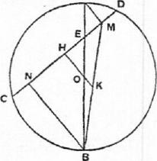
If a diameter AB of a circle meet any chord CD, not a diameter, in E, and if AM, BN be drawn perpendicular to CD, then
CN =
Let 0 be the centre of the circle, and OH perpendicular to CD. Join BM, and produce HO to meet BM in K.
Then CH =IID.

And, by parallels, since  Therefore  Accordingly | BOOK OF LEMMAS 165  BO =OA,  BK = KM.  NH=HM.  CN = DM.

PROPOSITION 14
Let ACB be a semicircle on AB as diameter, and let AD, BE be equal lengths measured along AB from A, B respectively. On AD, BE as diameters describe semicircles on the side towards C, and on 1)E as diameter a semicircle on the opposite side. Let the perpendicular to AB through 0, the centre of the first semicircle, meet the opposite semicircles in C, F respectively.
Then shall the area of the figure bounded by the circumferences of all the semicircles be equal to the area of the circle on CF as diameter.
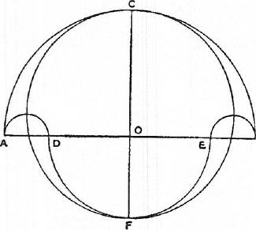By Eucl. II. 10, since ED is bisected at 0 and produced to A, EA²+AD²=2(E0²+0A²), and CF=OA+OE=EA. Therefore
AB²-1-DE²=4(E0²+0A²)=
2(CF²+AD²).
But circles (and therefore semis circles) are to one another as the squares on their radii (or diameters). Therefore
(sum of semicircles on AB, DE)
= (circle on CF) + (sum of semicircles on AD, BE).
Therefore
(area of "salinon") = (area of circle on CF as diam.).
PROPOSITION 15
Let AB be the diameter of a circle, AC a side of an inscribed regular pentagon, D
the middle point of the arc AC. Join CD and produce it to meet BA produced in
E; join AC, DB meeting in F, and draw FM perpendicular to AB. Then
EM = (radius of circle).
Let 0 be the centre of the circle, and join DA, DM, DO, CB.
Now L A BC = (right angle),
and Z ABD = Z DBC = Wight angle),
whence L AOD=2.(right angle).
Further, the triangles FCB, FMB are equal in all respects.
Therefore, in the triangles DCB, DMB, the sides CB, MB being equal and
BD common, while the angles CBI), MB!) are equal,
L BCD = L BALD = 2- (right angle).
But L BCD+ L BAD = (two right angles)
= ZBAD+ ZDAE
= ZBMD+ Z DMA,
so that LDAE= Z BCD,
and LBAD= Z AMD.
Therefore A D = MD.

168 ARCHINI WES
Now, in the triangle DMO,
L MOD = (right angle),
Z DM0 = *(right angle).
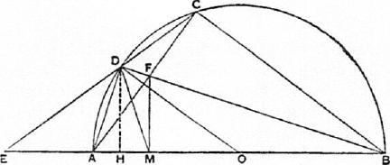
Therefore L ODM = 1.(right angle) = AOD;
whence OM = MD.
Again L EDA = (supplement of ADC)
= L C BA
= (right angle)
=
Therefore, in the triangles EDA, ODM,
L EDA = L ODM,
LEAD = L OM D,
and the sides AD, MD are equal.
Hence the triangles are equal in all respects, and
EA =MO.
Therefore EM =AO.
Moreover DE = DO; and it follows that, since DE is equal to the side of an inscribed hexagon, and DC is the side of an inscribed decagon, EC is divided at D in extreme and mean ratio [i.e. EC : ED = ED : DC]; "and this is proved in the book of the Elements." [Eucl. xtu. 9: "If the side of the hexagon and the side of the decagon inscribed in the same circle be put together, the whole straight line is divided in extreme and mean ratio, and the greater segment is the side of the hexagon."]

THE METHOD TREATING OF MECHANICAL
PROBLEMS
"Archimedes to Eratosthenes greeting.
"I sent you on a former occasion some of the theorems discovered by me, merely writing out the enunciations and inviting you to discover the proofs, which at the moment I did not give. The enunciations of the theorems which I sent were as follows:
- "If in a right prism with a parallelogrammic base a cylinder be inscribed which has its bases in the opposite parallelograms,' and its sides [i.e. four generators] on the remaining planes (faces) of the prism, and if through the centre of the circle which is the base of the cylinder and (through) one side of the square in the plane opposite to it a plane be drawn, the plane so drawn will cut off from the cylinder a segment which is bounded by two planes and the surface of the cylinder, one of the two planes being the plane which has been drawn and the other the plane in which the base of the cylinder is, and the surface being that which is between the said planes; and the segment cut off from the cylinder is one sixth part of the whole prism.
- "If in a cube a cylinder be inscribed which has its bases in the opposite parallelograms² and touches with its surface the remaining four planes (faces), and if there also be inscribed in the same cube another cylinder which has its bases in other parallelograms and touches with its surface the remaining four planes (faces), then the figure bounded by the surfaces of the cylinders, which is within both cylinders, is two-thirds of the whole cube.
"Now these theorems differ in character from those communicated before; for we compared the figures then in question, conoids and spheroids and segments of them, in respect to size, with figures of cones and cylinders: but none of those figures have yet been found to be equal to a solid figure bounded by planes; whereas each of the present figures bounded by two planes and surfaces of cylinders is found to be equal to one of the solid figures which are hounded by planes. The proofs then of these theorems I have written in this book and now send to you. Seeing moreover in you, as I say, an earnest student, a man of considerable eminence in philosophy, and an admirer [of mathematical inquiry], I thought fit to write out foryou and explain in detail in the same book the peculiarity of a certain method, by which it will be possible for you to get a start to enable you to investigate some of the problems in mathematics by means of mechanics. This procedure is, I am persuaded, no less useful even for the proof of the theorems themselves; for certain things first became clear to me by a mechanical method, although they had to be demonstrated by geom-
'The parallelogramS are apparently squtzres.
²i.e. squares.
167

168 ARCHINIEDES
etry afterwards because their investigation by the said method did not furnish an actual demonstration. But it is of course easier, when we have previously acquired, by the method, some knowledge of the questions, to supply the proof than it is to find it without any previous knowledge. This is a reason why, in the case of the theorems the proof of which Eudoxus was the first to discover, namely that the cone is a third part of the cylinder, and the pyramid of the prism, having the same base and equal height, we should give no small share of the credit to Democritus who was the first to make the assertion with regard to the said figure though he did not prove it. I am myself in the position of having first made the discovery of the theorem now to be published [by the method indicated], and I deem it necessary to expound the method partly because I have already spoken of it and I do not want to be thought to have uttered vain words, but equally because I am persuaded that it will be of no little service to mathematics; for I apprehend that some, either of my contemporaries or of my successors, will, by means of the method when once established, be able to discover other theorems in addition, which have not yet occurred to me.
"First then I will set out the very first theorem which became known to me by means of mechanics, namely that
"Any segment of a section of a right-angled cone (i.e. a parabola) is four-thirds of the triangle which has the same base and equal height,
and after this I will give each of the other theorems investigated by the same method. Then, at the end of the book, I will give the geometrical" [proofs of the propositions]...
[I premise the following propositions which I shall use in the course of the work.]
- "If from [one magnitude another magnitude be subtracted which has not the same centre of gravity, the centre of gravity of the remainder is found by] producing [the straight line joining the centres of gravity of the whole magnitude and of the subtracted part in the direction of the centre of gravity of the whole] and cutting off from it a length which has to the distance between the said centres of gravity the ratio which the weight of the subtracted magnitude has to the weight of the remainder." [On the Equilibrium of Planes, I. 8]
- "If the centres of gravity of any number of magnitudes whatever be on the same straight line, the centre of gravity of the magnitude made up of all
of them will be on the same straight line." [Cf. Ibid. i. 5]
- "The centre of gravity of any straight line is the point of bisection of the
straight line." [Cf. Ibid. I. 4]
- "The centre of gravity of any triangle is the point in which the straight lines drawn from the angular points of the triangle to the middle points of the
(opposite) sides cut one another." [Ibid. I. 13, 14]
- "The centre of gravity of any parallelogram is the point in which the
diagonals meet." [Ibid. I. 10]
- "The centre of gravity of a circle is the point which is also the centre [of the circle]."
- "The centre of gravity of any cylinder is the point of bisection of the axis."
- "The centre of gravity of any cone is [the point which divides its axis so that] the portion [adjacent to the vertex is] triple [of the portion adjacent to the base]."

'1'IlE 'METHOD TREATING Oh MECHANICAL PROBLEMS 169
[All these propositions have already been] proved.' [Besides these I require also the following proposition, which is easily proved:
If in two series of magnitudes those of the first series are, in order, proportional to those of the second series and further], "the magnitudes [of the first series], either all or some of them, are in any ratio whatever [to those of a third series], and if the magnitudes of the second series are in the same ratio to the corresponding magnitudes [of a fourth series], then the sum of the magnitudes of the first series has to the sum of the selected magnitudes of the third series the same ratio which the sum of the magnitudes of the second series has to the sum of the (correspondingly) selected magnitudes of the fourth series." [On Conoids and Spheroids, Prop. 1.]
PROPOSITION 1
Let ABC be a segment of a parabola bounded by the straight line AC and
the parabola ABC, and let, D be the middle point of AC. Draw the straight line
DBE parallel to the axis of the parabola and join AB, BC.
Then shall the segment ABC be 4- of the triangle ABC.
From A draw AKF parallel to DE, and let the tangent to the parabola at C
meet DBE in E and AKF in F. Produce CB to meet AF in K, and again pro-
duce CK to H, making KH equal to CK.
Consider CII as the bar of a balance, K being its middle point.
Let MO be any straight line parallel to ED, and let it meet CF, CK, AC in
M, N, O and the curve in P.
Now, since CE is a tangent. to the parabola and CD the semi-ordinate,
EB=BD;
"for this is proved in the Elements [of Conics]."²
H Since FA, MO are parallel to ED, it follows that
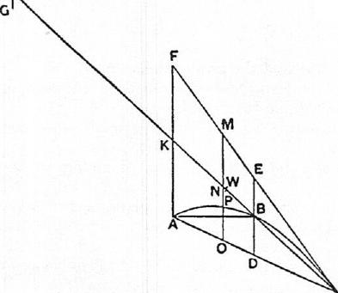FK=KA, MN=NO.
Now, by the property of the parabola, "proved in a lemma,"
MO : OP =CA : AO [Cf. Quad-rature of Parabola, Prop. 5]
=CK : KN
[Encl. vi. 2] =LIK : KN.
Take a straight line TG equal to OP, and place it with its centre of gravity at II, so that TH=I1G; then, since N is the centre of gravity of tile straight line MO, and
MO : TG=HK:KN,
it follows that TG at H and MO at N will be in equilibrium about K. [On the Equilibrium of Planes, I. 6, 7]
'The problem of finding the centre of gravity of a cone is not solved in any extant work
of Archimedes.
²1.e. the works on conies by Aristaeus and Euclid.

170 ARCHIMEDES
Similarly, for all other straight lines parallel to DE and meeting the arc of the parabola, (1) the portion intercepted between PC, AC with its middle point on KC and (2) a length equal to the intercept between the curve and AC placed with its centre of gravity at H will be in equilibrium about K.
Therefore K is the centre of gravity of the whole system consisting (1) of all the straight lines as MO intercepted between FC, AC and placed as they actually are in the figure and (2) of all the straight lines placed at H equal to the straight lines as PO intercepted between the curve and AC.
And, since the triangle CFA is made up of all the parallel lines like MO, and the segment CBA is made up of all the straight lines like PO within the curve,
it follows that the triangle, placed where it is in the figure, is in equilibrium about K with the segment CBA placed with its centre of gravity at H. Divide KC at W so that CK = 3KW;
then TV is the centre of gravity of the triangle ACP; "for this is proved in the books an equilibrium" (iv rocs I _cropportKois).
[Cf. On the Equilibrium of Planes r. 151
Therefore PACT : (segment ABC) =7IK : KW
=3 : 1.
Therefore segment ABC = 3 CF.PA
But. AACF=4AABC.
Therefore Segment A BC = 4-PARC.
"Now the fact here stated is not actually demonstrated by the argument
used; but that argument has given a sort of indication that the conclusion is true. Seeing then that the theorem is not demonstrated, but at the same time suspecting that the conclusion is true, we shall have recourse to the geometrical demonstration which I myself discovered and have already published."
PROPOSITION 2
We can investigate by the same method the propositions that.
- Any sphere is (in respect of solid content) four times the cone with base equal to a great circle of the sphere and height equal to its radius; and
- the cylinder with base equal to a great circle of the sphere and height equal to the diameter is 11 times the sphere.
(1) Let, ABCD he a great circle of a sphere, and AC, BD diameters at right angles to one another.
Let a circle be drawn about BD as diameter and in a plane perpendicular to A C,and on this circle as base let a cone he described with A as vertex. Let the surface of this cone he produced and then cut by a plane through C parallel to its base; the section will be a circle on EP as diameter. On this circle as base let a cylinder be erected with height and axis AC, and produce CA to H, making AH equal to CA.
Let CH be regarded as the bar of a balance, A being its middle point.
Draw any straight line MN in the plane of the circle ABCD and parallel to BD. Let MN meet the circle in 0, P, the diameter AC in 8, and the straight lines AE, AP in Q, R respectively. Join AO.
Through MN draw a plane at right angles to AC;

THE METHOD TREATING OF MECHANICAL PRO13LENIS 171
this plane will cut the cylinder in a circle with diameter MN, the sphere in a
circle with diameter OP, and the cone in a circle with diameter QR.
Now, since MS =AC, and QS= AS,
MS •SQ=CA -AS
—A0²
=08²+8Q².
And, since HA = AC,
HA : AS=CA :AS
=MS : SQ
=.ALS² : MS •SQ
=11S² : (0S²+SQ²),
from above,
= ItIN² (0P²+QR²)
= (circle, diam. MN) : (circle, diam. OP
+circle, diam. QR).
That is,
HA :AS = (circle in cylinder) : (circle in sphere+circle in cone).
Therefore the circle in the cylinder, placed where it is, is in equilibrium, about A, with the circle in the sphere together with the circle in the cone, if both the latter circles are placed with their centres of gravity at H. Similarly for the three corresponding sections made by a plane perpendicular to AC and passing through any other straight line in the parallelogram 1,F parallel to EF.
If we deal in the same way with all the sets of three circles in which
M_{i} ^{N} planes perpendicular to AC cut the
OQ
SR P
cylinder, the sphere and the cone,
8
o
and which make up those solids respectively, it follows that the cylinder, in the place where it is, will be in equilibrium about A with
the sphere and the cone together, when both are placed with their centres of gravity at II.
Therefore, since K is the centre of gravity of the cylinder,
HA : A K = (cylinder) : (sphere + cone A ER).
But I1A = 2A K,
therefore cylinder = 2(sphere+ cone A EF).
Now cylinder = 3(cone AEF); [Euel. xII. 10]
therefore cone AEF = 2(sphere).
But, since EF = 2BD,
cone AEF=8(cone A BD);
therefore sphere = 4(cone ABD).
(2) Through B, D draw VBTV, XDY parallel to AC;
and imagine a cylinder which has AC for axis and the circles on VX, WY as
diameters for bases.
x
1
G
K,)

E
C Y
w

172 ARCIIINIEDES
Then cylinder V Y = 2(cylinder VI))
= 6(cone ABU) [Euel. xii. 10]
= (sphere), from above.
"From this theorem, to the effect that a sphere is four times as great as the cone with a great circle of the sphere as base and with height equal to the radius of the sphere, I conceived the notion that the surface of any sphere is four times as great as a great circle in it; for, judging from the fact that any circle is equal to a triangle with base equal to the circumference and height equal to the radius of the circle, I apprehended that, in like manner, any sphere is equal to a cone with base equal to the surface of the sphere and height equal to the radius."
PROPOSITION 3
By this method we can also investigate the theorem that
A cylinder with base equal to the greatest circle in a spheroid and height equal
to the axis of the spheroid is 11 times the spheroid;
and, when this is established, it is plain that
If any spheroid be cut by a plane through the centre and at right angles to the
axis, the half of the spheroid is double of the cone which has the same base and the
same axis as the segment (i.e. the half of the spheroid).
Let a plane through the axis of a spheroid cut its surface in the ellipse
ABCD, the diameters (i.e. axes) of which are AC, BD; and let K be the centre.
Draw a circle about BD as diame-
ter and in a plane perpendicular to
V A X
G
0 Q |  | S | R | "
₆r |  |  |  |  | D
/...1(

E w C
AC; imagine a cone with this circle as base and A as vertex produced and cut by a plane through C parallel to its base; the section will be a circle in a plane at right angles to AC and about EF as diameter.
Imagine a cylinder with the latter circle as base and axis AC; produce CA to II, making AH equal to CA.
Let HC be regarded as the bar of a balance, A being its middle point.
In the parallelogram LF draw any straight line MN parallel to EF meeting the ellipse in 0, P and AE, AF, AC in Q, R, S respectively.
If now a plane be drawn through MN at right angles to A C, it will cut the cylinder in a circle with diame-
ter MN, the spheroid in a circle with diameter OP, and the cone in a circle with diameter QR.

THE METHOD TREATING OF MECHANICAL PROBLEMS 173
Since HA= AC,
HA : AS=CA :AS
=EA : AQ
=MS : SQ.
Therefore
HA : AS = MS' : MS •SQ.
But, by the property of the ellipse,
AS •Se : 80²=AK²:KB²
=AS² : SQ²;
therefore SQ² : 80² = A : AS • SC
=SQ²:SQ • QM,
and accordingly SO⁹= SQ • Q31.
Add SQ² to each side, and we have
80²+8Q²=SQ •SM
Therefore, from above, we have
HA : AS= MS² : (SO²+ SQ²)
(0P²+QR²)
= (circle, diam. MN) : (circle, diam. OP-Fcircle, diam. QR).
That is,
HA :.4S= (circle in cylinder) : (circle in spheroid-I-circle in cone).
Therefore the circle in the cylinder, in the place where it is, is in equilibrium,
about A, with the circle in the spheroid and the circle in the cone together, if
both the latter circles are placed with their centres of gravity at H.
Similarly for the three corresponding sections made by a plane perpendicu-
lar to AC and passing through any of her straight line in the parallelogram LP
parallel to EF.
If we deal in the same way with all the sets of three circles in which planes
perpendicular to AC cut the cylinder, the spheroid and the cone, and which
make up those figures respectively, it follows that the cylinder, in the place
where it is, will be in equilibrium about A with the spheroid and the cone
together, when both are placed with their centres of gravity at II.
Therefore, since K is the centre of gravity of the cylinder,
HA : AK= (cylinder) : (spheroid+cone A EF).
But. HA =2AK;
therefore cylinder = 2(spheroid+cone AEF).
111(1 cylinder =3(cone A EP); [Eucl. xii. 101
therefore cone AEI,' = 2(spheroid).
But, since EP =2BD,
cone AEF = 8(cone ADD);
therefore spheroid = 4(cone ABD),
and half the spheroid = 2(cone ABD).
Through B, D draw 1⁷1311⁷, XDY parallel to AC;
and imagine a cylinder which has AC for axis and the circles on VX, WY as
diameters for bases.
Then cylinder VY=2(cylinder VD)
=6(cone ADD)
=Rspheroid), from above. Q.E.D.

174 ARCHIMEDES
Prtorosrmos 4
Any segment of a right-angled conoid (i.e. a paraboloid of revolution) cut off by a
plane at right angles to the axis is 12 times the cone which has the same base and
the same axis as the segment.
This can be investigated by our method, as follows.
I,et a paraboloid of revolution be cut by a plane through the axis in the
parabola BA C;
and let it also be cut by another plane at right angles to the axis and intersect-
ing the former plane in BC. Produce DA, the axis of the segment, to II, making
HA equal to AD.
Imagine that HD is the bar of a balance, A being its middle point.
The base of the segment being the circle on BC as diameter and in a plane
perpendicular to AD,
imagine (1) a cone drawn with the latter
circle as base and A as vertex, and (2) a
cylinder with the same circle as base and
A D as axis.
In the parallelogram EC let any straight
line MN be drawn parallel to BC, and
through MN let a plane be drawn at right
angles to AD; this plane will cut the cylin-
der in a circle with diameter MN and the
paraboloid in a circle with diameter OP.
Now, BAC being a parabola and BD,
OS ordinates,
DA : AS= BD : 08²,
or HA : AS= MS² : AS0².
Therefore
: AS= (circle, rad. MS) : (circle, rad. OS)
= (circle in cylinder) : (circle in paraboloid).
Therefore the circle in the cylinder, in the place where it is, will be in equilibrium about A with the circle in the paraboloid, if the latter is placed with its centre of gravity at H.
Similarly for the two corresponding circular sections made by a plane perpendicular to AD and passing through any other straight line in the parallelogram which is parallel to BC.
Therefore, as usual, if we take all the circles making up the whole cylinder and the whole segment and treat them in the same way, we find that the cylinder, in the place where it is, is in equilibrium about A with the segment placed with its centre of gravity at II.
If K is the middle point of AD, K is the centre of gravity of the cylinder;
therefore HA : AK= (cylinder) : (segment).
Therefore cylinder = 2(segment).
And cylinder = 3(cone ABC); [Encl. XII. 10]
therefore segment = (cone A BC).

THE METHOD TREATING OF MECHANICAL PROBLEMS 175
PuoPosrrioN 5
The centre of gravity of a segment of a right-angled conoid (i.e. a paraboloid of
revolution) cut off by a plane at right angles to the axis is on the straight line which
is the axis of the segment, and divides the said straight line in such a way that the
portion of it adjacent to the vertex is double of the remaining portion.
This can be investigated by the method, as follows.
Let a paraboloid of revolution be cut by a plane through the axis in the
parabola BAC;
and let it also be cut by another. plane at right angles to the axis and intersect-
ing the former plane in 13C.
Produce DA, the axis of the segment, to H, making HA equal to AD; and
imagine 1)11 to be the bar of a balance, its middle. point being A.
The base of the segment being the circle on 13C as diameter and in a plane
perpendicular to .41),
imagine a cone with this circle as base and A as vertex, so that AB, AC are
generators of the conc.
In the parabola let any double ordinate
H OP be drawn meeting .4/3, A D, AC in Q, 8,
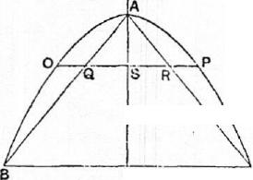1? respectively.
Now, from the property of the parabola,
BD² : OS' = DA : AS
= 13D : QS
=131)= : BD • QS.
Therefore OS²= BD • QS,
BD : OS=08 : QS,
whence R D : QS = 0S² : QS'.
But ED : QS = .4 D ::15
=1111 :AS.
Therefore HA :AS=OS' : QS'
K = OP' :
If now through OP a plane he drawn at right angles to AD, this plane cuts the par-c aboloid in a circle with diameter OP and
the cone in a circle with diameter Qll.
We see therefore that. HA :AS= (circle, diam. OP) : (circle, diam. QH)
= (circle in paraboloid) : (circle in cone); and the circle in the paraboloid, in the place where it is, is in equilibrium about :1 with the circle in the cone placed with its centre of gravity at H.
Similarly for the two corresponding circular sections made by a plane perpendicular to AD and passing through any other ordinate of the parabola.
Dealing therefore in the same way with all the circular sections which make up the whole of the segment of the paraboloid and the cone respectively, we see that the segment of the paraboloid, in the place where it is, is in equilibrium about A. with the cone placed with its centre of gravity at II.
Now, since II is the centre of gravity of the whole system as placed, and the centre of gravity of part of it , namely the cone, as placed, is at H, the centre of gravity of the rest, namely the segment, is at a point K on HA produced
such that 11A : AK = (segment) : (cone).
But segment = (cone). [Prop. 4]

176 ARCHIMEDES
Therefore IIA = xAK;
that is, K divides AD in such a way that AK =2KD.
PaorosrrioN 6
The centre of gravity of any hemisphere [is on the straight line which] is its axis,
and divides the said straight line in such a way that the portion of it adjacent to the
surface of the hemisphere has to the remaining portion the ratio which 5 has to 3.
Let a sphere be cut by a plane through its centre in the circle 4WD;
let AC, BD he perpendicular diameters of this circle,
and through BD let a plane be drawn at right angles to A C.
The latter plane will cut the sphere in a circle on BD as diameter.
Imagine a cone with the latter circle as base and A as vertex.
Produce CA to II, making A H equal to CA, and let //C be regarded as the
bar of a balance, A being its middle point.
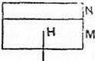
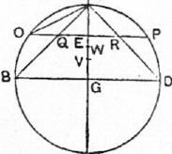
In the semicircle BAD, let any straight line OP be
drawn parallel to BD and cutting AC in E and the two
generators. A B, Al) of the cone in Q, R respectively.
Join AO.
Through OP let. a plane be drawn at right angles to
A C;
this plane \Viii cut the hemisphere in a circle with di-
ameter OP and the cone in a circle with diameter QR.
Now
IIA :AE=AC:AE
=AO' : AE²
= (0E²+:1E²) : AE²
(0E²+QE²) : QE2
= (circle, dizun. OP circle, diam. : (circle, diam. Therefore the circles with diameters OP, QR, in the
places where they are, are in equilibrium about A with the circle with diameter Ql? if the latter is placed with its centre of gravity at. II.
And, since the centre of gravity of the two circles with diameters VP, QR taken together, in the place where they are, is . .
[There is a lacuna here; but the proof can easily be completed on the lines of the corresponding but more difficult case in Prop. 8.
We proceed thus from the point where the circles with diameters OP, QR, in the place where they are, balance, about A, the circle with diameter QR placed with its centre of gravity at H.
A similar relation holds for all the other sets of circular sections made by other planes passing through points on AG and at right angles to AG.
Taking then all the circles which fill up the hemisphere BAD and the cone ABD respectively, we find that
the hemisphere BAD and the cone ABD, in the places where they are, together balance, about A, a cone equal to ABD placed with its centre of gravity at H. Let the cylinder 111+N be equal to the cone ABD.
Then, since the cylinder M+N placed with its centre of gravity at H balances the hemisphere BAD and the cone ABD in the places where they are, suppose that the portion M of the cylinder, placed with its centre of gravity at

TIIE METHOD TREATING OI'' MECHANICAL PROBLEMS 177
H, balances the cone A 131) (alone) in the place where it, is; therefore the portion N of the cylinder placed with its centre of gravity at II balances the hemisphere (alone) in the place where it is.
Now the centre of gravity of the cone is at a point V such that AG =4GV, therefore, since M at II is in equilibrium with the cone,
ill : (cone) = 4AG : HA = C : AC,
whence M = (cone).
But 1/-1-N.= (cone); therefore N= „(cone).
Now let the centre of gravity of the hemisphere be at. TV, which is somewhere
on AG.
Then, since Nat II balances the hemisphere alone,
(hemisphere) : N= HA : ATV.
But the hemisphere BAD= twice the cone ABD;
[On the Sphere and Cylinder I. 34 and Prop. 2 above]
and N = 4(cone), from above.
Therefore 2 : s = HA : A TV
=2AG : ATV,
whence AlV =r1,-AG, so that TV divides AG in such a way that
: !VG= 5 : 3.]
PROPOSITION 7
We can also investigate by the same method the theorem that
[Any segment of a sphere has] to the cone [with the same base and height the ratio which the sum of the radius of the sphere and the height of the complementary segment has to the height of the complementary segment.]
[There is a lacuna here; but all that is missing is the construction, and the construction is easily understood by means of the figure. BAD is of course the
_{H} segment of the sphere the vol-
ume of which is to be compared
with the volume of a cone with the same base and height.]
A
0 Q
_

The plane drawn through MN and at right angles to AC will cut the cylinder in a circle with diameter MN, the segment of the sphere in a circle with diameter OP, and the
N cone on the base EIS' in a circle
with diameter QR.
In the same way as before [cf. Prop. 2] we can prove that the circle with diameter MN, in the place where it is, is in equilibrium about A with the two circles with diameters 01', QR if these circles are both moved and placed with their centres of gravity at II.
The same thing can be proved of all sets of three circles in which the cylin-

178 ARC HIM EDES
der, the segment of the sphere, and the cone with the common height AG are all cut by any plane perpendicular to A C.
Since then the sets of circles make up the whole cylinder, the whole segment of the sphere and the whole cone respectively, it follows that the cylinder, in the place where it is, is in equilibrium about A with the sum of the segment of the sphere and the cone if both are placed with their centres of gravity at H.
Divide AG at TV, V in such a way that
A W= 1VG, AV = 3 VG.
Therefore TV will he the centre of gravity of the cylinder, and V will be the centre of gravity of the cone.
Since, now, the bodies are in equilibrium as described,
(cylinder) : (cone A.EF-Fsegment BAD of sphere) =11A : A W.
[The rest of the proof is lost.; but it can easily be supplied thus: We have
(cone AEF-Fsegmt. BAD) : (cylinder) =A W :AC
=ATV •AC : AC².
But (cylinder) : (cone AEF) = AC² : IEG²
=AC² :AAG².
Therefore, ex aequali,
(cone A EP-1-segmt. BAD) : (cone A EF) = ATV •AC : 3AG²
=1AC :
whence (segmt. BAD) : (cone A EF)= (1AC-³_{s}AG) :
Again (cone A EP) : (cone A BD) = EG² : DG²
=AG' :A_{E}G • GC =AG :G
=1AG:?GC.
Therefore, ex aequali,
(segment BAD) : (cone ABD)=(1AC —1AG) :1GC
=RAC—AG) : GC
=(1.4C+GC) :GC. Q.E.D.1
PROPOSITION 8
[The enunciation, the setting-out, and a few words of the construction are missing.
The enunciation however can be supplied from that of Prop. 9, with which it must be identical except that it cannot refer to "any segment," and the presumption therefore is that the proposition was enunciated with reference to one kind of segment only, i.e. either a segment greater than a hemisphere or a segment less than a hemisphere.
Heiberg's figure corresponds to the case of a segment greater than a hemisphere. The segment investigated is of course the segment BAD. The setting-out and construction are self-evident from the figure.]
Produce AC to II, 0, making HA equal to AC and CO equal to the radius of the sphere;
and let HC be regarded as the bar of a balance, the middle point being A.
In the plane cutting off the segment describe a circle with G as centre and radius (GE) equal to AG; and on this circle as base, and with A as vertex, let a cone be described. AE, A F are generators of this cone.

THE METHOD TREATING OF MECHA\ICAI. PItORLEMIS 179
Draw Kb, through any point Q on AG, parallel to EF and cutting the seg-
ment in K, I., and A E, A in I?, P respectively. Join AK.
Now
/1.1 :AQ=CA : AQ
= AK² AQ²
= (A-Q2 ₄_ Q..1 2) QA 2
= (K(2²-1-PQ²) : PQ²
= (circle, dia.m. diam. PR) : (circle, diam. PR).
Imagine a circle equal to the circle with diameter PIt placed with its centre of gravity at II; herefore the circles on diameters Kb, PI?, in the places where they are, are in equilibrium about A with the circle with diameter PI? placed with its centre of gravity at II.
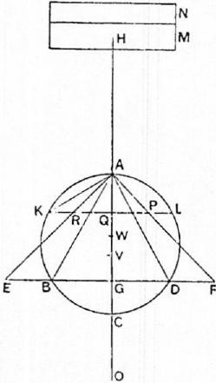
Similarly for the corresponding circular sections made by any other plane perpendicular to AG.
Therefore, taking all the circular sections which make up the segment ABD of the sphere and the cone AEI? respectively, we find that the segment ADD of the sphere and the cone A EF, in the places where they are, are in equilibrium with the cone AEF assumed to be placed with its centre of gravity at H.
Let the cylinder 411+N be equal to the cone AU which has A for vertex and the circle on El" as diameter for base.
Divide AG at V so that
.4G=4VG;
therefore V is the centre of gravity of the cone ARP; "for this has been proved before."
Let the cylinder -}-N be cut by a plane perpendicular to the axis in such a way that the cylinder A/ (alone), placed with its cent re of gravity at II, is in equilibrium with the cone AEF.
Since M-FN suspended at H is in equilibrium with the segment. Al BD of the sphere and the cone AEF in the places where they are,
while M, also at II, is in equilibrium with the cone AEF in the place where it is, it follows that
N at H is in equilibrium with the segment. A BD of the sphere in the place where it is.
Now (segment A lID of sphere) : (cone A BD)= 0(7 : GC;
"for this is already proved" [Cf. On the Sphere and Cylinder Ir. 2 (','or. as well
as Prop. 7 ante].
And (cone ADD) : (cone A El")
= (circle, diam. BD) : (circle, diam. EP) =BD' :EP'
= :(;E'
=CG • GA : GA'
=CG : G.4.

180 ARCIIIMEDES
Therefore, cx acquali,
(segment ABD of sphere) : (cone .4 EF)=OG :GA.
Take a point TV on AG such that
ATV :TVG= (GA+4GC) : (GA+2GC).
We have then, inversely,
GW :TVA=(2GC-FGA):(4GC+GA),
and, componendo,
GA : ATV =(6GC-F2GA) : (4GC ± GA).
But GO= -}(6GC+2GA), [for GO—GC =1(CG+GA)]
and CV = (-1GC-FGA);
therefore GA : A tV=OG : CV,
and, alternately and inversely,
OG : GA = CV : TVA .
It follows, from above, that
(segment ABD of sphere) : (cone AEF)=CV :WA.
Now, since the cylinder 111 with its centre of gravity at 11 is in equilibrium
about A with the cone AEF with its centre of gravity at V,
(cone AEP) : (cylinder M) =11A : A V
=CA : AV;
and, since the cone AEF = the cylinder we have, dividendo and inver-
tendo, (cylinder M): (cylinder N)= AV : CV.
Hence, componendo,
(cone A EF) : (cylinder N) =CA : C
=HA : CV.
But it was proved that
(segment ABD of sphere) : (cone A EF)=CV :WA;
therefore, cx acquali,
(segment ABD of sphere) : (cylinder N)=.H.4 : A IV.
And it was above proved that the cylinder N at H is in equilibrium about A
with the segment ABD, in the place where it is;
therefore, since H is the centre of gravity of the cylinder N, TV is the centre
of gravity of the segment ADD of the sphere.
PROPOSITION 9
In the same way we can investigate the theorem that
The centre of gravity of any segment of a sphere is on the straight line which is the axis of the segment, and divides this straight line in such a way that the part of it adjacent to the vertex of the segment has to the remaining part the ratio which the sum of the axis of the segment and four times the axis of the complementary segment has to the sum of the axis of the segment and double the axis of the complementary segment.
[As this theorem relates to "any segment" but states the same result as that proved in the preceding proposition, it follows that Prop. 8 must have related to one kind of segment, either a segment greater than a semicircle (as in Hei-berg's figure of Prop. 8) or a segment less than a semicircle; and the present proposition completed the proof for both kinds of segments. It would only require a slight change in the figure, in any case.]

THE METHOD TREATING OF MECHANICAL PROBLEMS 181
PROPOSITION 10
By this method too we can investigate the theorem that
[A segment of an obtuse-angled conoid (i.e. a hyperboloid of revolution) has to the cone which has] the same base [as the segment and equal height the same ratio as the sum of the axis of the segment and three times] the "annex to the axis" (i.e. half the transrerse axis of the hyperbolic section through the axis of the hyper-boloid, or, in other words, the distance between the vertex of the segment and the vertex of the enveloping cone) has to the sum of the axis of the segment and double of the "annex" [this is the theorem proved in On Conoids and Spheroids, Prop. 23], "and also many other theorems, which, as the method has been made clear by means of the foregoing examples, I will omit, in order that I may now proceed to compass the proofs of the theorems mentioned above."
PROPOSITION 11
If in a right prism with square bases a cylinder be inscribed having its bases in opposite square faces and touching with its surface the remaining four parallelo-grammic faces, and if through the centre of the circle which is the base of the cylinder and one side of the opposite square face a plane be drawn, the figure cut off by the plane so drawn is one sixth part of the whole prism.
"This can be investigated by the method, and, when it is set out, I will go back to the proof of it by geometrical considerations."
[The investigation by the mechanical method is contained in the two Propositions, 11, 12. Prop. 13 gives another solution which, although it contains no mechanics, is still of the character which Archimedes regards as inconclusive, since it assumes that the solid is actually made up of parallel plane sections and that an auxiliary parabola is actually made up of parallel straight lines in it. Prop. 14 added the conclusive geometrical proof.]
Let there be a right prism with a cylinder inscribed as stated.
Let the prism be cut through the axis of the
_{E} prism and cylinder by a plane perpendicular to
the plane which cuts off the portion of the cylinder; let this plane make, as section, the parallelogram a 13, and let it cut the plane cutting off the portion of the cylinder (which plane is perpendicular to A13) in the straight line BC.
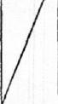
Let CD be the axis of the prism and cylinder,
A V Y let EF bisect it at right angles, and through EF
let a plane be drawn at right angles to CD; this plane will cut the prism in a square and the cylinder in a circle.
Let MN be the square and OPQ1 the circle, and let the circle touch the sides of the square in 0, P, Q, II [F, E in the first figure are identical with 0, Q respectively]. Let II be the centre of the circle.
Let KL be the intersection of the plane through EP' perpendicular to the axis of the cylinder and the plane cutting off the portion of the cylinder; KL is bisected by OHQ [and passes through the middle point of 1/(2].

182 ARCHIMEDES
Let any chord of the circle, as ST, be drawn perpendicular to HQ, meeting HQ in W;
and through ST let a plane be drawn at right angles to OQ and produced on both sides of the plane of the circle OPQR.
The plane so drawn will cut the half cylinder having the semicircle PQR for section and the axis of the prism for height in a parallelogram, one side of which is equal to ST and another is a generator of the cylinder; and it will also cut the portion of the cylinder cut off in a parallelogram, one side of which is equal to ST and the other is equal and parallel to UV (in the first figure).
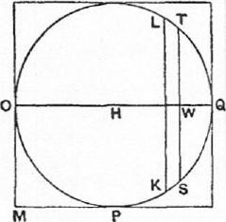
UV will be parallel to BY and will cut off, along Elf in the parallelogram DE, the segment EI equal to Q1V.
Now, since EC is a parallelogram, and VI is parallel to GC,
EG :GI =YC :CV -
=BY : V
= (0 in half cyl.) : (0 in portion of cyl.).
And EG =HQ, GI= QH =OH;
therefore 011:11 IV = (0 in half cyl.) : (O in portion).
Imagine that the parallelogram in the portion of the cylinder is moved and placed at 0 so that 0 is the centre of gravity, and that OQ is the bar of a balance, II being its middle point.
Then, since IV is the centre of gravity of the parallelogram in the half cylinder, it follows from the above that the parallelogram in the half cylinder, in the place where it is, with its centre of gravity at IV, is in equilibrium about H with the parallelogram in the portion of the cylinder when placed with its cent re of gravity at 0.
Similarly for the other parallelogrammic sections made by any plane perpendicular to OQ and passing through any other chord in the semicircle PQR perpendicular to OQ.
1f then we take all the parallelograms making up the half cylinder and the portion of the cylinder respectively, it follows that the half cylinder, in the place where it is, is in equilibrium about H with the portion of the cylinder cut off when the latter is placed with its centre of gravity at 0.
PROPOSITION 12
Let the parallelogram (square) .11 11% perpendicular to the axis, with the circle OPQR and its diameters OQ, PR, be drawn separately.
Join IIG, UM, and through them draw planes at right angles to the plane of the circle, producing them on both sides of that plane.
This produces a prism with triangular section CHM and height equal to the axis of the cylinder; this prism is I of the original prism circumscribing the cylinder.
Let LK, UT be drawn parallel to OQ and equidistant from it, cutting the circle in K, T, RP in S, F, and CH, HM in IV, V respectively.
Through LK, UT draw planes at right angles to PR, producing them on both sides of the plane of the circle;

THE METHOD TREATING OF MECHANICAL PROBLEMS 183
these planes produce as sections in the half cylinder PQR and in the prism GHM four parallelograms in which the heights are equal to the axis of the
cylinder, and the other sides are equal to KS, TF, LW, UV respectively
[The rest of the proof is missing, but, as Zeuthen says, the result obtained and the method of arriving at it are plainly indicated by the above.
Archimedes wishes to prove that the half cylinder PQR, in the place where it is, balances the prism GH.41, in the place where it is, about II as fixed point.
He has first to prove that the elements (1) the parallelogram with side = KS and (2) the parallelogram with side = L1V, in the places where they are, balance about 5, or, in other words that the straight lines SK, LW, in the places where they are, balance about S.
(radius of circle OPQR)2=sK2+ 3112,
SL² = SK² S If".
LiS² AS W² =S10,
G R N
L  0 | 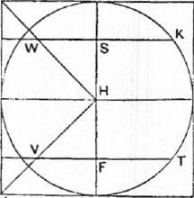

P
Now
or
Therefore
and accordingly (LS-I-SW) •LW =SK²,
whence 1-(LS+SIV) :1,SK=SK : LW.
And ..-(LS-FSIV) is the distance of the centre of gravity of LW from 8, while ISK is the distance of the centre of gravity of 8K from S.
Therefore SK and L W, in the places where they are, balance about S. Similarly for the corresponding parallelograms.
Taking all the parallelogrammic elements in the half cylinder and prism respectively, we find that
the half cylinder PQR and the prism GH.111, in the places where they are respectively, balance about II.
From this result and that of Prop. 11 we can at once deduce the volume of the portion cut off from the cylinder. For in Prop. 11 the portion of the cylinder, placed with its centre of gravity at 0, is shown to balance (about H) the half-cylinder in the place where it is. By Prop. 12 we may substitute for the half-cylinder in the place where it is the prism GHM of that proposition turned the opposite way relatively to RP. The centre of gravity of the prism as thus placed is at a point (say Z) on HQ such that. HZ= 3HQ.
Therefore, assuming the prism to be applied at its centre of gravity, we have
(portion of cylinder) : (prism) = IHQ :OH
=2 :3;
therefore (portion of cylinder) = i(prism GHM)
= *(original prism).
PROPOSITION 13
Let there he a right prism with square bases, one of which is A BCD; in the prism let a cylinder be inscribed, the base of which is the circle EFGH
touching the sides of the square ABCD in E, G, H.
Through the centre and through the side corresponding to CD in the square

184 ARCHIMEDES
face opposite to ABCD let a plane be drawn; this will cut, off a prism equal
to of the original prism and formed by three parallelograms and two triangles,
the triangles forming opposite faces.
In the semicircle ERG describe the parabola which has FK for axis and passes through E, G; draw MN parallel to KI? meeting GE in M, the parabola in L, the semicircle in 0 and CD in N.
Then MN • NL = NIA~²;
"for this is clear." [Cf. Apollonius, Conics I. 11]
[The parameter is of course equal to GK or KF.]
Therefore MN : NL=GK² : LS².
Through MN draw a plane at right angles to
EG ;
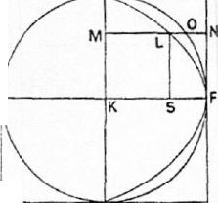this will produce as sections (1) in the prism cut off from the whole prism a right-angled triangle, the base of which is MN, while the perpendicular is perpendicular at N to the plane ABCD and
equal to the axis of the cylinder, and the hypot- H enuse is in the plane cutting the cylinder, and (2) in the portion of the cylinder cut off a right-angled triangle the base of which is MO, while the perpendicular is the generator of the cylinder
perpendicular at 0 to the plane KN, and the A
0
hypotenuse is
[There is a lacuna here, to be supplied as follows.
Since MN : NL=GK² :1,8²
= MN² : LS',
it follows that MN ; ML=MN² : (MN² — LS²)
= MN² : (M N²— MK')
= : MO'.
But the triangle (1) in the prism is to the triangle (2) in the portion of the
cylinder in the ratio of /1/N² : M0².
Therefore (A in prism) : (A in portion of cylinder)
=MN : ML
= (straight line in rect. DG) : (straight line in parabola).
We now take all the corresponding elements in the prism, the portion of the
cylinder, the rectangle DO and the parabola ERG respectively];
and it will follow that
(all the As in prism) : (all the As in portion of cylinder)
= (all the str. lines in ODG) : (all the straight lines between parabola and EG).
But the prism is made up of the triangles in the prism, [the portion of the
cylinder is made up of the triangles in it], the parallelogram DC of the straight
lines in it parallel to KF, and the parabolic segment of the straight lines paral-
lel to KF intercepted between its circumference and EG;
therefore (prism) : (portion of cylinder)
=(C3GD) : (parabolic segment ERG).
But DOD = -(parabolic segment ERG);
"for this is proved in my earlier treatise." [Quadrature of Parabola]
Therefore prism = 4(portion of cylinder).

THE METHOD TBEATINO MIECIIANICAI, PROBLEMS 185
If then we denote the portion of the cylinder by 2, the prism is 3, and the original prism circumscribing the cylinder is 12 (being 4 times the other prism); therefore the portion of the cylinder= i(original prism). Q.E.D. [The above proposition and the next are peculiarly interesting for the fact that the parabola is an auxiliary curve introduced for the sole purpose of analytically reducing the required eubature to the known quadrature of the parabola.]
PnoposrrioN 14
Let there be a right prism with square bases [and a cylinder inscribed therein
having its base in the square ABCD and touching its sides at E, G, 11;
let the cylinder be cut by a plane through EG and the side corresponding to CD in the square face opposite to ABCD1
This plane cuts off from the prism a prism, and from the cylinder a portion of it.
It can be proved that the portion of the cylinder cut off by the plane is * of the whole prism.
But we will first prove that it is possible to inscribe in the portion cut off from the cylinder, and to circumscribe about it, solid figures made up of prisms which have equal height and similar triangular bases, in such a way that the circumscribed figure exceeds the inscribed by less than any assigned magnitude.. ...
But it was proved that
(prism cut off by oblique plane) <1(figure inscribed in portion of cylinder).
Now (prism cut off) : (inscribed figure)
=ODG : (Os inscribed in parabolic segment);
therefore ODG<1(0s in parabolic segment):
which is impossible, since "it has been proved elsewhere" that the parallelo-
gram DG is 1- of the parabolic segment.
Consequently
not greater.
And (all the prisms in prism cut off)
: (all prisms in circumscr. figure)
= (all Os in ODG) : (all Os in fig. circumscr. about parabolic segmt.);
therefore
(prism cut off) : (figure circumscr. about portion of cylinder)
= (ODG) : (figure circumscr. about parabolic segment).
But the prism cut off by the oblique plane is> a of the solid figure circum-
scribed about the portion of the cylinder... :.
[There are large gaps in the exposition of this geometrical proof, but the way in which the method of exhaustion was applied, and the parallelism between this and other applications of it, are clear. The first fragment shows that solid figures made up of prisms were circumscribed and inscribed to the portion of the cylinder. The parallel triangular faces of these prisms were perpendicular to GE in the figure of Prop. 13; they divided GE into equal portions of the requisite smallness; each section of the portion of the cylinder by such a

186 ARCHIMEDES
plane was a triangular face common to an inscribed and a circumscribed right prism. The planes also produced prisms in the prism cut off by the same oblique plane as cuts off the portion of the cylinder and standing on CD as base.
The number of parts into which the parallel planes divided GE was made great enough to secure that the circumscribed figure exceeded the inscribed figure by less than a small assigned magnitude.
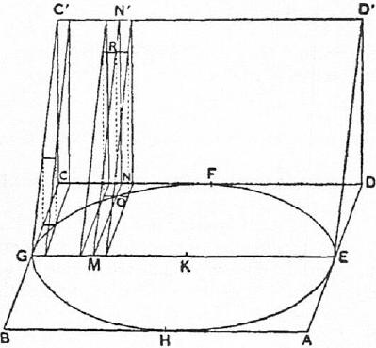
The second part of the proof began with the assumption that the portion of
the cylinder is > 3 of the prism cut off; and this was proved to be impossible,
by means of the use of the auxiliary parabola and the proportion
MN : ML= MN² : MO²
which are employed in Prop. 13.
We may supply the missing proof as follows.
In the accompanying figure are represented (1) the first element-prism circumscribed to the portion of the cylinder, (2) two element-prisms adjacent to the ordinate OM, of which that on the left is circumscribed and that on the right (equal to the other) inscribed, (3) the corresponding element-prisms forming part of the prism cut off (CC'GEDD') which is ₄ of the original prism.
In the second figure are shown element-rectangles circumscribed and inscribed to the auxiliary parabola, which rectangles correspond exactly to the circumscribed and inscribed element-prisms represented in the first figure (the length of GM is the same in both figures, and the breadths of the • element-rectangles are the same as the heights of the element-
prisms) ; the corresponding element-rectangles form- E 0
ing part of the rectangle CD are similarly shown.
For convenience we suppose that CE is divided into an even number of equal parts, so that GK contains an integral number of these parts.

TIIE METHOD TREATING U1 MITIIAN1CAL PROBLEMS 187
For the sake of brevity we will call each of the two element-prisms of which 031 is an edge "el. prism (0)" and each of the element-prisms of which MNN' is a common face "el. prism (N)." Similarly we will use the corresponding abbreviations "el. rect. (L)" and "el. rect. (N)" for the corresponding elements in relation to the auxiliary parabola as shown in the second figure.
Now it is easy to see that the figure made up of all the inscribed prisms is less than the figure made up of the circumscribed prisms by twice the final circumscribed prism adjacent to PK, i.e. by twice "el. prism (N)"; and, as the height of this prism may be made as small as we please by dividing UK into sufficiently small parts, it follows that inscribed and circumscribed solid figures made up of element-prisms can be drawn (Hireling by less than any assigned solid figure.
- Suppose, if possible, that
(portion of cylinder) > 3 (prism cut off),
or (prism cut off) <Rportion of cylinder).
Let (prism cut off) =4(portion of cylinder — X), say.
Construct circumscribed and inscribed figures made up of element-prisms,
such that
(circumscr. fig.) — (inscr. fig.) <X.
Therefore (inscr. fig.) > (circumscr. fig. —X),
and a fortiori > (portion of cyl. — X).
It follows that
(prism cut off) <3.(inscribed figure).
Considering now the element-prisms in the prism cut off and those in the
inscribed figure respectively, we have
el. prism (N) : el. prism (0) =.11 : mo2
= .1/N : L [as in Prop. 13]
=el. rect.. (N) : el. rect. (L).
It follows that
I{ el. prism (N)} : { el. prism (0)} =Ile!. rect. (N)) : ≥ {el. rect. (L)}.
(There are really two more prisms and rectangles in the first and third than
there are in the second and fourth terms respectively; but this makes no differ-
ence because the first and third terms may 1)e multiplied by a common factor
as n/(n-2) without affecting the truth of the proportion. Cf. the proposition
from On Conoids and Spheroids quoted on p. 571 above.)
Therefore
(prism cut off) : (figure inscr. in portion of cyl.)
= (rect. GD) : (fig. inscr. in parabola).
But it was proved above that
(prism cut off) <3(fig. inscr. in portion of cyl.);
therefore (rect. GD) <(fig. inscr. in parabola),
and, a fortiori (rect. GD)<(parabolic segmt.):
which is impossible, since
(rect. GD) = i(parabolie segmt.).
Therefore (portion of cyI.) is not greater than 3(prism cut off).
- In the second lacuna must have come the beginning of the next reductio ad a.bsurdum demolishing the other possible assumption that the portion of the cylinder is < 3 of the prism cut off.
In this case our assumption is that

188 ARCIIIMEDFS
(prism cut off) > (portion of cylinder); and we circumscribe and inscribe figures made up of element-prisms, such that
(prism cut off) > circumscr. about portion of cyl.).
We now consider the element-prisms in the prism cut off and in the circum-
scribed figure respectively, and the same argument as above gives
(prism cut off) : (fig. circumscr. about portion of cyl.)
= (rect. GD) : (fig. circumscr. about parabola),
whence it follows that
(rect. GD)>4(fig. circumscribed about parabola),
and, a fortiori,
(rect. GD) > 4(parabolic segment):
which is impossible, since
(rect. GD) = (parabolic segmt.).
Therefore
(portion of cyl.) is not less than ;(prism cut off).
But it was also proved that neither is it greater;
therefore (portion of cyl.) = 3(prism cut off)
=1₁(original prism).]
[PROPOSITION 15]
[This proposition, which is lost, would be the mechanical investigation of the second of the two special problems mentioned in the preface to the treatise, namely that of the cubature of the figure included between two cylinders, each of which is inscribed in one and the same cube so that its opposite bases are in two opposite faces of the cube and its surface touches the other four faces.
Zeut.hen has shown how the mechanical method can be applied to this case.
In the accompanying figure V IV YX is a section of the cube by a plane (that of the paper) passing through the axis BD of one of the cylinders inscribed in the cube and parallel to two opposite faces.
X
13 | 0 | Q | SR
/ |  |  | K
V11
The same plane gives the circle ABCD as the section of the other inscribed cylinder with axis perpendicular to the plane of the paper and extending on each side of the plane to a distance equal to the radius of the circle or half the M side of the cube.
A C is the diameter of the circle which is perpendicular to BD.
Join AB, AD and produce them to meet the tangent at C to the circle in E, F.
Then EC =CF =CA.
Let LG be the tangent at A, and complete the rectangle EFGL.
Draw straight lines from A to the four corners of the section in which the plane through BD perpendicular to AK cuts the cube. These straight lines, if

THE METHOD TREATING OF MECHANICAL PROBLEMS 189
produced, will meet the plane of the face of the cube opposite to A in four points forming the four corners of a square in that plane with sides equal to EF or double of the side of the cube, and we thus have a pyramid with A for vertex and the latter square for base.
Complete the prism (parallelepiped) with the same base and height as the pyramid.
Draw in the parallelogram LF any straight line MN parallel to EF, and through MN draw a plane at right angles to AC.
This plane cuts—
- the solid included by the two cylinders in a square with side equal to OP,
- the prism in a square with side equal to MN, and
- the pyramid in a square with side equal to QR.
Produce CA to H, making HA equal to AC, and imagine HC to be the bar
of a balance.
Now, as in Prop. 2, since MS= AC, QS= AS,
MS •SQ=CA •AS
=A0²
= 0S²-1-SQ².
Also HA : AS = CA : AS
=MS : SQ
= MS² : MS •SQ
= MS² : (08²+8Q²), from above,
= 3/N² : (0P²+QJ?²)
= (square, side MN) : (sq., side OP+sq., side QR).
Therefore the square with side equal to MN, in the place where it is, is in
equilibrium about A with the squares with sides equal to OP, QR respectively
placed with their centres of gravity at H.
Proceeding in the same way with the square sections produced by other
planes perpendicular to AC, we finally prove that the prism, in the place where
it is, is in equilibrium about A with the solid included by the two cylinders and
the pyramid, both placed with their centres of gravity at H.
Now the centre of gravity of the prism is at K.
Therefore HA : AK = (prism) : (solid+ pyramid)
or 2 : I = (prism) : (solid-Hi prism).
Therefore 2 (solid)+1(prism). (prism).
It follows that
(solid included by cylinders) = 1_{r}(prism)
= 3 (cube). Q.E.D.
There is no doubt that Archimedes proceeded to, and completed, the rigorous geometrical proof by the method of exhaustion.
As observed by Prof. C. Juel (Zeuthen l.c.), the solid in the present proposition is made up of 8 pieces of cylinders of the type of that treated in the preceding proposition. As however the two propositions are separately stated, there is no doubt that Archimedes' proofs of them were distinct.
In this case AC would be divided into a very large number of equal parts and planes would be drawn through the points of division perpendicular to AC. These planes cut the solid, and also the cube V )⁷, in square sections. Thus we can inscribe and circumscribe to the solid the requisite solid figures made up of element-prisms and differing by less than any assigned solid magnitude; the

190 ARCHIMEDES
prisms have square bases and their heights are the small segments of AC. The element-prism in the inscribed and circumscribed figures which has the square equal to OP² for base corresponds to an element-prism in the cube which has for base a square with side equal to that of the cube; and as the ratio of the element-prisms is the ratio 0S² : BK², we can use the same auxiliary parabola, and work out the proof in exactly the same way, as in Prop. 14.]

